Destination Life Cycle
Destinations are defined as a place to which a person or thing travels to. That being said, it is usually a country, state, region, city or town which is marketed or markets itself as a place for tourists to visit. With that definition, any place can be considered a destination, depending on how it's marketed.
Each destination has a life cycle. As proposed by Butler in 1980 Tourism Area Life Cycle (TALC) model and adapted by Miller and Gallucci, 2004, it looks like the figure below.
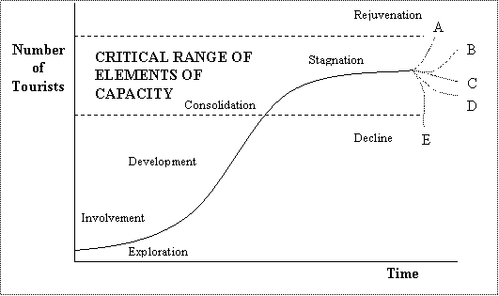
Exploration: The destination beings as a relatively unknown place to visitors. Travelers initially come in small numbers that are restricted by access, facilities, and local knowledge.Development: As word spreads about the destination, attractions and amenities are improved and there are more tourists that come to the area.
Stagnation: This is when a destination cannot take anymore visitors. It reaches a set carrying capacity that is determined by social and environmental limits. It usually happens pretty rapidly, and that is why it is shown as an exponential curve.
Rejuvenation towards A&B: With increases in technology and infrastructure, there is an increase in the carrying capacity and the destination can hold more travelers.
Decline towards C&D: With increased congestion and unsustainable development at a destination, tourists are less likely to travel to a place that is always full. This congestion also leads to a decrease in resources and an increase in corruption. It is also led by the law of diminishing returns (see below for definition).
Decline towards E: This is usually the result after a disaster, either natural or man made.

