Communication
Communications is fundamental to the existence and survival of humans as well as to an organization. It is a process of creating and sharing ideas, information, views, facts, feelings, etc. among the people to reach a common understanding. Communication is the key to the Directing
Communications Process Communications is a continuous process which mainly involves three elements viz. sender, message, and receiver. The elements involved in the communication process are explained below in detail:

1. Sender
The sender or the communicator generates the message and conveys it to the receiver. He is the source and the one who starts the communication

2. Message
It is the idea, information, view, fact, feeling, etc. that is generated by the sender and is then intended to be communicated further.

3. Encoding
The message generated by the sender is encoded symbolically such as in the form of words, pictures, gestures, etc. before it is being conveyed.

4. Media
It is the manner in which the encoded message is transmitted. The message may be transmitted orally or in writing. The medium of communication includes telephone, internet, post, fax, e-mail, etc. The choice of medium is decided by the sender.

5. Decoding
It is the process of converting the symbols encoded by the sender. After decoding the message is received by the receiver.

6. Receiver
He is the person who is last in the chain and for whom the message was sent by the sender. Once the receiver receives the message and understands it in proper perspective and acts according to the message, only then the purpose of communication is successful.

7. Feedback
Once the receiver confirms to the sender that he has received the message and understood it, the process of communication is complete.

8. Noise
It refers to any obstruction that is caused by the sender, message or receiver during the process of communication. For example, bad telephone connection, faulty encoding, faulty decoding, inattentive receiver, poor understanding of message due to prejudice or inappropriate gestures, etc.
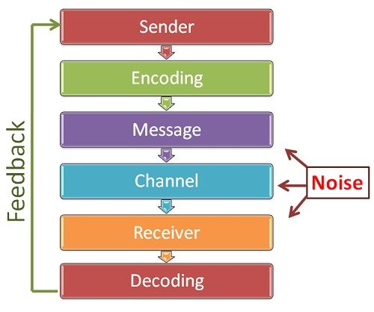
(Source: businessjargons)

Importance of Communication

1. The Basis of Co-ordination
The manager explains to the employees the organizational goals, modes of their achievement and also the interpersonal relationships amongst them. This provides coordination between various employees and also departments. Thus, communications act as a basis for coordination in the organization.

2. Fluent Working
A manager coordinates the human and physical elements of an organization to run it smoothly and efficiently. This coordination is not possible without proper communication.

3. The Basis of Decision Making
Proper communication provides information to the manager that is useful for decision making. No decisions could be taken in the absence of information. Thus, communication is the basis for taking the right decisions.

4. Increases Managerial Efficiency
The manager conveys the targets and issues instructions and allocates jobs to the subordinates. All of these aspects involve communication. Thus, communication is essential for the quick and effective performance of the managers and the entire organization.

5. Increases Cooperation and Organizational Peace
The two-way communication process promotes co-operation and mutual understanding amongst the workers and also between them and the management. This leads to less friction and thus leads to industrial peace in the factory and efficient operations.

6. Boosts Morale of the Employees
Good communication helps the workers to adjust to the physical and social aspect of work. It also improves good human relations in the industry. An efficient system of communication enables the management to motivate, influence and satisfy the subordinates which in turn boosts their morale and keeps them motivated.

Barriers to Communication
The communication barriers may prevent communication or carry incorrect meaning due to which misunderstandings may be created. Therefore, it is essential for a manager to identify such barriers and take appropriate measures to overcome them. The barriers to communication in organizations can be broadly grouped as follows:

1. Semantic Barriers
These are concerned with the problems and obstructions in the process of encoding and decoding of a message into words or impressions. Normally, such barriers result due to use of wrong words, faulty translations, different interpretations, etc.
For example, a manager has to communicate with workers who have no knowledge of the English language and on the other side, he is not well conversant with the Hindi language. Here, language is a barrier to communication as the manager may not be able to communicate properly with the workers.

2. Psychological Barriers
Emotional or psychological factors also act as barriers to communication. The state of mind of both sender and receiver of communication reflects in effective communication. A worried person cannot communicate properly and an angry recipient cannot understand the message properly.
Thus, at the time of communication, both the sender and the receiver need to be psychologically sound. Also, they should trust each other. If they do not believe each other, they cannot understand each other’s message in its original sense.

3. Organizational Barriers
The factors related to organizational structure, rules and regulations authority relationships, etc. may sometimes act as barriers to effective communication. In an organization with a highly centralized pattern, people may not be encouraged to have free communication. Also, rigid rules and regulations and cumbersome procedures may also become a hurdle to communication.

4. Personal Barriers
The personal factors of both sender and receiver may act as a barrier to effective communication. If a superior thinks that a particular communication may adversely affect his authority, he may suppress such communication.
Also, if the superiors do not have confidence in the competency of their subordinates, they may not ask for their advice. The subordinates may not be willing to offer useful suggestions

