EMA – EMA stands for Extra Mileage Allowance. Extra mileage allowance is a grace allowance in mileage which is permitted when traveling via a certain city (point).
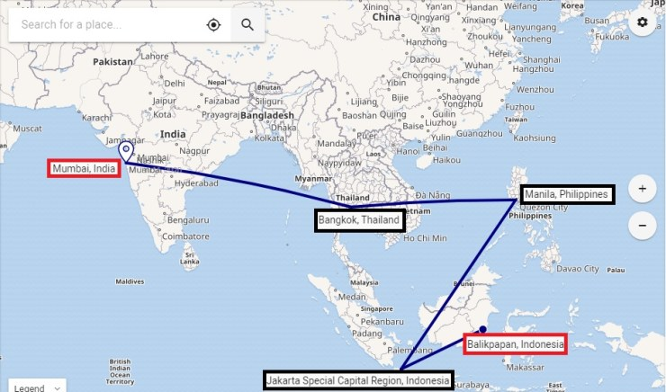EMA applied
For eg:- In the Above example, the travel is from Balikpapan Indonesia to Mumbai via Jakarta, Manila, and Bangkok. The Maximum permitted mileage between Balikpapan to Mumbai is set at 4011 miles and if the TPM goes beyond this surcharge would be charged. In the above scenario, the TPM for the above itinerary would be 4087 which is higher than the MPM and hence a surcharge should be applied, however, if you notice in below EMA table you will see that this routing is permitted to avail EMA. The Area 3 EMA paragraph specifies any travel within Area commencing or via Mumbai, New Delhi, Karachi and Islamabad will Qualify for Extra mileage allowance of 700. This EMA will be Added to MPM and hence the total becomes 4711 which is more than MPM 4087 hence surcharge won’t be applied for this itinerary because of Extra mileage allowance.
EMA Table 1EMA table 2EMA table 3
If you see the above tables Extra mileage allowance is applicable for routings throughout the globe via certain points hence it is essential to always check for EMA table before applying a surcharge for the itinerary.
EMS – EMS stands for Excess mileage surcharge. Excess mileage surcharge is calculated when TPM or the total number of miles flown exceed MPM or Maximum permitted miles. In a scenario where TPM exceeds MPM, a surcharge is added to the fare based upon a calculation, however, EMA or Extra mileage allowance should always be considered before calculating surcharge. In the scenario discussed in the previous example although TPM was greater than MPM after adding EMA the chance for surcharge was negated. However such situations don’t occur frequently and at times even after considering EMA the surcharge applies. In certain scenarios, the EMA plus MPM does not cover the TPM or total miles flown and the surcharge has to be applied. The formula to calculate the surcharge is very simple. TPM (total miles flown) divided by MPM (Maximum permitted mileage) and the output or result that you will get after this division decides the surcharge you will apply for the itinerary

