Basics On Fare Construction 1
Some of the points covered below can be of great value to students pursuing travel studies or IATA Foundation course.
COC – COC stands for Country of commencement. Its the point or city from where the itinerary will commence. If you are calculating fare between LON-NYC, then the country of commencement would be the United Kingdom. Determining COC is vital since it is the first step and will decide the final fare that needs to be determined in local currency.
NUC – NUC stands for the Neutral unit of construction. NUC is a unit used to build fares between two cities. NUC is a common unit which is used globally for constructing mileage-based fares by all airlines. All international fares are quoted in NUC and later converted to local Currency of respective countries this creates uniformity in fare construction globally. NUC is equivalent to the US dollar and has been designated by IATA as the sole unit of constructing a fare between two cities. Even though Local currency exchange rates may vary from country to country NUC level remains constant.
Below is a fare generated for an itinerary from Dubai to London and Back. You can see that even though the Fare is in AED 6160 (Emirates Dirham ) the fare constructed is in NUC. Taxes, on the other hand, will always be quoted in local currency.
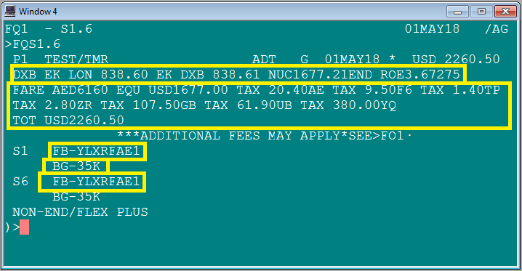Fare Quote Display
MPM – MPM stands for Maximum Permitted Mileage. It is the maximum mileage that is permitted for an itinerary between two cities. MPM is determined by IATA and it remains constant. However different global indicators have varying MPM and fares can be constructed accordingly. Below is an extract from IATA’s PAT (passenger air tariff book ) which shows MPM from Balikpapan Indonesia to a List of other cities.
Below is an example of an itinerary from Balikpapan to Venice Italy. If you notice Venice which is highlighted above in MPM table has 3 MPM’s as per global indicators EH-Eastern Hemisphere, AP – Atlantic pacific and TS – Trans Siberian. Since the traveler here wants to travel to japan en-route the Global indicator that will be applied for this itinerary is TS and the MPM against this Global indicator will be the maximum permitted mileage.
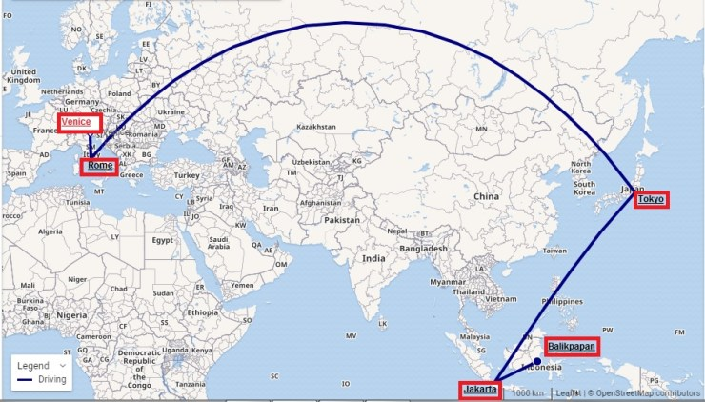
The itinerary that is constructed above has 3 stopovers i.e.:- in Jakarta, Tokyo and Rome. The cumulative flown mileage of this routing is 10749 miles and since we are taking a route via Tokyo Japan we can apply Trans Siberian as Global indicator for this itinerary which has MPM of 10832 miles which is just within the total mileage permitted for constructing this itinerary. EH is another global indicator that we could have used in case the traveler did not want to take a stopover in Tokyo.
Using global indicators in coordination with the above chart and a strong acumen of world geography will help you to construct good itineraries. Hence understanding the concept of MPM is vital in your study of Fare construction.
TPM – TPM stands for ticketed point mileage. It is the actual number of miles that are used for constructing an Itinerary between two points or cities. TPM can be greater, less or equal to MPM since TPM is the actual miles that are used for constructing a particular itinerary.

