IATA geography---TC1,TC2,TC3
IATA International Air Transport Association is a commercial community of the most international airlines over the world. IATA vision is to shape the future growth of safe, secure and sustainable air transport by representing, leading, and serving the airline industry.
ATA divided the world?
IATA has been working to achieve its aims since April,1945.
IATA starts forming its world geography [ IATA MAP] to manage and solve the commercial matters of air transport such as rates, routes and schedules and many other commercial matters.
It was difficult for IATA to solve commercial matters in one traffic conference in one location due to many reasons such as governments approvals, economic factors, lowering the costs etc.
In one of IATA traffic conference, IATA called for establishment many traffic conferences in different parts of the world.
In 1947, the traffic conference locations became three in different parts of the world [ IATA MAP].

IATA Traffic Conferences
IATA traffic conferences were established to deal with all International Air Traffic Matters involving Passengers, Cargo, and Mail in specific area in the world.
IATA member airlines singed agreements related to:
1- Fares & rates
2- Traffic documents (standard forms of passenger's air tickets, baggage checked, air waybills ...etc.).
3- Interline agreements
4- Administration of sales agents
IATA vision and IATA member airlines faith has grown-up the international air transport step by step with cooperation with ICAO.

IATA Map
IATA world map is not like what we studied in the school, in IATA map, there is little differences. For example, IATA definition of Europe comprises not only geographical Europe but includes also the following countries and islands:
- 3 North African countries, i.e. Morocco, Algeria and Tunisia
- The Azores, Madeira and the Canary Islands
These countries by IATA map were situated within the IATA Europe sub-area - IATA area 2.
Although geographically Egypt and Sudan were situated in the African continent, these countries are included by IATA map in IATA Middle East sub-area- IATA area 2.

IATA Tariff Conference Areas [ IATA TC 1,2, 3]
In order to fully understand the routing of Airlines and their respective fare calculations, IATA map divided the worlds into three areas known as Traffic Conferences-TC1, TC2, TC3 (It called as Passenger Tariff Conference, Passenger services Conference, Cargo services Conference, and Cargo Tariff Conference).
International Air Transport Association(IATA) World geography
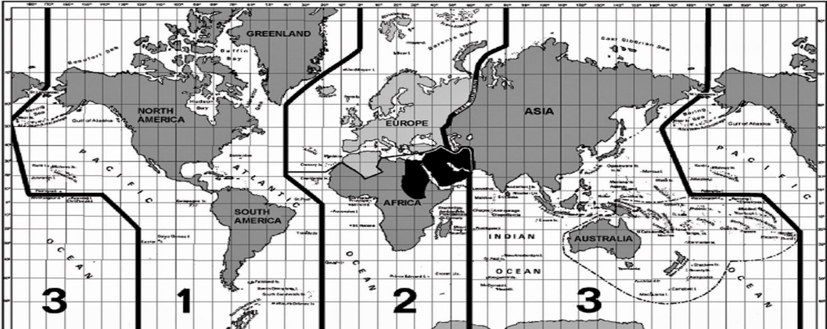

IATA has divided world into three areas: TC1, TC2, TC3
Note:
- Ural Mountain of Russia and Tehran in Middle East divides TC2 with TC3.
- Tc1 is Known as Western Hemisphere.
- TC2 and TC3 are together known as Eastern Hemisphere.

IATA Area1 or TC1
comprises of North America, South America, Central America and the adjacent islands like Greenland, Bermuda, West Indies, Islands of the Caribbean Sea, Hawaiian Islands which includes Midway and Palmyra.
Traffic Conference-1 Sub-Areas.
TC1 – North Atlantic North Atlantic comprises of Canada, Greenland, USA and Mexico excluding Alaska, Hawaii, Puerto Rico and US Virgin Island.
TC1 – Mid Atlantic Including The Caribbean Islands, Central America , South America plus Panama Canal Zone except Argentina, Brazil, Chile, Paraguay and Uruguay.TC1 – South Atlantic Argentina, Brazil, Chile, Paraguay & Uruguay.

IATA Area2 or TC2
comprises of Europe, Africa and Ascension Island and parts of Asia west of Ural mountains including Iran and countries of Middle East.
1. Europe
2. Africa
3. Middle East

IATA Area3 or TC3
Asia (East of the Urals), Oceania, (Australia, New Zealand and South Pacific Islands)
1. South East Asia
2. South Asian Sub continent
3. japan, Korea
4. South West pacific

