Entrepreneurial Motivation

Entrepreneurial motivation is the process of transforming an ordinary individual to a powerful businessman, who can create opportunities and helps in maximizing wealth and economic development. It is defined as various factors stimulate desires and activates enthusiasm in entrepreneurs which make them attain a particular goal. Entrepreneurship is the process of identifying strengths and opportunities which help in the realization of one’s dreams for designing, developing and running a new business by facing threats and risks effectively.
To become an entrepreneur one should identify their strengths and opportunities from the external environment. Here motivation plays a major role in identifying their own strengths to become strong leaders or powerful entrepreneurs which make them to accepting risks and face uncertainty for the purpose of reaching pre-described goals.Motivation makes entrepreneur by fulfilling higher level needs such as recognition, esteem, and self-actualization. Various theories explained motivation as an influencing concept, it can bring out hidden talents and creativity, and it contributes to the individual goals and society development. Maslow’s need hierarchy theory, Hertzberg’s two-factor theory, and David MC Clelland’s acquired needs theory proved that motivation can bring energy, enthusiasm, creativity and efficiencies in fulfilling the desired objectives.Motivation activates innate strengths to achieve a particular goal, many questions arise during knowing this concept such as why can’t all the human beings become leader or entrepreneurs even though they face same motivation during his/her lifetime? Who can become effective motivators? What type of motivation can influence one’s behavior? Is the extent of motivation decides the power of externalized behavior? Etc, entrepreneurial motivation is a psychological process in which all the motives may not influence with the same intensity, it varies with the perception levels of the individuals and factors responsible for the motivation. Sometimes a single motive can influence to become strong and powerful entrepreneurs, these motives may come from various factors as follows.
- Internal factors
- External factorsInternal factors

Need for self-actualization
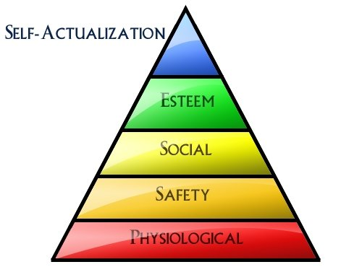
It is explained by Maslow and it is the top level need refers to the desire for self-fulfillment. Need for freedom and self-fulfillment makes the individuals or employees of the organization make them become powerful leaders or entrepreneurs.

Optimism
Individuals having positive mindset get motivated by finding opportunities during critical situations also. Positive attitude and perception motivate an individual to work out for the best even during unfavorable and tough situations also.

Positive attitude
The positive attitude is the most important factor which motivates the individuals to become successful entrepreneurs. Habituating positive attitude can lead an individual to develop constructive thinking; it motivates them to become powerful entrepreneurs, finally, the positive attitude can prove that how valuable they are.

Self-motivationMost of the successful and powerful entrepreneurs are self-motivated; here they fulfill the desired objectives by motivating themselves. Though many individuals have ideas but they cannot put those for business development; however self-motivated people can take decisions to implement ideas.

Enthusiasm Enthusiasm motivates in finding better solutions, finally, it stabilizes the ideas and makes them become creators and innovators which result in successful entrepreneurs.

Commitment Commitment towards a goal can make to achieve success. It motivates entrepreneurs by inspiring and developing emotional attachment towards an objective.

Education Education is the most important factor it motivates a person to innovate and create new products, this result in establishing an organization or a new business venture. The knowledge acquired during the course of time and innate skills highly motivates a person to become a successful entrepreneur.

Background
Family background, occupational background and a person’s own experience in a job motivates him/her to become an entrepreneur. Having entrepreneurial background acts as a clear path to becoming a successful and powerful entrepreneur.

Financial background Finance is the scarce resource which motivates and enables a person to become an entrepreneur. Money can make many things it is the major thing in deciding one’s status and development, strong financial background facilitates to start a business.

External factors
Influence
Influence of family members, friends, and society motivates the individuals to become entrepreneurs. The extent of influence shows an effect on the character, behavior, and development, it comes from the external environment. Here people get influenced by seeing successful entrepreneurs or by the words of others.

Availability of resources
Resource availability motivates at a high extent to become entrepreneurs, availability of land, labor, money, machinery, and materials make individual to start a new business. Though there is creativity, intelligence, commitment and enthusiasm in the individuals, but the unavailability of resources becomes an obstacle for new entrants or entrepreneurs.

Product’s demand
Higher demand for a particular product motivate entrepreneurs to produce innovative and value added products, here product’s demand motivates the individuals to become entrepreneurs. The hope of success makes them produce innovative products or substitute products, some entrepreneurs fulfill the market demand by producing complementary goods also. So the increase in products demand highly motivates to become entrepreneurs.

Government policies
Subsidies and benefits given by the government motivate entrepreneurs to produce new products or motivates individual to become entrepreneurs. Government policies show higher influence on establishing new firms and it leads to economic development. In the case of small scale industries, rural people are encouraged by the various training programs, financial support, and subsidies; it is one of the main reasons for the establishment of new firms and arrival of new entrants.

Information availability
Market knowledge and information motivate individuals to enter into the markets and to become entrepreneurs. If there is abundant information then it automatically creates interest in the minds of enthusiastic people to become entrepreneurs. Availability of information facilitates research and producing innovative and value added products, and it creates a scope to become entrepreneurs.

Technological advancement
Technological advancement acts as a path to transform ideas into products, feasibility in production and expected success rate highly motivates to become entrepreneurs. It reduces errors and cost of production and maximizes success rate, this is the reason why people are interested in becoming entrepreneurs with the increase in technology.

