Jagiroad coellge(RADHIKA RIMAL)

The presence of a nucleus is the principal feature that distinguishes eukaryotic from prokaryotic cells. DNA replication, transcription, and RNA processing all take place within the nucleus.

Nuclear Envelope-The nuclear envelope separates the contents of the nucleus from the cytoplasm and provides the structural framework of the nucleus and, acts as barriers that prevent the free passage of molecules between the nucleus and the cytoplasm, maintain the nucleus as a distinct biochemical compartment. The nuclear envelope has a complex structure consisting of two nuclear membranes, an underlying nuclear lamina, and nuclear pore complexes. The nucleus is surrounded by a system of two concentric membranes called the inner and outer nuclear membranes. The outer nuclear membrane is continuous with the endoplasmic reticulum, so the space between the inner and outer nuclear membranes is directly connected with the lumen of the endoplasmic reticulum. The critical function of the nuclear membranes is to act as a barrier that separates the contents of the nucleus from the cytoplasm. Like other cell membranes, each nuclear membrane is a phospholipid bilayer permeable only to small nonpolar molecules. The inner and outer nuclear membranes are joined at nuclear pore complexes—the sole channels through which small polar molecules and macromolecules pass through the nuclear envelope. Underlying the inner nuclear membrane is the nuclear lamina, a filamentous meshwork that provides structural support to the nucleus.
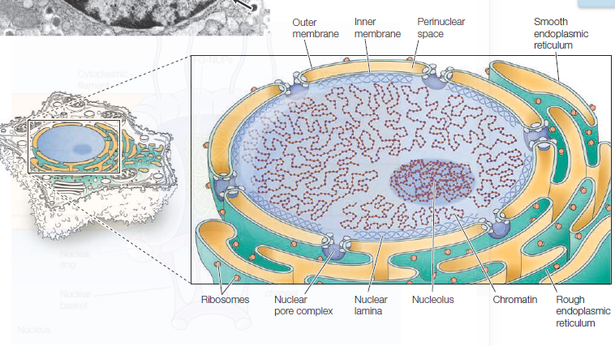
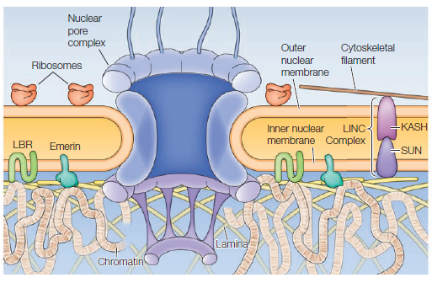
Figure: Nuclear envelope.

Nuclear pore complex- The nuclear pore complexes are the only channels through which small polar molecules, ions, and macromolecules (proteins and RNAs) can travel between the nucleus and the cytoplasm. The nuclear pore complex is an extremely large structure with a molecular mass of approximately 120 million daltons in humans—about 30 times the size of a ribosome. The nuclear pore complex is composed of multiple copies of about 30 different pore proteins (called nucleoporins or NUPs). By controlling the traffic of molecules between the nucleus and the cytoplasm, the nuclear pore complex plays a fundamental role in the physiology of all eukaryotic cells. RNAs synthesized in the nucleus must be efficiently exported to the cytoplasm where they function in protein synthesis. Conversely, proteins required for nuclear functions (e.g., transcription factors) must be transported to the nucleus from their sites of synthesis in the cytoplasm. In addition, many proteins shuttle continuously between the nucleus and the cytoplasm. Depending on their size and structure, molecules can travel through the nuclear pore complex by one of two mechanisms. Small molecules and some proteins with molecular mass less than approximately 40 kd diffuse freely through the pore in either direction: cytoplasm to nucleus or nucleus to cytoplasm. Most
proteins and RNAs, however, pass through the nuclear pore complex by a selective transport process.
Studies show that the nuclear pore complex consists of an assembly of eight spokes arranged around a central channel. The spokes are connected to ringsat the nuclear and cytoplasmic surfaces, and the spoke–ring assembly is anchored within the nuclear envelope at sites of fusion between the inner and outer nuclear membranes. Protein filaments extend from both the cytoplasmic and nuclear rings, forming a distinct basketlike structure on the nuclear side. The central channel is lined by proteins called FG-NUPs because they contain repeats that are rich in phenylanine and glycine residues. The FG-NUPs are the barrier to permeability of the pore and facilitate regulated transport between the nucleus and the cytoplasm.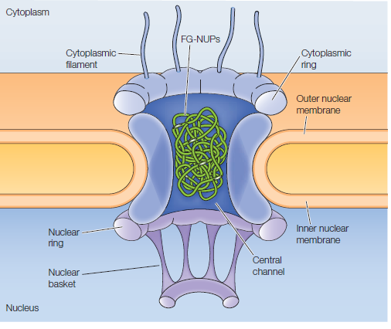
Figure: Nuclear pore complex.

Protein import through the nuclear pore complex- Transport begins when the nuclear localization sequence (NLS) of a cargo protein is recognized by an importin. The cargo/importin complex binds to nuclear pore proteins in the
cytoplasmic filaments and is transported through the pore. At the nuclear side of the envelope, Ran/GTP binds to the importin, disrupting the cargo/importin complex and releasing the cargo protein into the nucleus. The importin-Ran/GTP complex is re-exported through the nuclear pore and the GTPase-activating protein (Ran GAP) associated with cytoplasmic filaments stimulates hydrolysis of the GTP to GDP, releasing the importin. Ran/ GDP is then transported back to the nucleus in association with its own import receptor, NTF2. In the nucleus, Ran GEF (bound to chromatin) stimulates the exchange of GDP bound to Ran for GTP, leading to the conversion of Ran/GDP to Ran/GTP and maintaining a high concentration of Ran/GTP within the nucleus

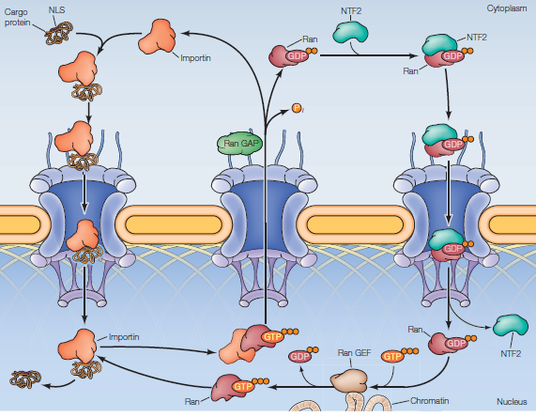
Figure- Transport of proteins through nuclear pore.

