Characteristics of Attitude
Characteristics of attitude are discussed below:
- Attitude are predispositions
- Attitude are different from values
- Attitude are evaluative statement
- Attitude influence human behavior
- Attitude have intensity
- Attitude are learnt
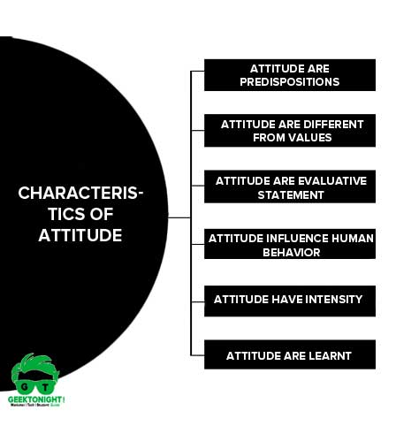Characteristics of Attitude

Attitude are predispositions
Attitude are predispositions of purpose, interest or opinion of the person to assess some objects in a favourable or an unfavourable manner.

Attitude are different from values
Attitude are different from values: Values are the ideals, whereas attitudes are narrow, they are our feelings.

Attitude are evaluative statement
Attitude are evaluative statements: either favourable or unfavourable concerning the objects, people or events.

Attitude influence human behavior
A positive attitude towards a thing will influence human behavior towards the thing favorably and vice-versa.

Attitude have intensity
It refers to the strength of the effective component. For example, we may dislike an individual but the extent of our disliking would determine the intensity of our attitude towards the person.

Attitude are learnt
Attitude is not inborn phenomenon. Attitude are learnt through social interaction and experience.

Functions of Attitude
Four important functions of attitude which are crucial in organizational behavior viewpoint are:
- Adjustment Function
- Ego-Defensive Function
- Value-Expressive Function
- Knowledge Function
Functions of Attitude

Adjustment Function
Attitudes often help individuals to adjust to their work environment.
Consumers hold certain brand attitudes partly because of the brand utility. If a product has helped us in the past even in a small way, our attitude towards it tends to be favorable. One way of changing attitude in favor of a product is by showing people that it can solve utilitarian goals. They may not have considered some advertisement which stresses the utilitarian benefits of a product.
Example: Well-treated employees tend to develop a positive attitude towards their management or job.

Ego-Defensive Function
Consumers want to protect their self concept from inner feelings of doubt. Cosmetic and personal hygiene products, by acknowledging this need, increase their relevance to the consumer and have the possibility of a favorable attitude by offering reassurance to the consumers self concept.

Knowledge Function
Attitudes provide frames of reference or standard that allow individuals to understand and perceive the world around him. Individuals have a strong need to know and understand the people and things with whom they come in contact, especially if they think they might influence their behavior

Types of Attitude
There are broadly three types of attitude in term of organisational behavior
- Job satisfaction
- Job involvement
- Organizational commitment
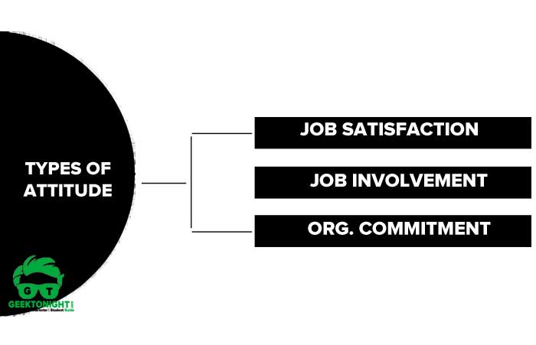Types of Attitude

Job satisfaction
A collection of positive and/or negative feelings that an individual holds toward his or her job.
A person will hold a positive attitude if had a high level of satisfaction, while dissatisfied people will generally display a negative attitude towards life.
When we talk about attitude, we generally speak about job satisfaction because they are inter-related in organizational behaviour
Job involvement
Job involvement refers to the degree to which a person identifies himself (psychologically) with his job, actively participates and considers his perceived performance level important to self-worth. (Robbins)
Higher job satisfaction leads to low absenteeism & employee turnover and indicates that the individual cares for his job.

Organizational commitment
Organizational commitment refers to a degree to which an employee identifies himself with the organizational goals and wishes to maintain membership in the organization.
Resigning from the job or absenting versus job satisfaction is a predictor of organizational commitment. Organizational commitment depends upon the degree of autonomy & freedom job and job enrichment factor

Attitude Formation
The question often arises, ‘how are the attitudes and subsequent behaviors formed?’ While attitudes are basically learned over the years, some inherited characteristics do affect such attitudes
Some of the learned characteristics responsible for attitude formation are:
- Experiences
- Perceptual biases
- Observation of other person attitude
- Association
- Personality
Attitude Formation

Experiences
Our personal experiences with people and situations develop our attitude towards such persons and situations.
Through job experience, people develop attitudes towards working conditions, salaries, supervision, group dynamics and so on.

Perceptual biases
Perception is the result of a complex interaction of various senses such as feelings, seeing, hearing and so on and plays an important part in our attitude and behavioural formation.
For example, if a manager perceives a subordinate’s ability as limited, he will give him limited responsibility. Similarly, we lose many good friends due to our changed perception about them.

Observation of other person attitude
When we like someone, we try to emulate that person’s attitude.
For example, when we are impressed by someone keeping calm under stressful circumstances and we appreciate such calmness, we might try to do the same.

Association
Our association with the group we belong to strongly influences our attitude. Our close association with a group would encourage us to be consistent with the attitude of the group.

Personality
Personality is a set of traits and characteristics, habit patterns and conditioned responses to certain stimuli that formulate the impression that a person makes upon others and this impression is a function of a person’s attitude.

Consumer Attitude Formation
Attitudes are learned though there are different approaches on how learning works as is acquired by individuals. Following factors lead to consumer attitude formation:
- Economic Factors
- Family Factors
- Social Factors
- Political Factors
- Psychological Factors
- Personality Factors
- Reference Group Factors

Importance of Attitude
An expert knows that a positive attitude is necessary for successful completion of a project or an assigned task. Having a positive attitude with positive thinking in the organization will reflect on what employee do and make them a more productive employee.
Importance of attitude in organisational behavior
Employees with a positive attitude will create a healthy atmosphere in the organization, develop positive relations with sub-ordinates, their supervisors, managers and top management. A positive attitude has significant benefits for an individual in many aspects.
Following are the aspects related to the importance of attitude:
- Career success
- Productivity
- Leadership
- Teamwork
- Decision making
- Motivation
- Interpersonal relations
- Stress management
Importance of Attitude

Career success
Performance is a parameter to measure employees‘ success in the workplace. Performance leads to success either through promotion or increased compensation. A positive attitude of an employee will help him to think of ways to accomplish their task in a well-defined manner

Productivity
An employee with a positive attitude tends to take more interest and responsibility and will provide better work, which in turn will improve productivity.

Leadership
Managing a diverse workforce is a crucial task for achieving the objective of an organization. Positive attitude demonstrated by leaders or employee will result in proper communication between the subordinate which will lead to efficient work.

Teamwork
A positive attitude of employees helps to appreciate each other‘s competencies and work as a team for achieving common objectives.

Decision making
An employee with a positive attitude and mindset will help employees to make better decisions, in an objective manner. It will enable employees to choose wisely and logically and avoid them to take an unambiguous decision.

Motivation
Motivation is an important factor for efficient work. An employee with a positive attitude will always be mentally prepared to face any obstacle in a job. The moment they are successful in overcoming obstacles, they are motivated to move forward.

Interpersonal relations
Customers prefer to make relation with someone who is positive in nature. A positive attitude helps in establishing valuable customer loyalty.

Stress management
Positive attitude and thinking will reduce the stress of an employee and with reduced stress employee can take a better decision and increase their productivity which results, employees, to enjoy better health and take fewer sick leaves

