Attitude Meaning
In simple words, an “attitude” is an individual’s way of looking or an individual’s point of view at something.
To be more specific, an “attitude” may be defined as the mental state of an individual, which prepares him to react or make him behave in a particular pre-determined way. It is actually an acquired feeling.

Attitude is the mixture of beliefs and feelings that people have about situations, specific ideas or other people

Definition of Attitude
Attitude is the manner, disposition, feeling, and position about a person or thing, tendency, or orientation, especially in mind.
According to Gordon Allport, “An attitude is a mental and neural state of readiness, organized through experience, exerting a directive or dynamic influence upon the individual’s response to all objects and situations with which it is related.”
Frank Freeman said, “An attitude is a dispositional readiness to respond to certain institutions, persons or objects in a consistent manner which has been learned and has become one’s typical mode of response.”
Thurstone said, “An attitude denotes the total of man’s inclinations and feelings, prejudice or bias, preconceived notions, ideas, fears, threats, and other any specific topic.”
Anastasi defined attitude as “A tendency to react favorably or unfavorably towards a designated class of stimuli, such as a national or racial group, a custom or an institution.”
According to N.L. Munn, “Attitudes are learned predispositions towards aspects of our environment. They may be positively or negatively directed towards certain people, service, or institution.”
“Attitudes are an ‘individual’s enduring favorable or unfavorable evaluations, emotional feelings, and action tendencies toward some object or idea.” — David Krech, Richard S. Crutchfield, and Egerton L. Ballackey.
“Attitude can be described as a learned predisposition to respond in a consistently favorable or unfavorable manner for a given object.” — Martin Fishbein and Icek Ajzen.
“An attitude is a relatively enduring organization of beliefs around an object or situation predisposing one to respond in some preferential manner.” — Milton Rokeach.

Components of Attitude
- Cognitive component
- Affective component
- Behavioral component

Compon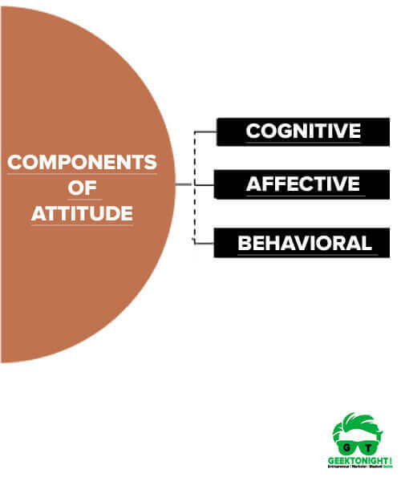ents of Attitude

Cognitive component
Beliefs are the cognitive components of consumer attitude. Cognitive component of attitude is associated with the value statement. It consists of values, belief, ideas and other information that a person may have faith in.
Positive brand associations enhance brand equity and are achieved through a number of positioning strategies. Through brand associations, marketers establish and influence favorable beliefs about a brand and unfavorable beliefs about competitors.
Example: Quality of sincere hard is a faith or value statement that a manager may have.

Affective component
Affective is the emotive component of consumer attitude. Affective component of attitude is associated with individual feelings about another person, which may be positive, neutral or negative.
Three research models describe the determinants of affective response.
- Functional theory of attitude explains that consumers buy as a result of one of four psychological functions: adjustment, ego defense, value expression, and application of prior knowledge.
- Fishbein model relates consumer beliefs and evaluations to affective response: if beliefs are strong and desirable, affective responses are positive.
- Belief importance model analyses affective responses across competing brands.
Example: I don’t like Sam because he is not honest, or I like Sam because he is sincere. It is an expression of feelings about a person, object or a situation.

Behavioral component
Intention is the behavioral component of consumer attitude. Behavioral component of attitude is associated with the impact of various condition or situations that lead to person behavior based on cognitive and affective components.
Two research models demonstrate the relationship between intention to purchase and actual purchase and consumption.
- The theories of reasoned action explain purchasing behavior as a direct result of intention, influenced by attitude toward purchase and by subjective norms.
- The theory of trying to consume explains actual consumption behavior of purchasers. It provides insight into the establishment and maintenance of long-term relationship with consumers.
Example: I don’t like Sam because he is not honest is an affective component, I, therefore, would like to disassociate myself with him, is a behavioural component and therefore I would avoid Sam.
Cognitive and affective components are bases for such behaviour. Former two components cannot be seen, only the behaviour component can be seen. Former is important because it is a base for the formation of attitude.

