What is STP marketing?
STP marketing is an acronym for Segmentation, Targeting, and Positioning – a three-step model that examines your products or services as well as the way you communicate their benefits to specific customer segments.
In a nutshell, the STP marketing model means you segment your market, target select customer segments with marketing campaigns tailored to their preferences, and adjust your positioning according to their desires and expectations.
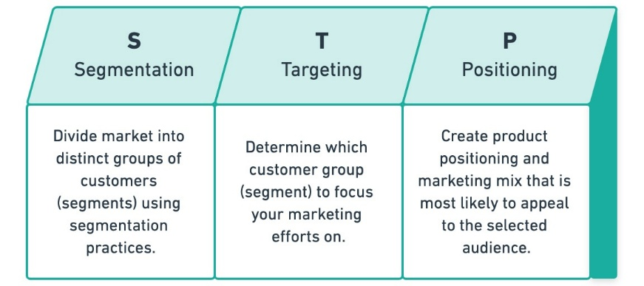
STP marketing is effective because it focuses on breaking your customer base into smaller groups, allowing you to develop very specific marketing strategies to reach and engage each target audience.
In fact, 59% of customers say that personalization influences their shopping decision and another 44% said that a personalized shopping experience would influence them to become repeat customers of a brand.
STP marketing represents a shift from product-focused marketing to customer-focused marketing. This shift gives businesses a chance to gain a better understanding of who their ideal customers are and how to reach them. In short, the more personalized and targeted your marketing efforts, the more successful you will be.

The STEP Formula
If you are looking for a simple way to remember and summarize the STP marketing concept, the acronym STEP is extremely useful:
Segmentation + Targeting Equals Positioning
This formula clearly illustrates that each segment requires tailored positioning and marketing mix to ensure its success. Let’s take a closer look at each of the three steps in the STP marketing model.

Segmentation
The first step of the STP marketing model is the segmentation stage. The main goal here is to create various customer segments based on specific criteria and traits that you choose. The four main types of audience segmentation include:
- Geographic segmentation: Diving your audience based on country, region, state, province, etc.
- Demographic segmentation: Dividing your audience based on age, gender, education level, occupation, gender, etc.
- Behavioral segmentation: Dividing your audience based on how they interact with your business: What they buy, how often they buy, what they browse, etc.
- Psychographic segmentation: Dividing your audience based on “who” your potential customer is: Lifestyle, hobbies, activities, opinions, etc.
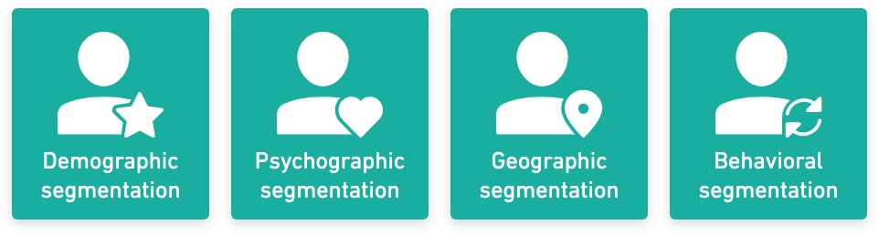

Targeting
Step two of the STP marketing model is targeting. Your main goal here is to look at the segments you have created before and determine which of those segments are most likely to generate desired conversions (depending on your marketing campaign, those can range from product sales to micro conversions like email signups).
Your ideal segment is one that is actively growing, has high profitability, and has a low cost of acquisition:
- Size: Consider how large your segment is as well as its future growth potential.
- Profitability: Consider which of your segments are willing to spend the most money on your product or service. Determine the lifetime value of customers in each segment and compare.
- Reachability: Consider how easy or difficult it will be for you to reach each segment with your marketing efforts. Consider customer acquisition costs (CACs) for each segment. Higher CAC means lower profitability.
There are limitless factors to consider when selecting an audience to target – we’ll get into a few more later on – so be sure that everything you consider fits with your target customer and their needs.

Positioning
The final step in this framework is positioning, which allows you to set your product or services apart from the competition in the minds of your target audience. There are a lot of businesses that do something similar to you, so you need to find what it is that makes you stand out.
All the different factors that you considered in the first two steps should have made it easy for you to identify your niche. There are three positioning factors that can help you gain a competitive edge:
- Symbolic positioning: Enhance the self-image, belongingness, or even ego of your customers. The luxury car industry is a great example of this – they serve the same purpose as any other car but they also boost their customer’s self-esteem and image.
- Functional positioning: Solve your customer’s problem and provide them with genuine benefits.
- Experiential positioning: Focus on the emotional connection that your customers have with your brand.
The most successful product positioning is a combination of all three factors. One way to visualize this is by creating a perceptual map for your industry. Focus on what is important for your target customers and see where you and your competitors land on the map.

