Inductive effects: the displacement of sigma electron along the carbon chin due to the presence of polar covalent bond is called inductive I-effect.
It arises due to electronegativity difference between two atoms forming a sigma bond.
* It is transmitted through the sigma bonds. No pi bonds are involved.
* The magnitude of inductive effect decreases while moving away from the groups causing it.
* It is a permanent effect. It may create permanent dipole in the molecule.
* It influences the chemical and physical properties of compounds.

Types of Inductive Effect

+I Effect
When an atom or group donates electrons towards the bond and acquires a partial positive charge, the atom or group is called +I group, and the corresponding effect is called the positive Inductive Effect or the +I effect.
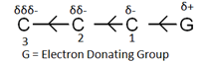
Example of +I groups: – O –, – COO –, –CR₃, –CHR₂, –CH₂R, –CH₃, –D

-I effect
When an atom or group attracts the bonding electrons towards itself and acquires a partial negative charge, the atom or group is called -I group and the corresponding effect is called the electron-withdrawing inductive effect, or the -I effect.
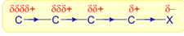
Example of -I groups: –NO₂, – SO₂R, –CN, –SO₂Ar, –COOH, –F, – Cl, – Br, – I, –OAr, –COOR, –OR, –COR, –SH, –SR, –OH, –Ar, – CH = CR₂

Inductive Effect Order for +I Groups
– O –> – COO –> –CR₃ > –CHR₂ > –CH₂R > –CH3 > –D

Inductive Effect Order for -I Groups
-NR₃⁺ > -SR₂⁺ > -NH₃⁺ > –NO₂ > – SO₂R > –CN > –SO₂Ar > –COOH > –F > – Cl > – Br > – I > –OAr > –COOR > –OR > –COR > –SH > –SR > –OH > –Ar > – CH = CR₂

Applications of Inductive Effect
The inductive effect affects some important following properties of organic compunds and these are may be
- Acidic strength of aliphatic carboxylic acids.
- The relative strength of organic bases.
- The effect on dipole moment and bond length.
- Stability of alkyl carbocation, carbanions, and carbon-free radicals.

Inductive Effect on Acidity and Basicity
Using the inductive effect, we can predict the acidity and basicity of compounds. As a generalisation, it may be said that the electron-withdrawing groups (EWG) increase the acidity of a compound and electron-donating group decrease the acidity of a compound.
This is because, if we take the conjugate base of the acid, that is, RCOO-, if R is electron-withdrawing, then the conjugate base is stabilised via delocalisation of the formed negative charge.
If R had been electron-donating, then the conjugate base would be destabilised because of inter-electronic repulsions.
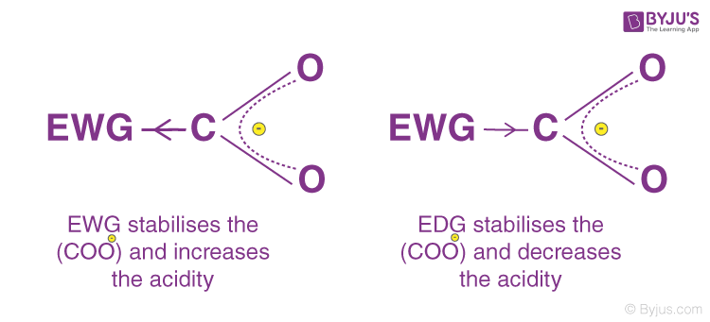
Thus, it can be said that, +I groups decrease acidity (or increase basicity) and –I groups increase acidity (or decrease basicity) of compounds.
For Example, formic acid ( HCOOH) is more acidic than acetic acid (CH3COOH) due to the +I inductive effect of the methyl group attached to the carboxylic acid group.
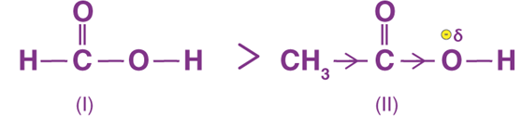
Consider, the acidity of mono-, di- and trichloroacetic acid.

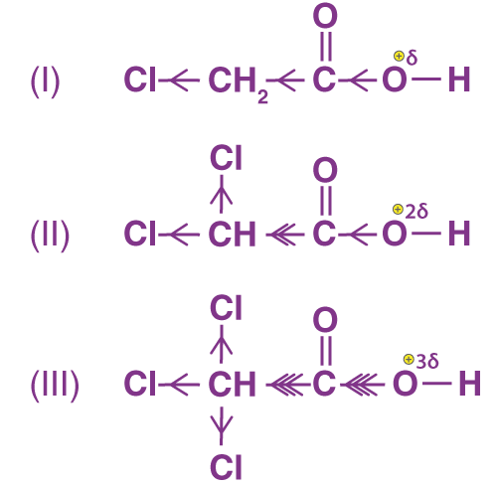
It can be said that the presence of three Cl atoms make oxygen highly electron deficient and thereby, polarising the O-H bond the most. Therefore, the acidity order for the above compounds would be, III > II > I.
Basic strength of amines:
The electron donating groups like alkyl groups increase the basic strength of amines whereas the electron withdrawing groups like aryl groups decrease the basic nature. Therefore alkyl amines are stronger Lewis bases than ammonia, whereas aryl amines are weaker than ammonia.
Thus the order of basic strength of alkyl and aryl amines with respect to ammonia is :CH₃NH₂ > NH₃ > C₆H₅NH₂

