Alcohols,
- Alcohols and phenols are formed when a hydrogen atom in a hydrocarbon, aliphatic and aromatic respectively, is replaced by –OH group.
- An alcohol contains one or more hydroxyl (OH) group(s) directly attached to carbon atom(s), of an aliphatic system (CH3OH) while a phenol contains –OH group(s) directly attached to carbon atom(s) of an aromatic system (C₆H₅OH).
- The substitution of a hydrogen atom in a hydrocarbon by an alkoxy or aryloxy group (R–O/Ar–O) yields another class of compounds known as ‘ethers’, for example, CH₃OCH₃ (dimethyl ether).
Classification
Alcohols and phenols may be classified as mono–, di–, tri- or polyhydric compounds depending on whether they contain one, two, three or many hydroxyl groups respectively in their structures as given below:
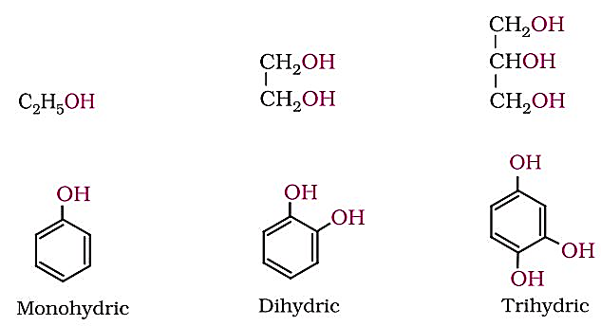
Monohydric alcohols may be further classified according to the hybridisation of the carbon atom to which the hydroxyl group is attached.
(i) Compounds containing C sp³ - OH bond: In this class of alcohols, the –OH group is attached to an sp³ hybridised carbon atom of an alkyl group. They are further classified as follows: Primary, secondary and tertiary alcohols: In these three types of alcohols, the –OH group is attached to primary, secondary and tertiary carbon atom, respectively as depicted below:
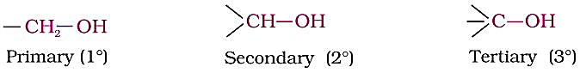
Allylic alcohols: In these alcohols, the —OH group is attached to a sp³ hybridised carbon next to the carbon-carbon double bond, that is to an allylic carbon. For example
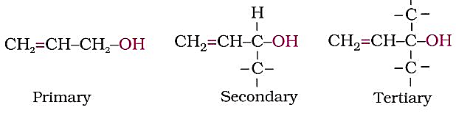
Benzylic alcohols: In these alcohols, the —OH group is attached to a sp³—hybridised carbon atom next to an aromatic ring. For example
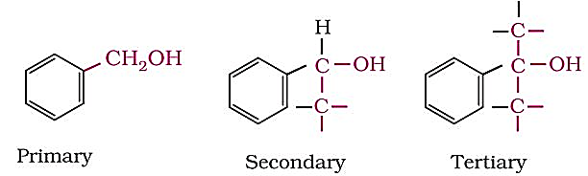
Allylic and benzylic alcohols may be primary, secondary or tertiary.

(ii) Compounds containing C sp²- OH bond: These alcohols contain —OH group bonded to a carbon-carbon double bond i.e., to a vinylic carbon or to an aryl carbon. These alcohols are also known as vinylic alcohols.
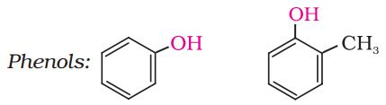

: Preparation of Alcohols:
- By acid catalysed hydration: Alkenes react with water in the presence of acid as catalyst to form alcohols. In case of unsymmetrical alkenes, the addition reaction takes place in accordance with Markovnikov’s rule
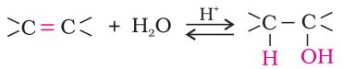
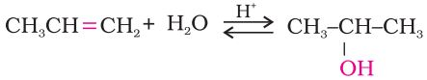
- By hydroboration–oxidation: Diborane (BH₃)₂ reacts with alkenes to give trialkyl boranes as addition product. This is oxidised to alcohol by hydrogen peroxide in the presence of aqueous sodium hydroxide.
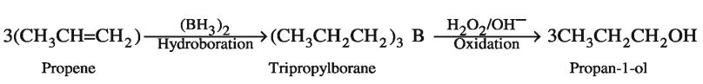
+ B(OH)₃
2. From carbonyl compounds:
(i) By reduction of aldehydes and ketones: Aldehydes and ketones are reduced to the corresponding alcohols by addition of hydrogen in the presence of catalysts (catalytic hydrogenation).
The usual catalyst is a finely divided metal such as platinum, palladium or nickel.
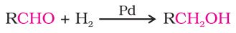
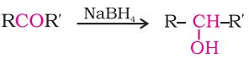
It is also prepared by treating aldehydes and ketones with sodium borohydride (NaBH₄) or lithium aluminium hydride (LiAlH4). Aldehydes yield primary alcohols whereas ketones give secondary alcohols.
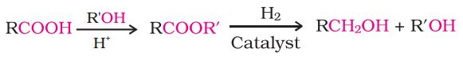
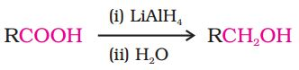
- By reduction of carboxylic acids and esters: Carboxylic acids are reduced to primary alcohols in excellent yields by lithium aluminium hydride, a strong reducing agent.
However, LiAlH4 is an expensive reagent, and therefore, used for preparing special chemicals only. Commercially, acids are reduced to alcohols by converting them to the followed by their reduction using hydrogen in the presence of catalyst (catalytic hydrogenation).
3. From Grignard reagents
Alcohols are produced by the reaction of Grignard reagents with aldehydes and ketones.
The first step of the reaction is the nucleophilic addition of Grignard reagent to the carbonyl group to form an adduct. Hydrolysis of the adduct yields an alcohol.
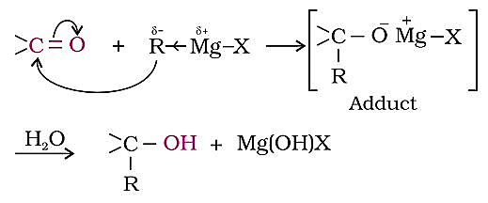
The reaction produces -- a primary alcohol with methanal, a secondary alcohol with other aldehydes and tertiary alcohol with ketones.

Physical Properties
Boiling Points: The boiling points of alcohols and phenols increase with increase in the number of carbon atoms (increase in van der Waals forces). In alcohols, the boiling points decrease with increase of branching in carbon chain (because of decrease in van der Waals forces with decrease in surface area).
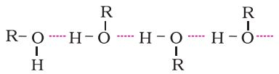
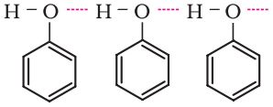
The –OH group in alcohols and phenols is involved in intermolecular hydrogen bonding as shown below:

It is interesting to note that boiling points of alcohols and phenols are higher in comparison to other classes of compounds, namely hydrocarbons, ethers, haloalkanes and haloarenes of comparable molecular masses. For example, ethanol and propane have comparable molecular masses but their boiling points differ widely. The boiling point of methoxymethane is intermediate of the two boiling points.
The high boiling points of alcohols are mainly due to the presence of intermolecular hydrogen bonding in them which is lacking in ethers and hydrocarbons.
Solubility: Solubility of alcohols and phenols in water is due to their ability to form hydrogen bonds with water molecules as shown. The solubility decreases with increase in size of alkyl/aryl (hydrophobic) groups. Several of the lower molecular mass alcohols are miscible with water in all proportions.
Chemical Reactions
Alcohols are versatile compounds. They react both as nucleophiles and electrophiles.
Alcohols as nucleophiles: The bond between O–H is broken when alcohols react as
nucleophiles.
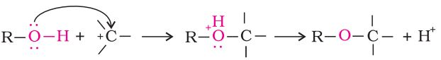
Alcohols as electrophiles: The bond between C–O is broken when they react as
electrophiles. Protonated alcohols react in this manner.
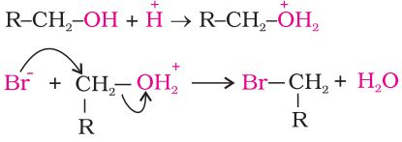
(a) Reactions involving cleavage of O–H bond
1. Acidity of alcohols: The acidic character of alcohols is due to the polar nature of O–H bond. An electron-releasing group (–CH3, –C2H5) increases electron density on oxygen tending to decrease the polarity of O-H bond. This decreases the acid strength. For this reason, the acid strength of alcohols decreases in the following order:
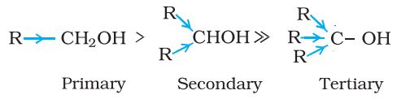
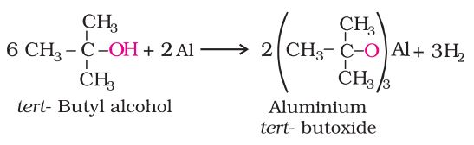
(ii) Reaction with metals: Alcohols react with active metals such as sodium, potassium and aluminium to yield corresponding alkoxides and hydrogen.
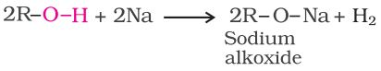
The above reactions show that alcohols and phenols are acidic in nature. In fact, alcohols and phenols are Brönsted acids i.e., they can donate a proton to a stronger base (B:).
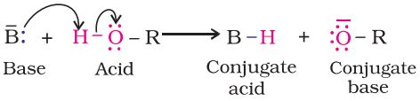
2. Esterification: Alcohols react with carboxylic acids, acid chlorides and acid anhydrides to form esters.
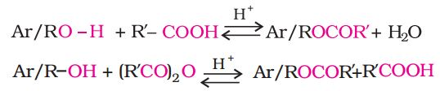
The reaction with carboxylic acid and acid anhydride is carried out in the presence of a small amount of concentrated sulphuric acid. The reaction is reversible, and therefore, water is removed as soon as it is formed. The reaction with acid chloride is carried out in the presence of a base (pyridine) so as to neutralise HCl which is formed during the reaction.
(b) Reactions involving cleavage of carbon – oxygen (C–O) bond in alcohols:
The reactions involving cleavage of C–O bond take place only in alcohols. Phenols show this type of reaction only with zinc.
1. Reaction with hydrogen halides: Alcohols react with hydrogen halides to form alkyl halides ROH + HX → R–X + H2O
The difference in reactivity of three classes of alcohols with HCl distinguishes them from one another (Lucas test). Alcohols are soluble in Lucas reagent (conc. HCl and ZnCl2) while their halides are immiscible and produce turbidity in solution. In case of tertiary alcohols, turbidity is produced immediately (within 1 minute) as they form the halides easily. Secondary alcohols, produced turbidity (within 5 minute). Primary alcohols do not produce turbidity at room temperature since there is no reaction.
2. Reaction with phosphorus trihalides: Alcohols are converted to alkyl bromides by reaction with phosphorus tribromide C₂H₅ OH + PBr₃ → C₂H₅- Br + H₃PO₃.
3. Dehydration: Alcohols undergo dehydration (removal of a molecule of water) to form alkenes on treating with a protic acid e.g., concentrated H2SO4 or H3PO4, or catalysts such as anhydrous zinc chloride or alumina.
Thus, the relative ease of dehydration of alcohols follows the following order:
Tertiary> Secondary > Primary
Primary alcohol (Ethanol) undergoes dehydration by heating it with strong oxidising agent concentrated H2SO4 at 443 K.
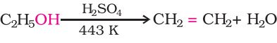
Secondary and tertiary alcohols are dehydrated under milder conditions. For example:
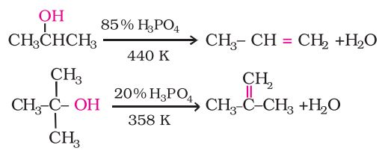
Mechanism of Dehydration e.g. ethanol
Step 1: Formation of protonated alcohol.
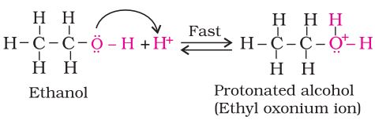
Step 2: Formation of carbocation: It is the slowest step and hence, the rate determining step of the reaction.
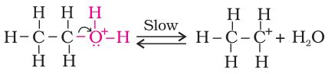
Step 3: Formation of ethene by elimination of a proton.
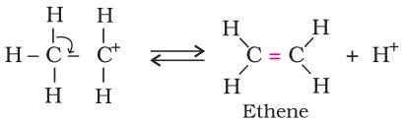
The acid used in step 1 is released in step 3. To drive the equilibrium to the right, ethene is removed as it is formed.
4. Oxidation: Oxidation of alcohols involves the formation of a carbon oxygen double bond with cleavage of an O-H and C-H bonds.
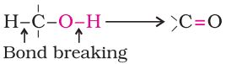
Such a cleavage and formation of bonds occur in oxidation reactions. These are also known as dehydrogenation reactions as these involve loss of dihydrogen from an alcohol molecule. Depending on the oxidising agent used, a primary alcohol is oxidised to an aldehyde which in turn is oxidised to a carboxylic acid.
Strong oxidising agents such as acidified potassium permanganate are used for getting carboxylic acids from alcohols directly. CrO3 in anhydrous medium is used as the oxidising agent for the isolation of aldehydes. A better reagent for oxidation of primary alcohols to aldehydes in good yield is pyridinium chlorochromate (PCC), a complex of chromium trioxide with pyridine and HCl.
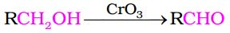
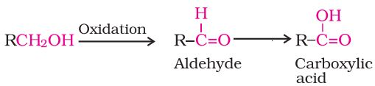

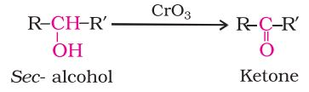
Secondary alcohols are oxidised to ketones by chromic anhydride (CrO3).

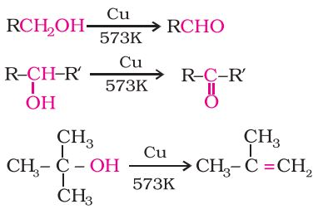
Tertiary alcohols do not undergo oxidation reactions under normal conditions due to lack of α-hydrogen. [Under strong reaction conditions such as strong oxidising agents (KMnO4) and elevated temperatures, cleavage of various C-C bonds takes place and a mixture of carboxylic acids containing lesser number of carbon atoms is formed.]
Catalytic dehydrogenation:
When the vapours of a primary or a secondary alcohol are passed over heated copper
at 573 K, dehydrogenation takes place and an aldehyde or a ketone is formed while tertiary
alcohols undergo dehydration.

Some Commercially Important Alcohols
Methanol and ethanol are among the two commercially important alcohols.
1. Methanol
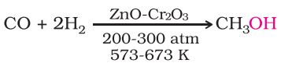
Methanol, CH3OH, also known as ‘wood spirit’, is produced by catalytic hydrogenation of carbon monoxide at high pressure and temperature and in the presence of ZnO – Cr₂O₃ catalyst.

Methanol is a colourless liquid and boils at 337 K. It is highly poisonous in nature. Ingestion of even small quantities of methanol can cause blindness and large quantities causes even death. Methanol is used as a solvent in paints, varnishes and chiefly for making formaldehyde.
2. Ethanol:
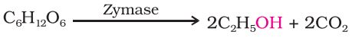
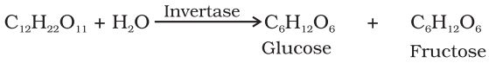
Ethanol, C₂H₅OH, is obtained commercially by fermentation, the oldest method is from sugars. The sugar in molasses, sugarcane or fruits such as grapes is converted to glucose and fructose, (both of which have the formula C₆H₁₂O₆), in the presence of an enzyme, invertase. Glucose and fructose undergo fermentation in the presence of another enzyme, zymase, which is found in yeast.

In wine making, grapes are the source of sugars and yeast. As grapes ripen, the quantity of sugar increases and yeast grows on the outer skin. When grapes are crushed, sugar and the enzyme come in contact and fermentation starts. Fermentation takes place in anaerobic conditions i.e. in absence of air. Carbon dioxide is released during fermentation. The action of zymase is inhibited once the percentage of alcohol formed exceeds 14 percent. (If air gets into fermentation mixture, the oxygen of air oxidises ethanol to ethanoic acid which in turn destroys the taste of alcoholic drinks.)
Ethanol is a colourless liquid with boiling point 351 K. It is used as a solvent in paint industry and in the preparation of a number of carbon compounds. The commercial alcohol is made unfit for drinking by mixing in it some copper sulphate (to give it a colour) and pyridine
(a foul-smelling liquid). It is known as denaturation of alcohol.
A large quantity of ethanol is obtained by hydration of ethene in presence of H2SO4.

