Definition of Accuracy, Precision, Resolution, Range

Source: Fluke

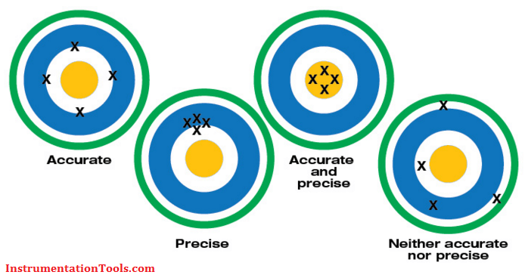

Accuracy: An instrument’s degree of veracity—how close its measurement comes to the actual or reference value of the signal being measured.

Resolution: The smallest increment an instrument can detect and display—hundredths, thousandths, millionths.

Range: The upper and lower limits an instrument can measure a value or signal such as amps, volts and ohms.

Precision: An instrument’s degree of repeatability—how reliably it can reproduce the same measurement over and over.

Accuracy:

Accuracy refers to the largest allowable error that occurs under specific operating conditions Accuracy is expressed as a percentage and indicates how close the displayed measurement is to the actual (standard) value of the signal measured. Accuracy requires a comparison to an accepted industry standard. The accuracy of a specific digital multimeter is more or less important depending on the application. For example, most AC power line voltages vary ±5% or more. An example of this variation is a voltage measurement taken at a standard 115 V AC receptacle. If a digital multimeter is only used to check if a receptacle is energized, a DMM with a ±3% measurement accuracy is appropriate. Some applications, such as calibration of automotive, medical aviation or specialized industrial equipment, may require higher accuracy. A reading of 100.0 V on a DMM with an accuracy of ±2% can range from 98.0 V to 102.0 V. This may be fine for some applications, but unacceptable for sensitive electronic equipment. Accuracy may also include a specified amount of digits (counts) added to the basic accuracy rating. For example, an accuracy of ±(2%+2) means that a reading of 100.0 V on the multimeter can be from 97.8 V to 102.2 V. Use of a DMM with higher accuracy allows a great number of applications.

Resolution

Resolution is the smallest increment a tool can detect and display. For a nonelectrical example, consider two rulers. One marked in 1/16-inch segments offers greater resolution than one marked in quarter-inch segments. Imagine a simple test of a 1.5 V household battery. If a digital multimeter (DMM) has a resolution of 1 mV on the 3 V range, it is possible to see a change of 1 mV while reading 1 V. The user could see changes as small as one one-thousandth of a volt, or 0.001. Resolution may be listed in a meter’s specifications as maximum resolution, which is the smallest value that can be discerned on the meter’s lowest range setting. For example, a maximum resolution of 100 mV (0.1 V) means that when the multimeter’s range is set to measure the highest possible voltage, the voltage will be displayed to the nearest tenth of a volt. Resolution is improved by reducing the DMM’s range setting as long as the measurement is within the set range.

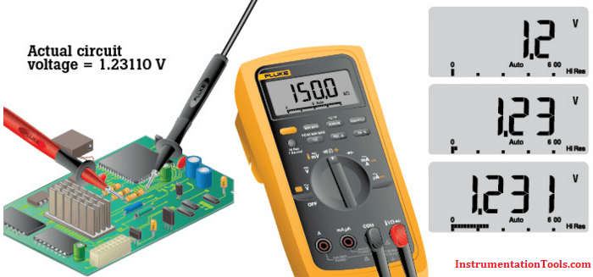

Range

Digital multimeter range and resolution are related and are sometimes specified in a DMM’s specs.Many multimeters offer an autorange function that automatically selects the appropriate range for the magnitude of the measurement being made. This provides both a meaningful reading and the best resolution of a measurement. If the measurement is higher than the set range, the multimeter will display OL (overload). The most accurate measurement is obtained at the lowest possible range setting without overloading the multimeter.

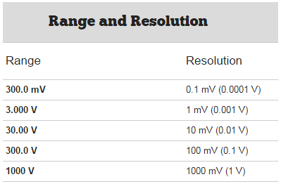

Link :

https://youtu.be/RAiK9tflnZA?t=409

https://youtu.be/RAiK9tflnZA

https://www.youtube.com/watch?v=-gqnVkTAMiE

Measurement Error
Definition: The measurement error is defined as the difference between the true or actual value and the measured value. The true value is the average of the infinite number of measurements, and the measured value is the precise value.

Types of Errors in Measurement
The error may arise from the different source and are usually classified into the following types. These types are
- Gross Errors
- Systematic Errors
- Random Errors
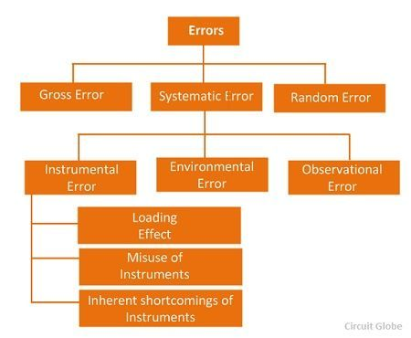
Their types are explained below in details.

1. Gross Errors
The gross error occurs because of the human mistakes. For examples consider the person using the instruments takes the wrong reading, or they can record the incorrect data. Such type of error comes under the gross error. The gross error can only be avoided by taking the reading carefully.
For example – The experimenter reads the 31.5ºC reading while the actual reading is 21.5Cº. This happens because of the oversights. The experimenter takes the wrong reading and because of which the error occurs in the measurement.
Such type of error is very common in the measurement. The complete elimination of such type of error is not possible. Some of the gross error easily detected by the experimenter but some of them are difficult to find. Two methods can remove the gross error.
Two methods can remove the gross error. These methods are
- The reading should be taken very carefully.
- Two or more readings should be taken of the measurement quantity. The readings are taken by the different experimenter and at a different point for removing the error.

2. Systematic Errors
The systematic errors are mainly classified into three categories.
- Instrumental Errors
- Environmental Errors
- Observational Errors

2 (i) Instrumental Errors
These errors mainly arise due to the three main reasons.
(a) Inherent Shortcomings of Instruments – Such types of errors are inbuilt in instruments because of their mechanical structure. They may be due to manufacturing, calibration or operation of the device. These errors may cause the error to read too low or too high.
For example – If the instrument uses the weak spring then it gives the high value of measuring quantity. The error occurs in the instrument because of the friction or hysteresis loss.
(b) Misuse of Instrument – The error occurs in the instrument because of the fault of the operator. A good instrument used in an unintelligent way may give an enormous result.
For example – the misuse of the instrument may cause the failure to adjust the zero of instruments, poor initial adjustment, using lead to too high resistance. These improper practices may not cause permanent damage to the instrument, but all the same, they cause errors.
(c) Loading Effect – It is the most common type of error which is caused by the instrument in measurement work. For example, when the voltmeter is connected to the high resistance circuit it gives a misleading reading, and when it is connected to the low resistance circuit, it gives the dependable reading. This means the voltmeter has a loading effect on the circuit.
The error caused by the loading effect can be overcome by using the meters intelligently. For example, when measuring a low resistance by the ammeter-voltmeter method, a voltmeter having a very high value of resistance should be used.

2 (ii) Environmental Errors
These errors are due to the external condition of the measuring devices. Such types of errors mainly occur due to the effect of temperature, pressure, humidity, dust, vibration or because of the magnetic or electrostatic field. The corrective measures employed to eliminate or to reduce these undesirable effects are
- The arrangement should be made to keep the conditions as constant as possible.
- Using the equipment which is free from these effects.
- By using the techniques which eliminate the effect of these disturbances.
- By applying the computed corrections.

2 (iii) Observational Errors
Such types of errors are due to the wrong observation of the reading. There are many sources of observational error. For example, the pointer of a voltmeter resets slightly above the surface of the scale. Thus an error occurs (because of parallax) unless the line of vision of the observer is exactly above the pointer. To minimise the parallax error highly accurate meters are provided with mirrored scales.

3. Random Errors
The error which is caused by the sudden change in the atmospheric condition, such type of error is called random error. These types of error remain even after the removal of the systematic error. Hence such type of error is also called residual error.

