What is Hybridization?
Hybridisation is the redistribution of the energy of orbitals of individual atoms to give new orbitals of equivalent energy. The new orbitals which are formed are called hybrid orbitals.

Types of Hybridisation
The following are the types of hybridisation:

1) sp³ – Hybridisation
In such hybridisation one s- and three p-orbitals are mixed to form four sp³– hybrid orbitals having same shape and energy. The angle between any two sp³ hybrid orbital is 109 ⁰ 28/.

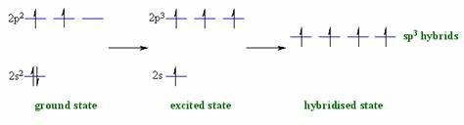
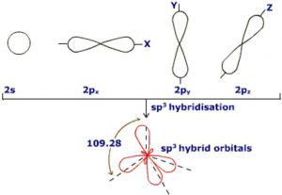
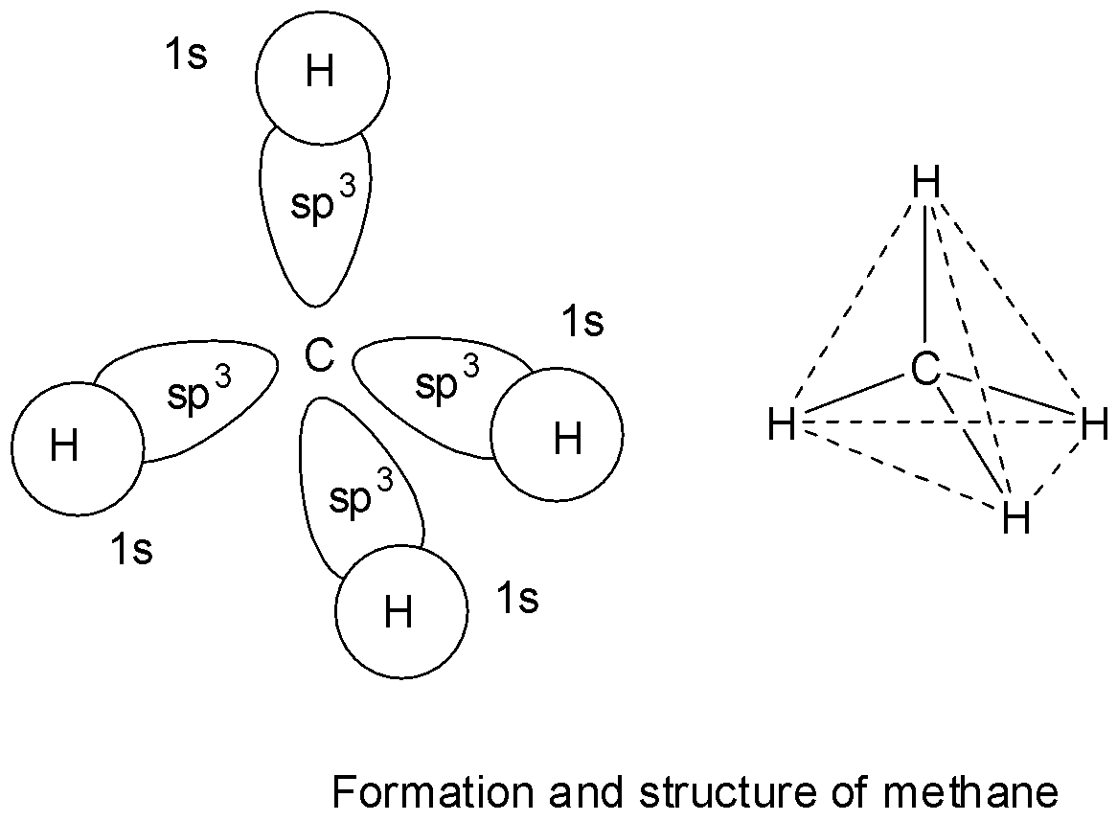

2) sp² – Hybridisation
In such hybridisation one s- and to p-orbitals are mixed form three sp²– hybrid orbitals. The three sp² hybrid orbitals are directed towards the three corner of a planar triangle where the angle between any two orbitalis 120 ⁰

Formation of C₂H₄ Molecules
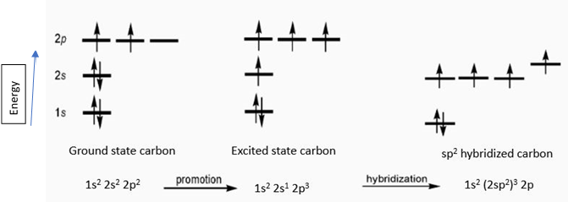
In C₂H₄ molecule carbon atoms are sp²-hybridised and one 2p-orbital remains unhybridised. This forms p-bond while sp² –hybrid orbitals form sigma- bonds

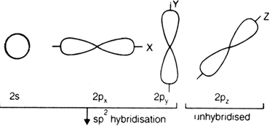

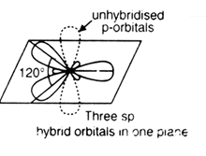

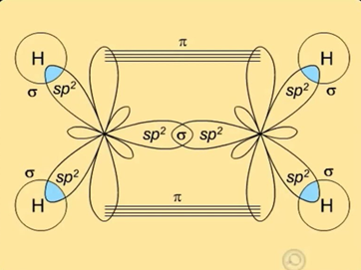

3) sp – Hybridisation
In such hybridisation one s- and one p-orbital are mixed to form two sp – hybrid orbitals, having a linear structure with bond angle 180 degrees.
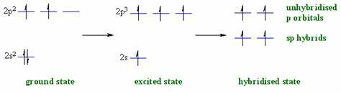
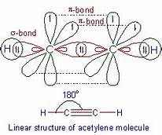

A Solved Question for You
Q: Discuss the rules of hybridisation. Are they important to the study of the concept as a whole?
Ans: Yes, the rules of hybridisation are very important to be studied before diving into the subject of hybridisation. Hence, these rules are essential to the understanding of the concepts of the topic. The following are the rules related to hybridisation:
- Orbitals of only a central atom would undergo hybridisation.
- The orbitals of almost the same energy level combine to form hybrid orbitals.
- The numbers of atomic orbitals mixed together are always equal to the number of hybrid orbitals.
- During hybridisation, the mixing of a number of orbitals is as per requirement.
- The hybrid orbitals scattered in space and tend to the farthest apart.
- Hybrid bonds are stronger than the non-hybridised bonds.

