Disciplines that contribute to organisational behaviour
Disciplines that contribute to our understanding of OB.
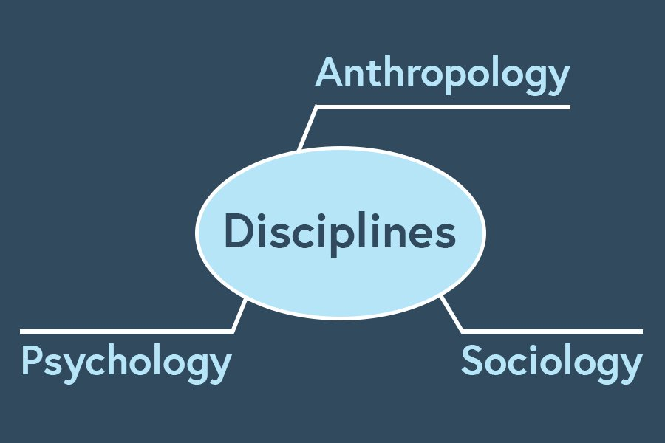

Psychology
The use of psychology focuses on psychological and organisational research and theory to find ways to enhance organisational effectiveness. The use of this discipline examines the lives of employees at work in an attempt to measure, explain and sometimes change the behaviour of employees within the organisation.

Sociology
While psychology focuses on the individual, sociology studies people in relation to their social environment or culture. It focuses on group behaviour in organisations, group dynamics, organisational culture, communication, power, conflict, structures and how order is maintained within these groups.

Anthropology
The use of anthropology focuses on the study of societies to learn about human beings, their cultures, environments and activities. It enables us to understand differences in fundamental values, attitudes and behaviour between people in different countries and within different organisations.

