 .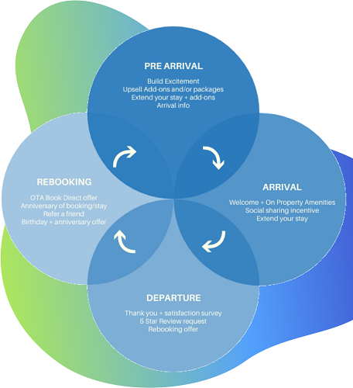

**Diagram Guest cycle**