Semi-Conservative mode of DNA Replication-
Initially, three models were proposed for DNA replication.
- In conservative replication the entire double-stranded DNA molecule serves as a template for a whole new molecule of DNA, and the original DNA molecule is fully conserved during replication.
- In dispersive replication, both nucleotide strands break down (disperse) into fragments, which serve as templates for the synthesis of new DNA fragments, and then somehow reassemble into two complete DNA molecules.
- Semiconservative replication, is intermediate between these two models; the two nucleotide strands unwind and each serves as a template for a new DNA molecule.
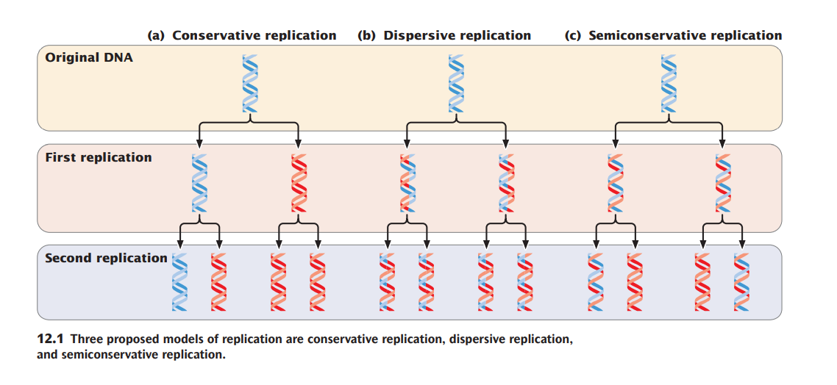
Meselson and Stahl’s Experiment
- They used two isotopes of nitrogen, 14N (the common form) and 15N (a rare, heavy form).
- Meselson and Stahl grew a culture of E. coli in a medium that contained 15N as the sole nitrogen source; after many generations, all the E. coli cells had 15N incorporated into all of the purine and pyrimidine bases of their DNA.
- They then switched the bacteria to a medium that contained only 14N.
- The bacterial DNA that was synthesized before the change in medium contained 15N and was relatively heavy, whereas any DNA synthesized after the switch contained 14N and was relatively light.
- Meselson and Stahl distinguished between the heavy 15N laden DNA and the light 14N-containing DNA with the use of equilibrium density gradient centrifugation.
