JAGIROAD COELLGE
RADHIKA RIMAL
ZOO-18,May,2021
UNIT-2(2026)-PART-1
PLASMA MEMBRANE

The plasma membrane consists of both lipids and proteins. The fundamental structure of the membrane is the lipid bilayer, which forms a stable barrier between two aqueous compartments.

Lipid bilayer-
The membranes of animal cells contain five major phospholipids (phosphatidylcholine, phosphatidylethanolamine, phosphatidylserine, phosphatidylinositol, and sphingomyelin), which together account for about 50% of the lipids in plasma membranes. The outer leaflet of the plasma membrane consists mainly of phosphatidylcholine and sphingomyelin, whereas phosphatidylethanolamine and phosphatidylserine are the predominant phospholipids of the inner leaflet. In addition to the phospholipids, the plasma membranes of animal cells contain glycolipids and cholesterol (see Figure 15.2). The glycolipids are found exclusively in the outer leaflet of the plasma membrane, with their carbohydrate portions exposed on the cell surface, as determined by their synthesis in the Golgi. Cholesterol has a rigid ring structure that inserts into a bilayer of phospholipids with its polar hydroxyl group close to the phospholipid head groups. Because it has a higher affinity for sphingomyelin than for the other phospholipids, it is more concentrated in the outer leaflet.
Function of lipid bilayer-
- acts as a membrane barrier between two aqueous compartments
- phospholipid is viscous not solid making it flexible
- lipid affects the fluidity basing on the presence of saturated and unsaturated fatty acids

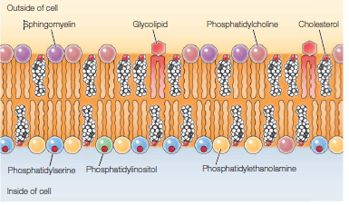

Plasma membrane protein
Most plasma membranes consist of approximately 50% lipid and 50% protein by weight, with the carbohydrate portions of glycolipids and glycoproteins constituting 5–10% of the membrane mass. Singer and Nicolson distinguished two classes of membrane-associated proteins, which they called peripheral and integral membrane proteins. Peripheral membrane proteins were operationally defined as proteins that dissociate from the membrane following treatments with polar reagents, such as solutions of extreme pH or high salt concentration that do not disrupt the phospholipid bilayer. In contrast to the peripheral membrane proteins, integral membrane proteins can be released only by treatments that disrupt the phospholipid bilayer. Portions of these integral membrane proteins are inserted into the lipid bilayer, so they can be dissociated only by reagents that disrupt hydrophobic interactions. Many integral proteins are transmembrane proteins, which span the lipid bilayer with portions exposed on both sides of the membrane. The membrane-spanning portions of transmembrane proteins are usually helices of 20–25 hydrophobic amino acids

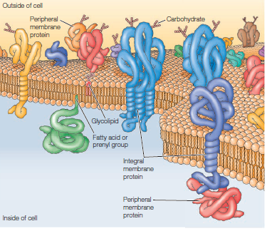
Figure: Plasma membrane proteins.

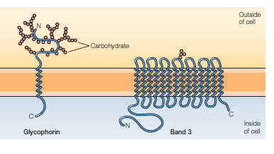
Figure: Integral membrane protein of RBC.

