Plant Ecology
INTRODUCTION
ECOLOGY - The branch of biology that deals with the relation of organisms to one another and to their physical surroundings.
Hanns Reiter (1868) gave the concept of ecology.
The term ‘ecology’ is derived from a Greek words Oekologie where ‘oikos’ meaning ‘house’ and ‘logos’ means “ the study of”. Literally it means ‘study of home’.
The term ecology was coined in 1869 by the German biologist Ernst Haeckel.
According to him ecology is a branch of science which deals with the study of interrelationship between living organisms and their surroundings (environment).
Scientifically ‘ecology’ has been defined as ‘study of inter-relationships of organisms with their surroundings. Various other definitions have been given by different scientists.
Woodbury (1954) defined ecology as “science that investigates organisms in relation to their environment’.
E.P. Odum (1969) defined ecology as “the study of structure and function of nature”.
The two components of nature – Organism & their environment are interdependent.
Based on Taxonomic affinities, Ecology is divided into Plant Ecology and Animal Ecology
Plant ecology deals with the relationship between plants & their enivironment.
Plant ecology is a subdiscipline of ecology which studies the distribution and abundance of plants, the effects of environmental factors upon the abundance of plants, and the interactions among and between plants and other organisms.
Animal ecology deals with relationship between animals & their environment.
Both the Plant and Animal ecology come under Environmental Biology.

Level of organization:
Based on level of organization, ecology is divided into – Autecology and Synecology
Autecology – concerned with the study of individual animal/plant species in realtion to the habitatin which it grows (ecology of individual)
Synecology – Concerned with the study of communities in relation to their environment.
Phytogeography/ Plant geography – Science which deals with distribution of plants on or near surface of earth and water.

Branches of Ecology
Habitat Ecology – It is the study of living organisms in different habitats Study of habitats and their effects on organism living there. It includes fresh water, desert, cropland, marine ecology. Etc.
Population ecology – It is the study of structure and dynamics (size, density, dispersion, demographics) of population in relation to environment. Variations in growth and regulation of a population .
Community ecology – It deals with structure and organization of a biological community with respect to environmental interactions. Factors such as structure, biodiversity, distribution, abundance of species and interactions such as predation, herbivory, competition, parasitism and mutualism are studied.
Ecosystem ecology – It is the study of living organisms (animals, plants and microorganisms) along with the non-living components of their environment (water, air and soil). The aspects such as nutrient and energy flows are considered.
Production ecology / ecological energetics – It is the study of energy conversion and flow through different organisms in relation to space and time.
Besides these some other branches of ecology such as conservation ecology, production ecology, space ecology, radiation ecology has also been recognized.

In an ecological system, various levels of biological organization (hierarchy) are noted.
These ranges from individual organisms to the biosphere.
Various units included in hierarchy include organisms, populations, communities, ecosystems and the biome. Hierarchy is the system of grouping organisms at different levels (Fig 1. 2).
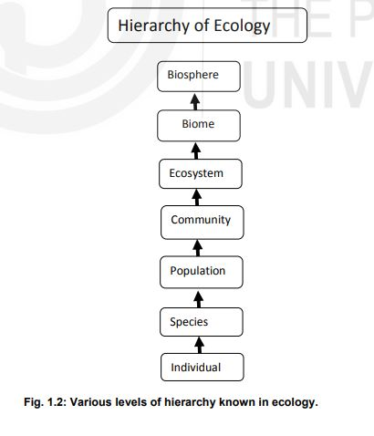
The levels of organization connected with ecological grouping are called ecological hierarchy.
i) An individual (organism) is the basic and distinct unit of ecological hierarchy. Individuals carry out all life processes and exchanges materials with the surroundings.
Species are group of living organisms consisting of similar individuals capable of exchanging genes or inter breeding. E.g- Homo sapiens
ii) A population is a group of individuals of the same species living together in a common area at a particular time.
iii) A community is the assembly of populations of different organisms in a particular environment.
iv) The ecosystem is the association of living and non-living components present in a particular environment of an area.
v) A Biome is the group of terrestrial ecosystems present at the regional or sub continental level.
vi) The Biosphere is the part of the earth where life is present. It comprises of atmosphere (air), lithosphere (land) and hydrosphere (water).

Basic Concepts of Ecology
Ecology can be divided into – Structural and Functional concepts
Structural concepts- organisms interact with 2 and 3 dimentional structure of their environment like Biome, succession, etc
Functional concepts – include trophic levels, energy pyramids, biogeochemical cycles, etc.

