**Alcohols, phenols and ethers**

* **Alcohols** and **phenols** are formed when a hydrogen atom in a hydrocarbon, aliphatic andaromatic respectively, is replaced by –OH group.
* The substitution of a hydrogen atom in ahydrocarbon by an alkoxy or aryloxy group(R–O/Ar–O) yields another class of compounds knownas ‘ethers’, for example, CH3OCH3(dimethyl ether).

Classification

Alcohols and phenols may be classified as mono–, di–, tri- orpolyhydric compoundsdepending on whether they contain one, two,three or many hydroxyl groups respectively in their structures asgiven below:

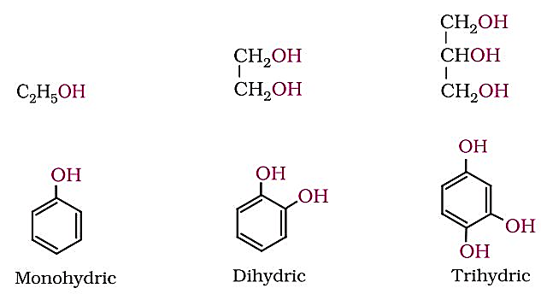

Monohydric alcohols may be further classified according to the hybridisation of the carbon atom to which the hydroxyl group is attached.

**(i) Compounds containing C sp3- OH bond***:* In this class of alcohols,the –OH group is attached to an *sp3* hybridised carbon atom of analkyl group. They are further classified as follows:*Primary, secondary and tertiary alcohols:* In these three types ofalcohols, the –OH group is attached to primary, secondary andtertiary carbon atom, respectively as depicted below:

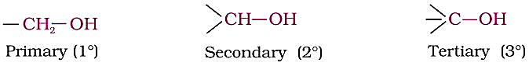

***Allylic alcohols****:* In these alcohols, the —OH group is attached toa *sp*3 hybridised carbon next to the carbon-carbon double bond,that is to an allylic carbon. For example

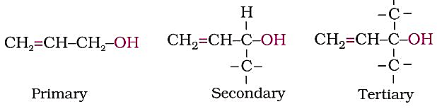

***Benzylic alcohols:***In these alcohols, the —OH group is attached toa *sp*3—hybridised carbon atom next to an aromatic ring. For example

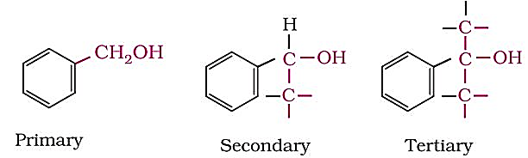

**(ii) Compounds containing C sp2- OH bond***:* These alcohols contain—OH group bonded to a carbon-carbon double bond i.e., to avinylic carbon or to an aryl carbon. These alcohols are also knownas ***vinylic alcohols***.

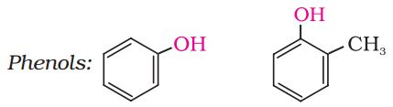



***Ethers:***Ethers are classified as **simple** or **symmetrical**, if the alkyl or arylgroups attached to the oxygen atom are the same, and **mixed** or**unsymmetrical**, if the two groups are different. Diethyl ether,C2H5OC2H5, is a symmetrical ether whereas C2H5OCH3 and C2H5OC6H5  
are unsymmetrical ethers.

**Nomenclature:**Cyclic alcohols are named using the prefix cyclo and consideringthe —OH group attached to C–1.

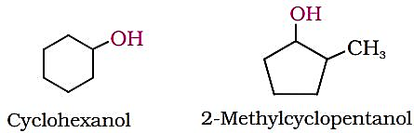

***Phenols:*** The simplest hydroxy derivative of benzene is phenol. 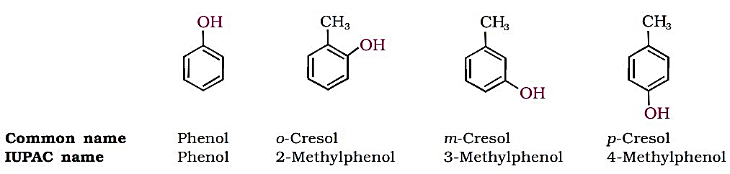

Dihydroxy derivatives of benzene are known as 1, 2-, 1, 3- and  
1, 4-benzenediol.

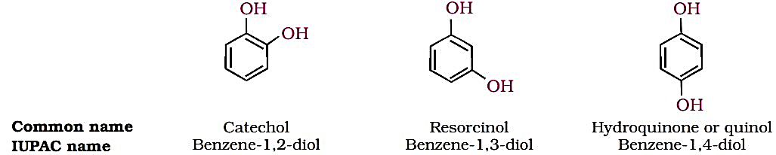

***Ethers:*** According to IUPAC ***Alkoxy Alkane*** e.g. CH3OCH2CH2CH3 1-Methoxypropane

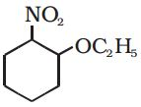  
1-Ethoxy-2-nitrocyclohexane

.

***Preparation of Alcohols:***

1. ***By acid catalysed hydration****:* Alkenes react with water in the presence of acid as catalyst to form alcohols.

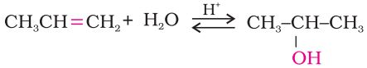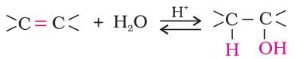

1. ***By hydroboration–oxidation***: Diborane (BH3)2 reacts with alkenes to give trialkyl boranes as addition product. This is oxidised to alcohol by hydrogen peroxide in the presence of aqueous sodium hydroxide.

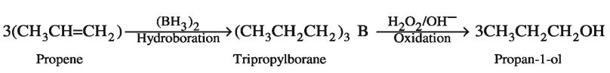

+ B(OH)3

***2. From carbonyl compounds:***

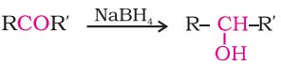(i) *By reduction of aldehydes and ketones*: Aldehydes and ketonesare reduced to the corresponding alcohols by addition of hydrogen in the presence of catalysts (catalytic hydrogenation).

1. 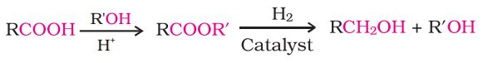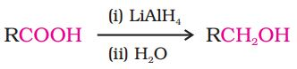*By reduction of carboxylic acids and esters*: Carboxylic acids are reduced to primary alcohols in excellent yields by lithium aluminium hydride, a strong reducing agent.

***3. From Grignard reagents***

Alcohols are produced by the reaction of Grignard reagents with aldehydes and ketones.  
The first step of the reaction is the nucleophilic addition of Grignardreagent to the carbonyl group to form an adduct. Hydrolysis of the adduct yields an alcohol.

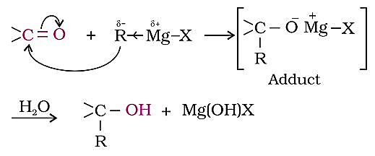

The reaction produces -- a primary alcohol with methanal, a secondary alcohol with other aldehydes and tertiary alcohol with ketones.

**Physical Properties**

***Boiling Points*:** The boiling points of **alcohols** and **phenols** *increase with* increase in thenumber of carbon atoms (increase in van der Waals forces). In alcohols,**the boiling points decrease with increase of branching** in carbon chain(because of decrease in van der Waals forces with decrease in surfacearea).

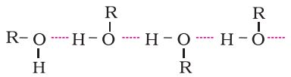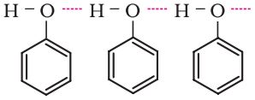The –OH group in alcohols and phenols is involved in intermolecularhydrogen bonding as shown below:

.

The high boiling points of alcohols are mainly due to the presenceof intermolecular hydrogen bonding in them which is lacking in ethersand hydrocarbons.

**Solubility:** Solubility of alcohols and phenols inwater is due to their ability to formhydrogen bonds with water moleculesas shown. The solubility decreases withincrease in size of alkyl/aryl (hydrophobic) groups. Several of the lowermolecular mass alcohols are misciblewith water in all proportions.

**Chemical Reactions**

Alcohols are versatile compounds. They react both as nucleophiles andelectrophiles.

***Alcohols as nucleophiles***:The bond between O–H is broken when alcohols react as  
nucleophiles.

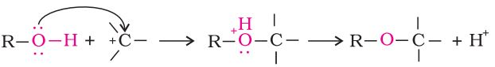

***Alcohols as electrophiles****:*The bond between C–O is broken when they react as  
electrophiles. Protonated alcohols react in this manner.

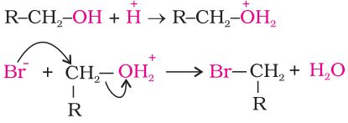

**(a) Reactions involving cleavage of O–H bond**

***1. Acidity of alcohols:***The acidic character of alcohols is due tothe polar nature of O–H bond. An electron-releasing group(–CH3, –C2H5) increases electron density on oxygen tending todecrease the polarity of O-H bond. This decreases the acidstrength. For this reason, the acid strength of alcohols decreasesin the following order:

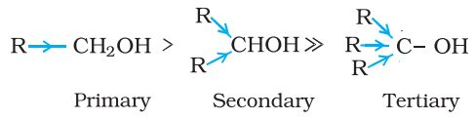

Alcohols are, however, weaker acids than water. This can beillustrated by the reaction of water with an alkoxide.

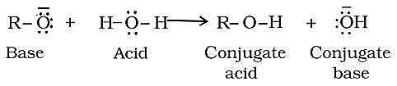

This reaction shows that water is a better proton donor (i.e.,stronger acid) than alcohol. Also, in the above reaction, we notethat an alkoxide ion is a better proton acceptor than hydroxideion, which suggests that alkoxides are stronger bases (acids and bases are always stronger than their conjugate counterparts). Hence, sodium ethoxide is a stronger base than sodium hydroxide

Alcohols act as Bronsted bases as well. It is due to thepresence of unshared electron pairs on oxygen, which makesthem proton acceptors.

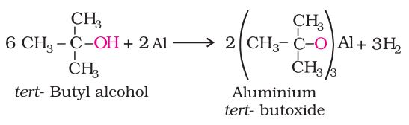***(ii) Reaction with metals***: Alcohols react with activemetals such as sodium, potassium and aluminium to yieldcorresponding alkoxides and hydrogen.

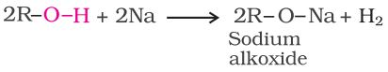

The above reactions show that alcohols and phenols areacidic in nature. In fact, alcohols and phenols are Brönstedacids i.e., they can donate a proton to a stronger base (B:).

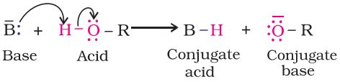

***2. Esterification:*** Alcohols react with carboxylic acids, acid chlorides andacid anhydrides to form esters.

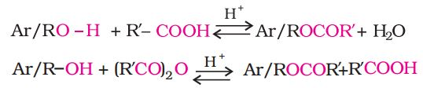

The reaction with carboxylic acid and acid anhydride is carriedout in the presence of a small amount of concentrated sulphuricacid. The reaction is reversible, and therefore, water is removed assoon as it is formed. The reaction with acid chloride is carried out inthe presence of a base (pyridine) so as to neutralise HCl which isformed during the reaction.

***(b) Reactions involving cleavage of carbon – oxygen (C–O) bond in alcohols:***

The reactions involving cleavage of C–O bond take place only inalcohols. Phenols show this type of reaction only with zinc.

***1. Reaction with hydrogen halides:*** Alcohols react with hydrogenhalides to form alkyl halides ROH + HX → R–X + H2O

The difference in reactivity of three classes of alcohols with HCldistinguishes them from one another (**Lucas test**). Alcohols are solublein Lucas reagent (conc. HCl and ZnCl2) while their halides are immiscibleand produce turbidity in solution. In case of tertiary alcohols, turbidityis produced immediately (within 1 minute) as they form the halides easily. Secondary alcohols,produced turbidity (within 5 minute). Primaryalcohols do not produce turbidity at room temperature since there is no reaction.

***2. Reaction with phosphorus trihalides:*** Alcohols are converted toalkyl bromides by reaction with phosphorus tribromide C2H5 OH + PBr3→ C2H5- Br + H3PO3.

***3. Dehydration:*** Alcohols undergo dehydration (removal of a molecule of water) to form alkenes on treating with a protic acid e.g., concentrated H2SO4 or H3PO4, or catalysts such as anhydrous zinc chloride or alumina.

Thus, the relative ease of dehydration of alcohols follows the followingorder:

***Tertiary>Secondary > Primary***

Primary alcohol (Ethanol) undergoes dehydration by heating it with strong oxidising agent concentratedH2SO4 at 443 K.



Secondary and tertiary alcohols are dehydrated under milderconditions. For example:

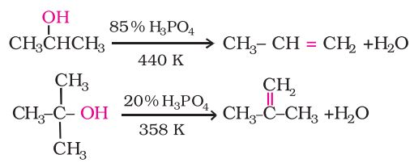

**Mechanism of Dehydration e.g. ethanol**

***Step 1:***Formation of protonated alcohol.

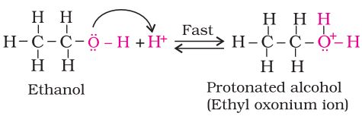

***Step 2:***Formation of carbocation: It is the slowest step and hence, therate determining step of the reaction.

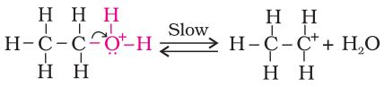

***Step 3:***Formation of ethene by elimination of a proton.

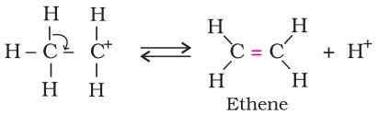

The acid used in step 1 is released in step 3. To drive the equilibriumto the right, ethene is removed as it is formed.

***4. Oxidation:*** Oxidation of alcohols involves the formation of a carbonoxygen doublebond with cleavage of an O-H and C-H bonds.

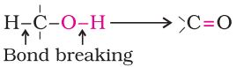

Such a cleavage and formation of bonds occur in oxidationreactions. These are also known as **dehydrogenation** reactions asthese involve loss of dihydrogen from an alcohol molecule. Dependingon the oxidising agent used, a primary alcohol is oxidised to analdehyde which in turn is oxidised to a carboxylic acid.

Strong oxidising agents such as acidified potassium permanganateare used for getting carboxylic acids from alcohols directly. CrO3 inanhydrous medium is used as the oxidising agent for the isolationof aldehydes.A better reagent for oxidation of primary alcohols to aldehydes in good yield is pyridinium chlorochromate (PCC), a complex of chromium trioxide with pyridine and HCl.

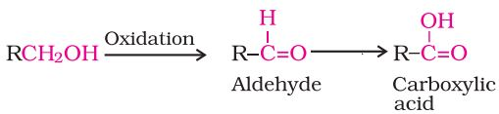



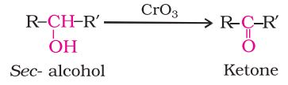Secondary alcohols are oxidised to ketones by chromic anhydride (CrO3).

Tertiary alcohols do not undergo oxidation

**Catalytic dehydrogenation:**

When the vapours of aprimary or a secondary alcoholare passed over heated copper  
at 573 K, dehydrogenationtakes place and an aldehyde ora ketone is formed while tertiary  
alcohols undergo dehydration.

