**Reactions of Haloarenes:**

1. ***Nucleophilic substitution***

Aryl halides are extremely less reactive towards nucleophilic substitution reactions due to the following reasons:

1. ***Resonance effect****:*In haloarenes, the electron pairs on halogenatom are in conjugation with π-electrons of the ring and thefollowing resonating structures are possible.

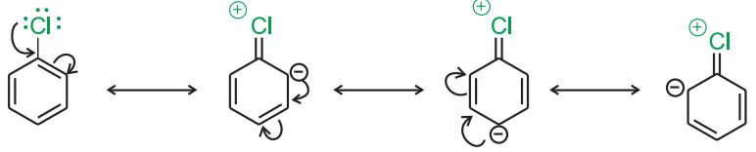

C—Cl bond acquires a partial double bond character due toresonance. As a result, the bondcleavage in haloarene is difficultthan haloalkane and therefore, they are less reactive towardsnucleophilic substitution reaction.

(ii) ***Difference in hybridisation of carbon atom in C—X bond****:* Inhaloalkane, the carbon atom attached to halogen is *sp3*hybridised while in case of haloarene, the carbon atom attachedto halogen is *sp2*-hybridised.

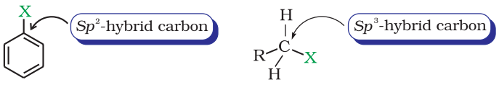

The *sp2*hybridised carbon with a greater *s*-character is moreelectronegative and can hold the electronpair of C—X bondmore tightly than *sp3*-hybridised carbon in haloalkane withless *s*-character. Thus, C—Cl bond length in haloalkane is177pm while in haloarene is 169 pm. Since it is difficult tobreak a shorter bond than a longer bond, therefore, haloarenesare less reactive than haloalkanes towards nucleophilicsubstitution reaction.

1. ***Instability of phenyl cation****:* In case of haloarenes, the phenyl cation formed as a result of self-ionisation will not be stabilised by resonance and therefore, SN1 mechanism is ruled out.
2. ***Because of the possible repulsion***, it is less likely for the electronrich nucleophile to approachelectron rich arenes.

***Replacement by hydroxyl group***

Chlorobenzene can be converted into phenol by heating in aqueoussodium hydroxide solution at a temperature of 623K and a pressureof 300 atmospheres.

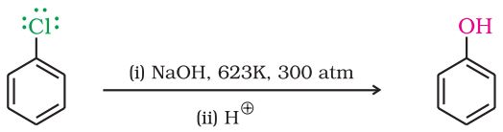

The presence of an electron withdrawing group (-NO2) at *ortho*- and*para*-positions increases the reactivity of haloarenes.

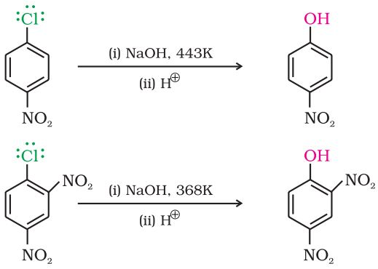

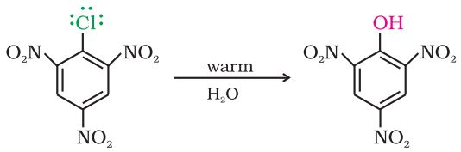

The effect is pronounced when (-NO2) group is introduced at *ortho*and *para*- positions. However, no effect on reactivity of haloarenes isobserved by the presence of electron withdrawing group at *meta*-position.Mechanism of the reaction is as depicted:

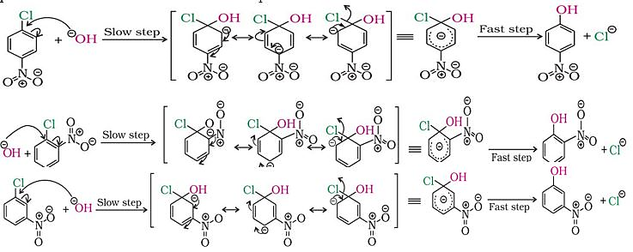

As shown, the presence of nitro group at *ortho*- and *para*-positions withdraws theelectron density from the benzene ring and thus facilitates the attack of the nucleophileon haloarene. The carbanion thus formed is stabilised through resonance. The negativecharge appeared at *ortho*- and *para*- positions with respect to the halogen substituent is stabilised by –NO2 group while in case of *meta*-nitrobenzene, none of the resonatingstructures bear the negative charge on carbon atom bearing the –NO2 group.Therefore,the presence of nitro group at *meta*- position does not stabilise the negative charge andno effect on reactivity is observed by the presence of –NO2 group at *meta*-position.

1. ***Electrophilic substitution reactions***

Haloarenes undergo the usual electrophilic reactions of the benzenering such as halogenation, nitration, sulphonation and Friedel-Craftsreactions. Halogen atom besides being slightly deactivating is *o, p*directing; therefore, further substitution occurs at *ortho-* and *para*positions with respect to the halogenatom. The *o, p*-directing influenceof halogen atom can be easily understood if we consider the resonatingstructures of halobenzene as shown:

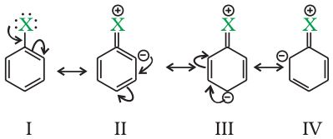

Due to resonance, the electron density increases more at *ortho-* and*para*-positions than at *meta*-positions. Further, the halogen atombecause of its –I effect has some tendency to withdraw electrons fromthe benzene ring. As a result, the ring gets somewhat deactivated ascompared to benzene and hence the electrophilic substitution reactionsin haloarenes occur slowly and require more drastic conditions ascompared to those in benzene.

1. **Halogenation**

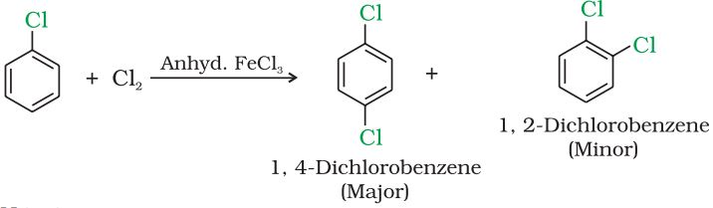

1. **Nitration**

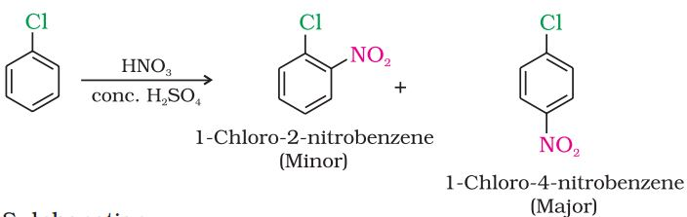

**(iii) Sulphonation**

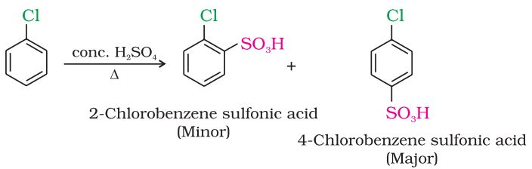

1. Friedel-Crafts reaction

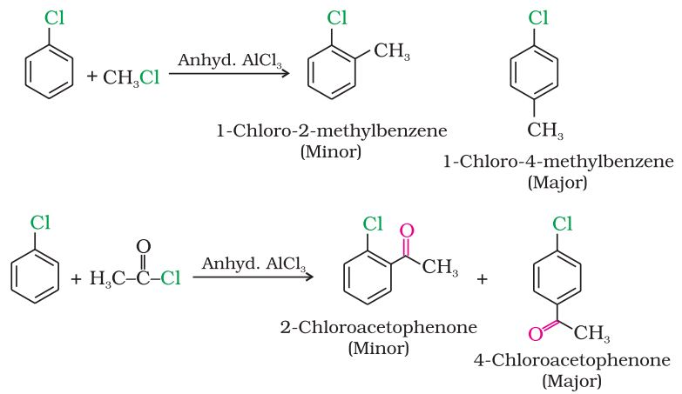

1. ***Electrophilic substitution reactions in Aryl Halides***

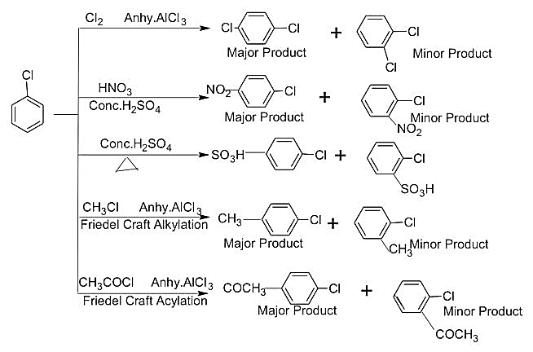

**Q.** Although chlorine is an electron withdrawing group, yet it is *ortho*-, *para*- directing in electrophilic aromatic substitution reactions. Why?

**Ans.**Chlorine withdraws electrons through inductive effect and releases electrons through resonance. Through inductive effect, chlorine destabilises the intermediate carbocation formed during the electrophilic substitution.

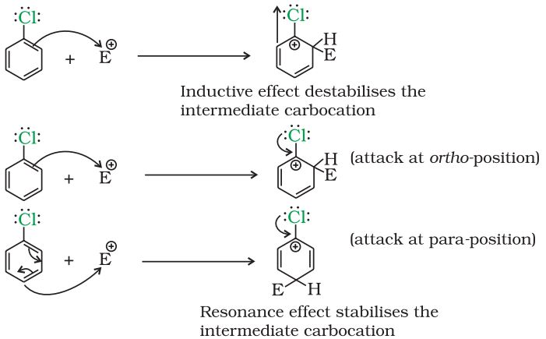

Through resonance, halogen tends to stabilise the carbocation andthe effect is more pronounced at *ortho*- and *para*- positions. Theinductive effect is stronger than resonance and causes net electron  
withdrawal and thus causes net deactivation. The resonance effecttends to oppose the inductive effect for the attack at *ortho*- and *para*positions and hence makes the deactivation less for *ortho*- and *para*attack. Reactivity is thus controlled by the stronger inductive effectand orientation is controlled by resonance effect.

1. ***Reaction with metals***

***Wurtz-Fittig reaction:*** A mixture of an alkyl halide and aryl halide gives an alkylarene when  
treated with sodium in dry ether and is called Wurtz-Fittig reaction.

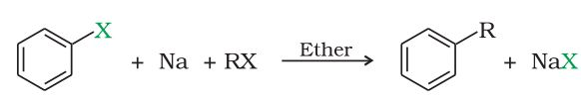

***Fittig reaction:*** Aryl halides also give analogous compounds when treated with sodiumin dry ether, in which two aryl groups are joined together. It is calledFittig reaction.



