Methods ofPreparation of Alkyl halides:
1. From alcohol: alcohols when treated with HCl/ZnCl_{2,} PCl₅ or RdeP/X₂ gives alkyl halide
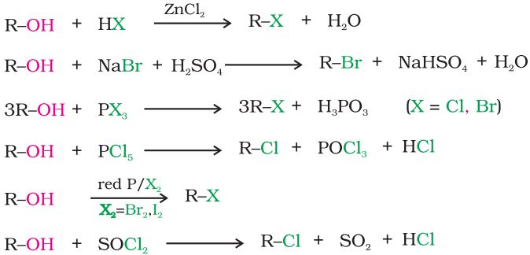

2 From alkenes: Addition of hydrogen halides: An alkene is converted to corresponding alkyl halide by reaction with hydrogen halide
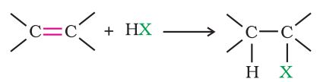

3. ByHalogen Exchange:
- Replacement of chlorides/bromides by iodine is carried out by Finkelstein reaction.
]

4.By

Physical Properties
Alkyl halides are colourless when pure. However, bromides and iodidesdevelop colour when exposed to light. Many volatile halogen compoundshave sweet smell.
Melting and boiling points
Lower alkyl group containing alkyl halides (e.g. methyl chloride, methyl bromide, ethyl chloride and somechlorofluoromethanes)are gases at room temperature.Higher membersare liquids or solids.
For the same alkyl group, the boilingpoints of alkyl halides decrease in the order: RI>RBr>RCl> RF. Thisis because with the increase in size and mass of halogen atom, the magnitude of van der Waal forces increases.
The boiling points of isomeric haloalkanes decrease with increase in branching. For example, 2-bromo-2-methylpropanehas the lowest boiling point among the three isomers.
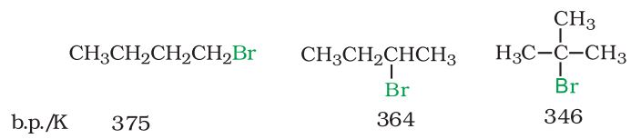
Boiling points of isomeric dihalobenzenes are very nearly the same.However, the para-isomers are high melting as compared to their orthoand meta-isomers. It is due to symmetry of para-isomers that fits in
crystal lattice better as compared to ortho- and meta-isomers.
Density
Bromo, iodo and polychloro derivatives of hydrocarbons are heavier thanwater. The density increases with increase in number of carbon atoms,halogen atoms and atomic mass of the halogen atoms.
Solubility
The haloalkanes are only very slightly soluble in water.

Chemical Properties: Reactions of Haloalkanes
The reactions of haloalkanes may be divided into the following categories:
(i) Nucleophilic substitution
(ii) Elimination reactions
- Reaction with metals.

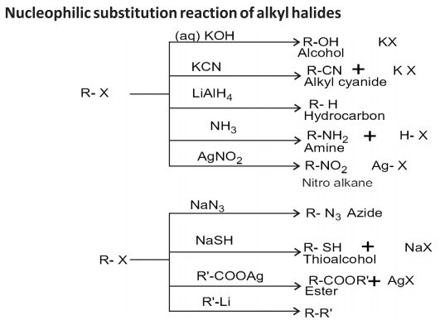
Nucleophilic substitution reactions:

