Performance Management: Giving and Receiving Feedback

.

Today’s session will help you to:
- Gain understanding for how to effectively give and receive feedback
- Identify your role and responsibilities related to giving and receiving feedback
- Familiarize yourself with feedback models and best practices

.

The Performance Management Cycle
3. Appraisal &
Reward
- Setting Goals and
Expectations
Developing Employees
- Ongoing
Review and Feedback

Setting Goals & Expectations | - Clearly communicate expectations re: job responsibilities and competencies (skills) and behaviors  - Communicate how individual goals align with department and organization goals  - Help your employees set clear, measurable performance goals
Ongoing Review and Feedback | - Holds people accountable for meeting performance goals and objectives  - Provides constructive feedback to help staff improve performance  - Takes appropriate action to address poor performance
Appraisal & Reward | - Conducts thorough annual performance reviews  - Assesses individuals fairly  - Differentiates high performers appropriately

Roles in Giving and Receiving Effective Feedback

Staff Member
  - Monitor own performance, seek performance information, apprise supervisor of successes, shortcomings, and needs
  - Act on feedback received

Supervisor
  - Provide clear feedback on an ongoing and often informal basis
  - Ensure that staff member understands expectations

Shared (Staff Member and Supervisor)
  - Agree upon a joint feedback process
(i.e., when and how feedback will be exchanged on a one-on-one basis)
  - Assume best intentions

Institution
  - Create a consistent language for getting and giving feedback
  - Establish a “No Fear” culture where staff can feel comfortable sharing and receiving frank feedback
  - Ensure supervisors model a feedback culture

The Performance Management Cycle:

Ongoing Feedback and Coaching

Feedback has a direct impact on our work:
  - Gives us specific information to help us improve
  - Makes performance expectations clear from the start
  - Heightens efficiency by reducing resentment, buildup, etc.
  - Strengthens relationships

Benefits of Positive Feedback
  - Gives clarity to the employee about good performance.
  - Creates enthusiasm.
  - Builds confidence and self-esteem.
  - Increases appropriate risk-taking and innovation.
  - Demonstrates care and involvement.
  - Makes an employee feel acknowledged.

When Positive Feedback is appropriate
  - When used to recognize specific job performance that has met and/or exceeded expectations. (It reinforces and motivates.)

Example of Positive Feedback: “The budget estimates you presented at the last staff meeting were very detailed and gave us good criteria for decision-making.”

Benefits of Developmental Feedback
  - It lets people know how to execute a task more effectively.
  - It steers actions; communicates what needs to change.
  - It increases the person’s self-awareness.
  - It is the foundation of all development.
  - It gives a bigger picture to the employee.

When Developmental Feedback is appropriate
  - When used to help an employee monitor and correct his or her own behavior.

Example of Developmental Feedback: “My expectation was that you would provide us with more details on the event budget. Because we didn’t have enough information, we won’t be able to make our final decisions until later this week. What can you do to ensure that we will have the correct information?”

YOU

Feedback Reflection:

Write the initials of the people that you work with in the shapes provided, including direct reports, peers, your manager, customers/clients, etc. Then for each person, answer the questions:

“Are you comfortable providing them with direct, constructive feedback?” If so, draw a solid arrow from you to their shape. If not, draw a dashed arrow.

“Are you comfortable receiving direct, constructive feedback from them?” If so, draw a solid arrow from their shape to you. If not, draw a dashed arrow.

What does your reflection tell you?

Feedback Framework:
Feedback is an essential component of a learning and performance culture. The framework assists in preparing to deliver feedback effectively.

Feedback is…
  - Most beneficial if on-going (which ensures no surprises)
  - Intended to support employee performance and development
  - Helpful and applies to both positive and constructive situations

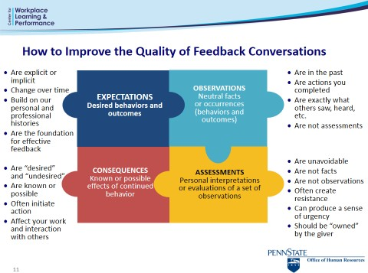

Copyright 2003 by The Segal Group, Inc., the parent of The Segal Company which includes its division, Sibson Consulting. All rights reserved. Used with permission by Sibson Consulting.

Let’s assume you are Jason’s supervisor and have some positive feedback to provide:

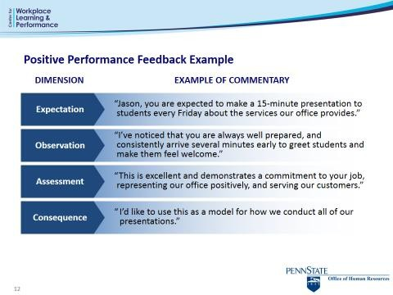

Let’s assume you are Anna’s supervisor and have some constructive feedback to provide:
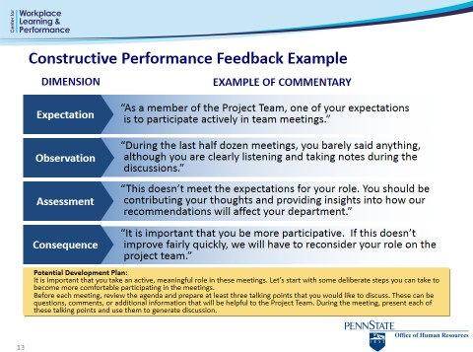

Examples used with permission from Sibson Consulting

To deliver positive feedback to Jerry:

Jerry is a relatively new member of your team who hasn’t had the opportunity to work on the “front lines” yet. The other day he stepped in for a colleague who called in sick and dealt with a notoriously difficult customer with diplomacy and patience.

1. State your Expectations | Describe the standards or expectations you have for the situation.
2. Describe Your Observations | Tell the employee what s/he did that you want to give feedback on. Be Specific. Focus on Behavior. Give examples.
3. Share your Assessment | Describe how the behavior impacted the department and/or Penn State. Be objective.
4. Explain  Consequence | Express your appreciation.

To deliver constructive/developmental feedback to Susan:

Susan is a junior member within your unit’s marketing department. Writing and sending emails and memos internally and externally is an important part of her job. Her writing lacks structure and is too wordy. People tend to delete her emails before they are read.

1. State your Expectations | Describe the standards or expectations you have for the situation.
2. Describe Your Observations | Tell the employee what s/he did that you want to give feedback on. Be Specific. Focus on Behavior. Give examples.
3. Share your Assessment | Describe how the behavior impacted the department and/or Penn State. Be objective.
4. Explain  Consequence | If the behavior should be changed, offer suggestions on what to do differently or how to improve.

Remember: Every discussion will look a little different, depending on the situation. The receiver of your message will undoubtedly interject at many points in between steps.
Whenever s/he starts talking, let him/her finish and then REPHRASE what they’ve said so s/he knows you got it.

  - Reluctance to discuss problems openly and on a timely basis
  - Looking only at extreme behavior, whether good or bad, and ignoring all other efforts
  - Lacking the courage to differentiate performance, either to avoid morale problems or to avoid having difficult conversations
  - Comparing people to each other rather than against their own goals/ expectations
  - Giving feedback without inviting and listening to the employee’s comments
  - Not confirming mutual understanding of expectations in the first place
  - Jumping to conclusions or making evaluations without facts

What gets in your way of providing feedback?

What actions can you take in order to avoid those pitfalls in the future?

Remember, giving feedback well begins with following good practices. Practice and experience will help you become more skilled and comfortable in giving feedback.
By providing timely, constructive, and candid feedback to your employees about their performance and career objectives, you will be an important part of their development and success.

Feedback from You as a Supervisor

- Do you provide clear expectations and observations?
- Do you communicate your assessments?
- Do you hold back because of fear of the staff’s response?
- Do you feel that feedback is a burden?
- Are conversations thorough?
- Do you provide feedback within a short time after the event?

Feedback for You as a Staff Member
- How often do you ask for feedback?
- Do you ever get defensive?
- Do you ask for more detail?
- Are conversations thorough?
- Do you ensure that expectations are clear?
- Do you set goals for improvement?
- Do you follow up to get additional feedback on progress?

Guidelines for Feedback Success:

- Act sooner rather than later

- Check your intentions

- Dialogue! Treat feedback as a shared responsibility

- Confirm mutual understanding and invite new information; probe for facts

- Don’t rely too much on a form

- Keep your emotions in check

- Respect differences

Tips for Receiving Feedback Successfully

- Ask for feedback on an ongoing basis

- Do not reject feedback. Assume best intentions.

- Listen for understanding. Clarify what the feedback means.

- Respond to feedback. Share your own views. Jointly agree on ways to improve.

- Thank the person for giving the feedback. Show appreciation.

Managing Reactions

Actively listen to the individual’s perspective, handle reactions and gain acknowledgement that the situation exists:

Acknowledge, Reflect:
“Sounds as though you have a concern…” “I’m hearing that you are frustrated…”

Understand your Employee’s Perspective
“Tell me more about that.”
“Help me understand with an example of…”

Be Straight Forward
Use examples to reinforce your assessment (directly observable data) Restate the impact

Keep the Discussion on Track
“Let’s focus on your review right now.”
“Let’s talk about that in our weekly update meeting.”
“I appreciate your telling me that, is there anything else you’d like to say?”
“I sense this is an important topic with a lot of emotion around it. I’d like to schedule another time for us to continue this conversation.”

When handling difficult reactions:
- Be aware of your own feelings and anticipate how you will respond to your employee’s reactions
- Make sure that the employee knows she/he is responsible for improved performance
- Offer support
- Actively listen to your employee’s perspective
- Gain acknowledgement that the situation exists
- Stay firm in your decision

Helping an employee modify difficult reactions is a process that is rarely completed in a single meeting. Continue to monitor and work with your employee afterward to enhance and sustain acceptance of their ownership of performance

Managerial Courage

Most employee attitude and skill surveys have items regarding how employees feel about the amount and quality of feedback they’re getting, and how they feel about their supervisor’s interests in their development, training and careers. These items usually score low in most organizations. Among the lower rated items are: encourages and accepts constructive criticism; gives consistently fair performance feedback; deals effectively with performance problems; talks to me honestly about my career, tells me what I need to do to get ahead, and gives developmental performance feedback in a timely manner.

Most managers don’t want to create bad feelings. They want to avoid disruptions in the boss/employee relationship, and in the work. They want to be able to manage the timing of events---so they delay delivering bad news. All very human and unfortunate.

Some managers even feel it’s “humane” to soften bad news. They don’t want to be the cause of stress, anxiety and trouble. They believe it is being sensitive and empathetic to withhold and delay bad news, and rationalize holding back on their true feelings about an employee’s performance and potential.

What is really fair and humane? What is the right thing to do? What do employees want? What do employees deserve? What serves the organization best?

Most managers know the answer. Most employees know the answer. It’s telling the truth. It’s being open, honest, direct and timely. Employees deserve the truth so they can work on their issues and problems and have more control over what happens to them. Employees deserve to know where they stand.

It’s a prime responsibility of managers to tell them the truth, to call performance and potential as they really see it, to give constructive and accurate feedback on a timely basis. And ultimately, to pay, reward and promote for performance. Only honest feedback, compassionately delivered, helps employees and the organization.

-- Eichinger & Lombardo

©2013 Career Systems International, extracted from CareerPower® workshop materials, with permission (www.careersystemsintl.com).

Performance Management: Things to Remember

  - Consistency is important (12 months a year)

  - Execution is important (how you coach and mentor)

  - Courage is important (tell it like it is)

  - Focusing on developing your employees’ talent is important!

  - Forms are not that important (Necessary? Yes. However, they are just a tool used to help document the process.)

Performance Management Next Step: Mid-Year Check-In

November 2017 – January 2018:

  - The employee schedules an appointment with the supervisor

  - The employee and supervisor discuss overall performance and review goals; if necessary, adjustments can be made to goals at this point. No formal evaluation or ratings are needed for this conversation

  - Both the employee and supervisor document that the conversation happened and what was discussed.

