An eyepiece for optical instruments consisting of two identical plano-convex lenses with their convex faces pointing towards each other. They are separated by a distance of two thirds of the focal length of either lens. It was invented by the British optical instrument maker Jesse Ramsden (1735–1800).

RAMSDEN EYEPIECE
It consists of two plano-convex lenses of equal focal length separated by the distance equal to two-thirds the focal length of either. The convex faces are towards each other and the eyepiece is placed beyond the image formed by the objective. In this eyepiece cross wires are provided and it is used in optical instruments where accurate quantitative measurements are made.
Let F be the focal length of the equivalent lens.
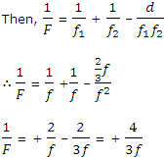
∴ F = + ¾ ƒ
The equivalent lens must be placed at a distance ¾ ƒ behind the field lens at a distance$α$ from it.
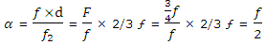
Thus, the equivalent lens is in between the field lens and the eye lens.
As the focal length of the eyepiece (equivalent lens) is ¾ ƒ, the image of the object due to the objective must be formed at a distance ¾ ƒ – ½ ƒ in front of the field lens. This image will act as an object for the eyepiece and the final image will be formed at infinity. The cross wires must be placed at the position where the image due to the objective is formed, i.e. at a distance of ½ ƒ in front of the field lens. This is the advantage of Ramsden eyepiece over the Huygens eyepiece.
The chromatic aberration in a Ramsden eyepiece is small. In some cases, both the lenses of the eyepiece are made of a combination of crown and flint glass and chromatic aberration is eliminated. As both the lenses are plano-convex with their convex surfaces facing such other the spherical aberration produced is small.

HUYGENS EYEPIECE
This eyepiece is achromatic and the spherical aberration is also eliminated. It consists of two lenses having focal lengths in the ratio 3 : 1 and the distance between them is equal to the difference in their focal lengths. The focal lengths and the positions of the two lenses are such that each lens produces and equal deviation of the ray and the system in achromatic.
Suppose the field lens and the eye of focal lengths ƒ₁ and ƒ₂ are placed D cm apart. If F is the focal length of the combination,
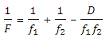
Differentiating
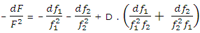
As the dispersive power
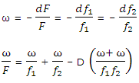
For achromatism, ω/F = 0
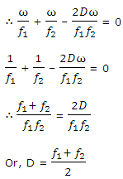
Also, for equal deviation of a ray by the two lenses, the distance between the two lenses should be equal to ƒ₁ – ƒ₂.
Thus, to satisfy both the conditions, Huygens constructed an eyepiece consisting of two plano-convex lenses of focal lengths 3ƒ and ƒ placed at a distance 2ƒ from each other.
II₁ is the image of the distant object formed by the objective in the absence of the field lens. With the field lens, the rays get refracted on passing through it and the image I’I’₁, is formed. This image lies at the focus of the eye lens so that the final image is seen at infinity.
In the modern design, the focal lengths of the lenses are 2ƒ and ƒ placed at a distance of 1.5 ƒ from each other.
The focal length of the combination
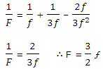
The equivalent lens must be placed behind the field lens at a distance
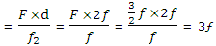
i.e. 3ƒ from the field lens or at a distance ƒ behind the eye lens.
Huygens eyepiece is known as the negative eyepiece because the real inverted image formed by the objective lies behind the field lens and this image acts as a virtual object for the eye lens. This eye-piece cannot be used to examine directly an object or a real image formed by the objective. The eyepiece is used in microscope or other optical instruments using white light only.
Moreover, the cross wires must be placed (if the measurement of final image is required) between the field lens and the eye lens. But the cross wires are viewed through the eye lens only while the distant object is viewed by rays refracted through both the lenses. Due to this reason relative lengths of the cross wires and the image are disproportionate. Hence cross wires cannot be used in a Huygens eyepiece and this is a disadvantage. Hence, Huygens eyepiece cannot be used in telescopes and other optical instruments with which distance and angles are to be measured.

APLANATIC LENS
A spherical lens which is free from the defects of spherical and coma is called an aplanatic lens. A pair of conjugate points free from spherical aberration and coma are called aplanatic points.
Fig. illustrates the property of an aplanatic lens. Let O be the centre of the curvature of the lens of refractive index $μ$ and radius of curvature R. P is a point on the axis of the lens such that . It can be shown that all rays passing through the point P appear to diverge through the point Q irrespective of the slope angle made by the incident rays. PA is the incident ray and AC is the refracted ray. The ray AC appears to diverge from the point Q which is the image of P. Let i and r be the angles of incidence and refraction and $α$ and $β$ the slope angles made by the incident and refracted rays.
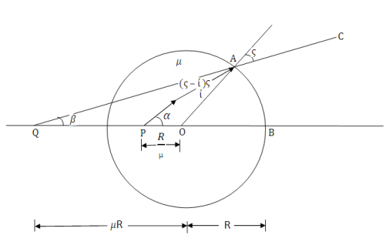
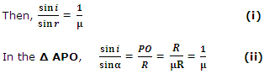
From (i) and (ii)
$$\frac{}{} \\ \frac{}{}\frac{}{}======\frac{}{}$$
$\frac{\sin{i}}{\sin{r}}=\frac{\sin{i}}{\sin{α}}$
∴ ∠ $α$ = ∠ r (iii)
In the Δ APO,
∠$α$ = $β$+ (r – i) (iv)
Substituting ∠$α$ = ∠ r in equation (iv)
r = $β$ + r – 1 or i = $β$ (v)
In the Δ AQO,
$\frac{\sin{r}}{\sin{β}}=\frac{\sin{r} }{\sin{i}}=μ = \frac{OQ}{OA}=\frac{oq}{R}$
OQ = $μ$.R
Thus, if the distance of the object point P is R/$μ$ from the centre of curvature, then the distance of the image point Q is $μ$ R irrespective of the slope angles $α$ and $β$. The object and image distances of the conjugate points that satisfy the above condition are BP = R + R/$μ$ and BQ = R +$μ$ R.
An aplanatic lens is mostly used as the front lens of a high power microscope objective called the oil immersion objective. As it is not possible to place an object inside a solid spherical lens, the lens is ground a little and the object to be examined is embedded in between a drop of oil and the lens surface. The oil chosen is such that it has the same refractive index as that of the lens.

