J agiroad College, Jagiroad, Morigaon, Assam
H oDs Format on course progression: Before and after declaration of Lock Down ( Status Report upto 12/05/2020)

Name of the Department: Education _ Semester: 4th Major & General

Sl. No | Name of the Teacher | Paper  Name/ No | Allotted  Course(s) | Total Credit / Total Marks | % of Course covered before Lock Down | Progression of allotted courses of the mentioned  semester after declaration of Lock Down |  |  | Total  % of Course completed before and after declaration of Lock  Down
 |  |  |  |  |  | No of Classes taken during Lock  Down | Mode of communication of online classes | % of Course covered during Lock Down
1 | Dr. Hema Chutia | 4.2 | 3 UNITS | 4 | 35% | 4 | College App/Whatsapp Group | 25% | 60%
2 | Dr. Srijani Das | 4.1 | 3 UNITS | 4 | 40% | 8 | College App/Whatsapp Group | 35% | 75%
3 | Kamrun Nehar | 4.2 | 3 UNITS | 4 | 35% | 6 | College App/Whatsapp Group | 30% | 65%
4 | Nikumoni Talukdar | 4.1 | 3UNITS | 4 | 35% | 6 | College App/Whatsapp Group | 35% | 70%
 |  |  | 4th Semester General
1 | Dr. Hema Chutia | 4.1 | 2 UNITS | 2 | 50% | - |  | - | 50%
2 | Dr. Srijani Das | 4.1 | 2 UNITS | 2 | 50% | 10 | College App/Whatsapp Group | 35% | 85%
3 | Kamrun Nehar | 4.1 | 2 UNITS | 2 | 50% | 3 | College App/Whatsapp Group | 30% | 80%
4 | Nikumoni Talukdar | 4.1 | 2 UNITS | 2 | 60% | 6 | College App/Whatsapp Group | 30% | 90%

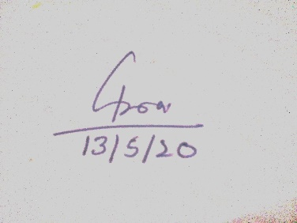
Signature of the HoD Signature of the Vice Principal
Date: Date:

