Difference between J.M.Keynes and Neo-Classical economists:
Neo-classical economics came into being in 1870s.Its founders were Carl Menger, Wieser, Bohm Bawerk, Jevons, Walras, Clark, Marshall and Pigou.It was started as a reaction to Classical Ricardianism and Marxism.They differ from Keynes in certain aspects.
Keynes is interested in macroeconomic analysis ,but, Neo-classical economists are concerned with microeconomic analysis.
The neo-classical economists assume that there exists fullemployment in the labour market,but believes in the existence of unemployment or below the level of fullemployment in the labour market.
According to the neo-classical economists, money is a veil.It doesn't serve the real purpose.It is simply a medium of exchange.But,keynes believes that money does not serve merely as a medium of exchange ,it influences the real factors of the economy
The neo-classical economists believe in self-regulating system in
bringing about stability .Instead,keynes believes in state interference in attaining stability.
Marginal Revolution: Marginal revolution indicates to the writings of Stanley Jevons,Carl Menger and Leon Walras
as they made fundamental changes in the apparatus of Economic analysis.They started looking at some of the important evonomic problems from an altogether new angle different from that of the classical economists.
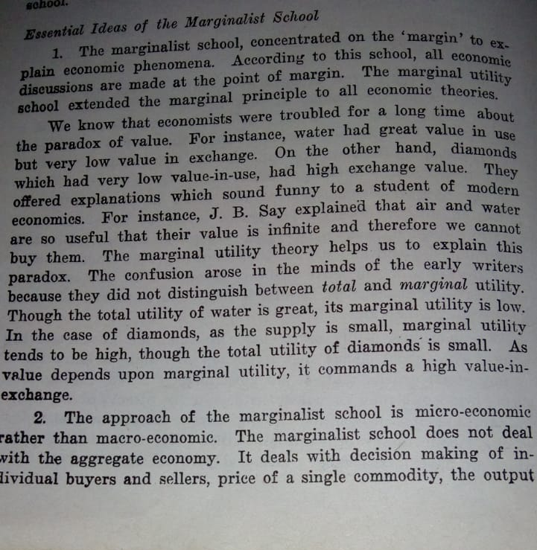
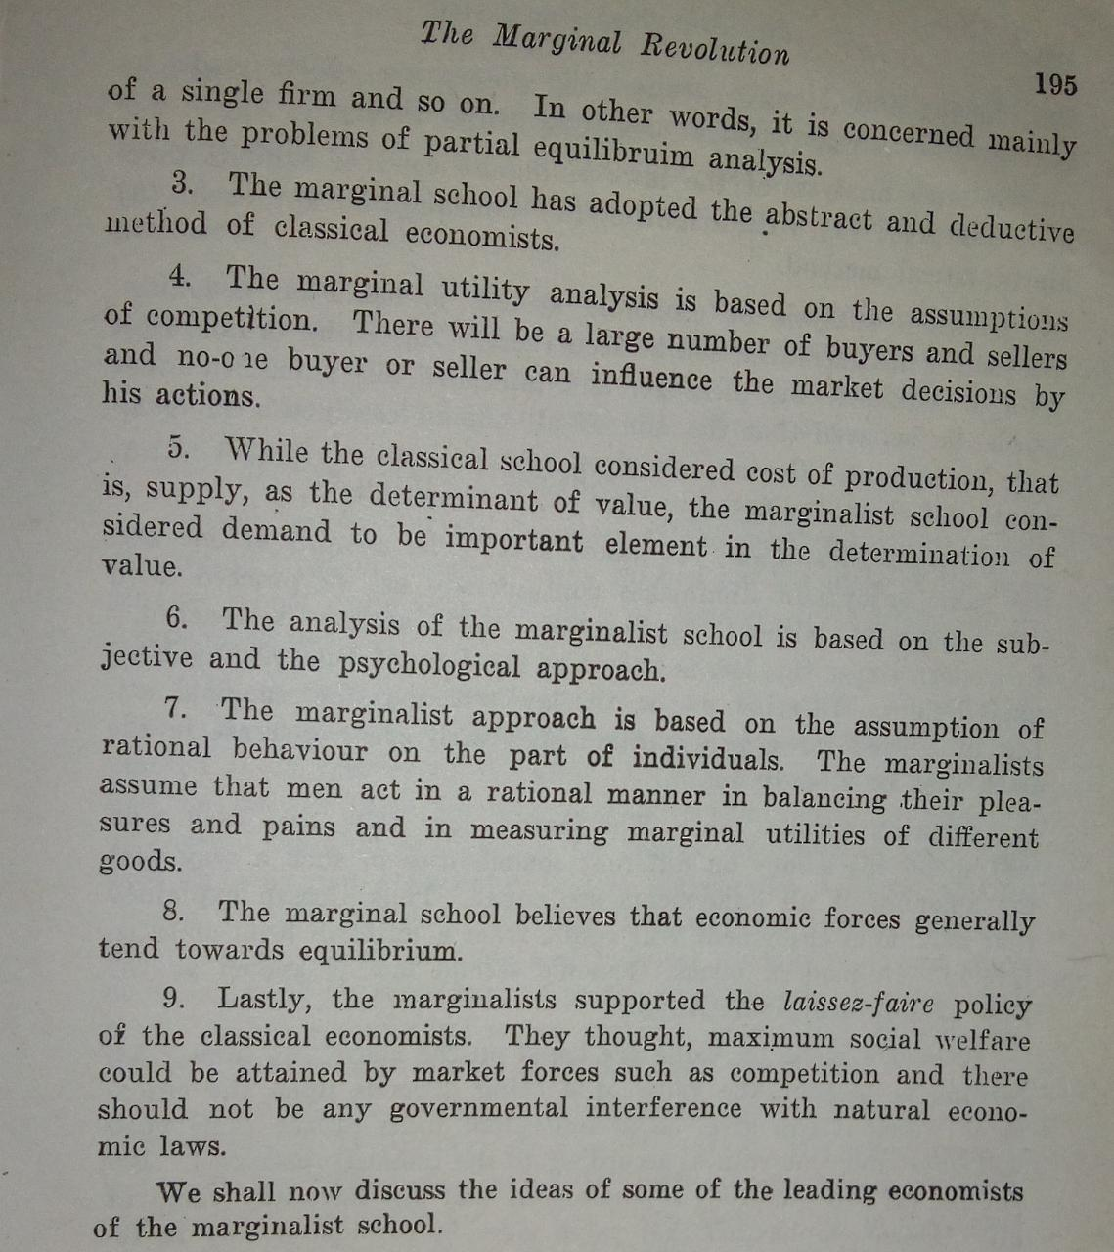
(you will write the first point upto....... Economic throries)

Horizontal and vertical Fiscal balance in a federation:
Horizontal balance or equity refers to equal treatment of equals while vertical equality regers to unequal treatment of unequals.The citizens of different states in a federation may be subjected to horizontal as well as vertical inequality .It means people of equal Economic position are not treated equally and the people of unequal economic position are not treated unequely in the spheres of tax payment and public expenditure.One pf the important purposes pf tax sharing and feferal transfer of resources is to remove such horizontal and vertical inequalities.

HORIZONTAL FISCAL MEASURES AND REMEDY:
Horizontal fiscal equity in a federation seeks to achieve inter-personal equity in tax payment among the various states.Thus, if two persons in two states have equsl income position , the tax liability of each on account of both federal and state taxes should be equal.Tjis equality can be realised through equalization of fiscal residue.Fiscal residue is the benefits from expenditure minus disutility from from tax payment.The fiscal residue is thus derived from budget operations of the Government.
Tax expenditure programmes in a federation at the levels of different layers of Government are planned independently.Different states are neither equally advanced nor equally .Federal and state taxes are bound to result in unequal fiscalresifue for their citizens.
The gap in the fiscal residue can be removed and horizontal fiscal balance may be achieved only through inter-state transfer of resources.i.e.the federal arrangement of resource transfer s from richer states to poorer states
Such Fiscal transfers will equalise per capita income in different states.Equalisation of fiscal residue can also be achieved through the application of benefit principle of taxation
Realisation of equality between Social Marginal Benefit and Social Marginal Cost does not mean interpersonal fiscal equity in the federating units in a federation.Since both MSB and MSC are larger in poorer states than in richer states ,transfer of resources to the former
to the latter will reduce inter-state differences in
MSB of public expenditure and in MSC of tax payment.Therefore ,
horizontal equity can be definitely increased through transfer of resources from richer to poorer stated.
VERTICAL FISCAL IMBALANCE AND REMEDY:
Federal Finance plays a significant role in reducing vertical fiscal imbalance .The expenditures on welfare activities and upliftment activities of the various states and local governments go on increasing.But, most of the revenue sources under their control are of inelastic nature.So, the growing expenditure can't be met with poor resources.The sources of revenue of the Central Government are much more elastic.It possesses surplus resources.Such resource gap between between the centre and the states are called vertical Fiscal imbalance.The different methods of achieving vertical fiscal equity between center and the regions in a federation are (a) tax sharing (b)tax credit (c) tax deductibility) (d)tax denial (e) general grants-in-aid and (f) selective grants-in-aid.
Since the revenue of the state government falls short of their need, some federal taxes are shared out to states by the centre
Tax credit refers to a system under which the amount of tax payable by a person to one government is reduced by the amount which he has already paid to another Government on the same kind of tax.
Under tax deduction , the the payer is allowed to deduct the amount of tax paid to one government from the tax base on which another Government levies tax.
In order to avoid double taxation of individuals , the central government uses the method of tax denial or tax restriction whereby the states are either denied or restricted relating to levy of some taxes.
The remaining gap is sought to be filled by central grants-in-aid in a federation. Geanta from centre may be either condotitional or unconditional or maybe matching or non- matching.
Some granta are made for specific purposes and if they are not uaed for these purposes , the funds have to be refunded.Matching grants are meant to help the state government in which the state is ready to spend from its own exchequer a part of the required investment.

implementing projects
(you will write the above separate two words in the last paragraph in between the state government.......in which the state is ready..)

