The p-n Junction Diode

Junction Diodes are small two-terminal which conducts current when forward biased and blocks current flow when reverse biased
The semiconductor p-n junction Diode is a small non-linear semiconductor devices generally used in electronic circuits, where small currents or high frequencies are involved such as in radio, television and digital logic circuits. The most widely used diodes is the 1N4001, IN4007, IN4148 and its equivalent 1N914 diode.
Small signal and switching diodes have much lower power and current ratings, around 150mA, 500mW maximum compared to rectifier diodes, but they can function better in high frequency applications or in clipping and switching applications that deal with short-duration pulse waveforms.
The characteristics of a signal point contact diode are different for both germanium and silicon types and are given as:
1. Germanium Signal Diodes – These have a low reverse resistance value giving a lower forward volt drop across the junction, typically only about 0.2 to 0.3v, but have a higher forward resistance value because of their small junction area.
2. Silicon Signal Diodes – These have a very high value of reverse resistance and give a forward volt drop of about 0.6 to 0.7v across the junction. They have fairly low values of forward resistance giving them high peak values of forward current and reverse voltage.
The electronic symbol given for any type of diode is that of an arrow with a bar or line at its end and this is illustrated below along with the Steady State V-I Characteristics Curve.

Silicon Diode V-I Characteristic Curve

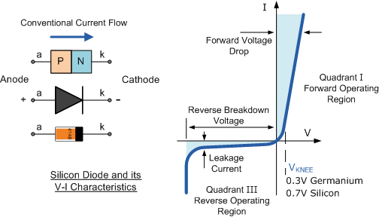
The arrow always points in the direction of conventional current flow through the diode meaning that the diode will only conduct if a positive supply is connected to the Anode, ( a ) terminal and a negative supply is connected to the Cathode ( k ) terminal thus only allowing current to flow through it in one direction only, acting more like a one way electrical valve, ( Forward Biased Condition ).
However, we know that if we connect the external energy source in the other direction the diode will block any current flowing through it and instead will act like an open switch, (Reversed Biased Condition ) as shown below.

Forward and Reversed Biased Diode
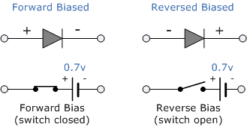
Then we can say that an ideal small signal diode conducts current in one direction ( forward-conducting ) and blocks current in the other direction ( reverse-blocking ). Diodes are used in a wide variety of applications such as a switch in rectifiers, current limiters and wave-shaping circuits.

Diode Parameters
Diodes are manufactured in a range of voltage and current ratings and care must be taken when choosing a diode for a certain application.

1. Maximum Forward Current
The Maximum Forward Current ( I_{F(max)} ) is as its name implies the maximum forward current allowed to flow through the device. When the diode is conducting in the forward bias condition, it has a very small “ON” resistance across the PN junction and therefore, power is dissipated across this junction ( Ohm´s Law ) in the form of heat.
Then, exceeding its ( I_{F(max)} ) value will cause more heat to be generated across the junction and the diode will fail due to thermal overload, usually with destructive consequences. When operating diodes around their maximum current ratings it is always best to provide additional cooling to dissipate the heat produced by the diode. For example, small 1N4148 signal diode has a maximum current rating of about 150mA with a power dissipation of 500mW at 25ºC. Then a resistor must be used in series with the diode to limit the forward current, ( I_{F(max)} ) through it to below this value.

2. Peak Inverse Voltage
The Peak Inverse Voltage (PIV) or Maximum Reverse Voltage ( V_{R(max)} ), is the maximum allowable Reverse operating voltage that can be applied across the diode without reverse breakdown and damage occurring to the device. This rating therefore, is usually less than the “avalanche breakdown” level on the reverse bias characteristic curve. Typical values of V_{R(max)} range from a few volts to thousands of volts and must be considered when replacing a diode.
The peak inverse voltage is an important parameter and is mainly used for rectifying diodes in AC rectifier circuits with reference to the amplitude of the voltage were the sinusoidal waveform changes from a positive to a negative value on each and every cycle.

3. Total Power Dissipation
Signal diodes have a Total Power Dissipation, ( P_{D(max)} ) rating. This rating is the maximum possible power dissipation of the diode when it is forward biased (conducting). When current flows through the signal diode the biasing of the PN junction is not perfect and offers some resistance to the flow of current resulting in power being dissipated (lost) in the diode in the form of heat.
As small signal diodes are non-linear devices the resistance of the PN junction is not constant, it is a dynamic property then we cannot use Ohms Law to define the power in terms of current and resistance or voltage and resistance as we can for resistors. Then to find the power that will be dissipated by the diode we must multiply the voltage drop across it times the current flowing through it: P_{D} = V*I

4. Maximum Operating Temperature
The Maximum Operating Temperature actually relates to the Junction Temperature ( T_{J} ) of the diode and is related to maximum power dissipation. It is the maximum temperature allowable before the structure of the diode deteriorates and is expressed in units of degrees centigrade per Watt, ( ºC/W ).
This value is linked closely to the maximum forward current of the device so that at this value the temperature of the junction is not exceeded. However, the maximum forward current will also depend upon the ambient temperature in which the device is operating so the maximum forward current is usually quoted for two or more ambient temperature values such as 25ºC or 70ºC.
Then there are three main parameters that must be considered when either selecting or replacing a signal diode and these are:
- The Reverse Voltage Rating
- The Forward Current Rating
- The Forward Power Dissipation Rating
Other types of specialized diodes not included here are Photo-Diodes, Zener Diodes, PIN Diodes, Tunnel Diodes, Light Emitting Diodes(LED) and Schottky Barrier Diodes. By adding more PN junctions to the basic two layer diode structure other types of semiconductor devices can be made.
For example a three layer semiconductor device becomes a Transistor, a four layer semiconductor device becomes a Thyristor or Silicon Controlled Rectifier and five layer devices known as Triac’s are also available.

Power Diodes and Rectifiers
Power Diodes are semiconductor pn-junctions capable of passing large currents at high voltage values for use in rectifier circuits.
a semiconductor signal diode will only conduct current in one direction from its anode to its cathode (forward direction), but not in the reverse direction acting a bit like an electrical one way valve.
A widely used application of this feature and diodes in general is in the conversion of an alternating voltage (AC) into a continuous voltage (Unidirectional). In other words, Rectification.
But small signal diodes can also be used as rectifiers in low-power, low current (less than 1-amp) rectifiers or applications, but where larger forward bias currents or higher reverse bias blocking voltages are involved the PN junction of a small signal diode would eventually overheat and melt so larger more robust Power Diodes are used instead.
The power semiconductor diode, known simply as the Power Diode, has a much larger PN junction area compared to its smaller signal diode cousin, resulting in a high forward current capability of up to several hundred amps (KA) and a reverse blocking voltage of up to several thousand volts (KV).
Since the power diode has a large PN junction, it is not suitable for high frequency applications above 1MHz, but special and expensive high frequency, high current diodes are available. For high frequency rectifier applications Sochottky Diodes are generally used because of their short reverse recovery time and low voltage drop in their forward bias condition.
Power diodes provide uncontrolled rectification of power and are used in applications such as battery charging and DC power supplies as well as AC rectifiers and inverters. Due to their high current and voltage characteristics they can also be used as free-wheeling diodes.
Power diodes are designed to have a forward “ON” resistance of fractions of an Ohm while their reverse blocking resistance is in the mega-Ohms range. Some of the larger value power diodes are designed to be “stud mounted” onto heat sinks reducing their thermal resistance to between 0.1 to 1ºC/Watt.
If an alternating voltage is applied across a power diode, during the positive half cycle the diode will conduct passing current and during the negative half cycle the diode will not conduct blocking the flow of current. Then conduction through the power diode only occurs during the positive half cycle and is therefore unidirectional i.e. DC as shown.

Power Diode Rectifier

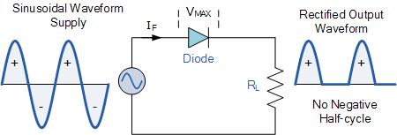
Power diodes can be used individually as above or connected together to produce a variety of rectifier circuits such as “Half-Wave”, “Full-Wave” or as “Bridge Rectifiers”. Each type of rectifier circuit can be classed as either uncontrolled, half-controlled or fully controlled where an uncontrolled rectifier uses only power diodes, a fully controlled rectifier uses thyristors (SCRs) and a half controlled rectifier is a mixture of both diodes and thyristors.
The most commonly used individual power diode for basic electronics applications is the general purpose 1N400x Series Glass Passivated type rectifying diode with standard ratings of continuous forward rectified current of about 1.0 ampere and reverse blocking voltage ratings from 50v for the 1N4001 up to 1000v for the 1N4007, with the small 1N4007GP being the most popular for general purpose mains voltage rectification.

Half Wave Rectification
A rectifier is a circuit which converts the Alternating Current (AC) input power into a Direct Current (DC) output power. The input power supply may be either a single-phase or a multi-phase supply with the simplest of all the rectifier circuits being that of the Half Wave Rectifier.
The power diode in a half wave rectifier circuit passes just one half of each complete sine wave of the AC supply in order to convert it into a DC supply. Then this type of circuit is called a “half-wave” rectifier because it passes only half of the incoming AC power supply as shown below.

Half Wave Rectifier Circuit

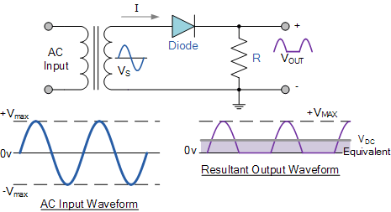
During each “positive” half cycle of the AC sine wave, the diode is forward biased as the anode is positive with respect to the cathode resulting in current flowing through the diode.
Since the DC load is resistive (resistor, R), the current flowing in the load resistor is therefore proportional to the voltage (Ohm´s Law), and the voltage across the load resistor will therefore be the same as the supply voltage, Vs (minus Vƒ), that is the “DC” voltage across the load is sinusoidal for the first half cycle only so Vout = Vs.
During each “negative” half cycle of the AC sinusoidal input waveform, the diode is reverse biased as the anode is negative with respect to the cathode. Therefore, NO current flows through the diode or circuit. Then in the negative half cycle of the supply, no current flows in the load resistor as no voltage appears across it so therefore, Vout = 0.
The current on the DC side of the circuit flows in one direction only making the circuit Unidirectional. As the load resistor receives from the diode a positive half of the waveform, zero volts, a positive half of the waveform, zero volts, etc, the value of this irregular voltage would be equal in value to an equivalent DC voltage of 0.318*Vmax of the input sinusoidal waveform or 0.45*Vrms of the input sinusoidal waveform.
Then the equivalent DC voltage, V_{DC} across the load resistor is calculated as follows.
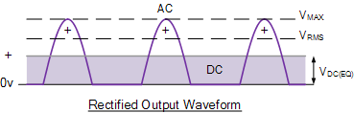

Half-wave Rectifier with Smoothing Capacitor

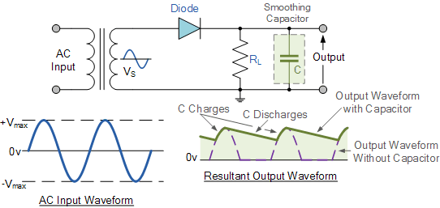
When rectification is used to provide a direct voltage (DC) power supply from an alternating (AC) source, the amount of ripple voltage can be further reduced by using larger value capacitors but there are limits.
For a given capacitor value, a greater load current (smaller load resistance) will discharge the capacitor more quickly (RC Time Constant ) and so increases the ripple obtained. Then for single phase, half-wave rectifier circuit using a power diode it is not very practical to try and reduce the ripple voltage by capacitor smoothing alone. In this instance it would be more practical to use “Full-wave Rectification” instead.
In practice, the half-wave rectifier is used most often in low-power applications because of their major disadvantages. The output amplitude is less than the input amplitude, there is no output during the negative half cycle so half the power is wasted and the output is pulsed DC resulting in excessive ripple.
To overcome these disadvantages a number of Power Diode are connected together to produce a Full Wave Rectifier.
Full Wave Rectifier
Full wave rectifiers have some fundamental advantages over their half wave rectifier counterparts. The average (DC) output voltage is higher than for half wave, the output of the full wave rectifier has much less ripple than that of the half wave rectifier producing a smoother output waveform.
In a Full Wave Rectifier circuit two diodes are now used, one for each half of the cycle. A multiple winding transformer is used whose secondary winding is split equally into two halves with a common centre tapped connection, (C). This configuration results in each diode conducting in turn when its anode terminal is positive with respect to the transformer centre point C producing an output during both half-cycles, twice that for the half wave rectifier so it is 100% efficient as shown below.

Full Wave Rectifier Circuit

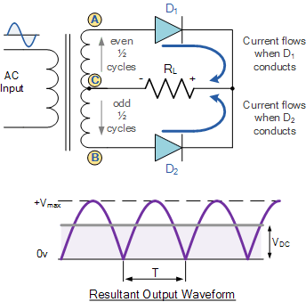
The full wave rectifier circuit consists of two power diodes connected to a single load resistance (R_{L}) with each diode taking it in turn to supply current to the load. When point A of the transformer is positive with respect to point C, diode D₁ conducts in the forward direction as indicated by the arrows.
When point B is positive (in the negative half of the cycle) with respect to point C, diode D₂ conducts in the forward direction and the current flowing through resistor R is in the same direction for both half-cycles. As the output voltage across the resistor R is the sum of the two waveforms combined, this type of full wave rectifier circuit is also known as a “bi-phase” circuit.
The main disadvantage of this type of full wave rectifier circuit is that a larger transformer for a given power output is required with two separate but identical secondary windings making this type of full wave rectifying circuit costly compared to the “Full Wave Bridge Rectifier” circuit equivalent.

The Full Wave Bridge Rectifier
Another type of circuit that produces the same output waveform as the full wave rectifier circuit below is that of the Full Wave Bridge Rectifier. This type of single phase rectifier uses four individual rectifying diodes connected in a closed loop “bridge” configuration to produce the desired output.
The main advantage of this bridge circuit is that it does not require a special centre tapped transformer, thereby reducing its size and cost. The single secondary winding is connected to one side of the diode bridge network and the load to the other side as shown below.

The Diode Bridge Rectifier

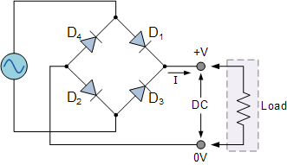
The four diodes labeled D₁ to D₄ are arranged in “series pairs” with only two diodes conducting current during each half cycle. During the positive half cycle of the supply, diodes D1 and D2 conduct in series while diodes D3 and D4 are reverse biased and the current flows through the load as shown below.

The Positive Half-cycle

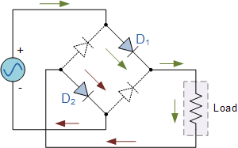

As the current flowing through the load is unidirectional, so the voltage developed across the load is also unidirectional the same as for the previous two diode full-wave rectifier, therefore the average DC voltage across the load is 0.637V_{max}.

The Negative Half-cycle
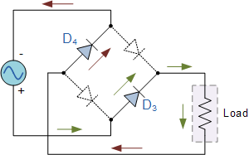
Typical Bridge Rectifier
However in reality, during each half cycle the current flows through two diodes instead of just one so the amplitude of the output voltage is two voltage drops ( 2*0.7 = 1.4V ) less than the input V_{MAX} amplitude. The ripple frequency is now twice the supply frequency (e.g. 100Hz for a 50Hz supply or 120Hz for a 60Hz supply.)

The Smoothing Capacitor
In the single phase half-wave rectifier produces an output wave every half cycle and that it was not practical to use this type of circuit to produce a steady DC supply. The full-wave bridge rectifier however, gives us a greater mean DC value (0.637 Vmax) with less superimposed ripple while the output waveform is twice that of the frequency of the input supply frequency.
We can improve the average DC output of the rectifier while at the same time reducing the AC variation of the rectified output by using smoothing capacitors to filter the output waveform. Smoothing or reservoir capacitors connected in parallel with the load across the output of the full wave bridge rectifier circuit increases the average DC output level even higher as the capacitor acts like a storage device as shown below.

Full-wave Rectifier with Smoothing Capacitor

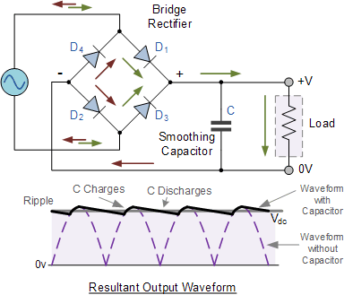

The smoothing capacitor converts the full-wave rippled output of the rectifier into a more smooth DC output voltage.

The Zener Diode
A Semiconductor Diode blocks current in the reverse direction, but will suffer from premature breakdown or damage if the reverse voltage applied across becomes too high.
However, the Zener Diode or “Breakdown Diode”, as they are sometimes referred too, are basically the same as the standard PN junction diode but they are specially designed to have a low and specified Reverse Breakdown Voltage which takes advantage of any reverse voltage applied to it.
The Zener diode behaves just like a normal general-purpose diode consisting of a silicon PN junction and when biased in the forward direction, that is Anode positive with respect to its Cathode, it behaves just like a normal signal diode passing the rated current.
However, unlike a conventional diode that blocks any flow of current through itself when reverse biased, that is the Cathode becomes more positive than the Anode, as soon as the reverse voltage reaches a pre-determined value, the zener diode begins to conduct in the reverse direction.
This is because when the reverse voltage applied across the zener diode exceeds the rated voltage of the device a process called Avalanche Breakdown occurs in the semiconductor depletion layer and a current starts to flow through the diode to limit this increase in voltage.
The current now flowing through the zener diode increases dramatically to the maximum circuit value (which is usually limited by a series resistor) and once achieved, this reverse saturation current remains fairly constant over a wide range of reverse voltages. The voltage point at which the voltage across the zener diode becomes stable is called the “zener voltage”, ( Vz ) and for zener diodes this voltage can range from less than one volt to a few hundred volts.
The point at which the zener voltage triggers the current to flow through the diode can be very accurately controlled (to less than 1% tolerance) in the doping stage of the diodes semiconductor construction giving the diode a specific zener breakdown voltage, ( Vz ) for example, 4.3V or 7.5V. This zener breakdown voltage on the I-V curve is almost a vertical straight line.

Zener Diode I-V Characteristics
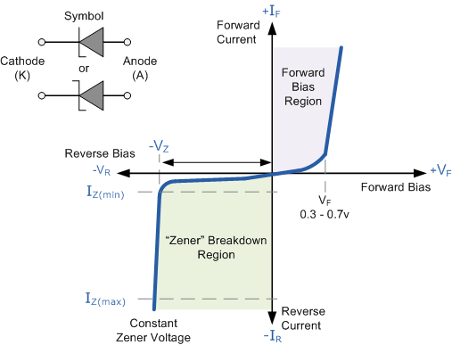
The Zener Diode is used in its “reverse bias” or reverse breakdown mode, i.e. the diodes anode connects to the negative supply. From the I-V characteristics curve above, we can see that the zener diode has a region in its reverse bias characteristics of almost a constant negative voltage regardless of the value of the current flowing through the diode.
This voltage remains almost constant even with large changes in current providing the zener diodes current remains between the breakdown current I_{Z(min)} and its maximum current rating I_{Z(max)}.
This ability of the zener diode to control itself can be used to great effect to regulate or stabilise a voltage source against supply or load variations. The fact that the voltage across the diode in the breakdown region is almost constant turns out to be an important characteristic of the zener diode as it can be used in the simplest types of voltage regulator applications.
The function of a voltage regulator is to provide a constant output voltage to a load connected in parallel with it in spite of the ripples in the supply voltage or variations in the load current. A zener diode will continue to regulate its voltage until the diodes holding current falls below the minimum I_{Z(min)} value in the reverse breakdown region.

The Zener Diode Regulator
Zener Diodes can be used to produce a stabilised voltage output with low ripple under varying load current conditions. By passing a small current through the diode from a voltage source, via a suitable current limiting resistor (R_{S}), the zener diode will conduct sufficient current to maintain a voltage drop of Vout.
The DC output voltage from the half or full-wave rectifiers contains ripple superimposed onto the DC voltage and that as the load value changes so the average output voltage also changes By connecting a simple zener stabiliser circuit as shown below across the output of the rectifier, a more stable output voltage can be produced.

Zener Diode Regulator
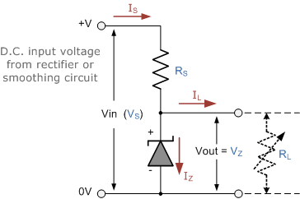
Resistor, R_{S} is connected in series with the zener diode to limit the current flow through the diode with the voltage source, V_{S} being connected across the combination. The stabilised output voltage V_{out} is taken from across the zener diode.
The zener diode is connected with its cathode terminal connected to the positive terminal of the DC supply so it is reverse biased and will be operating in its breakdown condition. Resistor R_{S} is selected so to limit the maximum current flowing in the circuit.
With no load connected to the circuit, the load current will be zero, ( I_{L} = 0 ), and all the circuit current passes through the zener diode which in turn dissipates its maximum power. Also a small value of the series resistor R_{S} will result in a greater diode current when the load resistance R_{L} is connected and large as this will increase the power dissipation requirement of the diode so care must be taken when selecting the appropriate value of series resistance so that the zener’s maximum power rating is not exceeded under this no-load or high-impedance condition.
The load is connected in parallel with the zener diode, so the voltage across R_{L} is always the same as the zener voltage, ( V_{R} = V_{Z} ). There is a minimum zener current for which the stabilization of the voltage is effective and the zener current must stay above this value operating under load within its breakdown region at all times. The upper limit of current is of course dependent upon the power rating of the device. The supply voltage V_{S} must be greater than V_{Z}.
One small problem with zener diode stabilizer circuits is that the diode can sometimes generate electrical noise on top of the DC supply as it tries to stabilize the voltage. Normally this is not a problem for most applications but the addition of a large value decoupling capacitor across the zener’s output may be required to give additional smoothing.
Then to summarize. A zener diode is always operated in its reverse biased condition. As such a simple voltage regulator circuit can be designed using a zener diode to maintain a constant DC output voltage across the load in spite of variations in the input voltage or changes in the load current.
The zener voltage regulator consists of a current limiting resistor R_{S} connected in series with the input voltage V_{S} with the zener diode connected in parallel with the load R_{L} in this reverse biased condition. The stabilized output voltage is always selected to be the same as the breakdown voltage V_{Z} of the diode.
The values of the individual Zener diodes can be chosen to suit the application while the silicon diode will always drop about 0.6 – 0.7V in the forward bias condition. The supply voltage, Vin must of course be higher than the largest output reference voltage and in our example above this is 19v.
A typical zener diode for general electronic circuits is the 500mW, BZX55 series or the larger 1.3W, BZX85 series were the zener voltage is given as, for example, C7V5 for a 7.5V diode giving a diode reference number of BZX55C7V5.
The 500mW series of zener diodes are available from about 2.4 up to about 100 volts and typically have the same sequence of values as used for the 5% (E24) resistor series with the individual voltage ratings for these small but very useful diodes are given in the table below.

Zener Diode Clipping Circuits
Thus far we have looked at how a zener diode can be used to regulate a constant DC source but what if the input signal was not steady state DC but an alternating AC waveform how would the zener diode react to a constantly changing signal.
Diode clipping and clamping circuits are circuits that are used to shape or modify an input AC waveform (or any sinusoid) producing a differently shape output waveform depending on the circuit arrangement. Diode clipper circuits are also called limiters because they limit or clip-off the positive (or negative) part of an input AC signal. As zener clipper circuits limit or cut-off part of the waveform across them, they are mainly used for circuit protection or in waveform shaping circuits.
For example, if we wanted to clip an output waveform at +7.5V, we would use a 7.5V zener diode. If the output waveform tries to exceed the 7.5V limit, the zener diode will “clip-off” the excess voltage from the input producing a waveform with a flat top still keeping the output constant at +7.5V. Note that in the forward bias condition a zener diode is still a diode and when the AC waveform output goes negative below -0.7V, the zener diode turns “ON” like any normal silicon diode would and clips the output at -0.7V as shown below.

Square Wave Signal
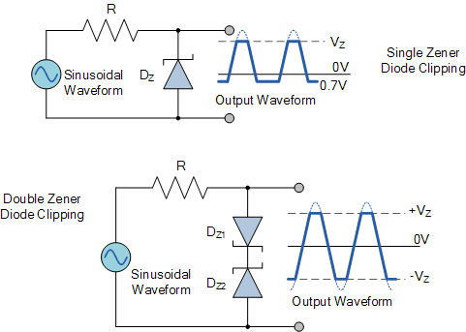
The back to back connected zener diodes can be used as an AC regulator producing what is jokingly called a “poor man’s square wave generator”. Using this arrangement we can clip the waveform between a positive value of +8.2V and a negative value of -8.2V for a 7.5V zener diode.
So for example, if we wanted to clip an output waveform between two different minimum and maximum values of say, +8V and -6V, we would simply use two differently rated zener diodes. Note that the output will actually clip the AC waveform between +8.7V and -6.7V due to the addition of the forward biasing diode voltage.
In other words a peak-to-peak voltage of 15.4 volts instead of expected 14 volts, as the forward bias volt drop across the diode adds another 0.7 volts in each direction.
This type of clipper configuration is fairly common for protecting an electronic circuit from over voltage. The two zener’s are generally placed across the power supply input terminals and during normal operation, one of the zener diodes is “OFF” and the diodes have little or no affect. However, if the input voltage waveform exceeds its limit, then the zener’s turn “ON” and clip the input to protect the circuit.
The LED is the forward biased PN junction of a diode to produce light. We know that when charge carriers move across the junction, electrons combine with holes and energy is lost in the form of heat, but also some of this energy is dissipated as photons but we cannot see them.
If we place a translucent lens around the junction, visible light will be produced and the diode becomes a light source. This effect produces another type of diode known commonly as the Light Emitting Diode which takes advantage of this light producing characteristic to emit light (photons) in a variety of colours and wavelengths

The Light Emitting Diode
They are the most visible type of diode that emit a fairly narrow bandwidth of either visible light at different coloured wavelengths, invisible infra-red light for remote controls or laser type light when a forward current is passed through them.
The “Light Emitting Diode” or LED as it is more commonly called, is basically just a specialized type of diode as they have very similar electrical characteristics to a PN junction diode. This means that an LED will pass current in its forward direction but block the flow of current in the reverse direction.
Light emitting diodes are made from a very thin layer of fairly heavily doped semiconductor material and depending on the semiconductor material used and the amount of doping, when forward biased an LED will emit a coloured light at a particular spectral wavelength.
When the diode is forward biased, electrons from the semiconductors conduction band recombine with holes from the valence band releasing sufficient energy to produce photons which emit a monochromatic (single colour) of light. Because of this thin layer a reasonable number of these photons can leave the junction and radiate away producing a coloured light output.
LED Construction
Then we can say that when operated in a forward biased direction Light Emitting Diodes are semiconductor devices that convert electrical energy into light energy.
The construction of a Light Emitting Diode is very different from that of a normal signal diode. The PN junction of an LED is surrounded by a transparent, hard plastic epoxy resin hemispherical shaped shell or body which protects the LED from both vibration and shock.
Surprisingly, an LED junction does not actually emit that much light so the epoxy resin body is constructed in such a way that the photons of light emitted by the junction are reflected away from the surrounding substrate base to which the diode is attached and are focused upwards through the domed top of the LED, which itself acts like a lens concentrating the amount of light. This is why the emitted light appears to be brightest at the top of the LED.
However, not all LEDs are made with a hemispherical shaped dome for their epoxy shell. Some indication LEDs have a rectangular or cylindrical shaped construction that has a flat surface on top or their body is shaped into a bar or arrow. Generally, all LED’s are manufactured with two legs protruding from the bottom of the body.
Also, nearly all modern light emitting diodes have their cathode, ( – ) terminal identified by either a notch or flat spot on the body or by the cathode lead being shorter than the other as the anode ( + ) lead is longer than the cathode (k).
Unlike normal incandescent lamps and bulbs which generate large amounts of heat when illuminated, the light emitting diode produces a “cold” generation of light which leads to high efficiencies than the normal “light bulb” because most of the generated energy radiates away within the visible spectrum. Because LEDs are solid-state devices, they can be extremely small and durable and provide much longer lamp life than normal light sources.

Light Emitting Diode Colours
So how does a light emitting diode get its colour. Unlike normal signal diodes which are made for detection or power rectification, and which are made from either Germanium or Silicon semiconductor materials, Light Emitting Diodes are made from exotic semiconductor compounds such as Gallium Arsenide (GaAs), Gallium Phosphide (GaP), Gallium Arsenide Phosphide (GaAsP), Silicon Carbide (SiC) or Gallium Indium Nitride (GaInN) all mixed together at different ratios to produce a distinct wavelength of colour.
Different LED compounds emit light in specific regions of the visible light spectrum and therefore produce different intensity levels. The exact choice of the semiconductor material used will determine the overall wavelength of the photon light emissions and therefore the resulting colour of the light emitted.

Light Emitting Diode Colours
Typical LED Characteristics
Semiconductor  Material | Wavelength | Colour | V_{F} @ 20mA
GaAs | 850-940nm | Infra-Red | 1.2v
GaAsP | 630-660nm | Red | 1.8v
GaAsP | 605-620nm | Amber | 2.0v
GaAsP:N | 585-595nm | Yellow | 2.2v
AlGaP | 550-570nm | Green | 3.5v
SiC | 430-505nm | Blue | 3.6v
GaInN | 450nm | White | 4.0v
Thus, the actual colour of a light emitting diode is determined by the wavelength of the light emitted, which in turn is determined by the actual semiconductor compound used in forming the PN junction during manufacture.
Therefore the colour of the light emitted by an LED is NOT determined by the colouring of the LED’s plastic body although these are slightly coloured to both enhance the light output and to indicate its colour when its not being illuminated by an electrical supply.
Light emitting diodes are available in a wide range of colours with the most common being RED, AMBER, YELLOW and GREEN and are thus widely used as visual indicators and as moving light displays.
Recently developed blue and white coloured LEDs are also available but these tend to be much more expensive than the normal standard colours due to the production costs of mixing together two or more complementary colours at an exact ratio within the semiconductor compound and also by injecting nitrogen atoms into the crystal structure during the doping process.
From the table above we can see that the main P-type dopant used in the manufacture of Light Emitting Diodes is Gallium (Ga, atomic number 31) and that the main N-type dopant used is Arsenic (As, atomic number 33) giving the resulting compound of Gallium Arsenide (GaAs) crystalline structure.
The problem with using Gallium Arsenide on its own as the semiconductor compound is that it radiates large amounts of low brightness infra-red radiation (850nm-940nm approx.) from its junction when a forward current is flowing through it.
The amount of infra-red light it produces is okay for television remote controls but not very useful if we want to use the LED as an indicating light. But by adding Phosphorus (P, atomic number 15), as a third dopant the overall wavelength of the emitted radiation is reduced to below 680nm giving visible red light to the human eye. Further refinements in the doping process of the PN junction have resulted in a range of colours spanning the spectrum of visible light as we have seen above as well as infra-red and ultra-violet wavelengths.
By mixing together a variety of semiconductor, metal and gas compounds the following list of LEDs can be produced.

Types of Light Emitting Diode
- Gallium Arsenide (GaAs) – infra-red
- Gallium Arsenide Phosphide (GaAsP) – red to infra-red, orange
- Aluminium Gallium Arsenide Phosphide (AlGaAsP) – high-brightness red, orange-red, orange, and yellow
- Gallium Phosphide (GaP) – red, yellow and green
- Aluminium Gallium Phosphide (AlGaP) – green
- Gallium Nitride (GaN) – green, emerald green
- Gallium Indium Nitride (GaInN) – near ultraviolet, bluish-green and blue
- Silicon Carbide (SiC) – blue as a substrate
- Zinc Selenide (ZnSe) – blue
- Aluminium Gallium Nitride (AlGaN) – ultraviolet
Like conventional PN junction diodes, light emitting diodes are current-dependent devices with its forward voltage drop V_{F}, depending on the semiconductor compound (its light colour) and on the forward biased LED current. Most common LED’s require a forward operating voltage of between approximately 1.2 to 3.6 volts with a forward current rating of about 10 to 30 mA, with 12 to 20 mA being the most common range.
Both the forward operating voltage and forward current vary depending on the semiconductor material used but the point where conduction begins and light is produced is about 1.2V for a standard red LED to about 3.6V for a blue LED.
The exact voltage drop will of course depend on the manufacturer because of the different dopant materials and wavelengths used. The voltage drop across the LED at a particular current value, for example 20mA, will also depend on the initial conduction V_{F} point. As an LED is effectively a diode, its forward current to voltage characteristics curves can be plotted for each diode colour as shown below.

Light Emitting Diodes I-V Characteristics.
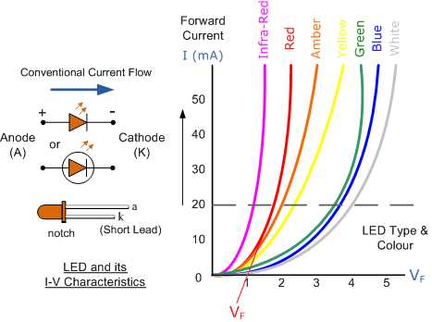
Light Emitting Diode (LED) Schematic symbol and I-V Characteristics Curves ,showing the different colours available.
Before a light emitting diode can “emit” any form of light it needs a current to flow through it, as it is a current dependent device with their light output intensity being directly proportional to the forward current flowing through the LED.
As the LED is to be connected in a forward bias condition across a power supply it should be current limited using a series resistor to protect it from excessive current flow. Never connect an LED directly to a battery or power supply as it will be destroyed almost instantly because too much current will pass through and burn it out.
From the table above we can see that each LED has its own forward voltage drop across the PN junction and this parameter which is determined by the semiconductor material used, is the forward voltage drop for a specified amount of forward conduction current, typically for a forward current of 20mA.
In most cases LEDs are operated from a low voltage DC supply, with a series resistor, R_{S} used to limit the forward current to a safe value from say 5mA for a simple LED indicator to 30mA or more where a high brightness light output is needed.

LED Series Resistance.
The series resistor value R_{S} is calculated by simply using Ohm´s Law, by knowing the required forward current I_{F} of the LED, the supply voltage V_{S} across the combination and the expected forward voltage drop of the LED, V_{F} at the required current level, the current limiting resistor is calculated as:

LED Series Resistor Circuit
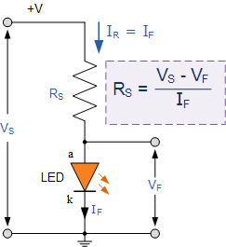

LED band gap and colour relation:-

$E_{g}=(h c)/λ_{max}$ , where $E_{g}$ is band gap, h is Plank’s constant, c is velocity of light and $λ_{max}$ is maximum wavelength. Now $λ_{max}={h c}/{E_{g}}$ , putting h=6.63$×{10}^{-34}$, c=3$×{10}^{8}$, and $E_{g}$=N$×1.6×{10}^{-19}$ Joules, where N is numerical value in electron volt we can calculate wavelength in nanometer($1nm={10}^{-9}m)$.

Product of h and c = hc=6.63$×{10}^{-34}×$3$×{10}^{8}$=19.89$×{10}^{-26}$ and dividing it with N$×1.6×{10}^{-19}$ we get $λ_{max}={12.4312×{10}^{-7}}/N$=1243.12$×{10}^{-9}/N$= 1243.12/N nm [1nm=${10}^{-9}$]
Now if band gap is in eV(electron volt) can be written as $E_{g}=$ N$×1.6×{10}^{-19}$ Joules , if $E_{g}$=1.9eV then N=1.9 and then$λ_{max}$= 1243.12/1.9nm=654.27nm corresponding to red colour.
If $E_{g}$=2.1eV then N=2.1 and then$λ_{max}$= 1243.12/2.1nm=591.96nm or 592nm corresponding to yellow colour.
And if $E_{g}$=2.25eV then N=2.25 and then$λ_{max}$= 1243.12/2.25nm=552.497nm or 552.5nm corresponding to green colour.
Similarly if $E_{g}$=2.6eV then N=2.6 and then$λ_{max}$= 1243.12/2.6nm=478.12nm or 478nm corresponding to blue colour.
We know band gap $E_{g}$=1.1eV for silicon p-n junction then N=1.1 and then$λ_{max}$= 1243.12/1.1nm=1130.10nm or 1130nm corresponding to invisible infrared region.
Again we know band gap $E_{g}$=0.7eV for germanium p-n junction then N=0.7 and then$λ_{max}$= 1243.12/0.7nm=1775.88nm or 1776nm corresponding to invisible infrared region.

Photo Diode:
A photodiode is a semiconductor device that converts light into an electrical current. The current is generated when photons are absorbed in the photodiode. Photodiodes may contain optical filters, built-in lenses, and may have large or small surface area
Photo diode operates in reverse bias condition i.e. the p -side of the photodiode is connected to negative terminal of the battery and n-side is connected to positive terminal of the battery.
The photodiode is reverse biased for operating in the photoconductive mode. As the photodiode is in reverse bias the width of the depletion layer increases. This reduces the junction capacitance and thereby the response time. In effect, the reverse bias causes faster response times for the photodiode
The operating principle of the photodiode is such that when the junction of this two-terminal semiconductor device is illuminated then the electric current starts flowing through it. Only minority current flows through the device when the certain reverse potential is applied to it.
A photodiode is one type of light detector, used to convert the light into current or voltage based on the mode of operation of the device. It comprises of optical filters, built-in lenses and also surface areas. These diodes have a slow response time when the surface area of the photodiode increases.

