What is bank?
--- Bank is a financial institution that accept deposits and advances loans to the public.

What is Commercial bank?
----- Commercial bank is defined as a bank which accepts deposits and advances loans to the public.Moreover,it promotes the use of cheque system, perform agency functions and general utility functions, issue debit and credit cards, provide ATM services and online transfer of funds accross the country or world.

PRIMARY DEPOSIT---When a bank accepts vash from the customer and opens a deposit account in his name it is called primary deposit.Here the role of the bank is passive in creating deposit.This deposit simply convert currency money into deposit money.
DERIVATIVE DEPOSIT:--
Derivative deposit is that type of deposit which is created by the bank by opening a deposit account in the name of the person who contacts bank to borrow money.The bank plays an active role in creating derivative deposit.Therefore it is called active deposit.It is also called secondary deposit.The primary deposit is the basis of secondary or derivative deposit.It is called credit credit creation.

CREDIT CREATION:
Credit creation refers to the unique Power of the bank d to multiply loans and advances.With a little amount of cash in hand, the banks can create additional purchasing power to a considerable degree. It is because of the multiple credit creating ppwer , the commercial banks have been called the 'factories of credit' or 'manufacturers of money'.
CREDIT CREATION BY A SINGLE BANK:

The process of credit creation by a single bank can be illustrated woth the help of an example.
Suppose, the customery cash-reserve ratio maintained by the bank is 20%.If person A deposits Rs.1000 with the bank, the bank does not keep the entire cash in reserve but only the 20%. of it to meet to meet day to day cash demand. Thus, after keeping Rs.200, the banklends the remaining Rs.800 to person B by opening a Credit account in his name.Again, keeping 20% of Rs 800 the bank advances the remaining Rs 640 to person C.Similarly, keeping 20% of Rs 640 , the bank advances 20% of 640 the nanl advances Rs
512 to person D ,and so on.This provess will continue till the initial primary deposit of Rs1000 and the initial excess reserves of Rs.800 lead to additional deposits of Rs 800+640+512+......=4000By adding up all the primary and secondary or derivative deposits we get totall total deposits of Rs.5000.Here, credit multiplier is 5.and credit creation is five times the initial excess reserves.The provess of Credit creation in a single bank system is shown in the following table.

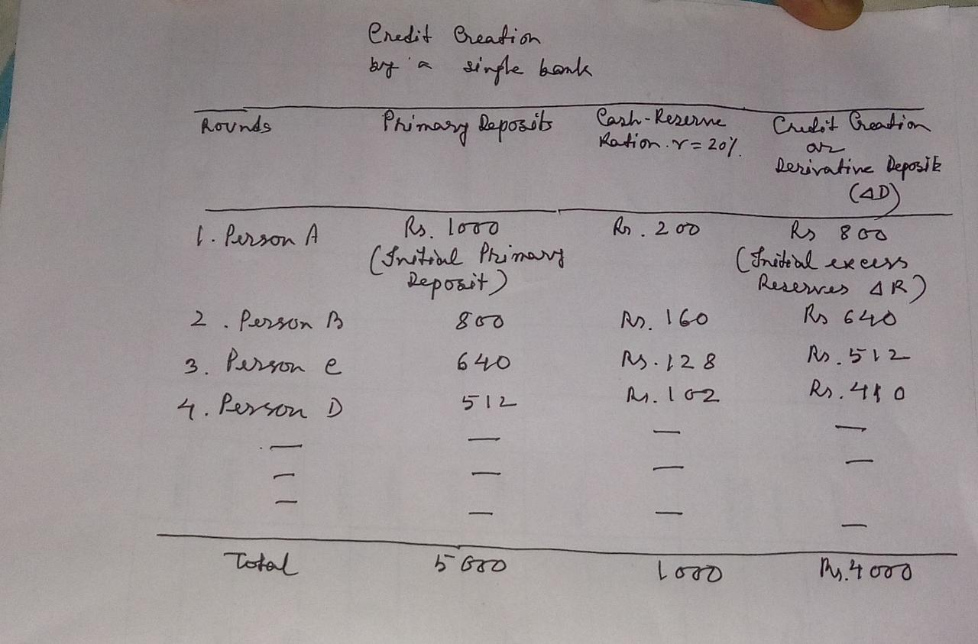
In the above table it is seen that on the basis of the cash reserve ratio of 20% and with the initial primary deposit of Rs.1000, the bank creates derivative deposits of Rs4000 and the totaldemand deposits will be Rs.5000.The credit expansion is five times the initial excess reserves.The credit multiplier will be 5, or

Credit creation depends upon the ratio of cash reserves to deposits.The higher the cash reserve ratio ,lower will be the credit multiplier, lower the cash reserve ratio higher will be the credit multiplier.
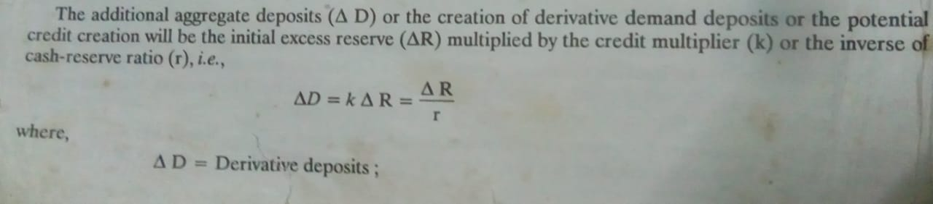
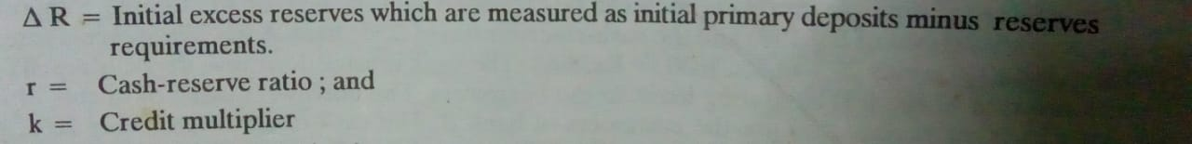
MULTIPLE CREDIT CREATION BY BANKING SYSTEM.
In real world, there are many banks existence comprising multiple banking system.The banking system can grant loans many times the the excess reserves of cash created for it
When an individual bank creates derivative deposits, it loses cash to other banks.
The loss of deposit of one bank is the gain of deposit by some other bank. This transfer of cash within banking system creates, in turn, primary deposit s and increases the possibility for a further creation of derivative deposits by the banks receiving cash.This process of the banking system to increase credit many times more than initial cash reserves is called multiple credit creation.
The process of multiple credit creation can be explained with the help of an example.Suppose, wilth the initial prary deposit of Rs. 1000 and the cash reserve ratio of 20% , bank A has initial eccess reserves of Rs.800 (1000-20% of 1000= Rs.800).The bank creates derivative deposits equal to it's initial excess reserves of Rs.800 by granting losns to the borrowers. The borrowers make payments of Rs.800 by cheques to other people who are the customers of bank B.Tje cash reserve ratio being 20%,the excess reserves of bank B are 640 (i.e.Rs.800 minus 20%of Rs.800=640) which it converts into derivative deposits by giving loans to borrowers.Further, the borrowers of bank Bske payment of Rs.640 by cheques to some
people. who are the customers of bank C. This creates the primary deposit of Rs 640 in bank C,which in turn, leads to the creation of excess reserves and derivative deposits of Rs.512 (i.e.640 minus 20% of Rs.640=Rs 512) in bank C.
This process will continue until the initial primary deposits of Rs.1000 with bank A lead to the creation of total deposits (primary plus derivative) of Rs.5000 .The initial excess reserves of Rs.800 in bank A leads to the multiple expansion of total derivative deposits of Rs.4000in the entire banking system. Thus, credit creation or creation of derivative deposits (delta D) by the banking system will be Rs.800+640+512+.….=Rs.4000 which is five times of the initial excess reserves (delta R) of Rs.800.
The following table illustrates the process of credit creation by the banking system.
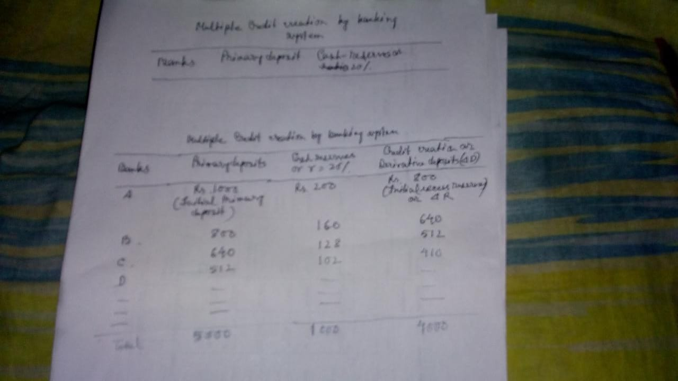
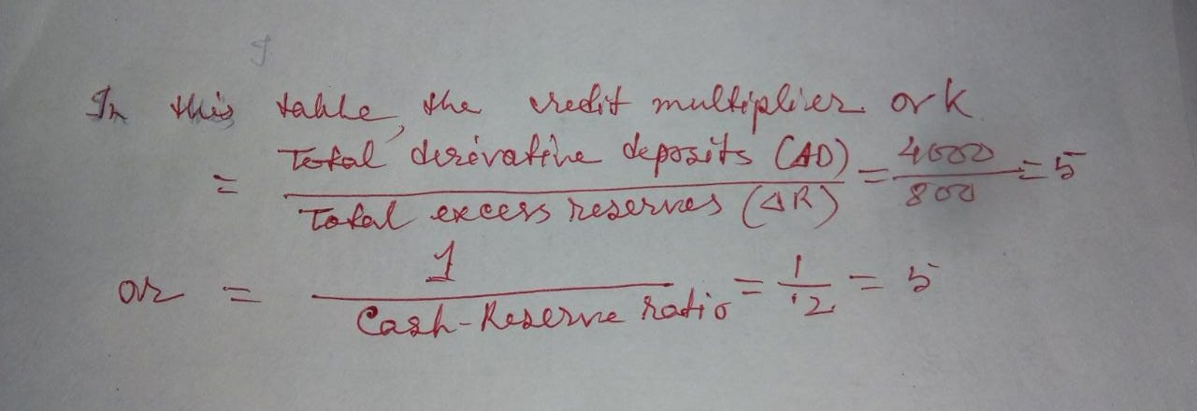

An initial primary deposits of Rs. 1000 in bank A increases Rs 5000( 1000 ×5) amount of credit in the banking system in this way.
LIMITATIONS of CREDIT CREATION:
1
Amount of cash-- The amount of credit creation primarily depends upon the amount of cash possessed by the banks.Larger the amount of cash with the banking system , greater will be the credit creation and vice versa.
2.Cash-Reserve Ratio---The higher the cash-reserve ratio, the smaller will be the volume of credit creation and vice versa.
3.Leakages--- The actual credit creation may be lower than potential credit creation due to certain leakages There are at least two such leakages in the credit creation process.
(i) Excess reserves--Due to certain reasons, the banks may not be willing to utilise their surplus funds in granting loans and may decide to maintain excess reserves.
(ii) Currency drains--The credit creation multiplier mechanism assumes that the amounts of loans granted by the banks return to them by way of new deposits. But the public may not keep the whole amounts of loans in the banks and may withdraw some amount to keep with them.This cash withdrawal reduces the power of the banks to create credit.
4.Availability of Borrowers----The amount of credit creation depends upon the availability of borrowers.If there is no borrower ,their will not be credit creation.
5.Availability of Securities---Bank loans are granted against securities.The bank does not create money out of thin air,it transmutes other forms of wealth into money..Thus, the power of the bank to turn other assets into money is restricted by the availability of good securities.

6.Credit policy of other banks----All banks may not adopt the same credit policy.Some banks decide not to utilise their full capacity for credit
creation and keep large cash reserves.The credit creation capacity in the economy will be limited to that extent.
7.Banking Habits---Development of banking system and banking habits of the people also influence the extent of credit creation.If people prefer to make transactions through cash and not by cheques, the banks will be left with a smaller cash.As a result ,there will be lesser credit creation.
8.Business Conditions---Credit creation is further limited by the nature of business conditions.During depression,due to low profit expectations businessmen do not come forward to borrow from banks.So, credit creation will be very small.On the contrary, during prosperity,due to high profit expectation ,businessmen approach the banks for loans.As a result, credit creation will be high.
9.Monetary policy--The extent of credit creation is highly influenced by the monetary policy adopted by the Central bank of the country
It can use various methods of credit control to influence the bank to expand and contract credit.

