Spherical Aberration
Spherical aberration that is caused by the spherical form of a lens or mirror and that gives different foci for central and marginal rays.
Spherical Aberration
For lenses made with spherical surfaces , rays which are parallel to the optic axis but at different distances from the optic axis fail to converge to the same point. For a single lens, spherical aberration can be minimized by bending the lens into its best form. For multiple lenses, spherical aberrations can be canceled by overcorrecting some elements. The use of symmetric doublets like the orthoscopic doublet greatly reduces spherical aberration.
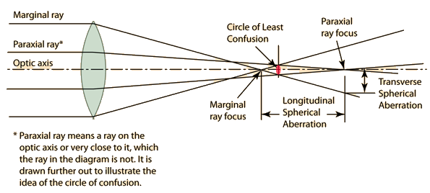
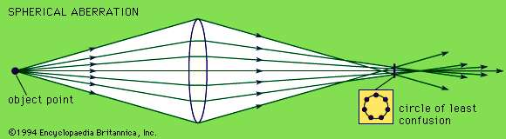
When the concept of principal focal length is used, the presumption is that all parallel rays focus at the same distance, which is of course true only if there are no aberrations. The use of the lens equation likewise presumes an ideal lens, and that equation is practically true only for the rays close to the optic axis, the so-called paraxial rays. For a lens with spherical aberration, the best approximation to use for the focal length is the distance at which the difference between the paraxial and marginal rays is the smallest. It is not perfect, but the departure from perfect focus forms what is called the "circle of least confusion". Spherical aberration is one of the reasons why a smaller aperture (larger f-number) on a camera lens will give a sharper image and greater depth of field since the difference between the paraxial and marginal rays is less. horizontal offset but not so well for other offsets.
Reducing Spherical Aberrations
Spherical aberrations can be reduced in different ways:
- The simplest method is to restrict the area of the incoming light with an optical aperture. That way, one can prevent that the outer regions, where spherical aberrations are most extreme, contribute to the image. However, that implies a reduced light throughput.
- One can use aspheric lenses, which have modified surface shapes such that spherical aberrations are avoided.
- One can use a combination of spherical lenses designed such that spherical aberrations are well compensated. This method is frequently used in photographic objectives, for example.
To some extent, one can also reduce spherical aberrations by choosing an appropriate type of lens, depending on the required configuration (see Figure 3):
- For imaging a small spot to a spot of equal size, the symmetric biconvex lens is well suited. However, it is even better to use two plano-convex lenses in combination, with the flat surfaces on the outer sides.
- For an asymmetric application, such as focusing a collimating beam or collimating a strongly divergent beam, a plano-convex lens can be more appropriate. The best solution would actually be an asymmetric lens with optimized curvature radii on both sides, but a plano-convex lens is often close enough. It must be oriented such that the curved surface is on the side of the collimated beam. Both lens surfaces then contribute to the focusing action.
Definition: Chromatic aberration. Chromatic aberration. Visible light is made of different colors. When visible light passes through a glass lens or a prism, it gets dispersed, or split, into its many colors. A lens focuses each color at a different point, causing a fringe of color to appear around bright objects.
Chromatic aberration is a phenomenon in which light rays passing through a lens focus at different points, depending on their wavelength. There are two types of chromatic aberration: axial chromatic aberration and lateral chromatic aberration.
Axial chromatic aberration is a variation in the length of each wavelength of light and lateral chromatic aberration is a variation in the magnification of the different colors of light; becoming more visible at the image periphery. Axial chromatic aberration results in blurred colors in front of and behind the focus position due to the differences in each color’s focal point. It can be noticeable at the peripheries of extremely bright portions of an image. Lateral Chromatic Aberration is the cause of color fringing. It is only seen at the edges of an image.
Lateral chromatic aberration is reduced to some degree by combining different lens elements with different refractive indexes, but optically speaking, it cannot be completely eliminated. In addition to red and its complimentary color cyan, and blue and its complimentary color yellow, some lenses may exhibit complex color fringing that combines these two primary types. It is greatly reduced by low-dispersion ED glass.
Chromatic aberration, colour distortion in an image viewed through a glass lens. Because the refractive index of glass varies with wavelength, every property of a lens that depends on its refractive index also varies with wavelength, including the focal length, the image distance, and the image magnification. The change of image distance with wavelength is known as chromatic aberration, and the variation of magnification with wavelength is known as chromatic difference of magnification, or lateral colour. Chromatic aberration can be eliminated by combining a strong lens of low-dispersion (crown) glass with a weaker lens made of high-dispersion (flint) glass. Such a combination is said to be achromatic. This method of removing chromatic aberration was discovered in 1729 by Chester Hall, an English inventor, and it was exploited vigorously in the late 18th century in numerous small telescopes. Chromatic variation of magnification can be eliminated by achromatizing all the components of a system or by making the system symmetrical about a central diaphragm. Both chromatic aberration and lateral colour are corrected in every high-grade optical system.
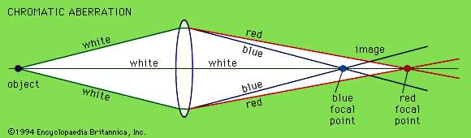
Chromatic aberration. Different wavelengths of light have different focal points.

Chromatic aberration was reduced by increasing the focal length of the lens where possible. It can be further minimized by using an achromatic lens or achromatic doublet, in which materials with differing dispersion are assembled together to form a compound lens.
Aberration, in optical systems, such as lenses and curved mirrors, the deviation of light rays through lenses, causing images of objects to be blurred. In an ideal system, every point on the object will focus to a point of zero size on the image. Practically, however, each image point occupies a volume of finite size and unsymmetrical shape, causing some blurring of the whole image. Unlike a plane mirror, which yields images free of aberrations, a lens is an imperfect image producer, becoming ideal only for rays passing through its centre parallel to the optical axis (a line through the centre, perpendicular to the lens surfaces). The equations developed for object-image relations in a lens having spherical surfaces are only approximate and deal only with paraxial rays—i.e., rays making only small angles with the optical axis. When light of only a single wavelength is present, there are five aberrations to be considered, called spherical aberration, coma, astigmatism, curvature of field, and distortion. A sixth aberration found in lenses (but not mirrors)—namely, chromatic aberration—results when light is not monochromatic (not of one wavelength).
In spherical aberration, rays of light from a point on the optical axis of a lens having spherical surfaces do not all meet at the same image point. Rays passing through the lens close to its centre are focused farther away than rays passing through a circular zone near its rim. For every cone of rays from an axial object point meeting the lens, there is a cone of rays that converges to form an image point, the cone being different in length according to the diameter of the circular zone. Wherever a plane at right angles to the optical axis is made to intersect a cone, the rays will form a circular cross section. The area of the cross section varies with distance along the optical axis, the smallest size known as the circle of least confusion. The image most free of spherical aberration is found at this distance.
Condition for minimum chromatic aberration of two lenses separated by a finite distance.
Consider two convex lenses of focal lengths $f_{1}$& $f_{2}$ are made from same material, are separated by a suitable distance d. The focal length of the combination is given by:

1/f = 1/$f_{1}$+1/$f_{2}$- d/${f_{1}f}_{2}$ –(1)
From Lens maker’s formula we $1/{f_{1}}$=${(n}_{1}-1)\left(1/{r_{1}}-1/{r_{2}}\right)$ – (2)
And $1/{f_{2}}$=${(n}_{2}-1)\left(1/{r_{1}^{'}}-1/{r_{2}^{'}}\right)$ – (3)
Where $n_{1}$ and$n_{2}$ are refractive indices of two lenses, also $r_{1}$,$r_{2}$,$r_{1}^{'}$ and $r_{2}^{'}$ are radii of curvature of the lenses.
For simplicity let $k_{1}=\left(1/{r_{1}}-1/{r_{2}}\right)$ and $k_{2}=$ $\left(1/{r_{1}^{'}}-1/{r_{2}^{'}}\right)$ then from equation(2) and (3) we have-
$k_{1}$=$1/{f_{1}{(n}_{1}-1)}$ and $k_{2}$=$1/{f_{2}{(n}_{2}-1)}$ .${dn_{1}}/{\left(n_{1}-1\right)}$

We know dispersive power ($ω)$ of lens and prism can be expressed as - $ω={\left(n_{v}-n_{r}\right)}/{\left(n-1\right)}$ or ${dn}/{\left(n-1\right)}$ , where $n_{v}$,$n_{r}$,n are refractive indices of violet, red and mean colour and $dn$=$\left(n_{v}-n_{r}\right)$.
Differentiating equation (2) and (3) we get $-{df_{1}}/{f_{1}^{2}}=k_{1}dn_{1}$ =${ω_{1}}/{f_{1}}$---(4)
$-{df_{2}}/{f_{2}^{2}}=k_{2}dn_{2}$=${ω_{2}}/{f_{2}}$---(5)
Dispersive power of two lenses will be $ω_{1}={dn_{1}}/{\left(n_{1}-1\right)}$ and $ω_{2}={dn_{2}}/{\left(n_{2}-1\right)}$
the value of d for which combination is free from chromatic aberration is calculated by differentiate equation(1) $-{df}/{f^{2}}$ = $-{df_{1}}/{f_{1}^{2}}-{df_{2}}/{f_{2}^{2}}-d\left[{df_{1}}/{f_{1}^{2}f_{2}}+{df_{2}}/{f_{2}^{2}f_{1}}\right]$
{ Since df=0 for Achromatism} so LHS will be zero(0)
$-{df_{1}}/{f_{1}^{2}}-{df_{2}}/{f_{2}^{2}}-d\left[{df_{1}}/{f_{1}^{2}f_{2}}+{df_{2}}/{f_{2}^{2}f_{1}}\right]$=0 ----(6)
Substituting equation (4) and (5) in equation (6) we have
${ω_{1}}/{f_{1}}+{ω_{2}}/{f_{2}}$=d$\left[{ω_{1}}/{f_{1}f_{2}}+{ω_{2}}/{f_{1}f_{2}}\right]$

Or d =${\left(ω_{1}f_{2}+ω_{2}f_{1}\right)}/{\left(ω_{1}+ω_{2}\right)}$
In case when lenses are of same material, $ω_{1}$= $ω_{2}$ = ω
Then d = ${\left(f_{1}+f_{2}\right)}/2$
Thus two lenses of same nature can be free from chromatic aberration if they are placed at a separation
d = ($f_{1}$+$f_{2}$)/2

