Fermat's principle: application to reflection and refraction at plane boundaries
Fermat’s principle states that when a light ray moves from one fixed point to another fixed point, through any number of reflections or refractions, the total optical path followed by the light ray should be stationary; it will either be minimum or maximum.
For reflection and refraction at plane surfaces, the total optical path followed by the light ray should be a minimum, while for reflection and refraction at curved surfaces, the total optical path followed by the light ray should be a maximum. It is also described as the ‘principle of least time’.
The optical path(L) is defined as the actual path followed by the light ray in vacuum or in air medium; so it is the product of the path length in the medium (l) with the refractive index of the medium ($μ)$.
L=$μ$l
Law of Reflection from Fermat’s Principle
A light ray incident upon a reflective surface will be reflected at an angle equal to the incident angle. Both angles are typically measured with respect to the normal to the surface. This law of reflection can be derived from Fermat's principle.
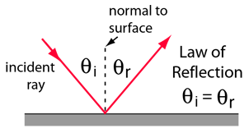
The law of reflection gives the familiar reflected image in a plane mirror where the image distance behind the mirror is the same as the object distance in front of the mirror.
Fermat's Principle: Reflection
Fermat's Principle: Light follows the path of least time. Of course the straight line from A to B is the shortest time, but suppose it has a single reflection. The law of reflection can be derived from this principle as follows:
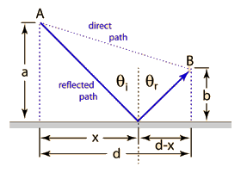
The pathlength from A to B is
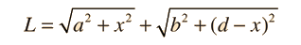
Since the speed is constant, the minimum time path is simply the minimum distance path. This may be found by setting the derivative of L with respect to x equal to zero.
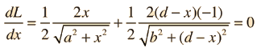
This reduces to
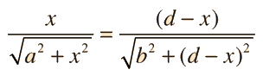
which is
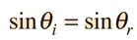
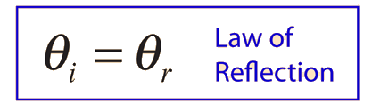
This derivation makes use of the calculus of maximum-minimum determination, the derivative of a square root, and the definitions of the triangle trig functions.
Fermat's Principle and Refraction
Fermat's Principle: Light follows the path of least time. Snell's Law can be derived from this by setting the derivative of the time =0. We make use of the index of refraction, defined as n=c/v.
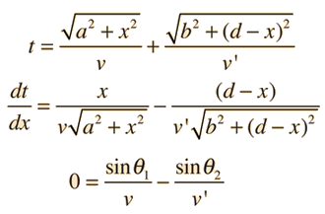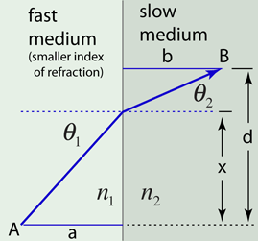
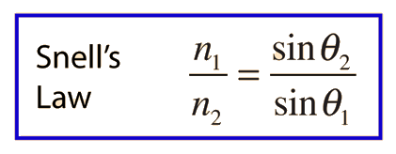
This derivation makes use of the calculus of maximum-minimum determination and the definitions of the triangle trig functions.

