Biot Savart Law
The Biot Savart Law is used to determine the magnetic field intensity H near a current-carrying conductor or we can say, it gives the relation between magnetic field intensity generated by its source current element. The law was stated in the year 1820 by Jean Baptisle Biot and Felix Savart. The direction of the magnetic field follows the right hand rule for the straight wire. Biot Savart law is also known as Laplace’s law or Ampere’s law.
Consider a wire carrying an electric current I and also consider an infinitely small length of a wire dl at a distance x from point A.
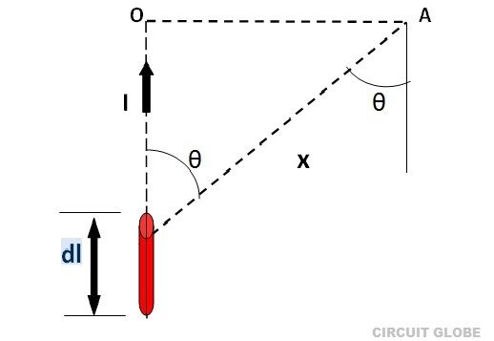
Biot Savart Law states that
The magnetic intensity dH at a point A due to current I flowing through a small element dl is
- Directly proportional to current (I)
- Directly proportional to the length of the element (dl)
- Directly proportional to the sine of angle θ between the direction of current and the line joining the element dl from point A.
- Inversely proportional to the square of the distance (x) of point A from the element dl.

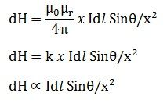

where k is constant and depends on the magnetic properties of the medium.
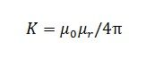
µ₀ = absolute permeability of air or vacuum and its value is 4 x 10⁻⁷ Wb/A-m
µ_{r}= relative permeability of the medium.

Biot Savart Law
We know that electric current or moving charges are source of magnetic field
A Small current carrying conductor of length dl (length element ) carrying current I is a elementary source of magnetic field .The force on another similar conductor can be expressed conveniently in terms of magnetic field dB due to the first
The dependence of magnetic field dB on current I ,on size and orientation of the length element dl and on distance r was first guessed by Biot and savart
The magnitude of the magnetic field dB at a distance r from a current element dl carrying current I is found to be proportional to I ,to the length dl and inversely proportional to the square of the distance |r|
The direction of the magnetic Field is perpendicular to the line element dl as well as radius r
Mathematically, Field dB is written as
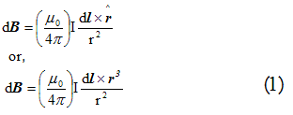
Here (μ₀/4π) is the proportionality constant such that
μ₀/4π=10⁻⁷ Tesla Meter/Ampere(Tm/A)
Figure below illustrates the relation between magnetic field and current element if in figure,
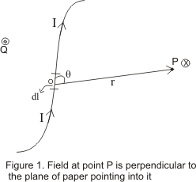
Consider that line element dl and radius vector r connecting line element mid point to the field point P at which field is to be found are in the plane of the paper
From equation (1) ,we expect magnetic field to be perpendicular to both dl and r.Thus direction of dB is the direction of advance of right hand screw whose axis is perpendicular to the plane formed by dl and r and which is rotated from dl to r ( right hand screw rule of vector product)
Thus in figure ,dB at point P is perpendicular directed downwards represented by the symbol (x) and point Q field is directed in upward direction represented by the symbol (•)
The magnitude of magnetic field is
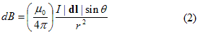
where θ is the angle between the line element dl and radius vector r
The resultant field at point P due to whole conductor can be found by integrating equation (1) over the length of the conductor i.e.
B=∫dB
Relation between permeability (μ₀ and permittivity (ε₀) of the free space
We know that
μ₀/4π=10⁻⁷ N/A² ----(a)
and 1/4πε₀=9*10⁹ N-m²/C² ----(b)
Dividing equation (a) by (b) we get
μ₀ε₀ =1/(9*10¹⁶) (C/Am)²
we know that 1C=1A-s
So μ₀ε₀ =1/(3*10⁸ m/s)²
And 3*10⁸ m/s is the speed of the light in free space So μ₀ε₀ =1/c² or c=1/√(μ₀ε₀)

Applications of Biot Savart law
Biot Savart law has much application. In this section we will now apply Biot-Savart law as studied in previous section to calculate field B in some important cases.

(i) Magnetic Field due to steady current in an infinitely long straight wire
Consider a straight infinitely long wire carrying a steady current I
We want to calculate magnetic field at a point P at a distance R from the wire as shown below in figure
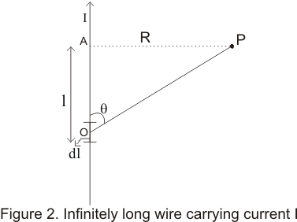
From Biot,-Savart law ,magnetic field dB due to small current element of the wire at point O at a distance |r|=r from point P is
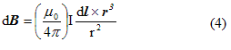
since current element Idl and vector r makes an angle θ with each other ,the magnitude of the product dlXr is dlrsinθ and is directed perpendicular to both dl and r vector as shown in the figure
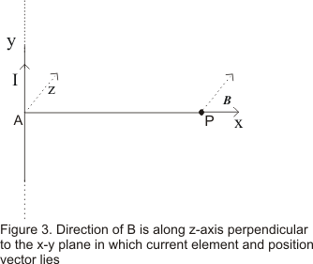
Since from our choice of co-ordinate, we found out that field B lies along z-axis therefore we can write
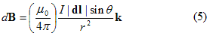
where k is the unit vector along z-axis
we will now express sinθ and r in terms of R which is fixed distance for any point in space and l which describes the position of current element on the infinitely long wire .From figure 1 we have
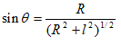
and r=(R² +l²)^{1/2}
Putting these values in the equation (5) we find
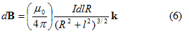
To find the field due to entire straight wire carrying wire ,we would have to integrate equation (6) B=∫dB
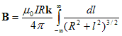
To evaluate the integral on the RHS substitute
l=RtanΦ and dl=Rsec²Φ dΦ
Therefore
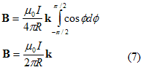
From equation (7) ,we noticed that
i) Magnetic field is proportional to the current I
ii) It is inversely proportional to the distance R
iii)Magnetic field is in the direction perpendicular to the straight wire and vector AP=R
The magnetic line of force near a linear current carrying wire is concentric circles around the conductor in a plane perpendicular to the wire
Hence the direction of field Bat point P at a distance R from wire, will be along the tangent drawn on a circle of radius R around the conductor as shown below in figure
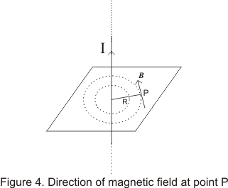
Direction of B
Direction of B can be found by right hand thumb rule i.e. grasp the wire with right hand ,the thumb pointing in direction of current ,the finger will curl around the wire in the direction of B
The magnetic field lines are circular closed curve around the wire

(ii) Force between two long and parallel current carrying

(ii) Force between two long and parallel current carrying conductor
It is experimentally established fact that two current carrying conductors attract each other when the current is in same direction and repel each other when the current are in opposite direction
Figure below shows two long parallel wires separated by distance d and carrying currents I₁ and I₂
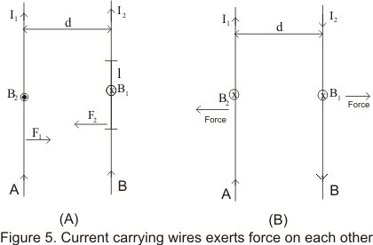
Consider fig 5(a) wire A will produce a field B₁ at all near by points .The magnitude of B₁ due to current I₁ at a distance d i.e. on wire b is
B₁=μ₀I₁/2πd ----(8)
According to the right hand rule the direction of B₁ is in downward as shown in figure (5a)
Consider length l of wire B and the force experienced by it will be (I₂lXB) whose magnitude is
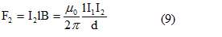
Direction of F₂ can be determined using vector rule .F₂ Lies in the plane of the wires and points to the left
From figure (5) we see that direction of force is towards A if I₂ is in same direction as I₁ fig( 5a) and is away from A if I₂ is flowing opposite to I₁ (fig 5b)
Force per unit length of wire B is
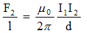
Similarly force per unit length of A due to current in B is
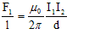
and is directed opposite to the force on B due to A. Thus the force on either conductor is proportional to the product of the current
We can now make a conclusion that the conductors attract each other if the currents are in the same direction and repel each other if currents are in opposite direction

(iii) Magnetic Field along axis of a circular current carrying coil
Let there be a circular coil of radius R and carrying current I. Let P be any point on the axis of a coil at a distance x from the center and which we have to find the field
To calculate the field consider a current element Idl at the top of the coil pointing perpendicular towards the reader
Current element Idl and r is the vector joining current element and point P as shown below in the figure
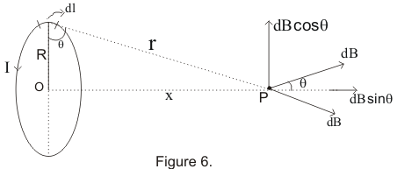
From Biot Savart law, the magnitude of the magnetic field due to this current element at P is
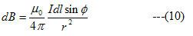
where Φ is the angle between the length element dl and r
Since Idl and r are perpendicular to each other so Φ=90.Therefore
Resolving dB into two components we have dBsinθ along the axis of the loop and another one is dBcosθ at right angles to the x-axis
Since coil is symmetrical about x-axis the contribution dB due to the element on opposite side ( along -y axis ) will be equal in magnitude but opposite in direction and cancel out. Thus we only have dBsinθ component
The resultant B for the complete loop is given by,
B=∫dB
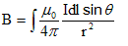
Now from figure 6
sinθ=R/r =R/√(R² + x²) So
eq
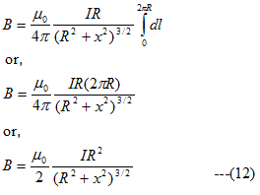
If the coil has N number of turns then
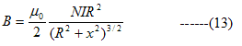
Direction of B
Direction of magnetic field at a point on the axis of circular coil is along the axis and its orientation can be obtained by using right hand thumb rule .If the fingers are curled along the current, the stretched thumb will point towards the magnetic field
Magnetic field will be out of the page for anti-clockwise current and into the page for clockwise direction
Field at center of the coil
At the center of the coil x=0
so
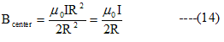
Field at point far away from the center x>>>R
In this case R in the denominator can be neglected hence
For coil having N number of turns
If the area of the coil is πR² then
m=NIA represents the magnetic moment of the current coil. Thus from equation (17) we have

(iv) Magnetic Field at the center of a current carrying arc
- Consider an arc of radius R carrying current I as shown below in the figure
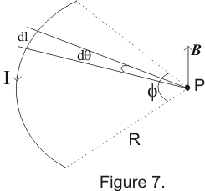
According to the Biot Savart law the magnetic field at any point P is given by
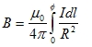
Here dl=RdΦ
So
If l is the length of the arc then
l=RΦ so that
Equation 19 and 20 gives us magnetic field only at the center of curvature of a circular arc of current
For semi-circular loop put Φ=π in equation 19 and for full circle Φ=2π in equation 19 and calculate to find the result
If the circular current loop lies on the plane of the paper then magnetic field will be out of the page for anticlockwise current and into the page for clockwise current as shown below in the figure
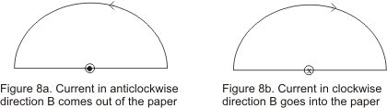

Ampere's circuital law
Ampere's circuital law in magnetism is analogous to gauss's law in electrostatics
This law is also used to calculate the magnetic field due to any given current distribution
This law states that
" The line integral of resultant magnetic field along a closed plane curve is equal to μ₀ time the total current crossing the area bounded by the closed curve provided the electric field inside the loop remains constant"
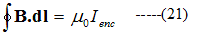

Thus where μ₀ is the permeability of free space and I_{enc} is the net current enclosed by the loop as shown below in the figure
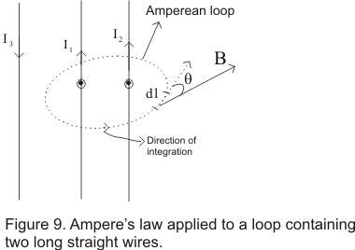
The circular sign in equation (21) means that scalar product B.dl is to be integrated around the closed loop known as Amperian loop whose beginning and end point are same
Anticlockwise direction of integration as chosen in figure 9 is an arbitrary one we can also use clockwise direction of integration for our calculation depending on our convenience
To apply the ampere's law we divide the loop into infinitesimal segments dl and for each segment, we then calculate the scalar product of B and dl
B in general varies from point to point so we must use B at each location of dl
Amperian Loop is usually an imaginary loop or curve, which is constructed to permit the application of ampere's law to a specific situation

Proof Of Ampere's Law
Consider a long straight conductor carrying current I perpendicular to the page in upward direction as shown below in the figure
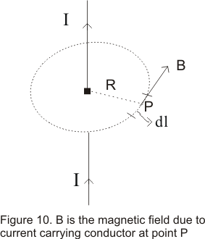
From Biot Savart law, the magnetic field at any point P which is at a distance R from the conductor is given by
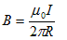
Direction of magnetic Field at point P is along the tangent to the circle of radius R withTh conductor at the center of the circle
For every point on the circle magnetic field has same magnitude as given by
And field is tangent to the circle at each point
The line integral of B around the circle is
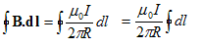
since ∫dl=2πR ie, circumference of the circle so,
This is the same result as stated by Ampere law
This ampere's law is true for any assembly of currents and for any closed curve though we have proved the result using a circular Amperian loop
If the wire lies outside the Amperian loop, the line integral of the field of that wire will be zero
but does not necessarily mean that B=0 everywhere along the path ,but only that no current is linked by the path
while choosing the path for integration ,we must keep in mind that point at which field is to be determined must lie on the path and the path must have enough symmetry so that the integral can be evaluated

Magnetic field of a solenoid
A solenoid is a long wire wound in a close-packed helix carrying a current I and the length of the solenoid is much greater than its diameter
Figure below shows a section of a stretched out solenoid in xy and yz plane
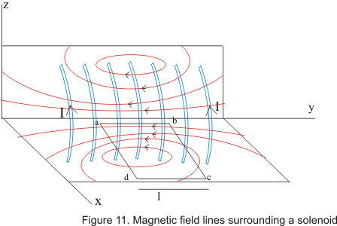
The solenoid magnetic field is the vector sum of the field produced by the individual turns that make up the solenoid
Magnetic field B is nearly uniform and parallel to the axis of the solenoid at interior points near its center and external field near the center is very small
Consider a dashed closed path abcd as shown in figure .Let l be the length of side ab of the loop which is parallel to the is of the solenoid
Let us also consider that sides bc and da of the loop are very-very long so that side cd is very much far away from the solenoid and magnetic field at this side is negligibly small and for simplicity we consider its equal to 0
At side a magnetic field B is approximately parallel and constant. So for this side
∫B.dl=Bl
Magnetic field B is perpendicular to sides bc and da ,hence these portions of the loop does not make any contributions to the line integral as B.dl=0 for the side bc and da
Side cd lies at external points solenoid where B.dl=0 as B=0 or negligibly small outside the solenoid
Hence sum around the entire closed path reduces to Bl
If N are number of turns per unit length in a solenoid then number of turns in length l is nl.The total current through the rectangle abcd is NIl and from ampere 's law
Bl=μ₀NlI
or B=μ₀NI (22)
we have obtained this relation for infinitely long solenoids considering the field at external points of the solenoid equal to zero.
However for real solenoids external field is relatively weak rather then equal to zero
Thus for actual solenoids relation 22 holds for internal points near the center of the solenoid
Field at internal points of the solenoid does not depend on length and diameter of the solenoid and is uniform over the cross-section of a solenoid

