Classical Theory of Employment----
The Classical evonomists believe that full employment of labour and other resources is a normal condition in an economy.If there is not fullemployment,there is a tendency towards full employment. Less than fullemployment is an abnormal situation which will disappear in the long run.The condition of fullemployment is consistent with a certain amount voluntary unemployment and frictional unemployment.Some people may not want to be employed at the existing wage rate.Frictional unemployment is a temporary phenomenon which arises due to the imperfections in the labour market such as, immobility of labour, seasonal nature of work,shortage of raw materials, ignorance of job opportunities,breakdown of machinery etc.
ASSUMPTIONS OF THEORY--
(i) Individuals are rational human beings and are motivated by self-interest.
(ii)Perfect competition exist both in the product market and factor market.
(iii) Individuals do not suffer from money illusion
(iv) Laissez-faire condition prevails.
(v) There is closed economy which has no international trade relations.
(vi) Technique of production and business organisations do not change..
(vii) Money is only a medium of exchange.
The Classical Theory of employment is based on the assumption of flexibility of wages,interest and prices.This means that wage rate, interest rate and price level changes in their respective market s according to the forces of demand and supply. Changes in these variables automatically adjust the evonomic system in such a way do as to ensure fullemployment.
According to the classical Theory of employment,other things
remaining constant, wage flexibility assures that, in a competitive market fullemployment is provided and fullemployment output is produced. Real wage rate is determined by the forces of demand and supply in the labour market.Demand for Labour is a negative function of real wa ge rate and supply of labour is a positive function of real wage rate.Real wage rate is determined at the level where demand for Labour and supply of labour are equal.This level also reprrsents fullemployment equilibrium level.If there is some unemployment ,the unemployed will competr for jobs and the real wage rate will fall. A fall in the real wage rate will lead to an increase in the demand for Labour and decrease in the supply of labour. This will remove unemploymentThus flexibility in wage rate ensured fullemployment.
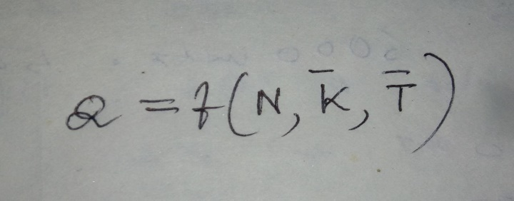
Where Q denotes level of output,N is the level of employment ,K bar and T bar(write in symbol both) represent fixed stock of capital and technology respectively.Thus, with a fixed stock of capital and given Technology, output (Q) will increase only when employment of labour (N) increases.So, employment (N) and output (Q) rise or fall together.
The Classical idea of determination of income and output is shown with the help of the following figures.
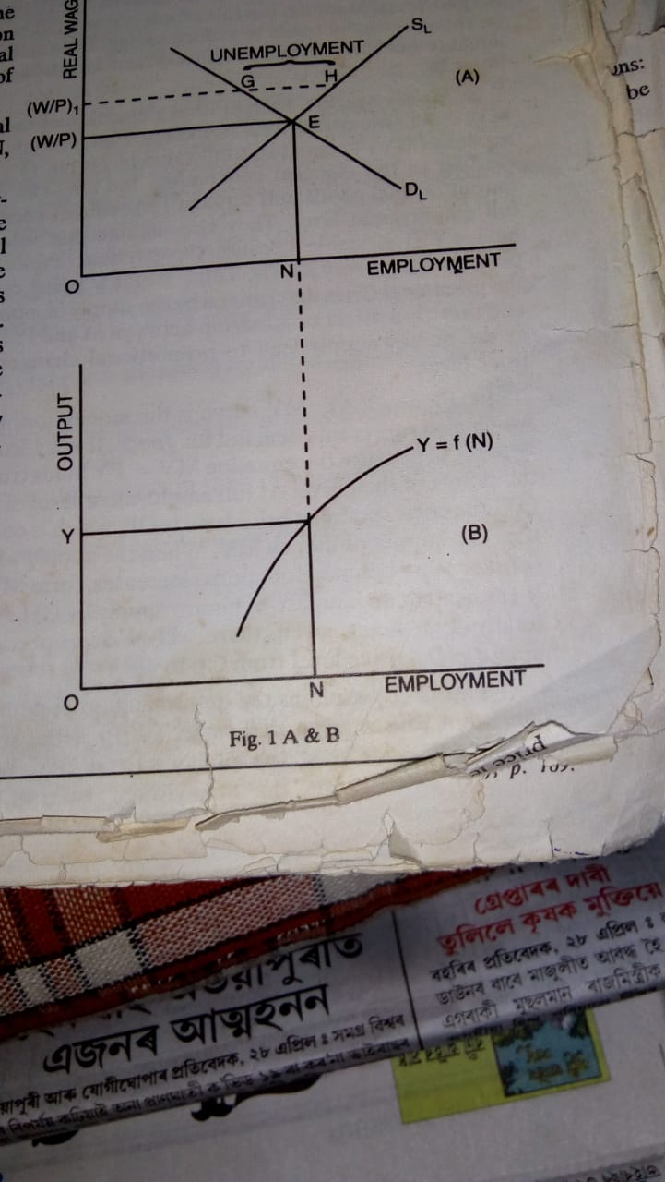
In figure (A) DL is the aggregate demand for Labour curve and SL is the aggregate supply of labour curve. Intersection of these two curves at point E determines the Equillibrium wage rate (w/p),at fullemployment level ON. If real wage rate is maintained at higher level (W/P)1, supply of labour will exceed demand for Labour by GH.This indicates the amount of unrmployment.Labour market being competitive, unemployment of labour will reduce wage rate to the oroginal Equillibrium level(W/P).This will remove unemployment and once again establishes Fullemployment level ON.
In figure (B),Q=f(N, K bar,T bar) curve represents total production function. At the fullemployment level,ON, the corresponding fullemployment output is OQ.
Criticisms of Classical theory of employment
...................................
The Classical theory of employment has been severely criticised .These are hiven below.

.....
1. Underemployment equilibrium---Keynes foremost attack was on Classical fullemployment assumption.Attacking their assumption, keynes stated that not fullemployment,but underemployment is a normal condition in the real capitalist world.
2.Repudiation of Say's law---+According to Say's law, an increase in iemployment increases income, the whole of whichis automatically spent on consumer goods or on investment goods.According to keynes, a part of increased income is spent on consumer goods and the other is saved.So,there arise a deficiency of demand and as a result supply doesn't create it's own demand

3.Rejection of Pigou's view--pigou asserts that if their arise unemployment,it can be reducef by cutting the wage rate.Wage cut policy leads to deficiency in demand which ultimately reduces investment and income.Moreover , in modern welfare society,there are various legislations regarding minimum wage rate , factory act , unemployment insurance etc.Further,at present trade union is so strong that it is not easy to adopt wage cut policy to generate employment.
4.No automatic adjustment---Keynes rejected the Classical
belief that evonomic system is self-adjusting in character.
5.Government intervention-----Keynes states that the economy does not reach fullemployment equilibrium automatically.Laissez-faire policy is not a reliable policy.Active Govt. intervention is needed in order to achieve Fullemployment.
6.Role of money--- keynes critised the role of money as a medium of exchange as assumed by the classical theory.Keynes states that when there is unemployment of resources,an increase in the quantity of money increases output and employment.
7.Long run analysis---
The Classical evonomists in their analysis states that their may be temporary imbalances in the economy,but all these imbalances disappear in the long run.According to Keynes ,actual problems are short run problems and they must ne given greater portance.
8.Static Analysis---The Classical theory gives a static picture of the economy by assuming fullemployment.
9.Not a general theory---
The Classical theory deals with the special case of fullemployment only.According to keynes,there may be underemployment, fullemployment or overfullemployment .

10. Assumption of perfect competition----
The theory is based on unrealistic assumption of perfect competition.
Though the Classical Theory is perfectly logical in it's content, butit has little practical relevance.
KEYNESIAN THEORY OF EMPLOYMENT or INCOME or EFFECTIVE DEMAND:
Keynes was the first to drvelop a systematic theory of employment or income in his book" The General Theory of Employment,Interest and Money(1936). According to Keynes, less than full employment or unemployment is the usual condition in an economy.That level of effective demand, which is necessary for the achievement of fullemployment doesn't exist in an economy. i.e.effective demand is the main determinant of the level of employment .Due to deficiency in effective demand, less than fullemployment or unemployment becomes the usual phenomena in any economy.
Effective demand is that type of demand which represents equillibrium level of aggregate spending in the economy.Only that level of demand is effective where aggregate demand and supply are fully matched and entrepreneurs have no inclination either to expand or to contract product and employment.Effrctive demand is determined by aggregate demand function and aggregate supply function.
Aggregate demand function represents different amounts of money which the entrepreneurs expect to get from the sale pf output at varying levels of employment.In other words, aggregate demand function reveals planned or intended expenditure at different levels of income.
Aggregate supply function represents different amount of money which the entrepreneurs must get from the sale of output at varying levels of employment with the corresponding minimum amount of sale proceeds of output resulting from those volumes of employment.In other words, aggregate supply function represents different levels of income which the entrepreneurs supply at different levels of expenditure.

The following schedule shows the determination of effective demand or level of employment by the ADF and ASF.
In the above schedule, effective demand is determined when both ADF and ASF are equal i.e.when ADF is 34 crores and ASF is 34 crores.At this equality point equilibrium level of employment is 4 lakhs of workers. The entrepreneur will go on employing additional numbers of workers till expected receipt (ADF) is higher than the cost ( ASF) incurred.When both are equal, he ceases to employ additional no of workers .It will bring hom loss if he does so, because his receipt will be lower than cost of employment.
Determination of effective demand or Equillibrium level of employment can be shown with the help of the following diagram.
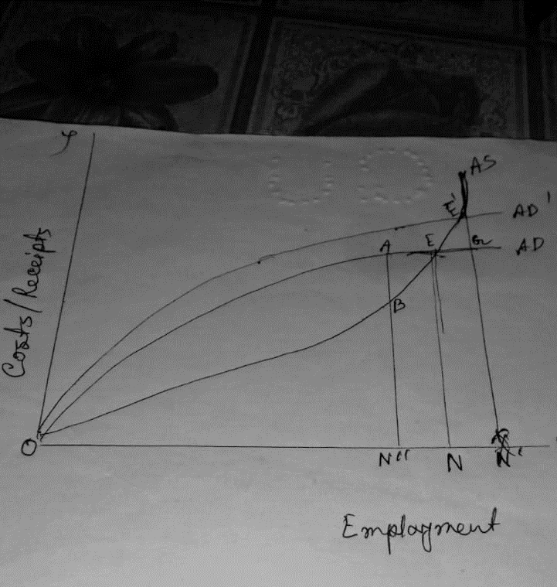
In this diagram, aggregate demand curve intersect the aggregate supply curve at point E.,which reprrsents the point of effective demand.The equilibrium level of employment is ON, at which receipts and costs are equal to EN.At ON employment level, entrepreneurs maximise their expected profits.Any other level of employment will reduce the profits and the econy will not be in equilibrium.At ON" level of employment the expected receipts are greater than the expected costs.This will induce entrepreneurs to employ more workers.On the other hand,at ON'. level of employment ,the expected receipt is lower than expected costs.It will bring to the entrepreneurs E'G amount of loss if they increase employment to ON'.
According to the diagram, total labour supply available in the economy is ON". But,number of labourers employed is ON'.NN' numbers of labourers remain unemployed due to deficiency of E'G amount of effective demand.If effective demand would have been
determined at E' point,this portion of labour would get employment. But, effective demand hre is determined at the point which is below the level of fullemployment.
Hence, according to keynes,unemployment or under fullemployment exist in any evonomy die to the lack of effective demand.

