Chapter 5
VISION IN ARTHROPODA

Vision is about how individuals see. More specifically, it covers any scientific field that investigates how individuals use light to gain information about their environments. The ultimate source of light on earth is the sun, and both plants and animals evolved physical and biochemical mechanisms to capture light and make responses to its presence or absence. In animals light influences sexual reproductive cycles, biological and seasonal rhythms, colour changes in the skin, hormone secretion, and various chemical reactions (for example, synthesis of vitamin D in the skin of humans). Even the simplest plant and animal forms have pigments that enable them to respond to light.
Visual receptors, at least in terms of anatomy and structure, evolved independently in different groups of animals. However, all use the same chromophore, 11-cis-retinal or a very similar compound, and the transmembrane protein, opsin. Opsin and the chromophore combine to form rhodopsin, the visual pigment in invertebrate and vertebrate photoreceptors. Opsin is species specific, as determined by its amino acid composition. The visual pigment molecules are embedded in a specialised organelle of the photoreceptors that is constructed from an intricately folded part of the cell membrane. Vision starts when a visual pigment molecule absorbs a photon. The absorbed light energy excites the molecule, which then goes through a series of photochemical steps and ultimately causes phototransduction, that is, triggers the chain of molecular processes that results in a neural signal.
Among the arthropods, crustaceans have the most diversity in eye structure. Some crustaceans have very simple eyes, but many have compound eyes very similar in structure and physiology to those in insects. Isopods, and some crabs, have apposition eyes (the eye restricts dispersal of light from one ommatidium to another due to a pigmented ommatidium wall) similar to the apposition compound eye in diurnal insects. Superposition eyes (the eye permits passage of light from one ommatidium to another through the unpigmented wall) occur in shrimp, crayfish, and lobster.

Visual Organs in Arthropoda
Arthropods possess three basic kinds of photoreceptors:
- Dorsal Ocelli (Simple Ocelli)
- Stemmata (Complex Lensed Ocelli)
- Compound Eyes

Dorsal Ocelli (Simple Ocelli)
Of the receptors responding to light in the visual spectrum, dorsal ocelli, or simple eyes, are the least complex of the visual structures. Dorsal ocelli are mostly found on the dorsal or front surface of the head. They often appear clustered in a triangular pattern on the head between the compound eyes in the winged adults of most orders and in the larvae of hemimetabola, but they may also occur singly. Typically, there are three ocelli forming an inverted triangle antero-dorsally on the head, although in Diptera and Hymenoptera they occupy a more dorsal position on the vertex. They are often absent in wingless forms. They are bounded by compound eyes on lateral sides. Dorsal ocelli are not present in those arthropods which lack compound eyes.
A typical ocellus consists of a convex transparent corneal lens with an aggregation of hundreds of light-sensitive retinula cells below (Figure 5.1). A region of each of the retinula cells known as the rhabdom contains the visual pigment rhodopsin that absorbs light and initiates the receptor potentials. A layer of cells underneath that contain urate crystals or closely packed tracheae may function as a reflecting tapetum. The axons from these retinula cells synapse with a small number of interneurons so that fewer axons enter the brain than the number of receptor cells present, effectively limiting its resolution even further. In flies, the three ocelli are connected to the protocerebrum by a single ocellar nerve. In locusts, 600 to 800 retinula cells synapse with only six interneurons. The ocelli thus appear to be poorly designed for image perception and may be able only to scan the horizon for light intensity to provide general information for navigation during flight. They serve as rotation detectors in conjunction with the compound eyes to maintain the insect’s rotation in space. Sensitive to ultraviolet light, they appear to be horizon detectors that interact with the processing of stimuli from the compound eyes to facilitate locomotion. Pigment cells sometimes invest the whole ocellus, but in some species, e.g., cockroaches, they are lacking.
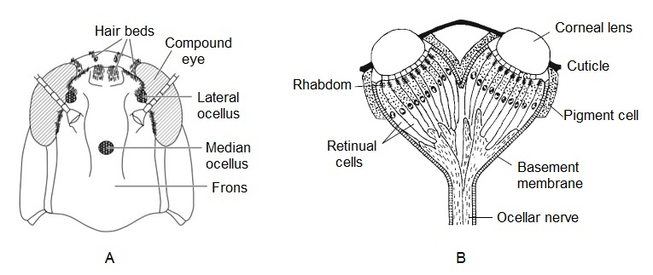

Fig 5.1. Ocelli. (A) Frontal view of head of grasshopper showing positions of ocelli (B) The generalized structure of a pair of ocelli. (From Toh and Tateda 1991).

Stemmata (Complex Lensed Ocelli)
Stemmata also called as lateral ocelli are the only the visual organs of larval holometabolous insects where they generally fail to persist through metamorphosis to the adult, and certain adults such as spring tails, silver fish, fleas and stylops. These are called lateral eyes because they are always present in the lateral region of the head. The number of lateral ocelli varies from one to six on each side of the head. Despite the name, their structures are more similar to the compound eyes than to the dorsal ocelli, but they fail to meet the image quality that is possible with compound eyes. The number of receptors associated with stemmata is usually too low to allow the formation of anything but a coarse mosaic of the environment. The larval holometabolous insects that bear these stemmata generally crawl and have no need for a visual system with the higher performance of the compound eyes in adults, where flight and mate identification require better image processing.
Typically, a stemma bears a cuticular corneal lens above a crystalline cone, and these serve as the optical elements (Figure 5.2). As in the dorsal ocelli, a portion of the plasma membrane of the retinular cells is specialized as a rhabdomere to contain a large number of microvilli that contain the visual pigment. The increase in surface area that the rhabdomere provides allows those neurons to pack abundant visual pigments into each cell. These may contain multiple photopigment systems, suggesting that colour discrimination is possible. Two or more rhodopsin’s that are tuned to different regions of the visual spectrum can allow the insect to discriminate visual stimuli on the basis of their wavelengths. The stemmata may also be sensitive to polarized light.
Depending on the species, there may be from as few as three to more than 5000 retinular cells below that are grouped around a central rhabdom consisting of the rhabdomeres of the retinular cell, and several of these rhabdoms may be present within a single stemma. The light from the lenses focuses on one or more of the rhabdoms. Stemmata may be present in insects, either in groups or singly, and provide a coarse mosaic of the environment but with far better resolution
than the dorsal ocelli. The largest stemmata, with exceptional resolution, are those of the tiger beetle larvae, with six units on each side of the head and more than 6000 retinal receptors. Larvae of the swallowtail butterfly have six stemmata on each side of the head, each with seven retinular cells that contribute to a single fused rhabdomere. The retinular cells within a stemma have sensitivities to green, blue, or ultraviolet light.
Larval stemmata are not necessarily eliminated during metamorphosis but can migrate to the posterior surface of the optic lobe of the developing adult. In adult Drosophila, they are present at the posterior margin of the compound eye known as Hofbauer-Buchner eyelets, and their homologs may be present in several other insects. The eyelets consist of pigmented organs with numerous microvilli that are arranged as rhabdomeres and contain optical pigments and clock proteins. These extraretinal photoreceptors innervate a portion of the brain thought to house the circadian pacemaker and are suspected to play a role in circadian perception in the adult and the entrainment of locomotor behaviour.
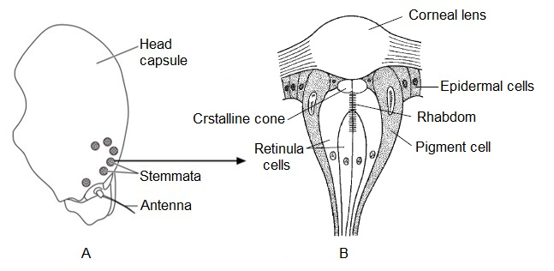

Fig 5.2. Stemmata (A) Side of the head showing the positions of the stemmata (B) A lateral ocellus, or stemma. (From Gullan and Cranston 2000).

Genital photoreceptors. Genital photoreceptors have been identified in many adult butterflies, developing during the pupal stage. These receptors provide little in the way of resolution and are thought to be involved in oviposition behaviour, informing the female that the ovipositor is extended far enough to successfully lay eggs. They also play a role in copulation in the male, providing information that the vagina of the female is aligned properly for penile insertion. Two pairs of genital receptors, P1 and P2 (Figure 5.3), mediate these behaviours in both sexes. Their structures resemble that of a phaosome, a primitive photoreceptor first identified from the epidermis of earthworms. The presence of photoreceptor pigments within the genital photoreceptors has yet to be confirmed.
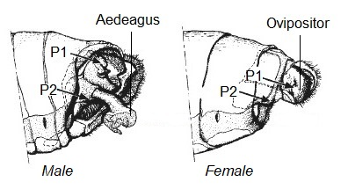

Fig 5.3. The genital photoreceptors in male and female Lepidoptera. (From Arikawa, 2001)

Compound Eyes
Compound eyes, the primary visual receptors, though found in all arthropod subphyla, have been lost or modified in various groups throughout the phylum. The compound eyes provide a panoramic view of the world with a large field of vision. As their name indicates, compound eyes comprise from a few to many distinct photoreceptive units, called ommatidia (Figure 5.4). Each ommatidium is supplied with its own nerve tracts leading to the major optic nerve, and each has its own field of vision through square or hexagonal cuticular facets on the eye surface. ln general, compound eyes with many small facets probably produce higher resolution images than eyes with fewer and larger facets. The function of an ommatidium is to concentrate light from a reasonably narrow direction into a receptor area, and an individual ommatidium cannot "focus" in the sense of image formation. Image formation is the result of multiple signals from multiple ommatidia.
Compound eyes are present in most adult pterygote insects and the larvae of hemimetabolous insects, but are strongly reduced or absent in wingless parasitic groups, such as the Phthiraptera and Siphonaptera, and in female coccids (Hemiptera). Each compound eye may be composed of several thousand ommatidia. There are up to 30,000 in the eyes of dragonﬂies, 10,000 in drone honey bees, 5,500 in worker honey bees and 800 in Drosophila. At the other extreme, workers of the ant Ponera punctatissima have only a single ommatidium on each side of the head. Collembolans have eight widely spaced ommatidia, while Protura and Diplura have no compound eyes. Usually compound eyes are separate on the two sides of the head, but in some insects, such as Anisoptera (Odonata) and male Tabanidae and Syrphidae (Diptera), the eyes are contiguous along the dorsal midline, this being known as the holoptic condition.
The ommatidia of some insects may be of different sizes in different areas of the compound eyes. For example, the aquatic beetle, Gyrinus, has a dorsal pair of eyes that looks above the water and a ventral pair of eyes that looks below into the water. Not all the facets that face the environment may respond similarly; different ommatidia in the compound eyes of honeybees process visual information differently, with shape detection and pattern and color discrimination processed best in the ventral part of the frontal visual field. Each lens forms a small image of the field of view, and the central nervous system patches these views together.

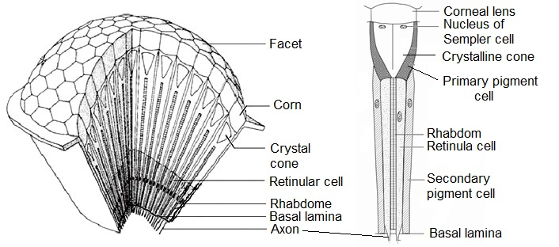

Fig 5.4. (A) Compound Eye (cutaway view) (B) Ommatidium

Structure of an Ommatidium. Each ommatidium consists of the following parts
1. Cornea. The outer surface of each ommatidium is convex and is covered by the transparent cuticle. It forms the cornea and functions as a biconvex lens. The special epidermal cells that produce the corneal elements are called corneagen cells. The external surface of cornea is generally hexagonal but sometimes square in shape and is called a corneal facet. Large number of facets gives an interesting appearance to the compound eyes, which often looks like a graph paper. Cornea, being cuticular in nature, sheds during each moult. Each corneal lens is produced by two epidermal cells, the corneagen cells, which later become withdrawn to the sides of the ommatidium and form the primary pigment cells.
2. Crystalline Cone. Beneath the cornea there are four cells called the Semper cells, which, in many insects, produce a second lens, the crystalline cone which is long, cylindrical or tapering and transparent. It is surrounded by 4-6 elongated cone cells, called vitrellae, with long and tapering ends. Crystalline cone functions as the second lens as mentioned above and helps to focus light upon the photoreceptors present in the ommatidium. The region of each ommatidium, from cornea till the end of cone cells, is termed as dioptrical region.
3. Photoreceptor Unit. Basal end of cone cells of the ommatidium lie upon a translucent cylinder, called rhabdome. Rhabdome receives light and functions as a single photoreceptor unit forming an image. Rhabdome is surrounded by 7-8 light-sensitive photoreceptor cells called retinular cells. These are arranged in a radial pattern like the sections of an orange. Each retinula cell rests upon a basement membrane called basal lamina and extends into an axon. The bundle of 7-8 axons leaving each ommatidium is further connected to the neurons of optic ganglion which is connected to the brain through optic nerve. Rhabdome and retinular cells collectively form the receptor region of the eye.
4. Pigment Cells. Each ommatidium is separated from its neighbouring ommatidia by certain pigment cells. The primary pigment, iris, is present in the proximal region of the ommatidium surrounding the tapering ends of the cone cells. The secondary pigment, retinal pigment, surrounds the rhabdome and retinal cells in the distal region of the ommatidium. These pigments are movable and can migrate centrally or distally depending upon the light intensity.

Image Formation
Compound eyes form image with the help of inputs received from ommatidia. Each ommatidium forms a separate image of a small part of the object. Thus, the image formed consists of several pieces and is crude. This type of vision is called mosaic vision. Compound eyes of arthropods can form two kinds of image depending on the intensity of light namely apposition image and superposition image (Figure 5.5).
1. Apposition Image: The compound eyes form apposition image in the bright light. The apposition eye design is most common in insects that are active during the day and probably represents the ancestral condition. The ommatidia are optically isolated from each other by the sheath of screening pigment that surrounds them.
- In bright light, both proximal and distal pigments extend and act as a screen to prevent light rays from passing from one ommatidium to another. The light rays remain restricted to the axial region of the crystalline cone and rhabdomes.
- As a result, only those rays which fall perpendicularly on the cornea and pass through rhabdome form the point of an image. The rays which fall obliquely on the cornea are absorbed by the pigment and do not produce any visual effect.
- Thus, each ommatidium responds to a patch of light from the visual field and overlaps little with the neighbouring ommatidia forming a point of an image.
- The final image is formed by combining all these points formed by the stimulated ommatidia.
- This is, therefore, mosaic vision as it results from small pieces put together.
Apposition eyes are the most common form of eye, and are presumably the ancestral form of compound eye. They are found in all arthropod groups.
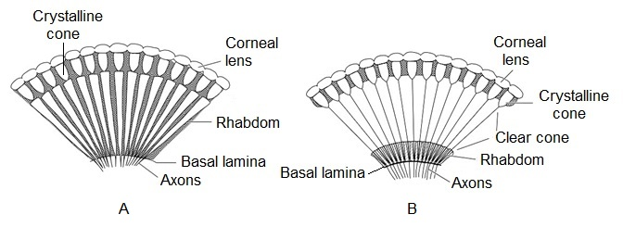

Figure 5.5. (A) Apposition eye. (Diagrammatic section through an apposition eye showing the rhabdoms extending to the crystalline cones) (B) Superposition eye (Diagrammatic section through a superposition eye showing the clear zone between the rhabdoms and the lens systems)

2. Superposition Image: The superposition image is formed in the dim light.
- In weak light, both proximal and distal pigments retract. The ommatidia do not remain optically isolated and the light rays can pass from one ommatidium to another.
- As a result, the oblique rays as well those which fall perpendicularly on the cornea and pass through rhabdome form the point of an image.
- Thus, each ommatidium responds to the light rays which had entered through different corneal facets.
- The final image is continuous formed by overlapping of the adjacent points of images.

Apposition Eye Versus Superposition Eye
The compound eyes of many arthropods are able to adapt both bright and weak light, such as in prawn. These species thus can see in daylight as well as in night. However, in several arthropods, the eyes are adapted and fixed for working under only one condition. Therefore, compound eyes can be classified as apposition eye and superposition eye. The rhabdom of apposition eyes usually extends the full length of the photoreceptor cells between the crystalline cone and the basal lamina. It is usually shorter in superposition eyes, there is a clear zone between the rhabdoms and the lens systems.

Table x. Difference between Apposition Eye and Superposition Eye
Features | Apposition Eye | Superposition Eye
Light intensity | Stimulated by strong light intensity | Stimulated by low intensity of light
Screening pigment | Well developed | Present but may be reduced or absent in some
Length of crystalline cone | Approximately equal to the focal length | Twice as long as the focal length
Rhabdome | Longer, usually extends the full length of the photoreceptor cells between the crystalline cone and the basal lamina | Usually shorter, clear zone exist between the rhabdoms and the lens systems
Retinular cells | Long extending till the basal membrane of retina | Shorter restricted to the base of ommatidium
Light rays | Enter through single ommatidium through axial region | Enter through several ommatidia through all regions
Examples | Diurnal species, such as butterfly | Nocturnal species, such as cockroaches, moths

Advantages and Disadvantages of Compound Eyes
Compound eyes have many advantages and disadvantages over human eyes.
Advantages
- The compound eyes have a convex corneal surface which results in a wide visual field. In crustaceans, eyes can cover an arc of 180° or even more.
- Compound eyes can detect even movements very easily. A slight movement in the point of light results in the corresponding shift in the ommatidia.
- Eyes of many diurnal arthropods possess high flicker fusion frequency because of which they perceive an object as a succession of separate images, instead of a single image. This helps them to detect motion readily.
Disadvantages
- The image formed by the compound eyes is very crude. An insect could see a row of closely spaced bar as a continuous horizontal bar.
- The compound eyes do not provide good visual effect in distance vision.
- Compound eyes possess poor resolving power because of the small-sized numerous lenses. Therefore, they cannot pick up details of an object as human eyes can do. For example, when a human eye can make out full details of a human hand, a compound eye can only make out an outline of the hand.

Perception of Polarized Light
Although the light originating from the sun is unpolarized and vibrates in all directions, the particles it encounters as it travels through the earth’s atmosphere cause it to become polarized and vibrate in a specific direction. The degree of polarization changes with regard to the position of the sun and the orientation of the observer, making it possible to determine the sun’s position even when clouds obscure it, as long as a portion of the sky is visible. Many insects can make use of this phenomenon for navigation by detecting polarized light. This ability is present in many social Hymenoptera such as bees, ants, and wasps that must orient to find food and return to their nests.
The ability to perceive polarized light lies largely within the orientation of the visual pigment within the rhabdomere. Some of the elongated rhabdomeres contain uniformly oriented rhodopsin within their microvilli, and the absorption of light is maximal when the light is polarized in the same direction as the pigment is oriented. If the receptors are moved as the insect rotates about its vertical axis, the output of the receptors is modulated as the microvilli become parallel to the light. Other receptors held at different angles record different responses to the rotation within the field of polarization. By scanning the sky, the insect can record the degree of polarization from the pattern registered in its receptors and can then later orient by matching the pattern in the sky with its recorded pattern in memory. Water can polarize reflected light, and aquatic insects can use their polarized light detection to identify the water surface.
In bees and ants that show polarization sensitivity, there is also a group of specialized ommatidia at the dorsal margins of the compound eyes believed to be involved in the detection of polarized light. The rhabdoms within this dorsal rim area are shorter with a larger cross-sectional area, and their microvilli, containing oriented pigments, are also oriented 90° to each other. Many other insects bear these dorsal rim area ommatidia but have not yet been studied for the ability to detect polarized light.

Infrared Receptors
Infrared irradiation can be detected by paired thoracic pit organs in the species of buprestid beetles that breed only in trees that have been recently killed by fire. The beetles respond to the infrared emitted from forest fires in the wavelength range of 2 to 4 μm using dome-shaped sensilla located in paired pits near the mesothoracic coxa that are exposed during flight. Each pit organ contains 50 to 100 sensilla with lens like cuticular structures that change in volume with exposure to infrared radiation and deform the dendrite of the underlying mechanoreceptor. These sensilla are activated specifically by the infrared wavelengths from burning forests, and other sensilla on the antennae respond to olfactory cues from phenolic compounds present in the smoke from these recent fires.

PRACTICE QUESTIONS
Multiple Choice
1. Hofbauer-Buchner eyelets of adult Drosophila contain
a) Optical pigments b) Clock proteins
c) None of the above d) Both a and b

2. Genital photoreceptors have been identified in adult
a) Ants b) Butterflies
c) Crickets d) Wasps

3. An ommatidium is the functional unit of the
a) Protocerebrum b) Compound eye
c) Subesophageal ganglion d) Male reproductive system

4. Which of the following is the least complex visual structure
a) Dorsal ocelli b) Stemmata
c) Compound eye d) Genital photoreceptor

5. Retinula cells are characteristic of
a) Dorsal ocelli b) Stemmata
c) Compound eye d) None of the above

6. A corneal lens, crystalline cone and rhabdomere are the components of
a) Dorsal ocelli b) Stemmata
c) Compound eye d) None of the above

7. What type of vision is found in cockroach?
a) Mosaic b) Super position
c) Binocular d) None of the above

8. Apposition image in eye of insects is formed in
a) Dim light b) Bright Light
c) Ocelli d) None

9. Superposition eye is characteristic of
a) Diurnal species b) Nocturnal species
c) Both a and b d) None of the above

10. A clear zone between the rhabdoms and the lens systems is found in
a) Apposition eye b) Superposition eye
c) Both a and b d) None of the above

Very short answer type
- What is meant by mosaic vision?
- What is the shape of cuticular facets on the surface of compound eye?
- Under what condition are compound eyes called hooptic?
- What is the region of ommatidium, from cornea till the end of cone cells called?
- What are Semper cells?
- How does the rhabdome of an apposition eye differ from that of a superimposition eye?
- Why are compound eyes so named?
- Dorsal ocelli are found in the larvae of _________ insects.
- Name the visual pigment of arthropods.
- Vision starts when a visual pigment molecule absorbs a _______.

Write short notes on
- Genital photoreceptors
- Complex lensed ocelli
- Dorsal Ocelli
- Infrared Receptors
- Superposition Eye

Long answer type
- Describe the structure of compound eye of Arthropoda. What are its advantages and disadvantages?
- How does image formation in compound eye take place? Distinguish between apposition and superimposition eye.
- Give a general account of vision in Arthropoda.

Answers to Multiple Choice Questions
1. (d) 2. (b) 3. (b) 4. (a) 5. (a)
6. (b) 7. (a) 8. (b) 9. (c) 10. (b)

