. Seven divisions of India Tourism
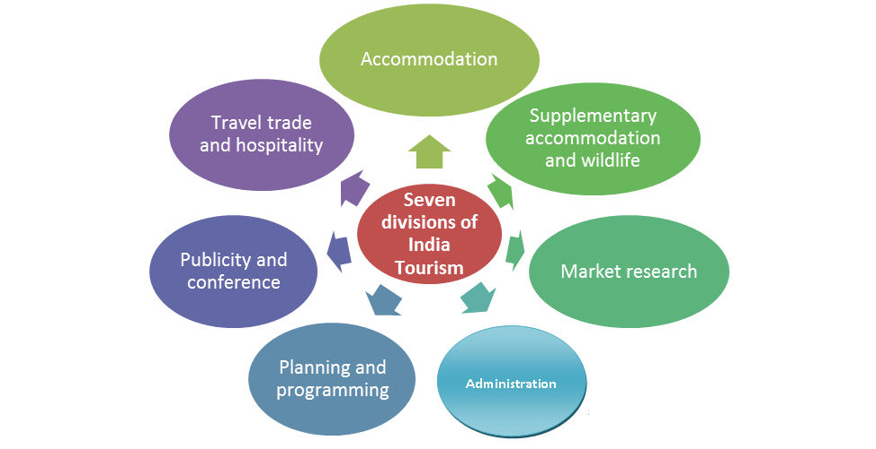

Functions of India tourism offices:
- Collection, compilation and dissemination of tourist information in India and abroad, and attending to enquiries of international tourists, tour operators and members of the travel industry such as airlines, steamship companies and hotels.
- Cooperation with international travel and tourist organizations at government and non-government levels.
- Development of tourist facilities of interest to international tourists.
- Publicity at home and abroad with the object of creating an overall awareness of the importance of tourism.
- Simplification of frontier formalities in respect of international tourists.
- Regulation of activities of the various segments of the travel trade such as hotels, youth hostels, travel agents, wildlife, guides etc. catering to tourist needs.
There are some specific functions of overseas offices of India Tourism along with above:
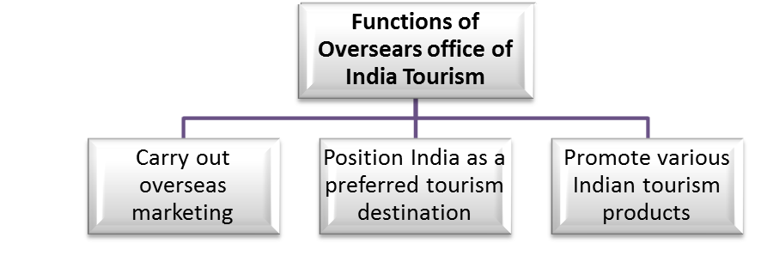
As a promotional activity following are the various types of publicity material produced by India tourism
- The ‘Incredible India’ theme brochures
- Destination leaflets
- Heritage destination leaflets
- Northeast brochures
- Maps
- Films
- CDs
- Many research scholars have complained to India tourism that Ajanta and Ellora caves, though full of beauty and potential, do not attract enough tourists every year. Foreign tourists visiting India do not give preference to Ajanta and Ellora caves though they visit Maharashtra. What additional steps would you suggest to increase number of tourist and enhance tourist satisfaction at Ajanta & Ellora caves? India Tourism is the nodal organization working for promotion of tourism in India and overseas.
- The offices working towards this goal are in India and worldwide at major tourist originating cities.
- As the organization representing the central government, India Tourism performs various functions for promoting tourism in India and promoting India as a tourist destination in overseas market.

