Leadership

What is Leadership
Leadership is a process by which an executive can direct, guide and influence the behavior and work of others towards accomplishment of specific goals in a given situation. Leadership is the ability of a manager to induce the subordinates to work with confidence and zeal.
Leadership is the potential to influence behaviour of others. It is also defined as the capacity to influence a group towards the realization of a goal. Leaders are required to develop future visions, and to motivate the organizational members to want to achieve the visions.
According to Keith Davis, “Leadership is the ability to persuade others to seek defined objectives enthusiastically. It is the human factor which binds a group together and motivates it towards goals.”

Characteristics of Leadership
- It is a inter-personal process in which a manager is into influencing and guiding workers towards attainment of goals.
- It denotes a few qualities to be present in a person which includes intelligence, maturity and personality.
- It is a group process. It involves two or more people interacting with each other.
- A leader is involved in shaping and moulding the behaviour of the group towards accomplishment of organizational goals.
- Leadership is situation bound. There is no best style of leadership. It all depends upon tackling with the situations.

Importance of Leadership
Leadership is an important function of management which helps to maximize efficiency and to achieve organizational goals. The following points justify the importance of leadership in a concern.
- Initiates action- Leader is a person who starts the work by communicating the policies and plans to the subordinates from where the work actually starts.
- Motivation- A leader proves to be playing an incentive role in the concern’s working. He motivates the employees with economic and non-economic rewards and thereby gets the work from the subordinates.
- Providing guidance- A leader has to not only supervise but also play a guiding role for the subordinates. Guidance here means instructing the subordinates the way they have to perform their work effectively and efficiently.
- Creating confidence- Confidence is an important factor which can be achieved through expressing the work efforts to the subordinates, explaining them clearly their role and giving them guidelines to achieve the goals effectively. It is also important to hear the employees with regards to their complaints and problems.
- Building morale- Morale denotes willing co-operation of the employees towards their work and getting them into confidence and winning their trust. A leader can be a morale booster by achieving full co-operation so that they perform with best of their abilities as they work to achieve goals.
- Builds work environment- Management is getting things done from people. An efficient work environment helps in sound and stable growth. Therefore, human relations should be kept into mind by a leader. He should have personal contacts with employees and should listen to their problems and solve them. He should treat employees on humanitarian terms.
- Co-ordination- Co-ordination can be achieved through reconciling personal interests with organizational goals. This synchronization can be achieved through proper and effective co-ordination which should be primary motive of a leader.
Following are the main roles of a leader in an organization :
- Required at all levels- Leadership is a function which is important at all levels of management. In the top level, it is important for getting co-operation in formulation of plans and policies. In the middle and lower level, it is required for interpretation and execution of plans and programmes framed by the top management. Leadership can be exercised through guidance and counseling of the subordinates at the time of execution of plans.
- Representative of the organization- A leader, i.e., a manager is said to be the representative of the enterprise. He has to represent the concern at seminars, conferences, general meetings, etc. His role is to communicate the rationale of the enterprise to outside public. He is also representative of the own department which he leads.
- Integrates and reconciles the personal goals with organizational goals- A leader through leadership traits helps in reconciling/ integrating the personal goals of the employees with the organizational goals. He is trying to co-ordinate the efforts of people towards a common purpose and thereby achieves objectives. This can be done only if he can influence and get willing co-operation and urge to accomplish the objectives.
- He solicits support- A leader is a manager and besides that he is a person who entertains and invites support and co-operation of subordinates. This he can do by his personality, intelligence, maturity and experience which can provide him positive result. In this regard, a leader has to invite suggestions and if possible implement them into plans and programmes of enterprise. This way, he can solicit full support of employees which results in willingness to work and thereby effectiveness in running of a concern.
Leadership Qualities That Make Good Leaders
- Honesty and integrity.
- Confidence.
- Inspire Others.
- Commitment and Passion.
- Good Communicator.
- Decision Making Capabilities.
- Accountability.
- Delegation and Empowerment.

Leader Vs Manager
A leader is someone whom people follow or someone who guides or directs others. A manager is someone who is responsible for directing and controlling the work and staff in an organization, or of a department within it.
The main difference between the two is that a leader works by example, while a manager dictates expectations. If a manager goes against the rules, that will tarnish his position as a manager. If a leader goes against the example he or she is trying to set, that will be seen as a setback. Following are a few subtle differences between the two −
- A leader is an innovator and creator whereas a manager is a commander.
- A leader can’t be a manager but the opposite is possible, a manager is more than a leader.
- A leader does what is right, while the manager makes things right.
- A leader deals with change whereas a manager plans for a change.
- A leader gives direction to do something whereas the manager plans for everything that is to be done.
- A leader encourages people whereas the manager controls people.
- A leader handles communication, credibility, and empowerment whereas a manager deals with organizing and staffing.
Contingency Theory: Contingency theories of leadership state that effective leadership comprises of all the three factors, i.e. traits, behaviour and situation. A leader’s behaviour varies as per the situation. To support this theory of leadership various models were developed, and multiple studies were conducted in this direction.
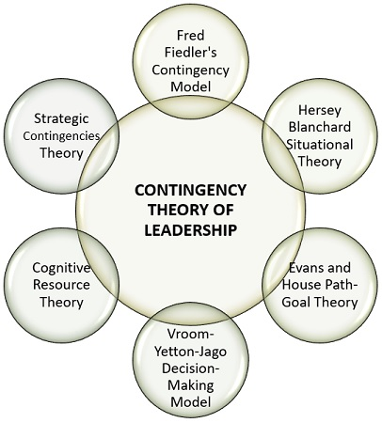
Following are the models of contingency theory:
- Fred Fiedler’s Contingency Model: Dr Fred E. Fiedler tried to explain that the performance of a group or team is banked on the pleasant and unpleasant situations and style of leadership.
Leadership style can be assessed with the help of Least Preferred Co-worker (LPC) scale. It is a technique in which a leader is asked to think of a person whom they least like to work with and score them on different bipolar scales.
For instance: Friendly-unfriendly, Efficient-inefficient, Cooperative-uncooperative, etc

