Write at least one difference between ordinary photograph and Holograph. Draw the diagram to explain how recording and reconstruction of holography is done. What do you understand by reference beam and object beam? State why coherent beam is necessary for recording of holograph? 2 +2+2+1=7
Solution:- Ordinary photograph gives the measure of light intensity from different parts of the object photographed. It carries information about the mean square value of the amplitude of the original light wave from the object. It loses information about the phase of the wave arriving at the film from different points of the object.
In holograph both amplitude and phase of light wave are recorded on the film.

The technique of holography consists of two operations (i) optical analysis (recording or making a hologram of the object) (ii) optical synthesis (reconstructing the image of the original object.
In order to perform the recording operation to make a hologram, highly coherent Laser beam is split up into two parts by a half-silvered mirror (i) reflected towards the object (ii) transmitted through the mirror straight to the photography plate. The object diffracts the beam incident on it and this diffracted then travels towards the plate. Thus the photography plate is illuminated by the ‘object beam’ diffracted or scattered by the object and the direct beam, called the reference beam. In the making of a hologram, the reference beam is modulated by interference with the object beam at photo-plate. The numerous points making up the image on plate are formed due to interference between the coherent object beam and reference beam.
The reconstruction of the image from hologram is done by illuminating it by same Laser light used for recording. The wave diffracted through the hologram carries the phase and amplitude of the waves originally diffracted by the object when the hologram was made. The object wave-fronts have thus been reconstructed. One of the diffracted beam form real image, while another forms a 3D virtual image. Thus a hologram may be regarded as three-dimensional view on a two-dimensional photography plate. The remarkable feature of a hologram is that even if it is cut into small pieces each, piece will reproduce the whole image.
(for image see book of Text book on Optics/ light by Ghatak or K G Majumder)
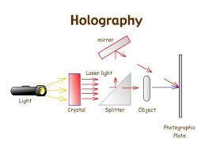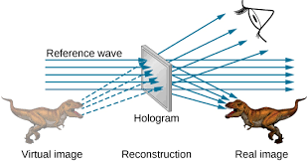
Recording (making of hologram) Reconstruction (viewing of 3D image)
The beam of Laser scattered or diffracted from object used at the time of recording of hologram is called object beam. While the direct Laser light from the same source which pass through the semi-silvered mirror and falls on the photography plate to superimpose with object beam is called reference beam.
The holography is a matter of interference which occurs between the object beam and the reference beam. In absence of coherent beam no interference will occur. Therefore coherent source of light such as Laser is must for making hologram.

