Pigouvian formulation of Say's law of market:

Two matters are given importance in Pigouvian formulation of Say's law of market.They are---A. Labour demand function B.Money wage rate.
According to Pigou ,in a perfectly competitive market,there is such a relationship between demand and wage rate that each and every labourer gets employment.He shows it with the help of the following equation—
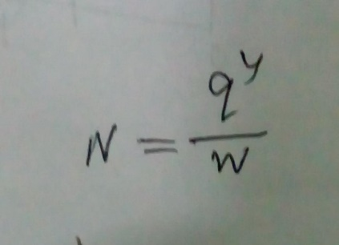
Here
N=Numbers of employed labourers.
q= Proportion of national income paid in terms of wage
Y= National income
W=Wage rate
It is clear from the above equation that employment can be generated by decreasing the wage rate if q and y remain constant.
In perfect competition,wage rate changes in such a manner that no of employed workers becomes equal to the no of workers that are available in full employment condition.According to Pogou, Government interference in the free functioning of the economy and rigidity in the wage rate leads to unemployment.If all the Government interference are removed and the market forces are allowed to perform their
activity automatically,then change in wage rate leads to full employment.
Pigovian version is represented with the help
of the following diagram
