RESPIRATION IN ARTHROPODA
Chapter 6

The primary goals of the arthropods respiratory system are to deliver oxygen from the air to the tissues and to transport carbon dioxide from the tissues to air. The structures and physiological mechanisms of respiration in arthropods vary dramatically with phylogeny, developmental stage, and habitat. The design of arthropod gas exchange structures has taken one form in aquatic groups and quite another in terrestrial taxa. The former is best exemplified by the crustaceans and the latter by the insects and terrestrial chelicerates. Some very tiny crustaceans (e.g., copepods) exchange gases cutaneously across the general body surface or at thin cuticular areas such as articulating membranes. However, most of the larger crustaceans have evolved various types of gills in the form of thin-walled, hemolymph-filled cuticular evaginations commonly called book gill. The gills of some crustaceans are exposed, unprotected, to the surrounding medium, whereas in others the gills are carried beneath protective extensions of the exoskeleton. The most successful terrestrial arthropods, the insects and arachnids have evolved gas exchange structures in the form of invaginations of the cuticle, rather than the evaginations seen in aquatic crustaceans. Many arachnids possess invaginations called book lungs, while the hexapods possess inwardly directed branching tubules called tracheae, which open externally through pores called spiracles.
Aquatic insects in particular evolved from terrestrial ancestors, and various adaptations have been necessary for them to return to the water. The oxygen content of water is considerably lower than in air because of the physical characteristics of gases in water. Therefore, to obtain a comparable degree of oxygen in the water, an aquatic insect must ventilate its gas exchange surface at a much higher rate than that of an air-breathing animal. However, the spiracles of terrestrial insects are too small to function in water, and their cuticles are impermeable to gas exchange. Obviously, to enable some insects to reexploit aquatic niches, it was necessary for them to evolve certain adaptations that allowed them to breathe in water. Many crustaceans, but few chelicerates and tracheates, use respiratory pigments to assist oxygen transport. The most common respiratory pigment in arthropods is copper-based hemocyanin; this is used by many crustaceans and a few centipedes. A few crustaceans and insects use iron-based haemoglobin, the respiratory pigment used by vertebrates. As with other invertebrates, the respiratory pigments of those arthropods that have them are generally dissolved in the blood and rarely enclosed in corpuscles as they are in vertebrates.

Book Gills – Organs of Respiration in Aquatic Arthropods
Book gills are characteristic respiratory organs of aquatic arthropods, especially crustaceans; though these can also be observed in some arachnids, such as Limulus (Fig 6.1). These are present at different places of the body, based on which they can be of various kinds:
- Podobranchs: These are also called foot gills as they are attached to the coxa of an appendage.
- Arthrobranchs: These gills are attached to the arthrodial membrane which joins the leg to the body of a crustacean. These are also called joint gills.
- Pleurobranchs: The side gills attached to the pleural membrane of the body segment bearing the limb are termed as pleurobranchs.
Structure of a Book Gill: The book gills are often flap-like or crescentic in shape. They are called so because they resemble a book. Each gill is made up of a number of thin structures, called gill lamellae or gill plates. These are arranged like the leaves/pages of a book at right angle to the gill base which is also called gill axis. The nerves and blood vessels enter and leave the gills through the gill axis. The gill lamellae of a book gill are of diverse shapes. Based on their structure, the book gills in arthropods are of three types:
- Phyllobranch: The gill lamellae are leaf-like, for example in Palaemon.
- Trichobranch: These gills have hair-like lamellae, e.g. in Astacus.
- Dendrobranch: These are the gills with lamellae divided into arborescent bundles.
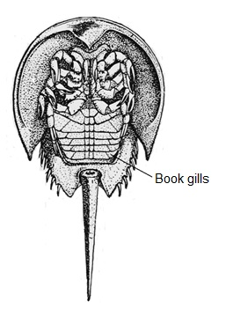

Fig 6.1. Book gill in Limulus (Horse shoe crab)

Mechanism of Respiration through Book Gills: Book gills, like fish gills are bathed in water and supplied with blood vessels. The exchange of respiratory gases takes place between water and blood flowing through the gill lamellae.
- The deoxygenated blood is carried to the gill lamellae with the help of afferent branchial vessel.
- During the flow of blood, gaseous exchange takes place with water which enters the gill chamber in the form of a current.
- The thin membranes of the gill lamellae act as an excellent surface for diffusion of respiratory gases.
- Consequently, oxygen from the flowing water diffuses into the blood while carbon dioxide from the deoxygenated blood diffuses in the water.
- The blood gets oxygenated which is carried by the efferent branchial vessel to the heart and then to all body parts.
- The carbon dioxide-rich water flows out of the gill chamber.

Book Lungs – Organs of Respiration in Terrestrial Arthropods
Book lungs are blind in-pocketing’s with highly folded inner linings across which gases diffuse between the hemolymph and the air (Fig 6.2). Book lungs are the characteristic respiratory organs of terrestrial arthropods; arachnids. These are always in pairs and considered to be evolved from book gills as an adaptation of terrestrial mode of life. Book lungs are often located in the abdominal segments of the arachnids; for example, in scorpion, there are four pairs of book lungs located in 3-6th abdominal segments.
Structure of a Book Lung. A book lung is consisting of two parts a dorsal chamber and a ventral chamber
1. Dorsal Chamber. It is also called pulmonary chamber and is formed by the invagination of ventral abdominal wall. It consists of approximately 150 leaf-like lamellae, each of which is lined with the cuticle. The lamellae lie parallel to each other like the leaves of a book. The thin space between two lamellae is filled with the air.
2. Ventral Chamber. The ventral chamber, also called atrial chamber is the non-folded part of the book lung and is filled with the air. On one side, it is continuous with the interlamellar spaces of pulmonary chamber and on the other side it opens to the outside through a slit-like opening, called stigma or spiracles.
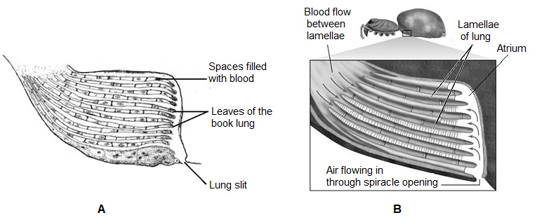

Fig 6.2. Book lung structure (A) and its cross section showing gaseous exchange (B)

Mechanism of Respiration through Book Lungs. The movement of air in the book lungs is controlled by certain muscles attached to them. These include; atrial muscles and dorso-ventral muscles.
- The contraction of the muscles results in the compression of book lungs. As a result, the air is forced out from the interlamellar spaces to the atrial chamber from where it is released outside through stigma.
- On the contrary, the book lungs regain their shape by the relaxation of the muscles and the air enters the atrial chamber through stigma reaching interlamellar spaces.
- The lamellae contain deoxygenated blood which is collected from the body of arachnids and drained through ventral sinus.
- The gaseous exchange takes place between blood and the air present in the interlamellar spaces through the thin membranous walls of lamellae.
- The blood gets oxygenated while carbon dioxide is released into the air.
- The oxygenated blood is collected into a pulmonary vein which carries blood to the pericardium from where it circulates into whole body.

Tracheal System – Primary Respiratory organs of Insects
Gaseous exchange in a great majority of insects occurs through a system of air-ﬁlled internal tubes, the tracheal system, an air-ﬁlled cuticle-lined invagination, the ﬁner branches of which extend to all parts of the body. Oxygen is carried by the trachea in the gas phase directly to its sites of utilization. While most insects appear to have intracellular hemoglobin, and some groups of insects have hemocyanin in the hemolymph, the dominant pathway of gas exchange is via the air-ﬁlled tracheae. The tracheal system provides a lightweight, high-capacity oxygen-delivery system that enables the highest rates of gas exchange in animals, and recovery from anoxia by diffusion. The trachea opens to the outside by spiracles, usually two pairs on the thorax and seven or eight pairs on the abdomen.
Structural Organization. The tracheal system consists of the following parts
1. Tracheae. The tracheae (Fig 6.3) are the larger tubes of the tracheal system, running inward from the spiracles and usually breaking up into ﬁner branches, the smallest of which are about 2mm in diameter. Larger tracheae are multicellular structures, while the smallest are formed by single cells. Tracheae are formed by invaginations of the ectoderm, composed of a single layer of cells and are lined with cuticle that is shed during molts along with the outer cuticle. Spiral thickenings of cuticle (called Taenidia) support the tracheae and prevent their collapse. In the wing tracheae of some insects, the taenidia are themselves twisted or supercoiled, giving some elasticity to the wall of the trachea. In some insects, the tracheae are expanded to form thin-walled air sacs which are apparently dilated tracheae without taenidia and often irregularly arranged. They are ﬂexible and are most common in the body cavity although they sometimes occur in appendages. Air sacs may allow internal organs to change in volume during growth without changing the shape of the insect, and they reduce the weight of large insects
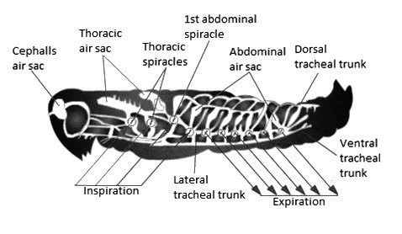

Fig 6.3. Air sacs in tracheal system of insect (Locust)
2. Tracheoles. At various points along their length, especially distally, the tracheae give rise to ﬁner tubes, the tracheoles (lined with cuticle, but not shed at ecdysis). Tracheoles (Fig 6.4) are blind-ended, air-ﬁlled extensions of terminal tracheal cells, and are the primary site of gas exchange. They are formed in “tracheolar cells,” which are derived from the epidermal cells lining the tracheae. The thin walls and high surface-to-volume ratio of the tracheoles enable their high diffusing capacity. Most tracheoles are extracellular, and in ﬂight muscles they generally run parallel to the muscle ﬁbers. In some ﬂight muscles they penetrate deeply into the muscle via invaginations of the plasma membrane.

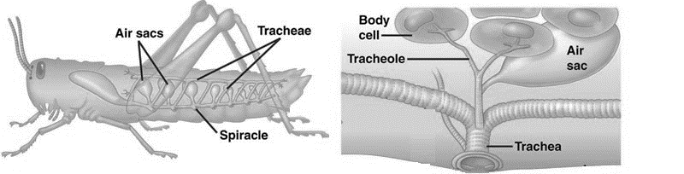

Fig. 6.4. Showing network of tracheoles terminating in body cells

3. Spiracles. The spiracles are the external openings of the tracheal system, found on the thorax or abdomen (never the head). They are lateral in position, and in the insects, there is never more than one pair of spiracles on a segment, usually on the pleuron. A spiracle may be merely a hole in the integument, as in primitively wingless insects, but there is usually a valve or some other closing mechanism that reduces water loss. Spiracles may also possess a ﬁltering device such as a sieve plate or a set of interlocking bristles that prevents the entrance of water, parasites, or dust into the tracheae. There is never more than one pair of spiracles per body segment, and the evolutionary trend has been toward the reduction of total numbers of spiracles. Spiracles are never present in the head capsule. The primitive number of spiracles was probably 12 pairs, but present-day insects have no more than 11, consisting of three thoracic and eight abdominal pairs, a condition found in diplurans. There are fewer spiracles present in other insects.
When all spiracles are present and functional, it is known as the holopneustic condition. When several pairs have become non-functional through evolutionary loss, the condition is referred to as hemipneustic. The propneustic and metapneustic conditions are found in pupal and larval dipterans in which only the first or last abdominal pair is functional. Insects that have no functional spiracles are termed apneustic, although they still retain an internal tracheal system and extract oxygen through a cuticle that is modified. With the exception of apterygote insects, the tracheae in most other insects are usually connected by large tracheal trunks to allow even a single spiracle to ventilate the entire system. The tracheal system is completely absent in some primitive collembolans that live in moist environments, and these insects respire directly through the cuticle. Wigglesworth (1954) has described six types tracheal systems as follows
- Two thoracic and eight abdominal spiracles open. e.g. cockroach.
- All spiracles open. Air sacs present. e.g., grasshopper, honeybee.
- All spiracles closed except the most posterior ones, e.g., larval insects.
- All spiracles closed (apneustic). Gaseous exchange through integument, e. g.
Collembola, parasitic larval Hymenoptera.
- Spiracles closed. Tracheal gills on abdomen. e.g., larvae of mayflies, dragonflies, etc.
- Spiracles closed. Gills present inside hindgut.
Gaseous exchange via Tracheal System: The gaseous exchange in the tracheal system is primarily by diffusion and ventilation. It takes place by the following steps:
- Alternate contractions and expansions of the insect abdomen lead to the changes in the diameter of tracheae which results in movement of air in/out of the tracheae.
- During inspiration, air enters the tracheae through the spiracles and passes through the tracheoles to the fluid-filled tips where it gets dissolved in the fluid.
- Now, the oxygen diffuses from the tracheoles into the body cells whereas CO₂ diffuses from the cells into the tracheoles.
- During expiration, CO₂-rich air is released outside the body through tracheae. However, CO₂ can also diffuse outside through the cuticular covering of the body.
During active metabolism, the tracheole fluid enters the surrounding tissues leading to the exposure of more surface area of tracheoles to oxygen and more oxygen can enter the tissues.

Gaseous Exchange in Aquatic Insects
Aquatic insects obtain oxygen directly from the air or from that dissolved in the water. The former necessitates some semi-permanent connection with the surface or frequent visits to the surface. Insects that obtain oxygen from water nearly always retain a modified tracheal system so that the oxygen must come out of solution into the gaseous phase. Gaseous exchange with water takes place through thin-walled gills well supplied with tracheae, but in other cases a thin, permanent ﬁlm of air (plastrons or bubbles) is present on the outside of the body. The spiracles open into this ﬁlm so that oxygen can readily pass from the water into the tracheae.
A. Aquatic Insects Obtaining Oxygen from the Air. Most aquatic forms obtaining air from above the water surface must make periodic visits to the surface, to renew the gases in the tracheal system but a few have semi-permanent connections with the air that enable them to remain submerged indeﬁnitely.
1. Gas Exchange by Respiratory Siphon. Respiratory siphon (Fig 6.5) is a tube found in larvae of certain insects used for breathing.
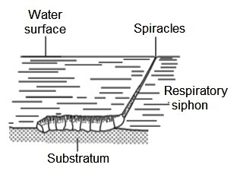

Fig. 6.5. Respiratory Siphon in the larva (rat-tailed maggot) of the hover ﬂy Eristalis,
(after Imms, 1947).
For example, the larva of the hover ﬂy Eristalis, (Diptera) has a telescopic terminal siphon which can extend to a length of 6 cm or more in a larva which is only 1 cm long. By means of the siphon the larva can reach the water surface with its posterior spiracles, while the body remains on the bottom mud.
2. Gas Exchange via Air Bubbles. Some aquatic insects, such as mosquito larvae, can remain submerged only as long as the supply of oxygen in the tracheae lasts, but others have an extratracheal air store, carrying a bubble of air (Fig 6.6) down into the water when they dive. The spiracles open into this bubble, so that it provides a store of air additional to that contained in the tracheal system, enabling the insects to remain submerged for longer periods.
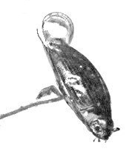

Fig 6.6. Formation of air bubble in Whirligig Beetle at the end of its abdomen
The position of the store is characteristic for each species. For example, in Dytiscus (Coleoptera), it is beneath the elytra, in Notonecta (Hemiptera), air is held by long hydrofuge hairs on the ventral surface as well as in a store under the wings and in a thin ﬁlm held by small bristles over the dorsal surface of the forewing. An air store also gives the insect buoyancy, so that as soon as the insect stops swimming or releases its hold on the vegetation, it ﬂoats to the surface.
B. Aquatic Insects Obtaining Oxygen from Water: In all insects living in water, some inward diffusion of oxygen from the water takes place through the cuticle, and in many larval forms gaseous exchange takes place solely in this way. Cutaneous diffusion depends on the permeability of the cuticle and a lower oxygen tension in the tissues as compared with the water. In very small larvae, such as the ﬁrst-stage larvae of Simulium (Diptera) and Chironomus (Diptera), in which the tracheal system is ﬁlled with ﬂuid, cutaneous diffusion into the hemolymph meets the whole oxygen requirement of the insect. The majority of insects that obtain oxygen from water do have a tracheal system, although the spiracles are non-functional. This is called a closed tracheal system.
1. Tracheal Gills. Tracheal gills that are outgrowths of the body wall covered by relatively thin cuticles with rich supplies of tracheae. The abdominal gills of ephemeropterans are plate like outgrowths that undulate continuously to circulate oxygenated water over their surfaces as the insect swims (Figure 6.7). Zygopteran odonate larvae have three caudal gills that are similarly configured to take up oxygen, and their undulations also serve as rudders to aid in swimming. Tracheal gills are present within the modified hindgut of dragonfly larvae, creating a brachial chamber that extracts oxygen from the water contained there. The wall of the chamber is lined with circular and longitudinal muscles that change its volume, causing oxygenated water to be alternately ventilated and ejected.
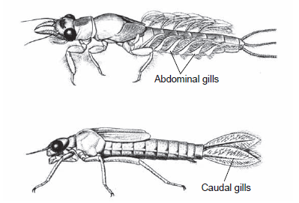

Fig 6.7. Abdominal gills of the mayfly.

Ventilatory contractions of the muscles of the hindgut cause water to be ejected from the anus, and dilator muscles draw fresh water into the brachial chamber (Fig 6.8). The walls are richly supplied with tracheoles that take up oxygen from the water. The rapid ejection of fluid from the anus can jet-propel the insect through the water. Approximately 85% of the water is regularly renewed. Digested food passing through the hindgut is enclosed in a peritrophic membrane and does not foul the brachial chamber with wastes.
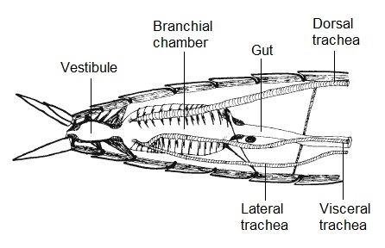

Fig 6.8. A longitudinal section of the abdomen of the dragonfly larva showing the brachial chamber

2. Plastron Respiration: Certain insect species have specialized structures holding a permanent thin ﬁlm of air on the outside of the body in such a way that an extensive air–water interface is always present for gaseous exchange. This ﬁlm of gas is called a plastron (Fig 6.9) and the tracheae open into it so that oxygen can pass directly to the tissues. The volume of the plastron is constant and usually small as it does not provide a store of air, but acts solely as a gill. In adult insects such as Aphelocheirus (Hemiptera) and Elmis (Coleoptera), the plastron is held by a very close hair pile in which the hairs resist wetting because of their hydrofuge properties and their orientation. In some insects the plastron is often supplemented by a less permanent macroplastron, consisting of a thicker layer of air outside the plastron and held by longer hairs than the plastron, as in Hydrophilus (Coleoptera)
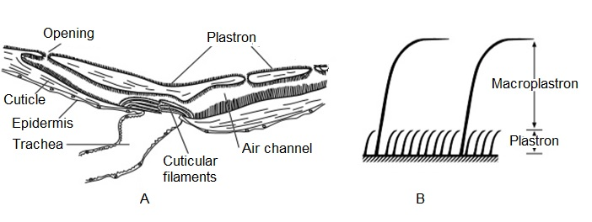

Fig 6.9. Plastron. (A) Plastron of Aphelocheirus (Hemiptera) (B) Macroplastron of Hydrophilus (Coleoptera) (after Thorpe and Crisp, 1949).

3. Spiracular Gills: Spiracular gills (Fig 6.10) are found in insects that inhabit running water that is highly oxygenated but also subject to periodical drying. They are present in the pupal stages of several dipterans and coleopterans that inhabit intertidal environments. The gills are rigid outgrowths of the spiracle or of the body wall that are able to resist collapse from the hydrostatic pressures that may be present underwater. Most spiracular gills are covered with a plastron that is connected to the tracheal system with aeropyles, providing a large surface area for oxygen transfer to occur by diffusion when these are immersed in water. Spiracular gills occur in the pupal stages of many ﬂies (Diptera) and beetles (Coleoptera) living intertidally or at the edges of streams. The spiracular gills of most dipteran pupae are prothoracic and connect with the prothoracic spiracles. In the craneﬂy, Taphrophila (Diptera), for example, there is a single gill on each side with eight branches. Blackﬂy pupae (Diptera: Simuliidae) also have two prothoracic gills. In the pupae of Psephenidae (Coleoptera), the spiracular gills are associated with the abdominal spiracles and in Psephenoides volatilis (Coleoptera) they are on abdominal segments 2–7. Abdominal spiracular gills also occur in the larvae of beetles of the genera Torridincola, Sphaerius and Hydroscapha.
The advantage of spiracular gills is their enormous surface area for this extraction of oxygen from water while also allowing for terrestrial respiration when out of water without engendering any more water loss than would a conventional spiracle under dry conditions. When dry, the plastron allows the direct uptake of oxygen from areas closest to the spiracle with the distal remainder of the structure largely non-functional. Oxygen can thus be taken up without reducing the permeability of the cuticle and involving a loss of water. Compared to the more water permeable tracheal gills, spiracular gills also offer the advantage of fewer osmoregulatory adaptations because the gills are not permeable to water and mechanisms to deal with water uptake are not as important.

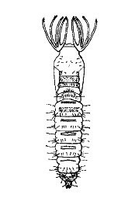

Fig 6.10. Spiracular gills on thorax of the black fly pupa

Blood Gills. Many trichopteran larvae possess between four and six blood gills at the hind end of the abdomen, and they are found in a similar position in some tipulid (Diptera) larvae. In endoparasitic braconid (Hymenoptera) larvae a blood-filled caudal vesicle is present. Apart from a few instances, like those just cited, the so-called blood gills are not held to be respiratory organs.
Respiratory Trumpet. Protuberances associated with the prothorax of the pupal stage in certain aquatic Diptera is termed as respiratory trumpet. They are structurally and functionally similar to the respiratory siphons present in the larvae and help in breathing.

Gas Exchange in Endoparasitic Insects
Endoparasitic insects may obtain their oxygen directly from the air outside the host or by diffusion through the cuticle from the surrounding host tissues. In many ichneumonid and braconid (Hymenoptera) larvae, the tracheal system of the ﬁrst instar is liquid-ﬁlled and, even when it becomes gas-ﬁlled, the spiracles remain closed until the last instar. Thus, these insects and the young larvae of most parasitic Diptera depend entirely on cutaneous diffusion.

Gas Exchange in Insect Eggs
Gas exchange in insect eggs occurs by diffusion through wax and protein layers. The eggs of many terrestrial insects are subject to occasional ﬂooding and those of many species have a chorionic plastron.
Physiological studies suggest that the egg chorion is a high-resistance structure, designed to minimize water loss while allowing adequate oxygen delivery.
Elongate projections of the egg chorion that form a plastron on the egg, facilitating gas exchange but minimizing water loss is called a respiratory horn. Respiratory horns are found on the eggs of several taxa, including Diptera, Hymenoptera, and some Hemiptera.

PRACTICE QUESTIONS

Multiple Choice
1. Podobranch is found in
a) Malacostraca b) Arachnida
c) Copepoda d) All of the above

2. Joint gills is the common name for
a) Podobranch b) Arthrobranch
c) Pleurobranch d) Trichobranch

3. The primary site of gas exchange in insects ia
a) Trachea b) Tracheole
c) Spiracle d) None of the above

4. When only the first abdominal pair of spiracles is functional, the condition is called
a) Holopneustic b) Hemipneustic
c) Propneustic d) Metapneustic

5. Aquatic insects breathe
a) By taking oxygen from air b) By taking oxygen from water
c) Both a and b d) None of the above

6. Plastron is made up of
a) A film of gas b) Insect cuticle
c) Gills d) Trachea

7. Gas exchange via air bubbles is facilitated by
a) Trachea b) Tracheole
c) Spiracle d) None of the above

8. Insects that inhabit running water that is highly oxygenated but also subject to periodical drying typically have
a) Abdominal gills b) Spiracular Gills
c) Caudal gills d) Tracheal gills

9. A brachial chamber is often found associated with
a) Abdominal gills b) Spiracular Gills
c) Caudal gills d) Tracheal gills

10. The spiracles are found located on the
a) Head b) Thorax
c) Abdomen d) Both b and c

Very short answer type
- Gills with leaf like lamellae are called ________.
- How many pairs of spiracles are usually present on thorax?
- What function does taenidia perform?
- What is meant by hemipneustic condition of spiracles??
- What is a closed tracheal system? In which insects is it found?
- What is macroplastron?
- What is a respiratory horn? Where is it found?
- Explain the function of a respiratory trumpet.
- Illustrate how the branchial chamber aids in respiration?
- Name a species the larva of which possesses a respiratory siphon.

Write short notes on
- Plastron respiration
- Gas exchange via air bubbles
- Gas exchange in insect eggs
- Book lungs
- Book gills

Long answer type
- What are book gills and book lungs? Explain how respiration in Arthropoda is manifested through these structures.
- Give an account of the method of respiration in aquatic insects.
- What are the primary respiratory organs found in insects? Describe their structural organization and explain the method of gaseous exchange through the tracheal system.

Answers to Multiple Choice Questions
1. (d) 2. (b) 3. (b) 4. (c) 5. (c)
6. (a) 7. (c) 8. (b) 9. (d) 10. (d)

