SERIES AND PARALLEL RESONANCE CIRUITS

Series RLC Circuit

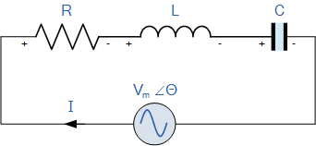
In a series RLC circuit there becomes a frequency point were the inductive reactance of the inductor becomes equal in value to the capacitive reactance of the capacitor. In other words, X_{L} = X_{C}. The point at which this occurs is called the Resonant Frequency point, ( ƒ_{r} ) of the circuit, and as we are analyzing a series RLC circuit this resonance frequency produces a Series Resonance.
Series Resonance circuits are one of the most important circuits used electrical and electronic circuits. They can be found in various forms such as in AC mains filters, noise filters and also in radio and television tuning circuits producing a very selective tuning circuit for the receiving of the different frequency channels. Consider the simple series RLC circuit above.
Inductive reactance X_{L} =2πfL= ωL
Capacitive reactance X_{C}=$\frac{1}{2πfC}=\frac{1}{ωC}$
When X_{L} > X_{C} the circuit is Inductive
When X_{C} > X_{L} the circuit is Capacitive
The total circuit reactance = X_{T} = X_{L} -X_{C} or X_{C} - X_{L}
The total circuit impedance Z= R + j X_{T} and magnitude will be$\left|Z\right|=\sqrt{R^{2}+{X_{T}}^{2}}$
From the above equation for inductive reactance, if either the Frequency or the Inductance is increased the overall inductive reactance value of the inductor would also increase. As the frequency approaches infinity the inductors reactance would also increase towards infinity with the circuit element acting like an open circuit.
However, as the frequency approaches zero or DC, the inductors reactance would decrease to zero, causing the opposite effect acting like a short circuit. This means then that inductive reactance is “Proportional” to frequency and is small at low frequencies and high at higher frequencies and this demonstrated in the following curve:

Inductive Reactance against Frequency
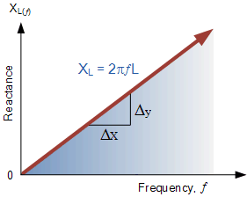
The graph of inductive reactance against frequency is a straight line linear curve. The inductive reactance value of an inductor increases linearly as the frequency across it increases. Therefore, inductive reactance is positive and is directly proportional to frequency ( X_{L} ∝ ƒ )
The same is also true for the capacitive reactance formula above but in reverse. If either the Frequency or the Capacitance is increased the overall capacitive reactance would decrease. As the frequency approaches infinity the capacitors reactance would reduce to practically zero causing the circuit element to act like a perfect conductor of 0Ω.
But as the frequency approaches zero or DC level, the capacitors reactance would rapidly increase up to infinity causing it to act like a very large resistance, becoming more like an open circuit condition. This means then that capacitive reactance is “Inversely proportional” to frequency for any given value of capacitance and this shown below:

Capacitive Reactance against Frequency
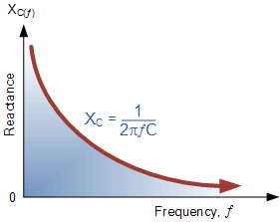
The graph of capacitive reactance against frequency is a hyperbolic curve. The Reactance value of a capacitor has a very high value at low frequencies but quickly decreases as the frequency across it increases. Therefore, capacitive reactance is negative and is inversely proportional to frequency ( X_{C} ∝ ƒ ⁻¹ )
We can see that the value of these resistances depends upon the frequency of the supply. At a higher frequency X_{L} is high and at a low frequency X_{C} is high. Then there must be a frequency point were the value of X_{L} is the same as the value of X_{C} and there is. If we now place the curve for inductive reactance on top of the curve for capacitive reactance so that both curves are on the same axes, the point of intersection will give us the series resonance frequency point, ( ƒ_{r} or ω_{r} ) as shown below.

Series Resonance Frequency

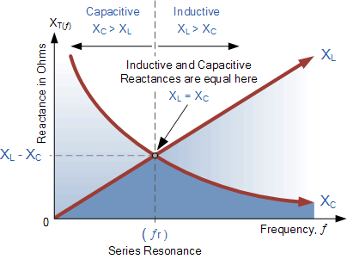
where: ƒ_{r} is in Hertz, L is in Henries and C is in Farads.
Electrical resonance occurs in an AC circuit when the two reactance which are opposite and equal cancel each other out as X_{L} = X_{C} and the point on the graph at which this happens is where the two reactance curves cross each other. In a series resonant circuit, the resonant frequency, ƒ_{r} point can be calculated as follows.
X_{L} = X_{C}$→$ 2πfL=$\frac{1}{2πfC}$
$f^{2}=\frac{1}{4π^{2}LC}$
$f_{r}=\frac{1}{2π\sqrt{LC}}$ (Hz) or $ω_{r}=\frac{1}{\sqrt{LC}}$ (rads)

We can see then that at resonance, the two reactances cancel each other out thereby making a series LC combination act as a short circuit with the only opposition to current flow in a series resonance circuit being the resistance, R. In complex form, the resonant frequency is the frequency at which the total impedance of a series RLC circuit becomes purely “real”, that is no imaginary impedance’s exist. This is because at resonance they are cancelled out. So the total impedance of the series circuit becomes just the value of the resistance and therefore: Z = R.
Then at resonance the impedance of the series circuit is at its minimum value and equal only to the resistance, R of the circuit. The circuit impedance at resonance is called the “dynamic impedance” of the circuit and depending upon the frequency, X_{C} (typically at high frequencies) or X_{L} (typically at low frequencies) will dominate either side of resonance as shown below.

Impedance in a Series Resonance Circuit
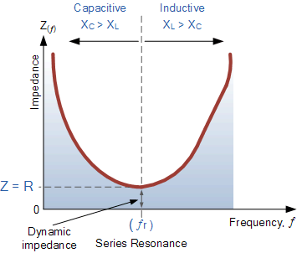
Note that when the capacitive reactance dominates the circuit the impedance curve has a hyperbolic shape to itself, but when the inductive reactance dominates the circuit the curve is non-symmetrical due to the linear response of X_{L}.
You may also note that if the circuits impedance is at its minimum at resonance then consequently, the circuits admittance must be at its maximum and one of the characteristics of a series resonance circuit is that admittance is very high. But this can be a bad thing because a very low value of resistance at resonance means that the resulting current flowing through the circuit may be dangerously high.
We recall from the previous tutorial about series RLC circuits that the voltage across a series combination is the phasor sum of V_{R}, V_{L} and V_{C}. Then if at resonance the two reactances are equal and cancelling, the two voltages representing V_{L} and V_{C} must also be opposite and equal in value thereby cancelling each other out because with pure components the phasor voltages are drawn at +90º and -90º respectively.
Then in a series resonance circuit as V_{L} = -V_{C} the resulting reactive voltages are zero and all the supply voltage is dropped across the resistor. Therefore, V_{R} = V_{supply} and it is for this reason that series resonance circuits are known as voltage resonance circuits, (as opposed to parallel resonance circuits which are current resonance circuits).

Series RLC Circuit at Resonance

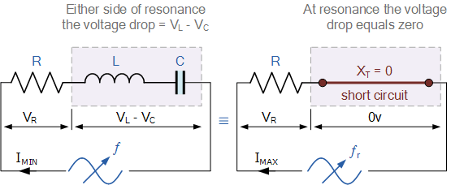
Since the current flowing through a series resonance circuit is the product of voltage divided by impedance, at resonance the impedance, Z is at its minimum value, ( =R ). Therefore, the circuit current at this frequency will be at its maximum value of V/R as shown below.

Series Circuit Current at Resonance
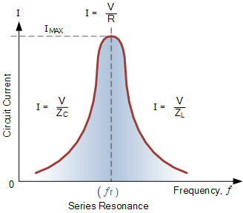
The frequency response curve of a series resonance circuit shows that the magnitude of the current is a function of frequency and plotting this onto a graph shows us that the response starts at near to zero, reaches maximum value at the resonance frequency when I_{MAX} = I_{R} and then drops again to nearly zero as ƒ becomes infinite. The result of this is that the magnitudes of the voltages across the inductor, L and the capacitor, C can become many times larger than the supply voltage, even at resonance but as they are equal and at opposition they cancel each other out.
As a series resonance circuit only functions on resonant frequency, this type of circuit is also known as an Acceptor Circuit because at resonance, the impedance of the circuit is at its minimum so easily accepts the current whose frequency is equal to its resonant frequency.
You may also notice that as the maximum current through the circuit at resonance is limited only by the value of the resistance (a pure and real value), the source voltage and circuit current must therefore be in phase with each other at this frequency. Then the phase angle between the voltage and current of a series resonance circuit is also a function of frequency for a fixed supply voltage and which is zero at the resonant frequency point when: V, I and V_{R} are all in phase with each other as shown below. Consequently, if the phase angle is zero then the power factor must therefore be unity.

Phase Angle of a Series Resonance Circuit

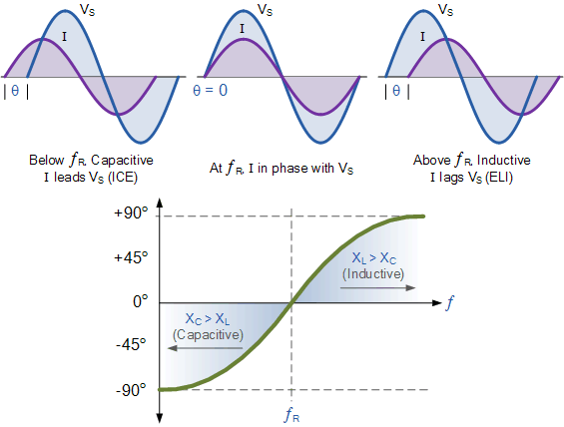

Notice also, that the phase angle (ɸ) is positive for frequencies above ƒ_{r} and negative for frequencies below ƒ_{r} and this can be proven by,
ɸ$=\tan^{-1}\left(\frac{X_{L}-X_{C}}{R}\right)=0^{°}$ (all real)

Bandwidth of a Series Resonance Circuit
If the series RLC circuit is driven by a variable frequency at a constant voltage, then the magnitude of the current, I is proportional to the impedance, Z, therefore at resonance the power absorbed by the circuit must be at its maximum value as P = I²Z.
If we now reduce or increase the frequency until the average power absorbed by the resistor in the series resonance circuit is half that of its maximum value at resonance, we produce two frequency points called the half-power points which are -3dB down from maximum, taking 0dB as the maximum current reference.
These -3dB points give us a current value that is 70.7% of its maximum resonant value which is defined as: 0.5( I² R ) = (0.707 x I)² R. Then the point corresponding to the lower frequency at half the power is called the “lower cut-off frequency”, labeled ƒ_{L} with the point corresponding to the upper frequency at half power being called the “upper cut-off frequency”, labeled ƒ_{H}. The distance between these two points, i.e. ( ƒ_{H} – ƒ_{L} ) is called the Bandwidth, (BW) and is the range of frequencies over which at least half of the maximum power and current is provided as shown.

Bandwidth of a Series Resonance Circuit

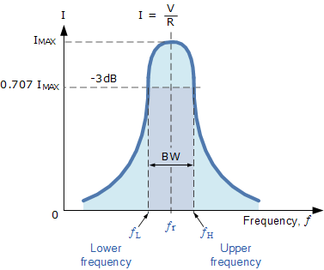
The frequency response of the circuits current magnitude above, relates to the “sharpness” of the resonance in a series resonance circuit. The sharpness of the peak is measured quantitatively and is called the Quality factor, Q of the circuit. The quality factor relates the maximum or peak energy stored in the circuit (the reactance) to the energy dissipated (the resistance) during each cycle of oscillation meaning that it is a ratio of resonant frequency to bandwidth and the higher the circuit Q, the smaller the bandwidth, Q = ƒ_{r} /BW.
As the bandwidth is taken between the two -3dB points, the selectivity of the circuit is a measure of its ability to reject any frequencies either side of these points. A more selective circuit will have a narrower bandwidth whereas a less selective circuit will have a wider bandwidth. The selectivity of a series resonance circuit can be controlled by adjusting the value of the resistance only, keeping all the other components the same, since Q = (X_{L} or X_{C})/R.

Bandwidth of a Series RLC Resonance Circuit

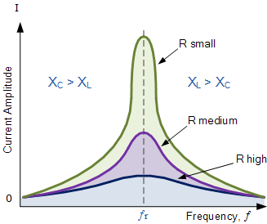

Then the relationship between resonance, bandwidth, selectivity and quality factor for a series resonance circuit being defined as :
1). Resonant Frequency, (ƒ_{r})

$ω_{r}=\frac{1}{\sqrt{LC}}$
2). Current, (I)
At $ω_{r}$ $Z_{T}=$ minimum $I_{S}=$ maximum
$$I_{max}=\frac{V_{max}}{Z}=\frac{V_{max}}{\sqrt{R^{2}+{\left(X_{L}-X_{C}\right)}^{2}}}=\frac{V_{max}}{\sqrt{R^{2}+{\left(ω_{r}L-\frac{1}{ω_{r}C}\right)}^{2}}}$$

3). Lower cut-off frequency, (ƒ_{L})

At half power $\frac{P_{m}}{2}$ I=$\frac{I_{m}}{\sqrt{2}}$ = 0.707$I_{m}$
Total reactance have two values X₁= $-R$ (Capacitive) and X₂ = $+R$ (Inductive)
And impedance Z =$\sqrt{2}$ R
$ω_{L}=-\frac{R}{2L}+\sqrt{{\left(\frac{R}{2L}\right)}^{2}+\frac{1}{LC}}$
4). Upper cut-off frequency, (ƒ_{H})
At half power $\frac{P_{m}}{2}$ I=$\frac{I_{m}}{\sqrt{2}}$ = 0.707$I_{m}$
Total reactance X₂ = $+R$ (Inductive)
And impedance Z =$\sqrt{2}$ R
$ω_{H}=+\frac{R}{2L}+\sqrt{{\left(\frac{R}{2L}\right)}^{2}+\frac{1}{LC}}$
5). Bandwidth, (BW)
BW= Upper cut-off frequency – Lower cut-off frequency, ($\left[f_{H}-f_{L}\right]=\frac{R}{2πL} Hz$) , ($ω_{H}-ω_{L}=\frac{R}{L}$ rads)
BW= $\frac{f_{r}}{Q}$ , where Q is quality factor of the circuit.
6. Quality factor Q (Voltage magnification factor) is defined as the ratio of voltage across inductor/ capacitor to voltage across resistor at resonance.
Q=$\frac{X_{L}}{R}=\frac{X_{C}}{R}$
Q=$\frac{ω_{r}L}{R}=\frac{1}{ω_{r}RC}$

Series Resonance Summary
You may have noticed that during the analysis of series resonance circuits in this tutorial, we looked at bandwidth, upper and lower frequencies, -3dB points and quality or Q-factor. All these are terms used in designing and building of Band Pass Filters (BPF) and indeed, resonance circuits are used in 3-element mains filter designs to pass all frequencies within the “passband” range while rejecting all others.
However, the main aim of this tutorial is to analyse and understand the concept of how Series Resonance occurs in passive RLC series circuits. Their use in RLC filter networks and designs is outside the scope of this particular tutorial, and so will not be looked at here, sorry.
- For resonance to occur in any circuit it must have at least one inductor and one capacitor.
- Resonance is the result of oscillations in a circuit as stored energy is passed from the inductor to the capacitor.
- Resonance occurs when X_{L} = X_{C} and the imaginary part of the transfer function is zero.
- At resonance the impedance of the circuit is equal to the resistance value as Z = R.
- At low frequencies the series circuit is capacitive as: X_{C} > X_{L}, this gives the circuit a leading power factor.
- At high frequencies the series circuit is inductive as: X_{L} > X_{C}, this gives the circuit a lagging power factor.
- The high value of current at resonance produces very high values of voltage across the inductor and capacitor.
- Series resonance circuits are useful for constructing highly frequency selective filters. However, its high current and very high component voltage values can cause damage to the circuit.
- The most prominent feature of the frequency response of a resonant circuit is a sharp resonant peak in its amplitude characteristics.
- Because impedance is minimum and current is maximum, series resonance circuits are also called Acceptor Circuits.
In the Parallel Resonance we will look at how frequency affects the characteristics of a parallel connected RLC circuit and how the Q-factor of a parallel resonant circuit determines its current magnification.

Series RLC Circuit Analysis

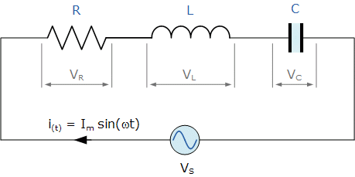
Series RLC circuits consist of a resistance, a capacitance and an inductance connected in series across an alternating supply
The series RLC circuit above has a single loop with the instantaneous current flowing through the loop being the same for each circuit element. Since the inductive and capacitive reactance’s X_{L} and X_{C} are a function of the supply frequency, the sinusoidal response of a series RLC circuit will therefore vary with frequency, ƒ. Then the individual voltage drops across each circuit element of R, L and C element will be “out-of-phase” with each other as defined by:
i_{(t)} = I_{max} sin(ωt)
- The instantaneous voltage across a pure resistor, V_{R} is “in-phase” with current
- The instantaneous voltage across a pure inductor, V_{L} “leads” the current by 90º
- The instantaneous voltage across a pure capacitor, V_{C} “lags” the current by 90º
- Therefore, V_{L} and V_{C} are 180º “out-of-phase” and in opposition to each other.
For the series RLC circuit above, this can be shown as:
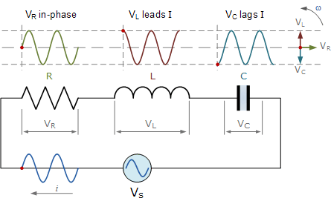
The amplitude of the source voltage across all three components in a series RLC circuit is made up of the three individual component voltages, V_{R}, V_{L} and V_{C} with the current common to all three components. The vector diagrams will therefore have the current vector as their reference with the three voltage vectors being plotted with respect to this reference as shown below.

Individual Voltage Vectors

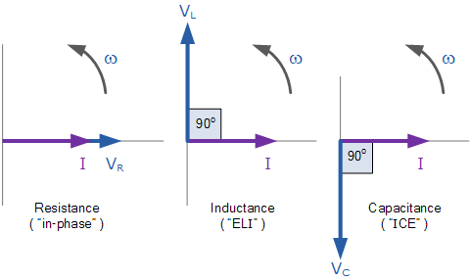

This means then that we cannot simply add together V_{R}, V_{L} and V_{C} to find the supply voltage, V_{S} across all three components as all three voltage vectors point in different directions with regards to the current vector. Therefore we will have to find the supply voltage, V_{S} as the Phasor Sum of the three component voltages combined together vectorially.
Kirchhoff’s voltage law ( KVL ) for both loop and nodal circuits states that around any closed loop the sum of voltage drops around the loop equals the sum of the EMF’s. Then applying this law to the these three voltages will give us the amplitude of the source voltage, V_{S} as.

Instantaneous Voltages for a Series RLC Circuit

KVL : V_{S} – V_{R} – V_{L} –V_{C} =0

V_{S} –RI -L$\frac{dI}{dt}$ $-\frac{Q}{C}=0$
V_{S} = RI + L$\frac{dI}{dt}$ $+\frac{Q}{C}$

The phasor diagram for a series RLC circuit is produced by combining together the three individual phasors above and adding these voltages vectorially. Since the current flowing through the circuit is common to all three circuit elements we can use this as the reference vector with the three voltage vectors drawn relative to this at their corresponding angles.
The resulting vector V_{S} is obtained by adding together two of the vectors, V_{L} and V_{C} and then adding this sum to the remaining vector V_{R}. The resulting angle obtained between V_{S} and i will be the circuits phase angle as shown below.

Phasor Diagram for a Series RLC Circuit

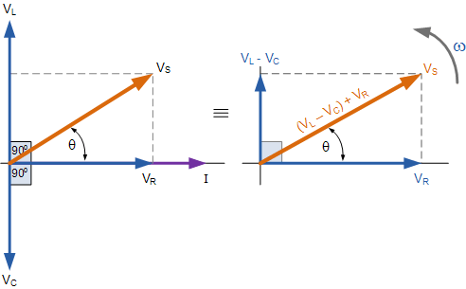
We can see from the phasor diagram on the right hand side above that the voltage vectors produce a rectangular triangle, comprising of hypotenuse V_{S}, horizontal axis V_{R} and vertical axis V_{L} – V_{C}. You will notice then, that this forms our old favourite the Voltage Triangle and we can therefore use Pythagoras’s theorem on this voltage triangle to mathematically obtain the value of V_{S} as shown.

Voltage Triangle for a Series RLC Circuit

$V_{S}^{2}=V_{R}^{2}+{\left(V_{L}-V_{C}\right)}^{2}$

$V_{S}^{2}=\sqrt{V_{R}^{2}+{\left(V_{L}-V_{C}\right)}^{2} }$
Note that when using the above equation, the final reactive voltage must always be positive in value, that is the smallest voltage must always be taken away from the largest voltage we can not have a negative voltage added to V_{R} so it is correct to have V_{L} – V_{C} or V_{C} – V_{L}. The smallest value from the largest otherwise the calculation of V_{S} will be incorrect.
We know from above that the current has the same amplitude and phase in all the components of a series RLC circuit. Then the voltage across each component can also be described mathematically according to the current flowing through, and the voltage across each element as.
$V_{R}=iR=I_{max}R\sin\left(ωt+0^{°}\right)$
$V_{L}=iX_{L}=I_{max}X_{L}sin\left(ωt+{90}^{°}\right)$ = i j$ωL$
$V_{C}=iX_{C}=I_{max}X_{C}sin\left(ωt-{90}^{°}\right)$ = i$\frac{1}{jωC}$
By substituting these values into the Pythagoras equation above for the voltage triangle will give us:
$V_{R}=iR$ , $V_{L}=iX_{V_{C}L}$ , $V_{C}=iX_{C}$

$V_{S}=\sqrt{V_{R}^{2}+{\left(V_{L}-V_{C}\right)}^{2} }$

$V_{S}=\sqrt{{\left(IR\right)}^{2}+{\left(IX_{L}-IX_{C}\right)}^{2}}$ = I $\sqrt{{\left(R\right)}^{2}+{\left(X_{L}-X_{C}\right)}^{2}}$
$V_{S}=IZ$ , where Z=$\sqrt{{\left(R\right)}^{2}+{\left(X_{L}-X_{C}\right)}^{2}}$

The Impedance of a Series RLC Circuit
As the three vector voltages are out-of-phase with each other, X_{L}, X_{C} and R must also be “out-of-phase” with each other with the relationship between R, X_{L} and X_{C} being the vector sum of these three components. This will give us the RLC circuits overall impedance, Z. These circuit impedance’s can be drawn and represented by an Impedance Triangle as shown below.

The Impedance Triangle for a Series RLC Circuit
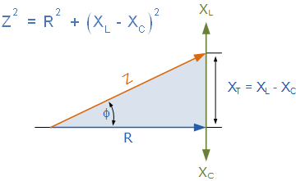
The impedance Z of a series RLC circuit depends upon the angular frequency, ω as do X_{L} and X_{C} If the capacitive reactance is greater than the inductive reactance, X_{C} > X_{L} then the overall circuit reactance is capacitive giving a leading phase angle.
Likewise, if the inductive reactance is greater than the capacitive reactance, X_{L} > X_{C} then the overall circuit reactance is inductive giving the series circuit a lagging phase angle. If the two reactance’s are the same and X_{L} = X_{C} then the angular frequency at which this occurs is called the resonant frequency and produces the effect of resonance which we will look at in more detail in another tutorial.
Then the magnitude of the current depends upon the frequency applied to the series RLC circuit. When impedance, Z is at its maximum, the current is a minimum and likewise, when Z is at its minimum, the current is at maximum. So the above equation for impedance can be re-written as:
Impedance Z= $\sqrt{R^{2}+{\left(ωL-\frac{1}{ωC}\right)}^{2}}$
The phase angle, θ between the source voltage, V_{S} and the current, i is the same as for the angle between Z and R in the impedance triangle. This phase angle may be positive or negative in value depending on whether the source voltage leads or lags the circuit current and can be calculated mathematically from the ohmic values of the impedance triangle as:

$\cos{ɸ=\frac{R}{Z}}$ , $\sin{ɸ=\frac{X_{L}-X_{C}}{Z}}$ , $\tan{ɸ=\frac{X_{L}-X_{C}}{R}}$

Series RLC Circuit Summary
In a series RLC circuit containing a resistor, an inductor and a capacitor the source voltage V_{S} is the phasor sum made up of three components, V_{R}, V_{L} and V_{C} with the current common to all three. Since the current is common to all three components it is used as the horizontal reference when constructing a voltage triangle.
The impedance of the circuit is the total opposition to the flow of current. For a series RLC circuit, and impedance triangle can be drawn by dividing each side of the voltage triangle by its current, I. The voltage drop across the resistive element is equal to I*R, the voltage across the two reactive elements is I*X = I*X_{L} – I*X_{C} while the source voltage is equal to I*Z. The angle between V_{S} and I will be the phase angle, θ.
When working with a series RLC circuit containing multiple resistances, capacitance’s or inductance’s either pure or impure, they can be all added together to form a single component. For example all resistances are added together, R_{T} = ( R₁ + R₂ + R₃ )…etc or all the inductance’s L_{T} = ( L₁ + L₂ + L₃ )…etc this way a circuit containing many elements can be easily reduced to a single impedance.

Parallel RLC Circuit Analysis
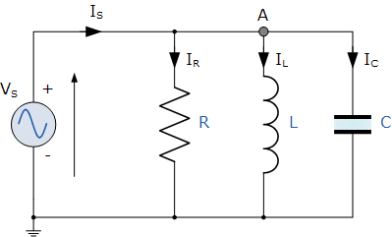

In the above parallel RLC circuit, we can see that the supply voltage, V_{S} is common to all three components whilst the supply current I_{S} consists of three parts. The current flowing through the resistor, I_{R}, the current flowing through the inductor, I_{L} and the current through the capacitor, I_{C}.
But the current flowing through each branch and therefore each component will be different to each other and also to the supply current, I_{S}. The total current drawn from the supply will not be the mathematical sum of the three individual branch currents but their vector sum.
Like the series RLC circuit, we can solve this circuit using the phasor or vector method but this time the vector diagram will have the voltage as its reference with the three current vectors plotted with respect to the voltage. The phasor diagram for a parallel RLC circuit is produced by combining together the three individual phasors for each component and adding the currents vectorially.
Since the voltage across the circuit is common to all three circuit elements we can use this as the reference vector with the three current vectors drawn relative to this at their corresponding angles. The resulting vector current I_{S} is obtained by adding together two of the vectors, I_{L} and I_{C} and then adding this sum to the remaining vector I_{R}. The resulting angle obtained between V and I_{S} will be the circuits phase angle as shown below.

Phasor Diagram for a Parallel RLC Circuit
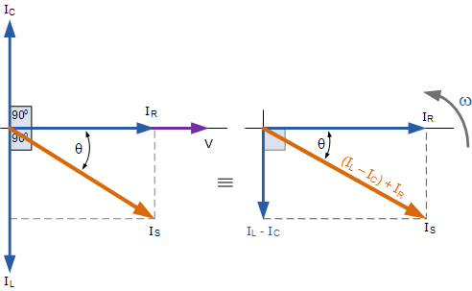

We can see from the phasor diagram on the right hand side above that the current vectors produce a rectangular triangle, comprising of hypotenuse I_{S}, horizontal axis I_{R} and vertical axis I_{L} – I_{C} Hopefully you will notice then, that this forms a Current Triangle. We can therefore use Pythagoras’s theorem on this current triangle to mathematically obtain the individual magnitudes of the branch currents along the x-axis and y-axis which will determine the total supply current I_{S} of these components as shown.

Current Triangle for a Parallel RLC Circuit
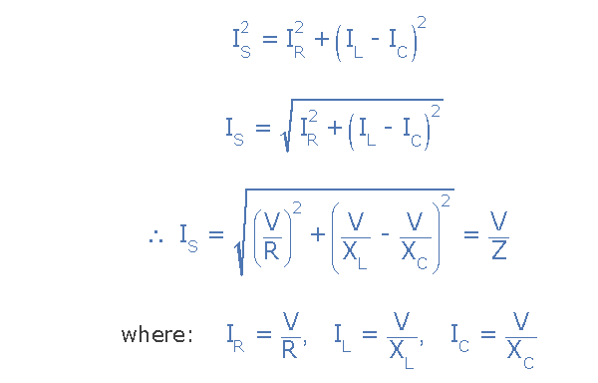
Since the voltage across the circuit is common to all three circuit elements, the current through each branch can be found using Kirchhoff’s Current Law, (KCL). Rember that Kirchhoff’s current law or junction law states that “the total current entering a junction or node is exactly equal to the current leaving that node”. Thus the currents entering and leaving node “A” above are given as:

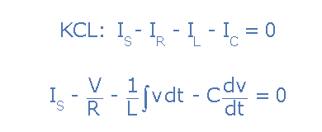
Taking the derivative, dividing through the above equation by C and then re-arranging gives us the following Second-order equation for the circuit current. It becomes a second-order equation because there are two reactive elements in the circuit, the inductor and the capacitor.

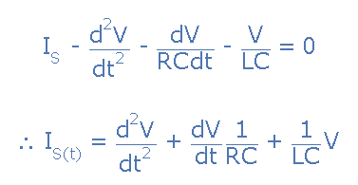
The opposition to current flow in this type of AC circuit is made up of three components: X_{L} X_{C} and R with the combination of these three values giving the circuits impedance, Z. We know from above that the voltage has the same amplitude and phase in all the components of a parallel RLC circuit. Then the impedance across each component can also be described mathematically according to the current flowing through, and the voltage across each element as.

Impedance of a Parallel RLC Circuit

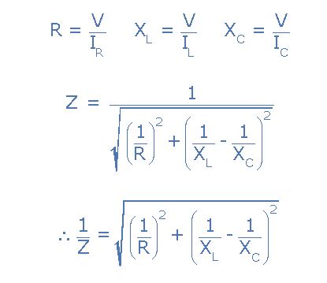
You will notice that the final equation for a parallel RLC circuit produces complex impedance’s for each parallel branch as each element becomes the reciprocal of impedance, ( 1/Z ). The reciprocal of impedance is commonly called Admittance, symbol ( Y ).
In parallel AC circuits it is generally more convenient to use admittance to solve complex branch impedance’s especially when two or more parallel branch impedance’s are involved (helps with the math’s). The total admittance of the circuit can simply be found by the addition of the parallel admittances. Then the total impedance, Z_{T} of the circuit will therefore be 1/Y_{T} Siemens as shown.

Admittance of a Parallel RLC Circuit

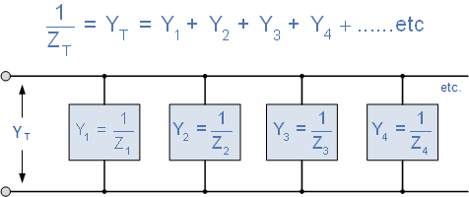
The unit of measurement now commonly used for admittance is the Siemens, abbreviated as S, ( old unit mho’s ℧, ohm’s in reverse ). Admittances are added together in parallel branches, whereas impedance’s are added together in series branches. But if we can have a reciprocal of impedance, we can also have a reciprocal of resistance and reactance as impedance consists of two components, R and X. Then the reciprocal of resistance is called Conductance and the reciprocal of reactance is called Susceptance.

Conductance, Admittance and Susceptance
The units used for conductance, admittance and susceptance are all the same namely Siemens ( S ), which can also be thought of as the reciprocal of Ohms or ohm⁻¹, but the symbol used for each element is different and in a pure component this is given as:

Admittance ( Y ) :
Admittance is the reciprocal of impedance, Z and is given the symbol Y. In AC circuits admittance is defined as the ease at which a circuit composed of resistances and reactances allows current to flow when a voltage is applied taking into account the phase difference between the voltage and the current.
The admittance of a parallel circuit is the ratio of phasor current to phasor voltage with the angle of the admittance being the negative to that of impedance.
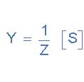

Conductance ( G ) :
Conductance is the reciprocal of resistance, R and is given the symbol G. Conductance is defined as the ease at which a resistor (or a set of resistors) allows current to flow when a voltage, either AC or DC is applied.
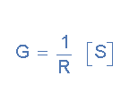

Susceptance ( B ) :
Susceptance is the reciprocal of of a pure reactance, X and is given the symbol B. In AC circuits susceptance is defined as the ease at which a reactance (or a set of reactances) allows an alternating current to flow when a voltage of a given frequency is applied.
Susceptance has the opposite sign to reactance so Capacitive susceptance B_{C} is positive, (+ve) in value while Inductive susceptance B_{L} is negative, (-ve) in value.
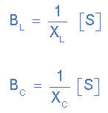
We can therefore define inductive and capacitive susceptance as being:
In AC series circuits the opposition to current flow is impedance, Z which has two components, resistance R and reactance, X and from these two components we can construct an impedance triangle. Similarly, in a parallel RLC circuit, admittance, Y also has two components, conductance, G and susceptance, B. This makes it possible to construct an admittance triangle that has a horizontal conductance axis, G and a vertical susceptance axis, jB as shown.

Admittance Triangle for a Parallel RLC Circuit
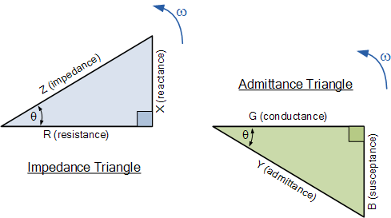

Now that we have an admittance triangle, we can use Pythagoras to calculate the magnitudes of all three sides as well as the phase angle as shown.
from Pythagoras
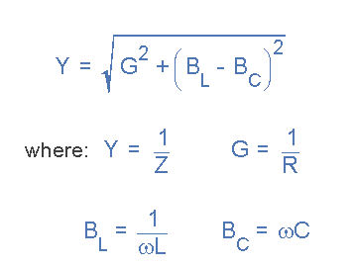
Then we can define both the admittance of the circuit and the impedance with respect to admittance as:
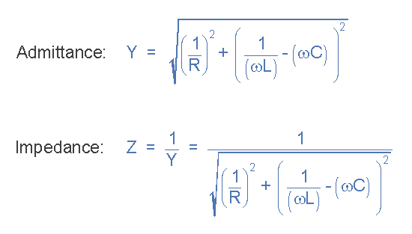
Giving us a power factor angle of:
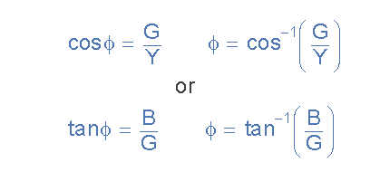
As the admittance, Y of a parallel RLC circuit is a complex quantity, the admittance corresponding to the general form of impedance Z = R + jX for series circuits will be written as Y = G – jB for parallel circuits where the real part G is the conductance and the imaginary part jB is the susceptance. In polar form this will be given as:
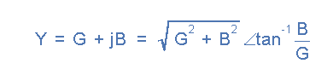

Parallel RLC Circuit Summary
In a parallel RLC circuit containing a resistor, an inductor and a capacitor the circuit current I_{S} is the phasor sum made up of three components, I_{R}, I_{L} and I_{C} with the supply voltage common to all three. Since the supply voltage is common to all three components it is used as the horizontal reference when constructing a current triangle.
Parallel RLC networks can be analysed using vector diagrams just the same as with series RLC circuits. However, the analysis of parallel RLC circuits is a little more mathematically difficult than for series RLC circuits when it contains two or more current branches. So an AC parallel circuit can be easily analysed using the reciprocal of impedance called Admittance.
Admittance is the reciprocal of impedance given the symbol, Y. Like impedance, it is a complex quantity consisting of a real part and an imaginary part. The real part is the reciprocal of resistance and is called Conductance, symbol Y while the imaginary part is the reciprocal of reactance and is called Susceptance, symbol B and expressed in complex form as: Y = G + jB with the duality between the two complex impedance’s being defined as:
Series Circuit | Parallel Circuit
Voltage, (V) | Current, (I)
Resistance, (R) | Conductance, (G)
Reactance, (X) | Susceptance, (B)
Impedance, (Z) | Admittance, (Y)
As susceptance is the reciprocal of reactance, in an inductive circuit, inductive susceptance, B_{L} will be negative in value and in a capacitive circuit, capacitive susceptance, B_{C} will be positive in value. The exact opposite to X_{L} and X_{C} respectively.
We have seen so far that series and parallel RLC circuits contain both capacitive reactance and inductive reactance within the same circuit. If we vary the frequency across these circuits there must become a point where the capacitive reactance value equals that of the inductive reactance and therefore, X_{C} = X_{L}.

Parallel Resonance Circuit
Parallel resonance occurs when the supply frequency creates zero phase difference between the supply voltage and current producing a resistive circuit.
In many ways a parallel resonance circuit is exactly the same as the series resonance circuit we looked at in the previous tutorial. Both are 3-element networks that contain two reactive components making them a second-order circuit, both are influenced by variations in the supply frequency and both have a frequency point where their two reactive components cancel each other out influencing the characteristics of the circuit. Both circuits have a resonant frequency point.
The difference this time however, is that a parallel resonance circuit is influenced by the currents flowing through each parallel branch within the parallel LC tank circuit. A tank circuit is a parallel combination of L and C that is used in filter networks to either select or reject AC frequencies. Consider the parallel RLC circuit below.

Parallel RLC Circuit

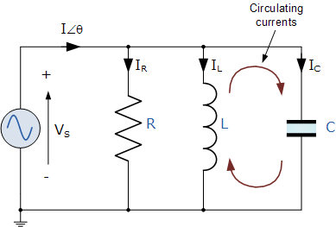

Let us define what we already know about parallel RLC circuits.

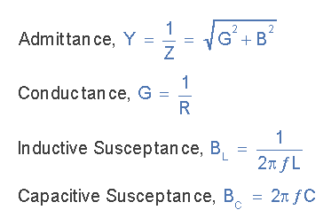
A parallel circuit containing a resistance, R, an inductance, L and a capacitance, C will produce a parallel resonance (also called anti-resonance) circuit when the resultant current through the parallel combination is in phase with the supply voltage. At resonance there will be a large circulating current between the inductor and the capacitor due to the energy of the oscillations, then parallel circuits produce current resonance.
A parallel resonant circuit stores the circuit energy in the magnetic field of the inductor and the electric field of the capacitor. This energy is constantly being transferred back and forth between the inductor and the capacitor which results in zero current and energy being drawn from the supply.
This is because the corresponding instantaneous values of I_{L} and I_{C} will always be equal and opposite and therefore the current drawn from the supply is the vector addition of these two currents and the current flowing in I_{R}.
In the solution of AC parallel resonance circuits we know that the supply voltage is common for all branches, so this can be taken as our reference vector. Each parallel branch must be treated separately as with series circuits so that the total supply current taken by the parallel circuit is the vector addition of the individual branch currents.
Then there are two methods available to us in the analysis of parallel resonance circuits. We can calculate the current in each branch and then add together or calculate the admittance of each branch to find the total current.
We know from the previous series resonance tutorial that resonance takes place when V_{L} = -V_{C} and this situation occurs when the two reactances are equal, X_{L} = X_{C}. The admittance of a parallel circuit is given as:

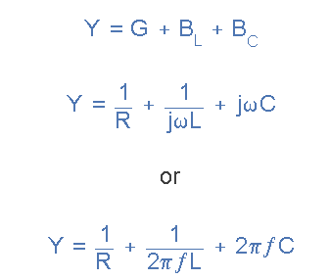
Resonance occurs when X_{L} = X_{C} and the imaginary parts of Y become zero. Then:
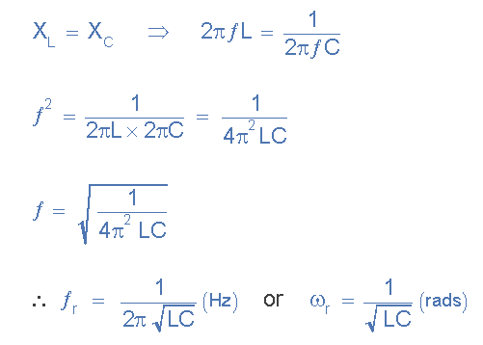
Notice that at resonance the parallel circuit produces the same equation as for the series resonance circuit. Therefore, it makes no difference if the inductor or capacitor is connected in parallel or series.
Also at resonance the parallel LC tank circuit acts like an open circuit with the circuit current being determined by the resistor, R only. So the total impedance of a parallel resonance circuit at resonance becomes just the value of the resistance in the circuit and Z = R as shown.
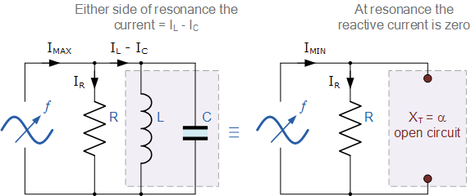

Thus at resonance, the impedance of the parallel circuit is at its maximum value and equal to the resistance of the circuit creating a circuit condition of high resistance and low current. Also at resonance, as the impedance of the circuit is now that of resistance only, the total circuit current, I will be “in-phase” with the supply voltage, V_{S}.
We can change the circuit’s frequency response by changing the value of this resistance. Changing the value of R affects the amount of current that flows through the circuit at resonance, if both L and C remain constant. Then the impedance of the circuit at resonance Z = R_{MAX} is called the “dynamic impedance” of the circuit.

Impedance in a Parallel Resonance Circuit
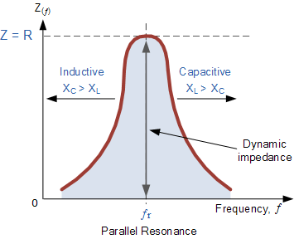
Note that if the parallel circuits impedance is at its maximum at resonance then consequently, the circuits admittance must be at its minimum and one of the characteristics of a parallel resonance circuit is that admittance is very low limiting the circuits current. Unlike the series resonance circuit, the resistor in a parallel resonance circuit has a damping effect on the circuits bandwidth making the circuit less selective.
Also, since the circuit current is constant for any value of impedance, Z, the voltage across a parallel resonance circuit will have the same shape as the total impedance and for a parallel circuit the voltage waveform is generally taken from across the capacitor.
We now know that at the resonant frequency, ƒ_{r} the admittance of the circuit is at its minimum and is equal to the conductance, G given by 1/R because in a parallel resonance circuit the imaginary part of admittance, i.e. the susceptance, B is zero because B_{L} = B_{C} as shown.

Susceptance at Resonance
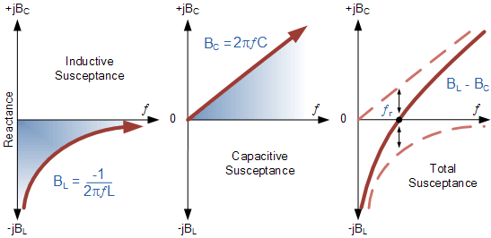
From above, the inductive susceptance, B_{L} is inversely proportional to the frequency as represented by the hyperbolic curve. The capacitive susceptance, B_{C} is directly proportional to the frequency and is therefore represented by a straight line. The final curve shows the plot of total susceptance of the parallel resonance circuit versus the frequency and is the difference between the two susceptance’s.
Then we can see that at the resonant frequency point were it crosses the horizontal axis the total circuit susceptance is zero. Below the resonant frequency point, the inductive susceptance dominates the circuit producing a “lagging” power factor, whereas above the resonant frequency point the capacitive susceptance dominates producing a “leading” power factor.
So at the resonant frequency, ƒr the current drawn from the supply must be “in-phase” with the applied voltage as effectively there is only the resistance present in the parallel circuit, so the power factor becomes one or unity, ( θ = 0º ).
Also as the impedance of a parallel circuit changes with frequency, this makes the circuit impedance “dynamic” with the current at resonance being in-phase with the voltage since the impedance of the circuit acts as a resistance. Then we have seen that the impedance of a parallel circuit at resonance is equivalent to the value of the resistance and this value must, therefore represent the maximum dynamic impedance (Z_{d}) of the circuit as shown.
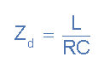

Current in a Parallel Resonance Circuit
As the total susceptance is zero at the resonant frequency, the admittance is at its minimum and is equal to the conductance, G. Therefore at resonance the current flowing through the circuit must also be at its minimum as the inductive and capacitive branch currents are equal ( I_{L} = I_{C} ) and are 180º out of phase.
We remember that the total current flowing in a parallel RLC circuit is equal to the vector sum of the individual branch currents and for a given frequency is calculated as:
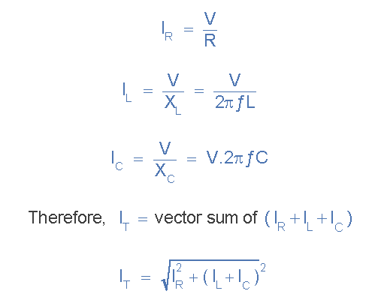
At resonance, currents I_{L} and I_{C} are equal and cancelling giving a net reactive current equal to zero. Then at resonance the above equation becomes.
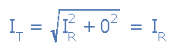
Since the current flowing through a parallel resonance circuit is the product of voltage divided by impedance, at resonance the impedance, Z is at its maximum value, ( =R ). Therefore, the circuit current at this frequency will be at its minimum value of V/R and the graph of current against frequency for a parallel resonance circuit is given as.

Parallel Circuit Current at Resonance
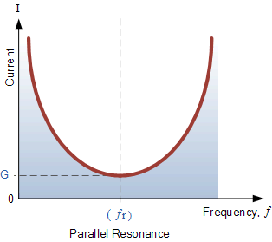
The frequency response curve of a parallel resonance circuit shows that the magnitude of the current is a function of frequency and plotting this onto a graph shows us that the response starts at its maximum value, reaches its minimum value at the resonance frequency when I_{MIN} = I_{R} and then increases again to maximum as ƒ becomes infinite.
The result of this is that the magnitude of the current flowing through the inductor, L and the capacitor, C tank circuit can become many times larger than the supply current, even at resonance but as they are equal and at opposition ( 180º out-of-phase ) they effectively cancel each other out.
As a parallel resonance circuit only functions on resonant frequency, this type of circuit is also known as an Rejecter Circuit because at resonance, the impedance of the circuit is at its maximum thereby suppressing or rejecting the current whose frequency is equal to its resonant frequency. The effect of resonance in a parallel circuit is also called “current resonance”.
The calculations and graphs used above for defining a parallel resonance circuit are similar to those we used for a series circuit. However, the characteristics and graphs drawn for a parallel circuit are exactly opposite to that of series circuits with the parallel circuits maximum and minimum impedance, current and magnification being reversed. Which is why a parallel resonance circuit is also called an Anti-resonance circuit.

Bandwidth & Selectivity of a Parallel Resonance Circuit
The bandwidth of a parallel resonance circuit is defined in exactly the same way as for the series resonance circuit. The upper and lower cut-off frequencies given as: ƒ_{upper} and ƒ_{lower} respectively denote the half-power frequencies where the power dissipated in the circuit is half of the full power dissipated at the resonant frequency 0.5( I² R ) which gives us the same -3dB points at a current value that is equal to 70.7% of its maximum resonant value, ( 0.707 x I )² R
As with the series circuit, if the resonant frequency remains constant, an increase in the quality factor, Q will cause a decrease in the bandwidth and likewise, a decrease in the quality factor will cause an increase in the bandwidth as defined by:
BW = ƒ_{r} /Q or BW = ƒ_{upper} - ƒ_{lower}
Also changing the ratio between the inductor, L and the capacitor, C, or the value of the resistance, R the bandwidth and therefore the frequency response of the circuit will be changed for a fixed resonant frequency. This technique is used extensively in tuning circuits for radio and television transmitters and receivers.
The selectivity or Q-factor for a parallel resonance circuit is generally defined as the ratio of the circulating branch currents to the supply current and is given as:
Note that the Q-factor of a parallel resonance circuit is the inverse of the expression for the Q-factor of the series circuit. Also in series resonance circuits the Q-factor gives the voltage magnification of the circuit, whereas in a parallel circuit it gives the current magnification.

Bandwidth of a Parallel Resonance Circuit

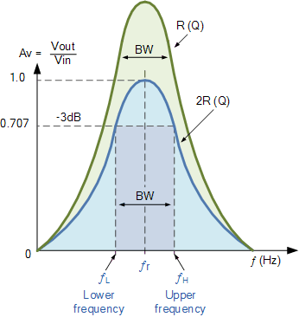

Parallel Resonance Summary
We have seen that Parallel Resonance circuits are similar to series resonance circuits. Resonance occurs in a parallel RLC circuit when the total circuit current is “in-phase” with the supply voltage as the two reactive components cancel each other out.
At resonance the admittance of the circuit is at its minimum and is equal to the conductance of the circuit. Also at resonance the current drawn from the supply is also at its minimum and is determined by the value of the parallel resistance.
The equation used to calculate the resonant frequency point is the same for the previous series circuit. However, while the use of either pure or impure components in the series RLC circuit does not affect the calculation of the resonance frequency, but in a parallel RLC circuit it does.
In this tutorial about parallel resonance, we have assumed that the the two reactive components are purely inductive and purely capacitive with zero impedance. However in reality, the inductor will contain some amount resistance in series, R_{S} with its inductive coil, since inductors (and solenoids) are wound coils of wire, usually made from copper, wrapped around a central core.
Therefore the basic equation above for calculating the parallel resonant frequency, ƒ_{r} of a pure parallel resonance circuit will need to be modified slightly to take account of the impure inductor having a series resistance.

Resonant Frequency using Impure Inductor

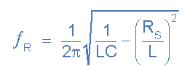
Where: L is the inductance of the coil, C is the parallel capacitance and R_{S} is the DC resistive value of the coil.

