Eight Classic Storytelling Techniques

Monomyth

The Monomyth also called hero’s journey is one of the most commonly used storytelling techniques. This storytelling technique is found in many folk tales, myths and religious writing around the world.
In this technique the whole story revolves around the hero’s journey from a safe and known place, circumstance to unknown, threating one and overcoming it with a change within himself.
This technique is good for
Taking the audience on a journey
Showing the benefit of taking risks
Demonstrating how you learned some newfound wisdom

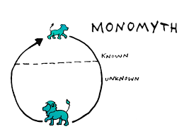

Mountain

The mountain structure is the way of mapping the tension and dramatic element in a story. It is almost similar to the monomyth but it doesn’t have a happy ending unlike monomyth.
The first part of the story introduces us the lead character/characters and put the setting of the story, followed by a series of challenges and raising dramatic action before a climatic conclusion.
Best examples are- Televise series of serials where in each episode there are few challenges and ups and downs all building up to a finale at the end of the series.

This technique is good for
Showing how you overcame a series of challenges
Slowly building tension
Delivering a satisfying conclusion

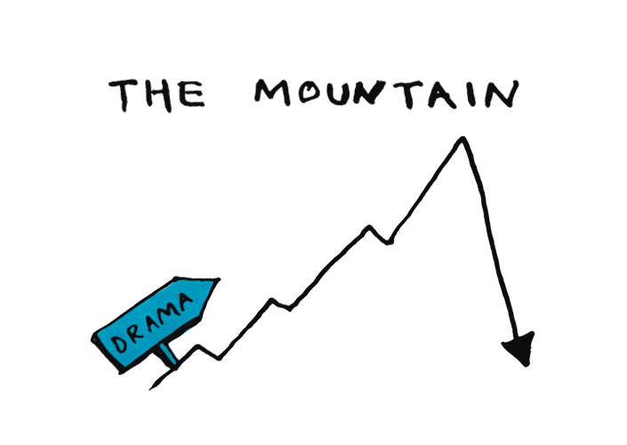

Nested Loop

Nested loops are a storytelling technique where three or more narratives are layered within each other.
The most important story – the core story with message is put in the centre, and other relating stories are used around it to elaborate or explain that central principle or the massage.
The story that begins first in this technique also finish at last.
Nested loops work a bit like a friend telling to another friend about a wise person in their life, someone who taught them an important lesson. The first loops are the friend's story, the second loops are the wise person's story. At the centre is the important lesson.

This technique is good for
Explaining the process of how you were inspired/ came to a conclusion
Using analogies to explain a central concept
Showing how a piece of wisdom was passed along to you

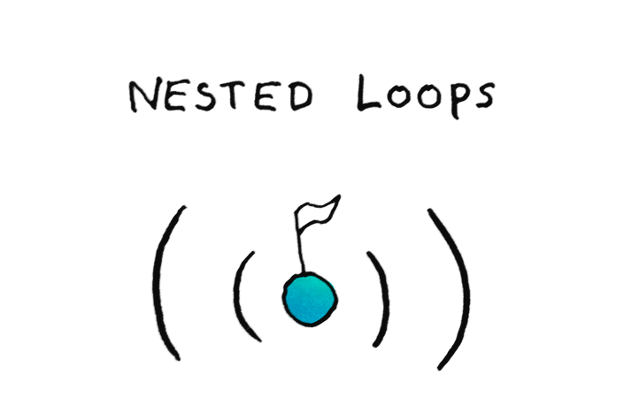

Sparklines
This storytelling technique put forward contrasting image of what it is and what could it be. It easily helps to grab the attention of the audience by making them believe that what we are actually having could have been batter. This technique helps to point out social and personal problems within the audience and arose a desire to have change.
This technique is highly emotional capturing and using the audience emotions for support of the storyteller.

This technique is good for

Inspiring the audience to action
Creating hope and excitement
Creating a following

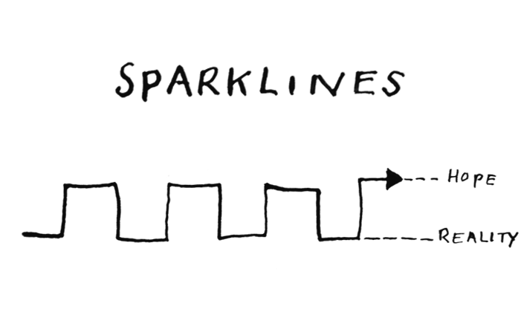

In Medias- Res

In this storytelling technique the story starts in heated argument or in the heat of the action and suddenly starting it over again from the beginning to explain how it occurred.
By starting the narrative from the most exiting part of the story the audience’s attention is easily drowned into it and they will stay engaged to know what actually happened. This technique makes the audience curious.

This technique is good for
Grabbing attention from the start
Keep an audience craving resolution
Focusing attention on a pivotal moment in your story

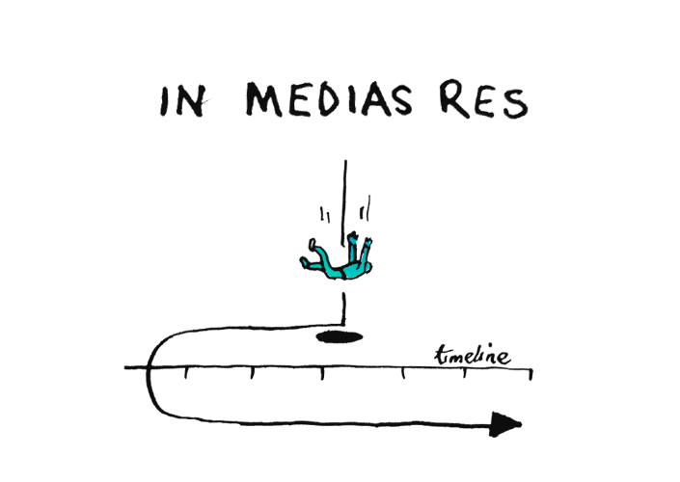

Conversing Idea

This technique is very useful while giving speech. This technique is useful to show the audience how different thinking, diverse personality etc comes together to form one product or idea. It can easily help to explain the birth of a movement or explain how a single idea with the culmination of several great minds work together for a particular goal.
Conversing idea is similar to the nested loop technique but rather then framing one story with complementary stories it can show several equally important stories having one strong conclusion.

This technique could be used to tell the stories of some of the world's greatest partnerships – for example, web developers Larry Page and Sergey Brin

This technique is good for
Showing how great minds came together
Demonstrating how a development occurred at a certain point in history
Showing how symbiotic relationships have formed

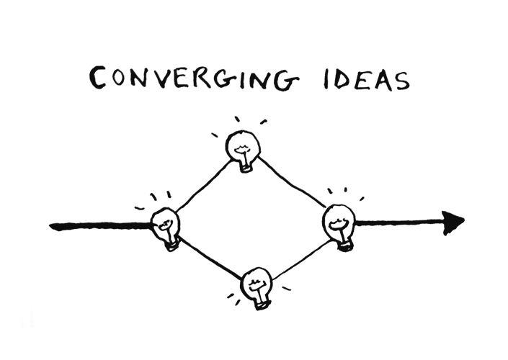

False Start

A 'false start' story is when it is started by telling a seemingly predictable story, before unexpectedly disrupting it and beginning it over again.
In this technique audience are given a false sense of security, and then shock them by turning the tables.
This format is great for talking about failure and things that one learned from that experience.

This technique is good for

Disrupting audience expectations
Showing the benefits of a flexible approach
Keeping the audience engaged

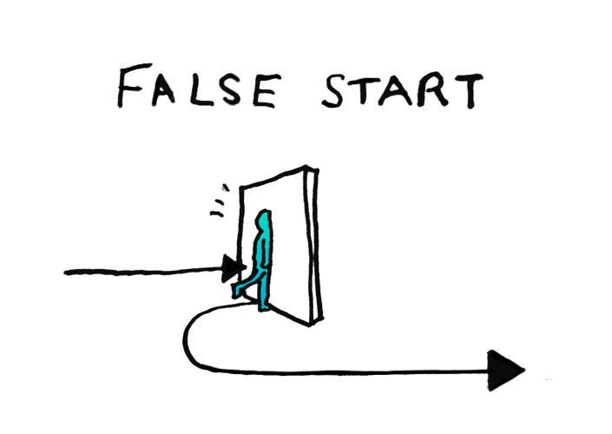

Petal Structure
The petal structure is a way of organising multiple speakers or stories around one central concept. This technique is useful when several unrelated stories or narrative have a single related massage or motive.
Here stories are told one by one before returning back to the centre. The petals can overlap as one story introduces the next but each should be a complete narrative in itself. By showing the audience how all these key stories are related to one another, it leaves them feeling the true importance and weight of the message.

This technique is good for

Demonstrating how strands of a story or process are interconnected
Showing how several scenarios relate back to one idea
Letting multiple speakers talk around a central theme

