Introduction to AC & DC
Direct Current or D.C. as it is more commonly called, is a form of electrical current or voltage that flows around an electrical circuit in one direction only, making it a “Uni-directional” supply.
Generally, both DC currents and voltages are produced by power supplies, batteries, dynamos and solar cells to name a few. A DC voltage or current has a fixed magnitude (amplitude) and a definite direction associated with it. For example, +12V represents 12 volts in the positive direction, or -5V represents 5 volts in the negative direction.
We also know that DC power supplies do not change their value with regards to time, they are a constant value flowing in a continuous steady state direction. In other words, DC maintains the same value for all times and a constant uni-directional DC supply never changes or becomes negative unless its connections are physically reversed. An example of a simple DC or direct current circuit is shown below.

DC Circuit and Waveform
An alternating function or AC Waveform on the other hand is defined as one that varies in both magnitude and direction in more or less an even manner with respect to time making it a “Bi-directional” waveform. An AC function can represent either a power source or a signal source with the shape of an AC waveform generally following that of a mathematical sinusoid being defined as: A(t) = A_{max}*sin(2πƒt).
The term AC or to give it its full description of Alternating Current, generally refers to a time-varying waveform with the most common of all being called a Sinusoid better known as a Sinusoidal Waveform. Sinusoidal waveforms are more generally called by their short description as Sine Waves. Sine waves are by far one of the most important types of AC waveform used in electrical engineering.
The shape obtained by plotting the instantaneous ordinate values of either voltage or current against time is called an AC Waveform. An AC waveform is constantly changing its polarity every half cycle alternating between a positive maximum value and a negative maximum value respectively with regards to time with a common example of this being the domestic mains voltage supply we use in our homes.
This means then that the AC Waveform is a “time-dependent signal” with the most common type of time-dependent signal being that of the Periodic Waveform. The periodic or AC waveform is the resulting product of a rotating electrical generator. Generally, the shape of any periodic waveform can be generated using a fundamental frequency and superimposing it with harmonic signals of varying frequencies and amplitudes but that’s for another tutorial.
Alternating voltages and currents cannot be stored in batteries or cells like direct current (DC) can, it is much easier and cheaper to generate these quantities using alternators or waveform generators when they are needed. The type and shape of an AC waveform depends upon the generator or device producing them, but all AC waveforms consist of a zero voltage line that divides the waveform into two symmetrical halves. The main characteristics of an AC Waveform are defined as:

AC Waveform Characteristics
- • The Period, (T) is the length of time in seconds that the waveform takes to repeat itself from start to finish. This can also be called the Periodic Time of the waveform for sine waves, or the Pulse Width for square waves.
- • The Frequency, (ƒ) is the number of times the waveform repeats itself within a one second time period. Frequency is the reciprocal of the time period, ( ƒ = 1/T ) with the unit of frequency being the Hertz, (Hz).
- • The Amplitude (A) is the magnitude or intensity of the signal waveform measured in volts or amps.
In our tutorial about Waveforms ,we looked at different types of waveforms and said that “Waveforms are basically a visual representation of the variation of a voltage or current plotted to a base of time”. Generally, for AC waveforms this horizontal base line represents a zero condition of either voltage or current. Any part of an AC type waveform which lies above the horizontal zero axis represents a voltage or current flowing in one direction.
Likewise, any part of the waveform which lies below the horizontal zero axis represents a voltage or current flowing in the opposite direction to the first. Generally for sinusoidal AC waveforms the shape of the waveform above the zero axis is the same as the shape below it. However, for most non-power AC signals including audio waveforms this is not always the same case.
The most common periodic signal waveforms that are used in Electrical and Electronic Engineering are the Sinusoidal Waveforms. However, an alternating AC waveform may not always take the shape of a smooth shape based around the trigonometric sine or cosine function. AC waveforms can also take the shape of either Complex Waves, Square Waves or Triangular Waves and these are shown below.

Types of Periodic Waveform

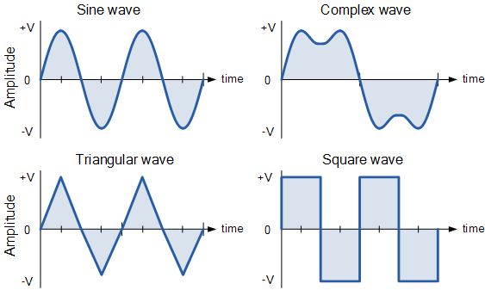

The time taken for an AC Waveform to complete one full pattern from its positive half to its negative half and back to its zero baseline again is called a Cycle and one complete cycle contains both a positive half-cycle and a negative half-cycle. The time taken by the waveform to complete one full cycle is called the Periodic Time of the waveform, and is given the symbol “T”.
The number of complete cycles that are produced within one second (cycles/second) is called the Frequency, symbol ƒ of the alternating waveform. Frequency is measured in Hertz, ( Hz ) named after the German physicist Heinrich Hertz.
Then we can see that a relationship exists between cycles (oscillations), periodic time and frequency (cycles per second), so if there are ƒ number of cycles in one second, each individual cycle must take 1/ƒ seconds to complete.

Relationship Between Frequency and Period
Frequency used to be expressed in “cycles per second” abbreviated to “cps”, but today it is more commonly specified in units called “Hertz”. For a domestic mains supply the frequency will be either 50Hz or 60Hz depending upon the country and is fixed by the speed of rotation of the generator. But one hertz is a very small unit so prefixes are used that denote the order of magnitude of the waveform at higher frequencies such as kHz, MHz and even GHz.

Definition of Frequency Prefixes

Prefix | Definition | Written as | Periodic Time
Kilo | Thousand | kHz | 1ms
Mega | Million | MHz | 1us
Giga | Billion | GHz | 1ns
Terra | Trillion | THz | 1ps

Amplitude of an AC Waveform
As well as knowing either the periodic time or the frequency of the alternating quantity, another important parameter of the AC waveform is Amplitude, better known as its Maximum or Peak value represented by the terms, Vmax for voltage or Imax for current.
The peak value is the greatest value of either voltage or current that the waveform reaches during each half cycle measured from the zero baseline. Unlike a DC voltage or current which has a steady state that can be measured or calculated using Ohm’s Law, an alternating quantity is constantly changing its value over time.
For pure sinusoidal waveforms this peak value will always be the same for both half cycles ( +Vm = -Vm ) but for non-sinusoidal or complex waveforms the maximum peak value can be very different for each half cycle. Sometimes, alternating waveforms are given a peak-to-peak, Vp-p value and this is simply the distance or the sum in voltage between the maximum peak value, +Vmax and the minimum peak value, -Vmax during one complete cycle.

The Average Value of an AC Waveform
The average or mean value of a continuous DC voltage will always be equal to its maximum peak value as a DC voltage is constant. This average value will only change if the duty cycle of the DC voltage changes. In a pure sine wave if the average value is calculated over the full cycle, the average value would be equal to zero as the positive and negative halves will cancel each other out. So the average or mean value of an AC waveform is calculated or measured over a half cycle only and this is shown below.

Average Value of a Non-sinusoidal Waveform
To find the average value of the waveform we need to calculate the area underneath the waveform using the mid-ordinate rule, trapezoidal rule or the Simpson’s rule found commonly in mathematics. The approximate area under any irregular waveform can easily be found by simply using the mid-ordinate rule.
The zero axis base line is divided up into any number of equal parts and in our simple example above this value was nine, ( V₁ to V₉ ). The more ordinate lines that are drawn the more accurate will be the final average or mean value. The average value will be the addition of all the instantaneous values added together and then divided by the total number. This is given as.

Average Value of an AC Waveform

$$V_{Ave}=\frac{2}{π}V_{max}$$

For a pure sinusoidal waveform this average or mean value will always be equal to 0.637*V_{max} and this relationship also holds true for average values of current.

The RMS Value of an AC Waveform
The average value of an AC waveform that we calculated above as being: 0.637*V_{max} ($\frac{2}{π}V_{max}$) is NOT the same value we would use for a DC supply. This is because unlike a DC supply which is constant and and of a fixed value, an AC waveform is constantly changing over time and has no fixed value. Thus the equivalent value for an alternating current system that provides the same amount of electrical power to a load as a DC equivalent circuit is called the “effective value”.
The effective value of a sine wave produces the same I²*R heating effect in a load as we would expect to see if the same load was fed by a constant DC supply. The effective value of a sine wave is more commonly known as the Root Mean Squared or simply RMS value as it is calculated as the square root of the mean (average) of the square of the voltage or current.
That is V_{rms} or I_{rms} is given as the square root of the average of the sum of all the squared mid-ordinate values of the sine wave. The RMS value for any AC waveform can be found from the following modified average value formula as shown.

RMS Value of an AC Waveform
$I_{RMS}=\frac{1}{\sqrt{2}}I_{max}$ or $V_{RMS}=\frac{1}{\sqrt{2}}V_{max}$

For a pure sinusoidal waveform this effective or R.M.S. value will always be equal too: 1/√2*V_{max} which is equal to 0.707*V_{max} and this relationship holds true for RMS values of current. The RMS value for a sinusoidal waveform is always greater than the average value except for a rectangular waveform. In this case the heating effect remains constant so the average and the RMS values will be the same.
One final comment about R.M.S. values. Most multimeters, either digital or analogue unless otherwise stated only measure the R.M.S. values of voltage and current and not the average. Therefore when using a multimeter on a direct current system the reading will be equal to I = V/R and for an alternating current system the reading will be equal to Irms = Vrms/R.
Also, except for average power calculations, when calculating RMS or peak voltages, only use V_{RMS} to find I_{RMS} values, or peak voltage, Vp to find peak current, Ip values. Do not mix them together as Average, RMS or Peak values of a sine wave are completely different and your results will definitely be incorrect.

Form Factor and Crest Factor
Although little used these days, both Form Factor and Crest Factor can be used to give information about the actual shape of the AC waveform. Form Factor is the ratio between the average value and the RMS value and is given as.

For a pure sinusoidal waveform the Form Factor will always be equal to 1.11. Crest Factor is the ratio between the R.M.S. value and the Peak value of the waveform and is given as.

For a pure sinusoidal waveform the Crest Factor will always be equal to 1.414.

AC Waveform Example No2
A sinusoidal alternating current of 6 amps is flowing through a resistance of 40Ω. Calculate the average voltage and the peak voltage of the supply.
The use and calculation of Average, R.M.S, Form factor and Crest Factor can also be used with any type of periodic waveform including Triangular, Square, Saw-toothed or any other irregular or complex voltage/current waveform shape. Conversion between the various sinusoidal values can sometimes be confusing so the following table gives a convenient way of converting one sine wave value to another.

Sinusoidal Waveform Conversion Table
Convert From | Multiply By | Or By | To Get Value
Peak | 2 | (√2)² | Peak-to-Peak
Peak-to-Peak | 0.5 | 1/2 | Peak
Peak | 0.707 | 1/(√2) | RMS
Peak | 0.637 | 2/π | Average
Average | 1.570 | π/2 | Peak
Average | 1.111 | π/(2√2) | RMS
RMS | 1.414 | √2 | Peak
RMS | 0.901 | (2√2)/π | Average

A Sinusoidal Waveform is an alternating quantity that can be presented graphically in the time domain along an horizontal zero axis. We also saw that as an alternating quantity, sine waves have a positive maximum value at time π/2, a negative maximum value at time 3π/2, with zero values occurring along the baseline at 0, π and 2π.
However, not all sinusoidal waveforms will pass exactly through the zero axis point at the same time, but may be “shifted” to the right or to the left of 0º by some value when compared to another sine wave.
For example, comparing a voltage waveform to that of a current waveform. This then produces an angular shift or Phase Difference between the two sinusoidal waveforms. Any sine wave that does not pass through zero at t = 0 has a phase shift.
The phase difference or phase shift as it is also called of a Sinusoidal Waveform is the angle Φ (Greek letter Phi), in degrees or radians that the waveform has shifted from a certain reference point along the horizontal zero axis. In other words phase shift is the lateral difference between two or more waveforms along a common axis and sinusoidal waveforms of the same frequency can have a phase difference.
The phase difference, Φ of an alternating waveform can vary from between 0 to its maximum time period, T of the waveform during one complete cycle and this can be anywhere along the horizontal axis between, Φ = 0 to 2π (radians) or Φ = 0 to 360º depending upon the angular units used.
Phase difference can also be expressed as a time shift of τ in seconds representing a fraction of the time period, T for example, +10mS or – 50uS but generally it is more common to express phase difference as an angular measurement.
Then the equation for the instantaneous value of a sinusoidal voltage or current waveform we developed in the previous Sinusoidal Waveform will need to be modified to take account of the phase angle of the waveform and this new general expression become

Phase Difference Equation

$$A_{\left(t\right)}=A_{max}\sin\left(ωt±Φ\right)$$
Where:
I_{max} – is the amplitude of the waveform.
ω – is the angular frequency of the waveform in radian/sec.
Φ (phi) – is the phase angle in degrees or radians that the waveform has shifted either left or right from the reference point.
If the positive slope of the sinusoidal waveform passes through the horizontal axis “before” t = 0 then the waveform has shifted to the left so Φ >0, and the phase angle will be positive in nature, +Φ giving a leading phase angle. In other words it appears earlier in time than 0º producing an anticlockwise rotation of the vector.
Likewise, if the positive slope of the sinusoidal waveform passes through the horizontal x-axis some time “after” t = 0 then the waveform has shifted to the right so Φ <0, and the phase angle will be negative in nature -Φ producing a lagging phase angle as it appears later in time than 0º producing a clockwise rotation of the vector. Both cases are shown below.

Phase Relationship of a Sinusoidal Waveform

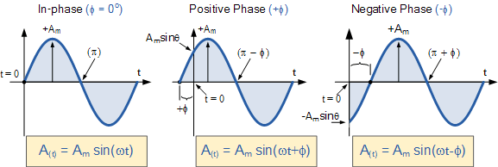

Firstly, let’s consider that two alternating quantities such as a voltage, v and a current, i have the same frequency ƒ in Hertz. As the frequency of the two quantities is the same the angular velocity, ω must also be the same. So at any instant in time we can say that the phase of voltage, v will be the same as the phase of the current, i.
Then the angle of rotation within a particular time period will always be the same and the phase difference between the two quantities of v and i will therefore be zero and Φ = 0. As the frequency of the voltage, v and the current, i are the same they must both reach their maximum positive, negative and zero values during one complete cycle at the same time (although their amplitudes may be different). Then the two alternating quantities, v and i are said to be “in-phase”.

Two Sinusoidal Waveforms – “in-phase”

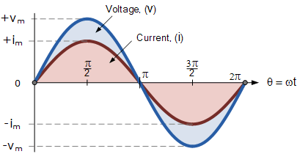
Now let’s consider that the voltage, v and the current, i have a phase difference between themselves of 30º, so (Φ = 30º or π/6 radians). As both alternating quantities rotate at the same speed, i.e. they have the same frequency, this phase difference will remain constant for all instants in time, then the phase difference of 30º between the two quantities is represented by phi, Φ as shown below.

Phase Difference of a Sinusoidal Waveform

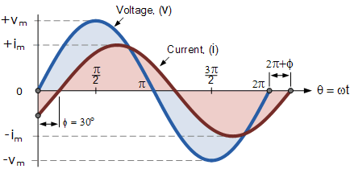

The voltage waveform above starts at zero along the horizontal reference axis, but at that same instant of time the current waveform is still negative in value and does not cross this reference axis until 30º later. Then there exists a Phase difference between the two waveforms as the current cross the horizontal reference axis reaching its maximum peak and zero values after the voltage waveform.
As the two waveforms are no longer “in-phase”, they must therefore be “out-of-phase” by an amount determined by phi, Φ and in our example this is 30º. So we can say that the two waveforms are now 30º out-of phase. The current waveform can also be said to be “lagging” behind the voltage waveform by the phase angle, Φ. Then in our example above the two waveforms have a Lagging Phase Difference so the expression for both the voltage and current above will be given as.
Voltage ( $V_{t}$)= $V_{m}\sin\left(ωt\right)$
Current ( $I_{t}$)= $I_{m}\sin\left(ωt-Φ\right)$
where, i lags v by angle Φ
Likewise, if the current, i has a positive value and crosses the reference axis reaching its maximum peak and zero values at some time before the voltage, v then the current waveform will be “leading” the voltage by some phase angle. Then the two waveforms are said to have a Leading Phase Difference and the expression for both the voltage and the current will be.
Voltage ( $V_{t}$)= $V_{m}\sin\left(ωt\right)$
Current ( $I_{t}$)= $I_{m}\sin\left(ωt+Φ\right)$
where, i leads v by angle Φ
The phase angle of a sine wave can be used to describe the relationship of one sine wave to another by using the terms “Leading” and “Lagging” to indicate the relationship between two sinusoidal waveforms of the same frequency, plotted onto the same reference axis. In our example above the two waveforms are out-of-phase by 30º. So we can correctly say that i lags v or we can say that v leads i by 30º depending upon which one we choose as our reference.
The relationship between the two waveforms and the resulting phase angle can be measured anywhere along the horizontal zero axis through which each waveform passes with the “same slope” direction either positive or negative.
In AC power circuits this ability to describe the relationship between a voltage and a current sine wave within the same circuit is very important and forms the bases of AC circuit analysis.

The Cosine Waveform
So we now know that if a waveform is “shifted” to the right or left of 0º when compared to another sine wave the expression for this waveform becomes A_{m} sin(ωt ± Φ). But if the waveform crosses the horizontal zero axis with a positive going slope 90º or π/2 radians before the reference waveform, the waveform is called a Cosine Waveform and the expression becomes.

Cosine Expression

$$\sin\left(ωt+{90}^{°}\right)=\sin\left(ωt+\frac{π}{2}\right)=\cos\left(ωt\right)$$
The Cosine Wave, simply called “cos”, is as important as the sine wave in electrical engineering. The cosine wave has the same shape as its sine wave counterpart that is it is a sinusoidal function, but is shifted by +90º or one full quarter of a period ahead of it.

Phase Difference between a Sine wave and a Cosine wave

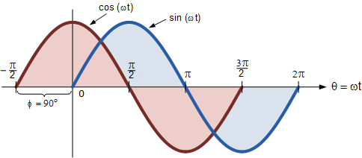

Alternatively, we can also say that a sine wave is a cosine wave that has been shifted in the other direction by -90º. Either way when dealing with sine waves or cosine waves with an angle the following rules will always apply.

Sine and Cosine Wave Relationships

$\cos\left(ωt+Φ\right)$ =$\sin\left(ωt+{Φ+90}^{°}\right)$

$sin\left(ωt+Φ\right)$=$\cos\left(ωt+{Φ-90}^{°}\right)$

Phasor Diagrams and Phasor Algebra
Phasor Diagrams are a graphical way of representing the magnitude and directional relationship between two or more alternating quantities
Sinusoidal waveforms of the same frequency can have a Phase Difference between themselves which represents the angular difference of the two sinusoidal waveforms. Also the terms “lead” and “lag” as well as “in-phase” and “out-of-phase” are commonly used to indicate the relationship of one waveform to the other with the generalized sinusoidal expression given as: A_{(t)} = A_{m} sin(ωt ± Φ) representing the sinusoid in the time-domain form.
But when presented mathematically in this way it is sometimes difficult to visualise this angular or phasor difference between two or more sinusoidal waveforms. One way to overcome this problem is to represent the sinusoids graphically within the spacial or phasor-domain form by using Phasor Diagrams, and this is achieved by the rotating vector method.
Basically a rotating vector, simply called a “Phasor” is a scaled line whose length represents an AC quantity that has both magnitude (“peak amplitude”) and direction (“phase”) which is “frozen” at some point in time.
A phasor is a vector that has an arrow head at one end which signifies partly the maximum value of the vector quantity ( V or I ) and partly the end of the vector that rotates.
Generally, vectors are assumed to pivot at one end around a fixed zero point known as the “point of origin” while the arrowed end representing the quantity, freely rotates in an anti-clockwise direction at an angular velocity, ( ω ) of one full revolution for every cycle. This anti-clockwise rotation of the vector is considered to be a positive rotation. Likewise, a clockwise rotation is considered to be a negative rotation.
Although the both the terms vectors and phasors are used to describe a rotating line that itself has both magnitude and direction, the main difference between the two is that a vectors magnitude is the “peak value” of the sinusoid while a phasors magnitude is the “rms value” of the sinusoid. In both cases the phase angle and direction remains the same.
The phase of an alternating quantity at any instant in time can be represented by a phasor diagram, so phasor diagrams can be thought of as “functions of time”. A complete sine wave can be constructed by a single vector rotating at an angular velocity of ω = 2πƒ, where ƒ is the frequency of the waveform. Then a Phasor is a quantity that has both “Magnitude” and “Direction”.
Generally, when constructing a phasor diagram, angular velocity of a sine wave is always assumed to be: ω in rad/sec. Consider the phasor diagram below.

Phasor Diagram of a Sinusoidal Waveform

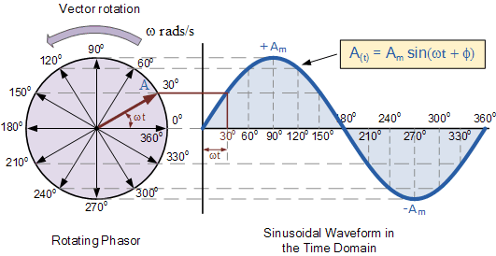

As the single vector rotates in an anti-clockwise direction, its tip at point A will rotate one complete revolution of 360º or 2π representing one complete cycle. If the length of its moving tip is transferred at different angular intervals in time to a graph as shown above, a sinusoidal waveform would be drawn starting at the left with zero time. Each position along the horizontal axis indicates the time that has elapsed since zero time, t = 0. When the vector is horizontal the tip of the vector represents the angles at 0º, 180º and at 360º.
Likewise, when the tip of the vector is vertical it represents the positive peak value, ( +Am ) at 90º or π/2 and the negative peak value, ( -Am ) at 270º or 3π/2. Then the time axis of the waveform represents the angle either in degrees or radians through which the phasor has moved. So we can say that a phasor represent a scaled voltage or current value of a rotating vector which is “frozen” at some point in time, ( t ) and in our example above, this is at an angle of 30º.
Sometimes when we are analyzing alternating waveforms we may need to know the position of the phasor, representing the Alternating Quantity at some particular instant in time especially when we want to compare two different waveforms on the same axis. For example, voltage and current. We have assumed in the waveform above that the waveform starts at time t = 0 with a corresponding phase angle in either degrees or radians.
But if a second waveform starts to the left or to the right of this zero point or we want to represent in phasor notation the relationship between the two waveforms then we will need to take into account this phase difference, Φ of the waveform. Consider the diagram below

Phase Difference of a Sinusoidal Waveform

The generalised mathematical expression to define these two sinusoidal quantities will be written as:
$V_{t}$= $V_{m}\sin\left(ωt\right)$
$I_{t}$= $I_{m}\sin\left(ωt-Φ\right)$
The current, i is lagging the voltage, v by angle Φ and in our example above this is 30º. So the difference between the two phasors representing the two sinusoidal quantities is angle Φ and the resulting phasor diagram will be.

Phasor Diagram of a Sinusoidal Waveform

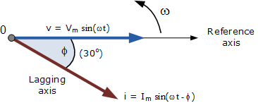
The phasor diagram is drawn corresponding to time zero ( t = 0 ) on the horizontal axis. The lengths of the phasors are proportional to the values of the voltage, ( V ) and the current, ( I ) at the instant in time that the phasor diagram is drawn. The current phasor lags the voltage phasor by the angle, Φ, as the two phasors rotate in an anticlockwise direction as stated earlier, therefore the angle, Φ is also measured in the same anticlockwise direction.

If however, the waveforms are frozen at time t, $ωt$= 30º, the corresponding phasor diagram would look like the one shown on the right. Once again the current phasor lags behind the voltage phasor as the two waveforms are of the same frequency.
However, as the current waveform is now crossing the horizontal zero axis line at this instant in time we can use the current phasor as our new reference and correctly say that the voltage phasor is “leading” the current phasor by angle, Φ. Either way, one phasor is designated as the reference phasor and all the other phasors will be either leading or lagging with respect to this reference.

Phasor Addition
Sometimes it is necessary when studying sinusoids to add together two alternating waveforms, for example in an AC series circuit, that are not in-phase with each other. If they are in-phase that is, there is no phase shift then they can be added together in the same way as DC values to find the algebraic sum of the two vectors. For example, if two voltages of say 50 volts and 25 volts respectively are together “in-phase”, they will add or sum together to form one voltage of 75 volts (50 + 25).
If however, they are not in-phase that is, they do not have identical directions or starting point then the phase angle between them needs to be taken into account so they are added together using phasor diagrams to determine their Resultant Phasor or Vector Sum by using the parallelogram law.
Consider two AC voltages, V₁ having a peak voltage of 20 volts, and V₂ having a peak voltage of 30 volts where V₁ leads V₂ by 60º. The total voltage, V_{T} of the two voltages can be found by firstly drawing a phasor diagram representing the two vectors and then constructing a parallelogram in which two of the sides are the voltages, V₁ and V₂ as shown below.

Phasor Addition of two Phasors

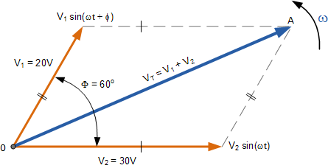
By drawing out the two phasors to scale onto graph paper, their phasor sum V₁ + V₂ can be easily found by measuring the length of the diagonal line, known as the “resultant r-vector”, from the zero point to the intersection of the construction lines 0-A. The downside of this graphical method is that it is time consuming when drawing the phasors to scale.
Also, while this graphical method gives an answer which is accurate enough for most purposes, it may produce an error if not drawn accurately or correctly to scale. Then one way to ensure that the correct answer is always obtained is by an analytical method.
Mathematically we can add the two voltages together by firstly finding their “vertical” and “horizontal” directions, and from this we can then calculate both the “vertical” and “horizontal” components for the resultant “r vector”, V_{T}. This analytical method which uses the cosine and sine rule to find this resultant value is commonly called the Rectangular Form.
In the rectangular form, the phasor is divided up into a real part, x and an imaginary part, y forming the generalised expression Z = x ± jy. ( we will discuss this in more detail in the next tutorial ). This then gives us a mathematical expression that represents both the magnitude and the phase of the sinusoidal voltage as:

Definition of a Complex Sinusoid

$$v=V_{m}\cos\left(ɸ\right)+jV_{m}\sin\left(ɸ\right)$$

So the addition of two vectors, A and B using the previous generalised expression is as follows:

A =x + j y & B=w + jz

A+B= (x+w) + j(y+z)

Phasor Addition using Rectangular Form
Voltage, V₂ of 30 volts points in the reference direction along the horizontal zero axis, then it has a horizontal component but no vertical component as follows.
• Horizontal Component = 30 cos 0º = 30 volts
• Vertical Component = 30 sin 0º = 0 volts
This then gives us the rectangular expression for voltage V₂ of: 30 + j0
Voltage, V₁ of 20 volts leads voltage, V₂ by 60º, then it has both horizontal and vertical components as follows.
• Horizontal Component = 20 cos 60º = 20 x 0.5 = 10 volts
• Vertical Component = 20 sin 60º = 20 x 0.866 = 17.32 volts
This then gives us the rectangular expression for voltage V₁ of: 10 + j17.32
The resultant voltage, V_{T} is found by adding together the horizontal and vertical components as follows.
V_{Horizontal} = sum of real parts of V₁ and V₂ = 30 + 10 = 40 volts
V_{Vertical} = sum of imaginary parts of V₁ and V₂ = 0 + 17.32 = 17.32 volts
Now that both the real and imaginary values have been found the magnitude of voltage, V_{T} is determined by simply using Pythagoras’s Theorem for a 90º triangle as follows.

$V_{T}=\sqrt{{\left(Real or Horizontal Component\right)}^{2}+{\left(Imaginary or Virtical Component\right)}^{2}}$
$V_{T}=\sqrt{{\left(40\right)}^{2}+{\left(17.32\right)}^{2}}$
$V_{T}$ =43.6 volts

Resultant Value of V_{T}

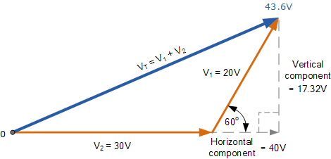

Phasor Subtraction
Phasor subtraction is very similar to the above rectangular method of addition, except this time the vector difference is the other diagonal of the parallelogram between the two voltages of V₁ and V₂ as shown.

Vector Subtraction of two Phasorss
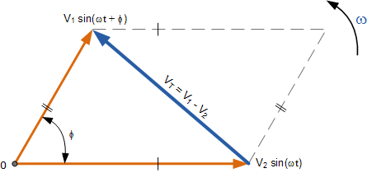
This time instead of “adding” together both the horizontal and vertical components we take them away, subtraction.

A =x + j y & B=w + jz

A-B= (x-w) + j(y-z)

Phasor Diagram Summary
Then to summarise this tutorial about Phasor Diagrams a little.
In their simplest terms, phasor diagrams are a projection of a rotating vector onto a horizontal axis which represents the instantaneous value. As a phasor diagram can be drawn to represent any instant of time and therefore any angle, the reference phasor of an alternating quantity is always drawn along the positive x-axis direction.
- Vectors, Phasors and Phasor Diagrams ONLY apply to sinusoidal AC alternating quantities.
- A Phasor Diagram can be used to represent two or more stationary sinusoidal quantities at any instant in time.
- Generally the reference phasor is drawn along the horizontal axis and at that instant in time the other phasors are drawn. All phasors are drawn referenced to the horizontal zero axis.
- Phasor diagrams can be drawn to represent more than two sinusoids. They can be either voltage, current or some other alternating quantity but the frequency of all of them must be the same.
- All phasors are drawn rotating in an anticlockwise direction. All the phasors ahead of the reference phasor are said to be “leading” while all the phasors behind the reference phasor are said to be “lagging”.
- Generally, the length of a phasor represents the r.m.s. value of the sinusoidal quantity rather than its maximum value.
- Sinusoids of different frequencies cannot be represented on the same phasor diagram due to the different speed of the vectors. At any instant in time the phase angle between them will be different.
- Two or more vectors can be added or subtracted together and become a single vector, called a Resultant Vector.
- The horizontal side of a vector is equal to the real or “x” vector. The vertical side of a vector is equal to the imaginary or “y” vector. The hypotenuse of the resultant right angled triangle is equivalent to the “r” vector.
- In a three-phase balanced system each individual phasor is displaced by 120º.
In the next tutorial about AC Theory we will look at representing sinusoidal waveforms as complex numbers in Rectangular form, Polar form and Exponential form.
Inductors and chokes are basically coils or loops of wire that are either wound around a hollow tube former (air cored) or wound around some ferromagnetic material (iron cored) to increase their inductive value called inductance.
Inductors store their energy in the form of a magnetic field that is created when a voltage is applied across the terminals of an inductor. The growth of the current flowing through the inductor is not instant but is determined by the inductors own self-induced or back emf value. Then for an inductor coil, this back emf voltage V_{L} is proportional to the rate of change of the current flowing through it.
This current will continue to rise until it reaches its maximum steady state condition which is around five time constants when this self-induced back emf has decayed to zero. At this point a steady state current is flowing through the coil, no more back emf is induced to oppose the current flow and therefore, the coil acts more like a short circuit allowing maximum current to flow through it.
However, in an alternating current circuit which contains an AC Inductance, the flow of current through an inductor behaves very differently to that of a steady state DC voltage. Now in an AC circuit, the opposition to the current flowing through the coils windings not only depends upon the inductance of the coil but also the frequency of the applied voltage waveform as it varies from its positive to negative values.
The actual opposition to the current flowing through a coil in an AC circuit is determined by the AC Resistance of the coil with this AC resistance being represented by a complex number. But to distinguish a DC resistance value from an AC resistance value, which is also known as Impedance, the term Reactance is used.
Like resistance, reactance is measured in Ohm’s but is given the symbol “X” to distinguish it from a purely resistive “R” value and as the component in question is an inductor, the reactance of an inductor is called Inductive Reactance, ( X_{L} ) and is measured in Ohms. Its value can be found from the formula.

Inductive Reactance

$X_{L}=2πfL$
Where: X_{L} = Inductive Reactance in Ohms, (Ω) π (pi) = a numeric constant of 3.142
ƒ = Frequency in Hertz, (Hz) L = Inductance in Henries, (H)
We can also define inductive reactance in radians, where Omega, ω equals 2πƒ.
So whenever a sinusoidal voltage is applied to an inductive coil, the back emf opposes the rise and fall of the current flowing through the coil and in a purely inductive coil which has zero resistance or losses, this impedance (which can be a complex number) is equal to its inductive reactance. Also reactance is represented by a vector as it has both a magnitude and a direction (angle). Consider the circuit below.

AC Inductance with a Sinusoidal Supply

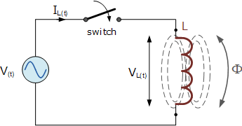

This simple circuit above consists of a pure inductance of L Henries ( H ), connected across a sinusoidal voltage given by the expression: V(t) = V_{max} sin ωt. When the switch is closed this sinusoidal voltage will cause a current to flow and rise from zero to its maximum value. This rise or change in the current will induce a magnetic field within the coil which in turn will oppose or restrict this change in the current.
But before the current has had time to reach its maximum value as it would in a DC circuit, the voltage changes polarity causing the current to change direction. This change in the other direction once again being delayed by the self-induced back emf in the coil, and in a circuit containing a pure inductance only, the current is delayed by 90º.
The applied voltage reaches its maximum positive value a quarter ( 1/4ƒ ) of a cycle earlier than the current reaches its maximum positive value, in other words, a voltage applied to a purely inductive circuit “LEADS” the current by a quarter of a cycle or 90º as shown below.

Sinusoidal Waveforms for AC Inductance

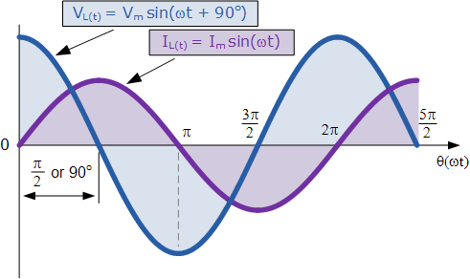
This effect can also be represented by a phasor diagram were in a purely inductive circuit the voltage “LEADS” the current by 90º. But by using the voltage as our reference, we can also say that the current “LAGS” the voltage by one quarter of a cycle or 90º as shown in the vector diagram below.

Phasor Diagram for AC Inductance

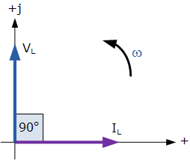
So for a pure loss less inductor, V_{L} “leads” I_{L} by 90º, or we can say that I_{L} “lags” V_{L} by 90º.
There are many different ways to remember the phase relationship between the voltage and current flowing through a pure inductor circuit, but one very simple and easy to remember way is to use the mnemonic expression “ELI” (pronounced Ellie as in the girls name). ELI stands for Electromotive force first in an AC inductance, L before the current I. In other words, voltage before the current in an inductor, E, L, I equals “ELI”, and whichever phase angle the voltage starts at, this expression always holds true for a pure inductor circuit.

The Effect of Frequency on Inductive Reactance
When a 50Hz supply is connected across a suitable AC Inductance, the current will be delayed by 90º as described previously and will obtain a peak value of I amps before the voltage reverses polarity at the end of each half cycle, i.e. the current rises up to its maximum value in “T secs“.
If we now apply a 100Hz supply of the same peak voltage to the coil, the current will still be delayed by 90º but its maximum value will be lower than the 50Hz value because the time it requires to reach its maximum value has been reduced due to the increase in frequency because now it only has “1/2 T secs” to reach its peak value. Also, the rate of change of the flux within the coil has also increased due to the increase in frequency.
Then from the above equation for inductive reactance, it can be seen that if either the Frequency OR the Inductance is increased the overall inductive reactance value of the coil would also increase. As the frequency increases and approaches infinity, the inductors reactance and therefore its impedance would also increase towards infinity acting like an open circuit.
Likewise, as the frequency approaches zero or DC, the inductors reactance would also decrease to zero, acting like a short circuit. This means then that inductive reactance is “directly proportional to frequency” and has a small value at low frequencies and a high value at higher frequencies as shown.

Inductive Reactance against Frequency
The inductive reactance of an inductor increases as the frequency across it increases therefore inductive reactance is proportional to frequency ( X_{L} α ƒ ) as the back emf generated in the inductor is equal to its inductance multiplied by the rate of change of current in the inductor.
Also as the frequency increases the current flowing through the inductor also reduces in value.
We can present the effect of very low and very high frequencies on a reactance of a pure AC Inductance as follows:
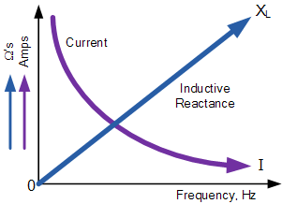
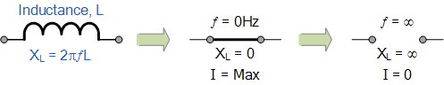
In an AC circuit containing pure inductance the following formula applies:

Current I=$\frac{VOLTAGE}{REACTANCE}=\frac{V}{X_{L}}$
So how did we arrive at this equation. Well the self-induced emf in the inductor is determined by Faraday’s Law that produces the effect of self-induction in the inductor due to the rate of change of the current and the maximum value of the induced emf will correspond to the maximum rate of change. Then the voltage in the inductor coil is given as:
$$V_{L}\left(t\right)=L\frac{di_{L}\left(t\right)}{dt }$$
If $i_{L}\left(t\right)=I_{max}\sin\left(ωt\right)$
then $V_{L}\left(t\right)=L\frac{d [I_{max}\sin\left(ωt\right) ]}{dt }$
$V_{L}\left(t\right)=ωL I_{max}\cos\left(ωt\right)$
then the voltage across an AC inductance will be defined as:
$$V_{L}\left(t\right)=ωL I_{max}\sin\left(ωt+{90}^{°}\right)$$

AC through a Series R + L Circuit
We have seen above that the current flowing through a purely inductive coil lags the voltage by 90º and when we say a purely inductive coil we mean one that has no ohmic resistance and therefore, no I²R losses. But in the real world, it is impossible to have a purely AC Inductance only.
All electrical coils, relays, solenoids and transformers will have a certain amount of resistance no matter how small associated with the coil turns of wire being used. This is because copper wire has resistivity. Then we can consider our inductive coil as being one that has a resistance, R in series with an inductance, L producing what can be loosely called an “impure inductance”.
If the coil has some “internal” resistance then we need to represent the total impedance of the coil as a resistance in series with an inductance and in an AC circuit that contains both inductance, L and resistance, R the voltage, V across the combination will be the phasor sum of the two component voltages, V_{R} and V_{L}.
This means then that the current flowing through the coil will still lag the voltage, but by an amount less than 90º depending upon the values of V_{R} and V_{L}, the phasor sum. The new angle between the voltage and the current waveforms gives us their phase difference which as we know is the phase angle of the circuit given the Greek symbol phi, Φ.
Consider the circuit below was a pure non-inductive resistance; R is connected in series with a pure inductance, L.

Series Resistance-Inductance Circuit
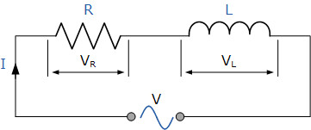
In the RL series circuit above, we can see that the current is common to both the resistance and the inductance while the voltage is made up of the two component voltages, V_{R} and V_{L}. The resulting voltage of these two components can be found either mathematically or by drawing a vector diagram. To be able to produce the vector diagram a reference or common component must be found and in a series AC circuit the current is the reference source as the same current flows through the resistance and the inductance. The individual vector diagrams for a pure resistance and a pure inductance are given as:

Vector Diagrams for the Two Pure Components

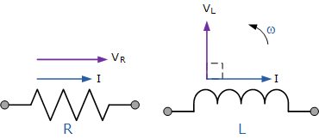
We can see from above and from our previous tutorial about AC Resistance that the voltage and current in a resistive circuit are both in phase and therefore vector V_{R} is drawn superimposed to scale onto the current vector. Also from above it is known that the current lags the voltage in an AC inductance (pure) circuit therefore vector V_{L} is drawn 90º in front of the current and to the same scale as V_{R} as shown.

Vector Diagram of the Resultant Voltage

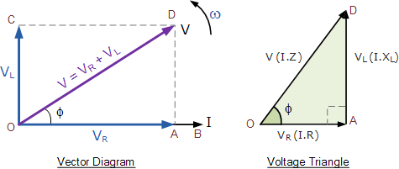
From the vector diagram above, we can see that line OB is the horizontal current reference and line OA is the voltage across the resistive component which is in-phase with the current. Line OC shows the inductive voltage which is 90º in front of the current therefore it can still be seen that the current lags the purely inductive voltage by 90º. Line OD gives us the resulting supply voltage. Then:
V equals the r.m.s value of the applied voltage. I equals the r.m.s. value of the series current.
V_{R} equals the I.R voltage drop across the resistance which is in-phase with the current.
V_{L} equals the I.X_{L} voltage drop across the inductance which leads the current by 90º.
As the current lags the voltage in a pure inductance by exactly 90º the resultant phasor diagram drawn from the individual voltage drops V_{R} and V_{L} represents a right angled voltage triangle shown above as OAD. Then we can also use Pythagoras theorem to mathematically find the value of this resultant voltage across the resistor/inductor ( RL ) circuit.
As V_{R} = I.R and V_{L} = I.X_{L} the applied voltage will be the vector sum of the two as follows:
$V=\sqrt{{V_{R}}^{2}+{V_{L}}^{2}}$
$V=\sqrt{{\left(I R\right)}^{2}+{\left(I X_{L}\right)}^{2}}$
$I =\frac{V}{\sqrt{R^{2}+{X_{L}}^{2}}}$
The quantity $\sqrt{R^{2}+{X_{L}}^{2}}$ represents the impedance, Z of the circuit.

The Impedance of an AC Inductance
Impedance, Z is the “TOTAL” opposition to current flowing in an AC circuit that contains both Resistance, ( the real part ) and Reactance ( the imaginary part ). Impedance also has the units of Ohms, Ω. Impedance depends upon the frequency, ω of the circuit as this affects the circuits reactive components and in a series circuit all the resistive and reactive impedance’s add together.
Impedance can also be represented by a complex number, Z = R + jX_{L} but it is not a phasor, it is the result of two or more phasors combined together. If we divide the sides of the voltage triangle above by I, another triangle is obtained whose sides represent the resistance, reactance and impedance of the circuit as shown below.

The RL Impedance Triangle

The impedance, Z= $\sqrt{R^{2}+{X_{L}}^{2}}$
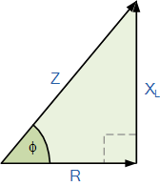
Then: ( Impedance )² = ( Resistance )² + ( j Reactance )² where j represents the 90º phase shift.
This means that the positive phase angle, θ between the voltage and current is given as.

Phase Angle
${Z^{2}=R}^{2}+{X_{L}}^{2}$
$\cos{ɸ= \frac{R}{Z}}$ , $\sin{ɸ}$=$\frac{X_{L}}{Z}$
$\tan{ɸ=\frac{X_{L}}{R}}$

While our example above represents a simple non-pure AC inductance, if two or more inductive coils are connected together in series or a single coil is connected in series with many non-inductive resistances, then the total resistance for the resistive elements would be equal to: R₁ + R₂ + R₃ etc, giving a total resistive value for the circuit.
Likewise, the total reactance for the inductive elements would be equal to: X₁ + X₂ + X₃ etc, giving a total reactance value for the circuit. This way a circuit containing many chokes, coils and resistors can be easily reduced down to an impedance value, Z comprising of a single resistance in series with a single reactance, Z² = R² + X².

AC Capacitance and Capacitive Reactance
The opposition to current flow through an AC Capacitor is called Capacitive Reactance and which itself is inversely proportional to the supply frequency
Capacitors store energy on their conductive plates in the form of an electrical charge. When a capacitor is connected across a DC supply voltage it charges up to the value of the applied voltage at a rate determined by its time constant.
A capacitor will maintain or hold this charge indefinitely as long as the supply voltage is present. During this charging process, a charging current, i flows into the capacitor opposed by any changes to the voltage at a rate which is equal to the rate of change of the electrical charge on the plates. A capacitor therefore has an opposition to current flowing onto its plates.
The relationship between this charging current and the rate at which the capacitors supply voltage changes can be defined mathematically as: i = C(dv/dt), where C is the capacitance value of the capacitor in farads and dv/dt is the rate of change of the supply voltage with respect to time. Once it is “fully-charged” the capacitor blocks the flow of any more electrons onto its plates as they have become saturated and the capacitor now acts like a temporary storage device.
A pure capacitor will maintain this charge indefinitely on its plates even if the DC supply voltage is removed. However, in a sinusoidal voltage circuit which contains “AC Capacitance”, the capacitor will alternately charge and discharge at a rate determined by the frequency of the supply. Then capacitors in AC circuits are constantly charging and discharging respectively.
When an alternating sinusoidal voltage is applied to the plates of an AC capacitor, the capacitor is charged firstly in one direction and then in the opposite direction changing polarity at the same rate as the AC supply voltage. This instantaneous change in voltage across the capacitor is opposed by the fact that it takes a certain amount of time to deposit (or release) this charge onto the plates and is given by V = Q/C. Consider the circuit below.

AC Capacitance with a Sinusoidal Supply

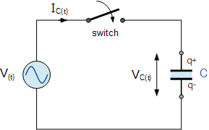
When the switch is closed in the circuit above, a high current will start to flow into the capacitor as there is no charge on the plates at t = 0. The sinusoidal supply voltage, V is increasing in a positive direction at its maximum rate as it crosses the zero reference axis at an instant in time given as 0º. Since the rate of change of the potential difference across the plates is now at its maximum value, the flow of current into the capacitor will also be at its maximum rate as the maximum amount of electrons are moving from one plate to the other.
As the sinusoidal supply voltage reaches its 90º point on the waveform it begins to slow down and for a very brief instant in time the potential difference across the plates is neither increasing nor decreasing therefore the current decreases to zero as there is no rate of voltage change. At this 90º point the potential difference across the capacitor is at its maximum ( V_{max} ), no current flows into the capacitor as the capacitor is now fully charged and its plates saturated with electrons.
At the end of this instant in time the supply voltage begins to decrease in a negative direction down towards the zero reference line at 180º. Although the supply voltage is still positive in nature the capacitor starts to discharge some of its excess electrons on its plates in an effort to maintain a constant voltage. This results in the capacitor current flowing in the opposite or negative direction.
When the supply voltage waveform crosses the zero reference axis point at instant 180º the rate of change or slope of the sinusoidal supply voltage is at its maximum but in a negative direction, consequently the current flowing into the capacitor is also at its maximum rate at that instant. Also at this 180º point the potential difference across the plates is zero as the amount of charge is equally distributed between the two plates.
Then during this first half cycle 0º to 180º the applied voltage reaches its maximum positive value a quarter (1/4ƒ) of a cycle after the current reaches its maximum positive value, in other words, a voltage applied to a purely capacitive circuit “LAGS” the current by a quarter of a cycle or 90º as shown below.

Sinusoidal Waveforms for AC Capacitance

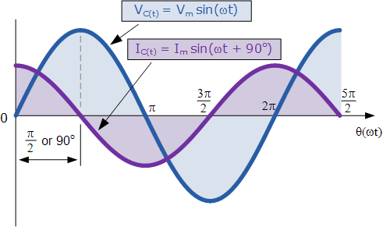
During the second half cycle 180º to 360º, the supply voltage reverses direction and heads towards its negative peak value at 270º. At this point the potential difference across the plates is neither decreasing nor increasing and the current decreases to zero. The potential difference across the capacitor is at its maximum negative value, no current flows into the capacitor and it becomes fully charged the same as at its 90º point but in the opposite direction.
As the negative supply voltage begins to increase in a positive direction towards the 360º point on the zero reference line, the fully charged capacitor must now loose some of its excess electrons to maintain a constant voltage as before and starts to discharge itself until the supply voltage reaches zero at 360º at which the process of charging and discharging starts over again.
From the voltage and current waveforms and description above, we can see that the current is always leading the voltage by 1/4 of a cycle or π/2 = 90º “out-of-phase” with the potential difference across the capacitor because of this charging and discharging process. Then the phase relationship between the voltage and current in an AC capacitance circuit is the exact opposite to that of an AC Inductance we saw in the previous tutorial.
This effect can also be represented by a phasor diagram where in a purely capacitive circuit the voltage “LAGS” the current by 90º. But by using the voltage as our reference, we can also say that the current “LEADS” the voltage by one quarter of a cycle or 90º as shown in the vector diagram below.

Phasor Diagram for AC Capacitance
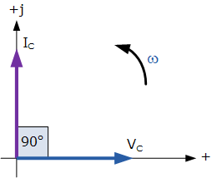
So for a pure capacitor, V_{C} “lags” I_{C} by 90º, or we can say that I_{C} “leads” V_{C} by 90º.
There are many different ways to remember the phase relationship between the voltage and current flowing in a pure AC capacitance circuit, but one very simple and easy to remember way is to use the mnemonic expression called “ICE”. ICE stands for current I first in an AC capacitance, C before Electromotive force. In other words, current before the voltage in a capacitor, I, C, E equals “ICE”, and whichever phase angle the voltage starts at, this expression always holds true for a pure AC capacitance circuit.

Capacitive Reactance
So we now know that capacitors oppose changes in voltage with the flow of electrons onto the plates of the capacitor being directly proportional to the rate of voltage change across its plates as the capacitor charges and discharges. Unlike a resistor where the opposition to current flow is its actual resistance, the opposition to current flow in a capacitor is called Reactance.
Like resistance, reactance is measured in Ohm’s but is given the symbol X to distinguish it from a purely resistive R value and as the component in question is a capacitor, the reactance of a capacitor is called Capacitive Reactance, ( X_{C} ) which is measured in Ohms.
Since capacitors charge and discharge in proportion to the rate of voltage change across them, the faster the voltage changes the more current will flow. Likewise, the slower the voltage changes the less current will flow. This means then that the reactance of an AC capacitor is “inversely proportional” to the frequency of the supply as shown.

Capacitive Reactance

$X_{C}=\frac{1}{2πfC}$
Where: X_{C} is the Capacitive Reactance in Ohms, ƒ is the frequency in Hertz and C is the AC capacitance in Farads, symbol F.
When dealing with AC capacitance, we can also define capacitive reactance in terms of radians, where Omega, ω equals 2πƒ.
$X_{C}=\frac{1}{ωC}$
From the above formula we can see that the value of capacitive reactance and therefore its overall impedance ( in Ohms ) decreases towards zero as the frequency increases acting like a short circuit. Likewise, as the frequency approaches zero or DC, the capacitors reactance increases to infinity, acting like an open circuit which is why capacitors block DC.
The relationship between capacitive reactance and frequency is the exact opposite to that of inductive reactance, ( X_{L} ) we saw in the previous tutorial. This means then that capacitive reactance is “inversely proportional to frequency” and has a high value at low frequencies and a low value at higher frequencies as shown.

Capacitive Reactance against Frequency
Capacitive reactance of a capacitor decreases as the frequency across its plates increases. Therefore, capacitive reactance is inversely proportional to frequency. Capacitive reactance opposes current flow but the electrostatic charge on the plates (its AC capacitance value) remains constant.
This means it becomes easier for the capacitor to fully absorb the change in charge on its plates during each half cycle. Also as the frequency increases the current flowing into the capacitor increases in value because the rate of voltage change across its plates increases.
We can present the effect of very low and very high frequencies on the reactance of a pure AC Capacitance as follows:
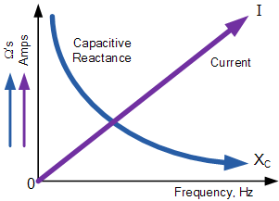
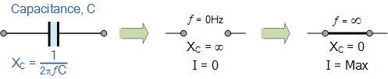
In an AC circuit containing pure capacitance the current (electron flow) flowing into the capacitor is given as:
$$I_{C}\left(t\right)=\frac{dq}{dt }$$
If $q=CV_{C}{=C V}_{max}\sin\left(ωt\right)$
then $I_{C}\left(t\right)=C\frac{d [V_{max}\sin\left(ωt\right) ]}{dt }$ = $ωCV_{max}\cos\left(ωt\right) ]$
If $I_{max}=\frac{V_{max}}{X_{C}}$ where $X_{C}=\frac{1}{ωC}$ then $I_{max}=ωC{ V}_{max}$
and therefore, the rms current flowing into an AC capacitance will be defined as:
$I_{C}\left(t\right)=I_{max}\sin\left(ωt+{90}^{°}\right)$
Where: I_{C} = V/(1/ωC) (or I_{C} = V/X_{C}) is the current magnitude and θ = + 90º which is the phase difference or phase angle between the voltage and current. For a purely capacitive circuit, Ic leads Vc by 90º, or Vc lags Ic by 90º.

Phasor Domain
In the phasor domain the voltage across the plates of an AC capacitance will be:
$V_{C}=\frac{1}{jωC}×$ $I_{C}$
Where $\frac{1}{jωC}=-jX_{C}=Impedance Z$
and in Polar Form this would be written as: X_{C}∠-90º where:
X_{C}∠$θ=\frac{V_{C}∠0^{°}}{I_{C}∠{90}^{°}}$

AC Across a Series R + C Circuit
We have seen from above that the current flowing into a pure AC capacitance leads the voltage by 90º. But in the real world, it is impossible to have a pure AC Capacitance as all capacitors will have a certain amount of internal resistance across their plates giving rise to a leakage current.
Then we can consider our capacitor as being one that has a resistance, R in series with a capacitance, C producing what can be loosely called an “impure capacitor”.
If the capacitor has some “internal” resistance then we need to represent the total impedance of the capacitor as a resistance in series with a capacitance and in an AC circuit that contains both capacitance, C and resistance, R the voltage phasor, V across the combination will be equal to the phasor sum of the two component voltages, V_{R} and V_{C}.
This means then that the current flowing into the capacitor will still lead the voltage, but by an amount less than 90º depending upon the values of R and C giving us a phasor sum with the corresponding phase angle between them given by the Greek symbol phi, Φ.
Consider the series RC circuit below where an ohmic resistance, R is connected in series with a pure capacitance, C.

Series Resistance-Capacitance Circuit
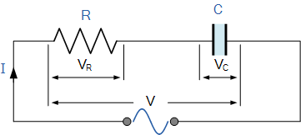
In the RC series circuit above, we can see that the current flowing into the circuit is common to both the resistance and capacitance, while the voltage is made up of the two component voltages, V_{R} and V_{C}. The resulting voltage of these two components can be found mathematically but since vectors V_{R} and V_{C} are 90º out-of-phase, they can be added vectorially by constructing a vector diagram.
To be able to produce a vector diagram for an AC capacitance a reference or common component must be found. In a series AC circuit the current is common and can therefore be used as the reference source because the same current flows through the resistance and into the capacitance. The individual vector diagrams for a pure resistance and a pure capacitance are given as:

Vector Diagrams for the Two Pure Components
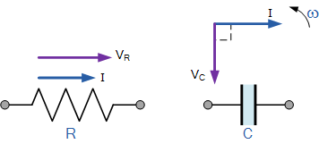
Both the voltage and current vectors for an AC Resistance are in phase with each other and therefore the voltage vector V_{R} is drawn superimposed to scale onto the current vector. Also we know that the current leads the voltage ( ICE ) in a pure AC capacitance circuit, therefore the voltage vector V_{C} is drawn 90º behind ( lagging ) the current vector and to the same scale as V_{R} as shown.

Vector Diagram of the Resultant Voltage
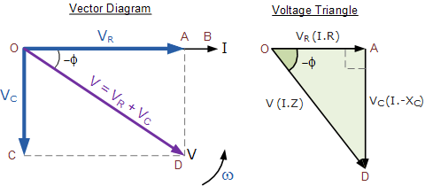
In the vector diagram above, line OB represents the horizontal current reference and line OA is the voltage across the resistive component which is in-phase with the current. Line OC shows the capacitive voltage which is 90º behind the current therefore it can still be seen that the current leads the purely capacitive voltage by 90º. Line OD gives us the resulting supply voltage.
As the current leads the voltage in a pure capacitance by 90º the resultant phasor diagram drawn from the individual voltage drops V_{R} and V_{C} represents a right angled voltage triangle shown above as OAD. Then we can also use Pythagoras theorem to mathematically find the value of this resultant voltage across the resistor/capacitor ( RC ) circuit.
As V_{R} = I.R and V_{C} = I.X_{C} the applied voltage will be the vector sum of the two as follows.
$V=\sqrt{{V_{R}}^{2}+{V_{L}}^{2}}$
$V^{2}={V_{R}}^{2}+{V_{C}}^{2}$
$V=\sqrt{{\left(I R\right)}^{2}+{\left(I X_{C}\right)}^{2}}$
$I =\frac{V}{\sqrt{R^{2}+{X_{C}}^{2}}}=$ $\frac{V}{Z}$
The quantity $\sqrt{R^{2}+{X_{C}}^{2}}$ represents the impedance, Z of the circuit

The Impedance of an AC Capacitance
Impedance, Z which has the units of Ohms, Ω is the “TOTAL” opposition to current flowing in an AC circuit that contains both Resistance, ( the real part ) and Reactance ( the imaginary part ). A purely resistive impedance will have a phase angle of 0º while a purely capacitive impedance will have a phase angle of -90º.
However when resistors and capacitors are connected together in the same circuit, the total impedance will have a phase angle somewhere between 0º and 90º depending upon the value of the components used. Then the impedance of our simple RC circuit shown above can be found by using the impedance triangle.

The RC Impedance Triangle
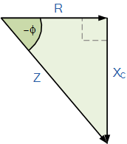
Then: (Impedance )² = ( Resistance )² + ( j Reactance )² where j represents the 90º phase shift.
This means then by using Pythagoras theorem the negative phase angle, θ between the voltage and current is calculated as.

Phase Angle
$Z^{2}=R^{2}+{X_{C}}^{2}$
$\cos{ɸ=\frac{R}{Z}}$ and $\sin{ɸ=\frac{X_{C}}{Z}}$
$\tan{ɸ}$=$\frac{X_{C}}{R}$

AC Capacitance Summary
In a pure AC Capacitance circuit, the voltage and current are both “out-of-phase” with the current leading the voltage by 90º and we can remember this by using the mnemonic expression “ICE”. The AC resistive value of a capacitor called impedance, ( Z ) is related to frequency with the reactive value of a capacitor called “capacitive reactance”, X_{C}. In an AC Capacitance circuit, this capacitive reactance value is equal to 1/( 2πƒC ) or 1/( jωC )
Thus far we have seen that the relationship between voltage and current is not the same and changes in all three pure passive components. In the Resistance the phase angle is 0º, in the Inductance it is +90º while in the Capacitance it is -90º.
In the next tutorial about Series RLC Circuits we will look at the voltage-current relationship of all three of these passive components when connected together in the same series circuit when a steady state sinusoidal AC waveform is applied along with the corresponding phasor diagram representation.

