SAY'S LAW OF MARKET:

A French economist J.B
Say explained a law of market in his book"Treatise on Political Economy".The law states "Supply creates it's own Demand"It means that demand for commodities automatically arises in its supply.
Producers need not to be bother about whether the produced commodities can be sold in the market or not.All the commodities will be demanded whatever is brought to the market for exchange.No any commodity remain unsold.Produced commodities are consumed equally.So,there is no overproduction or underconsumption of commmodities.
Say's law of market is based on the following assumptions.
a. There exist perfect commodities both in factor market and commodity market.
b. Free market economy and price system contributes to increase in population and capital.
c. There's optimum allocation of resources.
d.Demand and supply forces determine the prices of commodities and factors.
e. There is the need of flexibility of wages,interest and prices for the automatic activity of the economic system.
f.No Govt. interference in free market economy.
g. Scope of market is not limited.
h.Money acts only as a medium of exchange.
i.Equillibrium process of an economy is considered from the long-run point of view
ay's law of market is self-adjusting in barter economy.In barter economy, commodities are either produced for self-consumption or to directly exchange for other goods. Each seller is a buyer.If a producer produces excess commodities than he needs, he will collect other commodities exchanging these excess commodities.
Say's law pf market is also applicable in money economy.
In money economy, goods are sold for money and that money is used in buying other goods.Money simply acts as advantageous medium of exchange.Due to neutral role of money,Say's law of market is applied in money economy.
According to J.B.Say, the production system itself leads to the creation of demand for goods.The producers pay rewards in the form of rent,wage,interest etc. to the factors while they employ them in production process.These are included in production cost.These rewards create demand that are equivalent to supply as whole amount of income earned are spent on consumption.
Say's law of market in money economy are shown by the equality between aggregate demand and aggregate supply in the following diagram
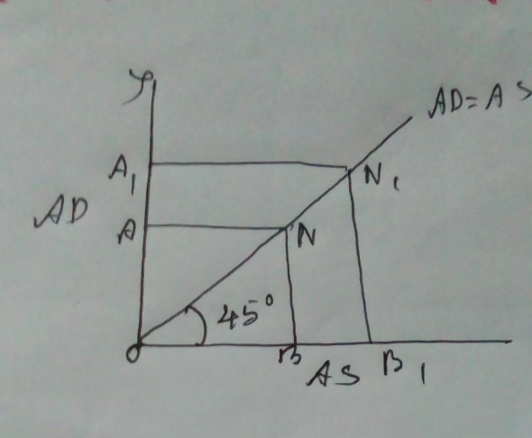
In this diagram,AD=AS is a 45° line, which indicates equality between AS and AD in all the points of the line.At point N, aggregate demand is equal to aggregate supply OB.At point N1, when aggregate supply increases to OB1, aggregate demand also increases to OA1.There does not arise overproduction or general unemployment in the economy.
CRITICISMS OF SAY'S LAW:

a. Deficiency of aggregate demand--Demand cannot be equal to supply as assumed by J.B.Say.So,there is always deficiency of aggregate demand which is pointed out by J.M.Keynes.
B.Possibility of general over production--- As demand is not equal to supply,production exceeds demand.
C. Impossibility of full employment equilibrium of the economy:---keynes pointed out that the economy is in underemployment equilibrium position.
D. Depression of 1930's proves Say's law wrong.
E. Need of Government intervention----Full employment can't be attained by an economy automatically. Govt has to intervene in increasing aggregate expenditure to attain full employment.
Saving-investment equality ---Keynes criticised the assumption of Say that flexibility in the rate of interest brings equality between saving and interest. Keynes states that income creates equality between saving and investment instead of rate of interest.
G. Role of money--According to Keynes money is not only a medium of exchange but also a store of value. Money plays a vital role in determining income, employment and production in an economy.
IMPLICATIONS OF SAY'S LAW:
A. There can't be deficiency of aggregate demand as supply creates its own demand.
B. There can't be unemployment in an economy as overproduction is impossible.
C. Flexibility in the rate of interest brings equality between saving and investment

D.Flexibility in wage rate ensures full employment in labour market.Employment can be generated by cutting the wage rate.
E. Production is more important than consumption.
F.Saving increases production as saving is invested automatically..
G.There is in-built mechanism in the economy.

