METAMORPHOSIS IN INSECTS
Chapter 7

Metamorphosis is one of the most widely used life history strategies of animals. The term metamorphosis is derived from the Greek word meta meaning “change” and morphe meaning “form”, designating change in form. Most organisms undergo a change in form as they grow from an embryo to an adult. Some changes are radical and the immatures bear little resemblance to the adults; others are more gradual, with the immatures looking very much like the adults. Whenever the development of an embryo into adult takes place through a series of successive transitional, morphologically alike or variable forms, such type of post embryonic development is called metamorphosis. It is a biological process of transformation or abrupt changes in the animal's body structure through cell growth and differentiation, after birth or hatching into one or different forms before attaining the sexually mature adult form.
Insect metamorphosis is the transformation of an immature larval individual into a reproducing adult of very different form, structure, and habit of life. It occurs to some extent in all except the most primitive species and is under endocrine control. Insect metamorphosis primarily involves the destruction of larval tissues and their replacement by an entirely different population of cells. Insects grow by moulting (shedding their cuticle) and forming a new cuticle as their size increases. Insect growth is discontinuous, at least for the sclerotized (hardened by conversion into sclerotin) cuticular parts of the body, because the rigid cuticle limits expansion. Size increase is by moulting – the periodic formation of new cuticle of greater surface area and subsequent ecdysis, the shedding of the old cuticle. The interval between the ecdysis is known as the stadium or intermoult period and the form assumed during a particular stadium is termed, the instar. The egg hatches out into the first instar and the last instar is the adult stage or imago. The first instar attains the adult stage by passing through a number of consecutive instars, fixed for each species. Instars are known as the nymphs, naids or larvae and pupae.

Kind of Metamorphosis in Insects
Insects can be grouped into three categories – Ametabolous, Hemimetabolous and Holometabolous – according to the extent of the change at metamorphosis (Fig 7.1). Most species are either holometabolous or hemimetabolous, with more than 85% of them holometabolous and most of the rest hemimetabolous.
1. Ametabolous (Little or No Metamorphosis). Ametabolous insects have no metamorphosis, the adult form resulting from a progressive increase in size of the larval form. This is characteristic of the Apterygota (a subclass of the class Insecta that do not possess wings) in which the larva hatches in a form essentially like the adult apart from its small size and lack of development of genitalia. Immediately after they hatch, these insects have a pronymph stage bearing the structures that enabled it to get out of the egg. But after this transitory stage, the insect looks like a small adult; it grows larger after each moult but is unchanged in form (Truman and Riddiford 1999). At each moult the larva grows bigger and the genitalia develop progressively. Adults and larvae live in the same habitat. The number of moults is indeﬁnite, and moulting may continue throughout life. Very few insect species (apterygotes) are ametamorphic, example- Collembola (spring tails), Diplura (campodeids), Protura and Thysanura (silverfish).
2. Hemimetabolous/Paurometabolous (Simple, Gradual or Incomplete Metamorphosis). Hemimetabolous means incomplete metamorphosis comprising a simple process of gradual or partial development. Development through egg, nymph, and adult is covered by this term. After spending a very brief period of time as a pronymph (whose cuticle is often shed as the insect hatches), the insect looks like an immature adult and is called a nymph. The rudiments of the wings, genital organs, and other adult structures are present and become progressively more mature with each moult. At the final moult, the emerging insect is a winged and sexually mature adult, or imago. The instars (a phase between two periods of moulting) show fairly advanced stage of morphological development, resembling with the adult in possessing alike mouth parts and compound eyes but differ in the absence of wings and matured sexual organs, e.g. Ephemeroptera, Odonata, Plecoptera, Dictyoptera, Orthoptera, Dermaptera, Isoptera, Anoplura, Mallophaga, Psocoptera and Hemiptera.
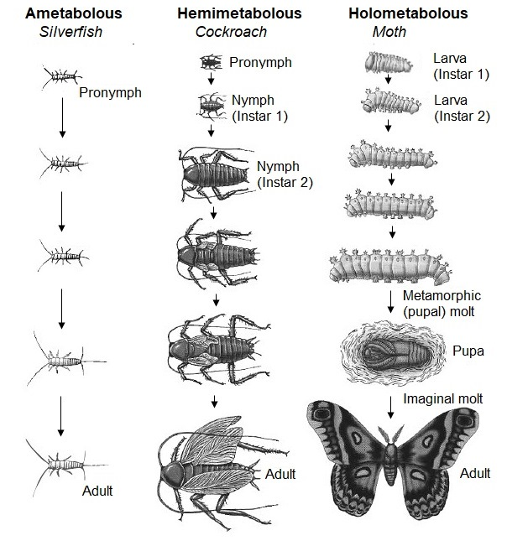

Fig…(a): Metamorphosis: Three types of development in insects.

Fig 7.1. Showing types of metamorphosis in insects

3. Holometabolous (Complete Metamorphosis). Holometabolous (Fig 7.2) means development through egg, larva, pupa, and adult. In the holometabolous insects such as flies, beetles, moths, and butterflies, there is no pronymph stage. The juvenile form that hatches from the egg is called a larva. Larvae of lepidoptera are called the caterpillars, that of beetles, the grubs and fly, the maggots. The larva (a caterpillar, grub, or maggot) undergoes a series of moults as it becomes larger. The stages between these larval moults are called instars. The number of larval moults before becoming an adult is characteristic of a species, although environmental factors can increase or decrease the number. The larval instars grow in a stepwise fashion, each instar being larger than the previous one. Finally, there is a dramatic and sudden transformation between the larval and adult stages: after the final instar, the larva undergoes a metamorphic moult to become a pupa. The pupa does not feed, and its energy must come from those foods it ingested as a larva. During pupation, adult structures form and replace the larval structures. The pupal stage is usually considered a resting phase, although many active changes are occurring internally, hidden from view. The larval tissues and organs break down entirely, then reorganize into the adult form. External rudiments of wings appear only in the pupal stage. Eventually, an imaginal moult enables the adult (imago) to shed its pupal case and emerge. While the larva is said to hatch from an egg, the imago is said to ecdose from the pupa. Holometabolous metamorphosis is characteristic of Mecoptera, Neuroptera, Lepidobtera, Trichoptera, Diptera, Coleoptera, Strepsiptera, Hymenoptera, etc.
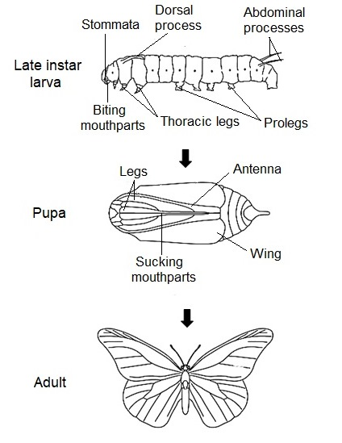

Fig 7.2. Successive stages in the postembryonic development of a Holometabolous insect. Only one larval stage is shown (Danaus, Lepidoptera) (after Urqhart, 1960)

The term neometaboly (Fig 7.3) is sometimes used for the thrips and some hemipterans that have independently evolved a life cycle involving a quiescent stage between the larva and the adult.
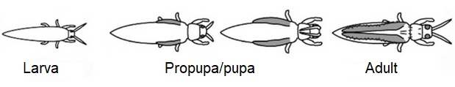

Fig 7.3. Neometaboly

Larvae vs. Nymphs and Naiads
There is little difﬁculty in deﬁning an egg or an adult, but naming and deﬁning the instars or stages that may occur between egg and adult can be problematic. In 1918, Comstock proposed restricting the term larva to juveniles of the holometabolous orders, nymph to the juveniles of his paurometabolous (Hemimetabolous) terrestrial orders, and naiad to the juveniles of his hemimetabolous nonholometabolous aquatic orders (Ephemeroptera, Odonata, and Plecoptera).
Currently there is a tendency to use larva for all immature insects that are not eggs, pupae, or adults and the term immature insect for all life stages except adults, no matter how many specialized names are applied to the various developmental forms in the different orders. When the term larva is used in the comprehensive sense, the subcategories “exopterygote larva” (Hemimetabola that have the wing-pads developing externally) and “endopterygote larva” (Holometabola that have the wing-pads appearing externally in the pupal stage but having developed from internal larval histoblasts) are useful for pterygote immatures. A useful term roughly equivalent to larva in the comprehensive sense is “juvenile,” which can be used as a general term for nonadult larvae of all orders.

Types of Larvae in Insects
Insects larvae are characterized by
- Their mouth parts and feeding habits differ from that of the adult.
- Their eyes are lateral stemmata and differ from compound eyes of adults.
- Their wings are represented almost by internal rudiments enclosed in epidermal sacs beneath the general invaginated surface. All adult organs are preserved in the form of small epidermal thickenings, called the imaginal discs.
- The juvenile hormone is responsible for their juvenile condition occurring throughout the larval life (Gilbert, 1964).
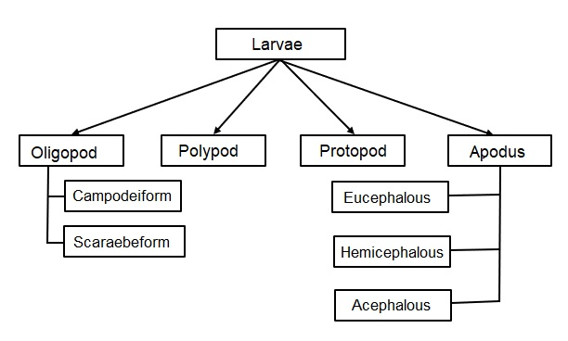

Fig 7.4. Showing insect larva types

Among endopterygotes the extent of variation between the larval and adult habits and structures are enormous. There are largely four types of larvae in insects (Fig 7.4):
1. Protopod Larvae: Found in parasitic Hymenoptera
- Emerge in early embryonic phase
- They lie in a highly nutritive medium such as either eggs or body of the host
- Devoid of segmentation in abdomen
- Bear rudimentary cephalic and thoracic appendages
2. Polypod Larvae: Found in Lepidoptera, saw-flies and scorpion flies
- Also called cruciform larvae
- Well defined segmentation
- Poorly developed thoracic legs and antennae
- Presence of abdominal limbs or prolegs
3. Oligopod Larvae
- Well-developed thoracic legs
- Absence of abdominal appendages
- Head capsule and appendages well developed
- They are of two sub types
  - Campodeiform larvae resemble Campodea and typically possess a long-compressed body, well sclerotized cuticle and long thoracic legs, e.g. Neuroptera, Trichoptera, Strepsiptera and some Coleoptera
  - Scarabaeform larvae are stout, subcylindrical and C-shaped larvae with short thoracic legs fleshy body, e.g. Coleoptera (Scarabaeidea)
4. Apodous Larvae
- Trunk appendages completely suppressed.
- It is derived from the oligopod larva.
- Depending on the degree of development of head, they are of three types:
  - Eucephalous larvae have more or less sclerotized head capsule with relatively little reduction of the cephalic appendages, e.g. Nematocera (Diptera), Cerambycidae (Hymenoptera)
  - Hemicephalous larvae have reduced head capsule and its appendages accompanied by marked retraction of the head into the thorax, e.g. Tipulidae and Brachycera (Diptera)
  - Acephalous larvae have no head capsule or appendages, e.g. Cyclorrhapha (Diptera)

Hormonal Control of Insect Metamorphosis
Although the details of insect metamorphosis differ among species, the general pattern of hormonal action is very similar. The metamorphosis of insects is regulated by systemic hormonal signals (Fig 7.5), which are controlled by neurohormones from the brain. Insect moulting and metamorphosis are controlled by two effector hormones:
- 20-hydroxyecdysone (20 E): It is a steroid which coordinates each moult and regulates the changes in gene expression that occur during metamorphosis.
- The lipid juvenile hormone (JH). Juvenile hormone prevents the ecdysone-induced changes in gene expression that are necessary for metamorphosis. Thus, its presence during a moult ensures that the result of that moult is another larval instar, not a pupa or an adult.
The moulting process is initiated in the brain, where neurosecretory cells release prothoracicotropie hormone (PTTH) in response to neural, hormonal, or environmental signals. PTTH is a peptide hormone with a molecular weight of approximately 40,000, and it stimulates the production of ecdysone by the prothoracic gland by activating the RTK pathway in those cells (Rewitz et al. 2009). Ecdysone is modified in peripheral tissues to become the active moulting hormone 20E. Each moult is initiated by one or more pulses of 20E. For a larval moult, the first pulse produces a small rise in the 20E concentration in the larval hemolymph (blood) and elicits a change in cellular commitment in the epidermis. A second, larger pulse of 20E initiates the differentiation events associated with moulting. These pulses of 20E commit and stimulate the epidermal cells to synthesize enzymes that digest the old cuticle and synthesize a new one.
Juvenile hormone is secreted by the corpora allata. The secretory cells of the corpora allata are active during larval moults but inactive during the metamorphic moult and the imaginal moult. As long as JH is present, the 20E-stimulated moults result in a new larval instar. In the last larval instar, however, the medial nerve from the brain to the corpora allata inhibits these glands from producing JH, and there is a simultaneous increase in the body's ability to degrade existing JH (Safranek and Williams 1989). Both these mechanisms cause JH levels to drop below a critical threshold value, triggering the release of PTTH from the brain. PTTH, in turn, stimulates the prothoracic gland to secrete a small amount of ecdysone. The resulting pulse of 20E, in the absence of high levels of JH, commits the epidermal cells to pupal development. Larva-specific mRNAs are not replaced, and new mRNAs are synthesized whose protein products inhibit the transcription of the larval messages.

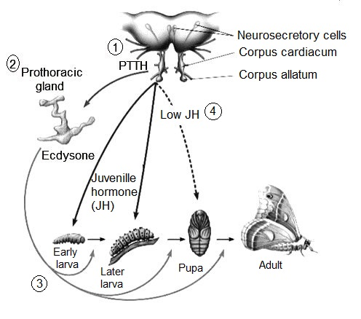

Fig 7.5. Hormonal control of insect development. 1. NSC in the brain produce PTTH and stored in corpora cardiaca for future release 2. PTTH send signals to prothoracic gland to produce ecdysone 3. Ecdysone release results in insect moult when a specific instar is fully grown 4. JH released from corpora allata is a decisive hormone as its titer (dotted line and continuous arrow) helps in determining which state would be maintained next in metamorphosis.

There are two major pulses of 20E during Drosophilla metamorphosis. The first pulse occurs in the third instar larva and triggers the initiation of ("prepupal") morphogenesis of the leg and wing imaginal discs (as well as the death of the larval hindgut). The larva stops eating and migrates to find a site to begin pupation. The second 20E pulse occurs 10-12 hours later and tells the "prepupa" to become a pupa. The head inverts and the salivary glands degenerate (Riddiford 1982; Nijhout 1994). It appears, then that the first ecdysone pulse during the last larval instar triggers the processes that inactivate the larva-specific genes and initiates the morphogenesis of imaginal disc structures. The second pulse transcribes pupa-specific genes and initiates the moult (Nijhout 1994). At the imaginal moult, when 20E acts in the absence of juvenile hormone, the imaginal discs fully differentiate and the moult gives rise to an adult.

Genes and Metamorphosis
1. Regulatory Genes: Ecdysteroids initiate a cascade of gene activity that involves both early and late genes. Most of these genes code for transcription factors that activate a series of genes for the proteins that build the structures of the various stages. Thus flies, mosquitoes, beetles and moths have homologous genes that are activated in the same order in response to ecdysteroids, although the culmination of their action is to build very different kinds of insects. A key ﬁnding illuminating the nature of metamorphosis is that the gene encoding the transcription factor broad complex (brc) is expressed during moulting in several insects in response to ecdysteroid moulting hormones, but only in the absence of JH. The gene product is required for the insect to develop a normal pupal phenotype at the larval–pupal moult, and then again for a normal adult phenotype at the time of the pupal–adult moult. Expression of brc when it would not normally be present (i.e., before the last larval stage) causes pupal genes to be expressed prematurely. brc thus appears to be a key determinant of metamorphic developmental progression
The transcription factor broad complex was first discovered in Drosophila where it is expressed in response to ecdysteroids as they initiate the larval/pupal moult, but it is not expressed at larval/larval moults. A gene with a similar sequence is expressed in Manduca larvae in the same manner, at the larva/pupal moult, but not at larval/larval moults. In Manduca, juvenoids prevent the activation of broad, in keeping with their status quo action.
2. Effector Genes: Effector Genes are the genes that code for proteins that contribute directly to the form and function of the morphologically distinct metamorphic stages of the holometabolous insects. These can be structural proteins, such as cuticular proteins, or enzymes that participate in physiological activities such as digestion and intermediary metabolism, or even enzymes necessary for the formation of pigments found in different stages. Analyses of cuticular proteins and their genes revealed that quite different structures could be built from the same cuticular components. Thus, the hard structures found in lepidopteran larvae, the head capsule and tubercles, that dot the thorax and abdomen, are composed of the same cuticular proteins that contribute to the hard cuticles of the pupa that cover most of the body surface, the pupal dorsal-fore wing and the abdominal sclerites. The soft cuticles found across the larval abdomen and in the intersegmental membranes of pupae and adults also share many of the same cuticular proteins. In these cases, the same genes are reused to code for the structural proteins of vastly different morphological structures. The evolution of metamorphosis thus required the development of new morphogenetic signals (architectural plans) affecting the spatial and temporal expression of different genes, so that common structural proteins could be assembled in new ways. Accompanying this was also the appearance of new or modified genes to code for those features that are unique to each metamorphic stage. It is the complex orchestration of spatial and temporal activities of similar hormones and genes that results in the vast diversity of form and function that is displayed by metamorphosing insects.

PRACTICE QUESTIONS

Multiple Choice
1. In complete metamorphosis, an insect
a) Hatches into a small version of adult and grows through several instars
b) Hatches out as a caterpillar, grows, pupates, becomes different adult form
c) Is born live
d) All of the above

2. The number of distinct stages in the life cycle of insects with complete metamorphosis is
a) One b) Two
c) Three d) Four

3. Some insects pass through four different stages of development before reaching maturity: egg, larva, pupa, and adult. This series of changes is called
a) Complete metamorphosis b) No metamorphosis
c) Gradual metamorphosis d) Incomplete metamorphosis

4. Incomplete metamorphosis is also called
a) Ametabolous b) Hemimetabolous
c) Holometabolous d) None of the above

5. A term describing insects with complete metamorphosis is
a) Ametabolous b) Hemimetabolous
c) Holometabolous d) None of the above

6. The developmental stages between molts are called
a) Instars b) Cocoons
c) Morphs d) Forms

7. Which of these insect orders does not have a naiad stage?
a) Beetles b) Stoneflies
c) Dragonflies d) Mayflies

8. A butterfly pupa is called
a) Chrysalis b) Cocoon
c) Naiad d) Exuvium

9. Which of the following insect groups does not have complete metamorphosis?
a) Mayflies b) Butterflies
c) Caddisflies d) Weevils

10. The larval stages of insects with complete metamorphosis may be known by all the following names except
a) Naiads b) Caterpillars
c) Maggots d) Grubs

Very short answer type
- What is neometaboly?
- Protopod larva is characteristic of parasitic ________.
- What is larva with completely suppressed trunk appendages named?
- Why are acephalous larva so named?
- Give the full form of 20E hormone.
- What is PTTH?
- Which part of the brain secretes the Juvenile hormone?
- What is a pronymph?
- What is paurometabolous metamorphosis?
- Name two species which are ametabolous.

Write short notes on following aspects of Mollusca
- Complete metamorphosis
- Types of larvae in insects
- Regulatory genes.
- Larvae vs. nymphs and naiads
- Simple metamorphosis

Short answer type
- Describe the basic characteristics of insect larva
- How do the two major pulses of 20E affect Drosophila metamorphosis?
- Comment on the role of Juvenile hormone in insect metamorphosis.
- Describe the nature of effector genes and illustrate their role in metamorphosis.
- From which larva are the apodus larva derived? Describe their types.

Long answer type
- What is meant by insect metamorphosis? With appropriate diagrams, describe the various types of metamorphosis found in various insect groups.
- Comment on the hormonal and genetic regulation of metamorphosis in insects.

Answers to Multiple Choice Questions
1. (b) 2. (d) 3. (a) 4. (b) 5. (c)
6. (a) 7. (a) 8. (a) 9. (a) 10. (a)

