Tour Operators
Tour operator is an organization, firm or company who buys individual travel components, separately from their suppliers and combines them into a package tour, which is sold with their own price tag to the public directly or through middlemen, is called a Tour Operator.
Tour operators are primarily responsible for delivering and performing the services specified in a given package tour. Tour operators are sometimes called as wholesalers but this is partially true because a wholesaler buys goods and services in bulk at his own account to prepare a tour package and then retails it through the travel agencies or directly to clients.

Definitions
Poyther (1993) defines, “tour operator is one who has the responsibility of putting the tour ingredients together, marketing it, making reservations and handling actual operation.”

Types of Tour Operators
Tour operators are basically categories into four types. These are categories on the basis of their nature of the business and their operations.
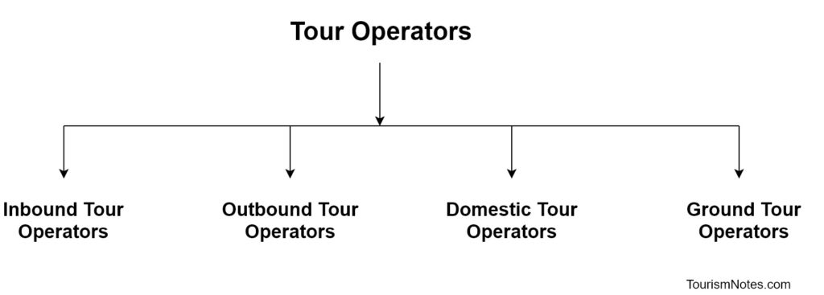
- Inbound Tour Operators
- Outbound Tour Operators
- Domestic Tour Operators
- Ground Operators

Inbound Tour Operators
These are also known as incoming tour operators. Technically, the operators who receive guests, clients/tourists and handle arrangements in the host country are called inbound tour operators.

Outbound Tour Operators
Tour operator who promote tours for foreign destinations, maybe business tour or leisure tour is called outbound tour operators. For example a group of American tourists going to a trip of India and Thomas Cook handle arrangement in America like as ticket reservation, hotel booking etc. then

Domestic Tour Operators
Domestic tour operators are those who assemble, combine tourist components into inclusive tours and sell it to the domestic travelers. The domestic tour operators operate within the boundary of the home

Ground Operators/Destination Management Companies
These are commonly known as handling agencies and their main function is to organize tour arrangements for incoming tourists on the behalf of overseas operators.

Functions of Tour Operator
A tour operator is an organization, firms or a person who is responsible for the actual arrangement of transport and accommodation facilities in any tour or vacations. They are also responsible for operating and providing vacation through contracting, booking and packaging together of the various components of the tour such as hotel, transportation, meals, guides, optional tours and sometimes flights. Some most important functions of the tour operators are following as:
- Planning a Tour
The most important functions of the tour operators are planning a tour. Tour operators plan a tour and make tour itinerary which contains the identification of the origin, destination and all the stopping point in a traveler’s tours.
- Making Tour Package
Tour operator buys individual travel components, separately from their suppliers and combines them into a package tour. Tour operators make tour package by assembling various travel components into a final product that is called tour package which is sold to tourist with own price tag. Making tour packages is also an important function of Tour Operator.
- Arranging a Tour
Tour operators make tour package and also arrange a tour according to tourist demands. Tour operators arrange the tour package and various tourists’ activities to provide the best experience to tourists/traveler.
- Travel Information
Whatever the size of tour operators, it has provided necessary travel information to the tourists. This task is utterly difficult and very complicated. A tour operator must give up-to-date, accurate and timely information regarding destinations, modes of travel, accommodation, sightseeing, immigration, health and security rules about various permits required to travel in a particular area etc.
- Reservation
It is a very important function of all type tour operators and travel agencies. Tour operator makes all the reservation by making linkages with accommodation sector, transport sector and other entertainment organizations to reserve rooms, and seats in cultural programmes and transportation.
- Travel Management
Tour operators manage tour from beginning to the end of the tour. A tour operator has the responsibility to look after the finer details of a vacation or tour such as hotel, accommodation, meals, conveyance etc. Tour operators provide travel guide, escorting services and arrange all travel related needs and wants.
- Evaluate the Option Available
Tour operators evaluate all available options to provide a unique or unforgettable travel experience to tourists during their journey. Tour operators evaluate the various options available for a tour package and provide best of them to tourists.
- Promotion
Tour Operators makes tour packages and promote them into various tourists markets at domestic as well international level. Tour operators promote a travel destination to attract a large group of tourists at domestic as well as international level. In the promotion of tourist destination, tour operators play a key role. Travel agencies or tour operators are called as image builder of a country.
- Sales and Marketing
Tour operators do sales and marketing of tourist products. Tour operators buy individual travel components, separately and combine them into a tour package, which is sold with their own price tag to the public directly. Tour operators do marketing of tourist destinations and tourism product to attracts the attention of the tourists/travelers.
- Taking Care of Glitch
Tours operators are also called handling agencies which handles tour package and take care of all the glitches and problems arises during a tour package. Tour operators fix the glitches and provide the best available alternative to tourists during their journey.

