Tour Package

Tour package means a pre-arrangement, prepaid trip that combines two or more travel components like airfare, airport transfer, accommodation, and other services. Practically, to define the tour package concept is complex one rather understands
According to Gregorg “a tour package is advertised journey including specific features, arranged and promoted with tour literature by a tour operator and paid for in full by the tourists before starting the tour.”

Types of Tour Packages
A travel agency/tour operator deals with variety of ‘tour packages,’ catering to the diverse needs of tourists such as adventure, beach, architecture, cultural, business, conference, incentive tours, ayurvedic packages, Buddhist, religious, incentive tour, special interest tours, cruise tour group tour, educational tour, heritage, monuments, wildlife lovers, etc. These are broadly classified into five categories:

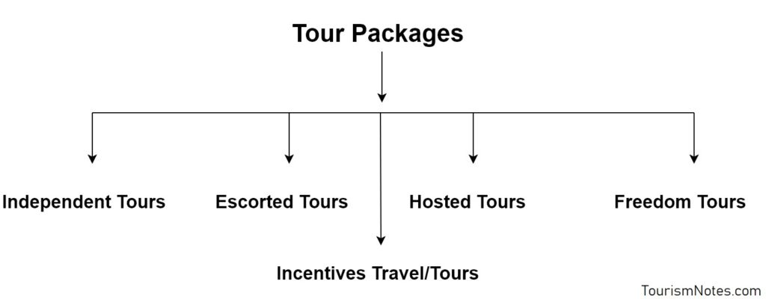
- Independent Tours
- Escorted Tours
- Hosted Tours
- Incentives Travel/Tours
- Freedom Tours

Independent Tour
Independent tours are prepared/formulated for those tourists who want to travel independently. The components of such tours are air travel, air transfer, accommodation, travel documents, sightseeing, boat riding, entertainment, and other travel services.
However, in some cases, the tourists are free to purchase every single component separately. Thus, this type of tour provides the tourists considerable freedom to plan the activities according to their own choice.
An independent tour may or may not be an all-inclusive tour. Therefore, tour price varies depending on the type of air travel, air transfer, accommodation and is inclusive of other tour components. The foreign independent travel (FITs) and domestic independent travel (DITs) are examples of an independent tour.

Escorted Tour
When a travel agency includes the services of a well educated and trained tour manager in its package, the tour is called an escorted tour. Basically, escorted tours are meant for those travelers who are planning to visit a foreign country first time.
The escort’s responsibilities and duties are to provide comprehensive information and assistance to the group or individual traveler, at the origin, en route and the destination place. The excursion tours are the example of escorted tours.

Hosted Tours
A hosted tour means when an agency utilizes the services of another agency at a particular destination. Suppose a group of French tourists is coming to India. When the group arrives in India, they are greeted at the airports by TCI, which assists them in clearing their baggage and transfer them to the hotel.
Their tour-host (TCI) is available to offer device and information about the local attractions and entertainment. Further, when the group arrives at another designation in India, a different travel agency greets them at each tourist spot. Thus, a hosted tour provides the tourists maximum level of pre-arranged and personalized services.

Incentives Travel/Tour
It is a motivational programme or a fully paid holiday which is given to the employees by the enterprises as a reward. Mostly in medium and large-scale companies and usually too distant destinations to spur them in maintaining their track record, to increase output, improve the image and moreover to earn the long period loyalty of the employees.
There are a number of the other packages offered by a tour company such as a custom tour an excursion tour, an adventure, and special interest package tours.

Freedom Tours
Freedom tours are becoming very popular these days among the working class. These tours are designed as per the choice of tourists. The tourist is free to choose and plan how they want to travel and enjoy their holidays. These types of tours are meant for that kind of people who like to decide how, when, and where to travel.
This tourist may an individual, family, group holidays for families and group travel for business. These tours are promoted and developed by the ORBIT.

