Gene and genetic code: The genetic code is the set of rules by which information encoded within genetic material (DNA or mRNA sequences) is translated into proteins by living cells. The code defines how sequences of nucleotide triplets, called codons, specify which amino acid will be added next during protein synthesis.
A gene is a locus (or region) of DNA which is made up of nucleotides and is the molecular unit of heredity
structure of ATP: ATP consists of a base, in this case adenine (red), a ribose (magenta) and a phosphate chain (blue).
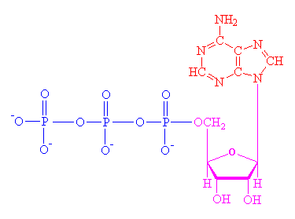

Nicotinamide adenine dinucleotide (NAD) is a coenzyme found in all living cells. The compound is a dinucleotide, because it consists of two nucleotides joined through their phosphate groups. One nucleotide contains an adenine base and the other nicotinamide. Nicotinamide adenine dinucleotide exists in two forms, an oxidized and reduced form abbreviated as NAD⁺ and NADH respectively.
Although NAD⁺ is written with a superscript plus sign because of the formal charge on a particular nitrogen. atom, at physiological pH for the most part it is actually a singly charged anion (charge of minus 1), while NADH is a doubly charged anion
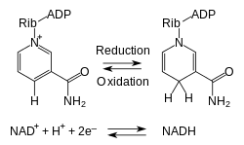
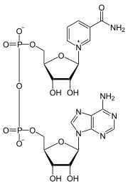

q. what is globin of Haemoglobin?
the oxygen-carrying component of red blood cells.
a colorless protein obtained by removal of heme from a conjugated protein and especially hemoglobin
Q.Mevalonic acid is the true precursor of terpenes. Draw the strucfure of mevalonic acid.
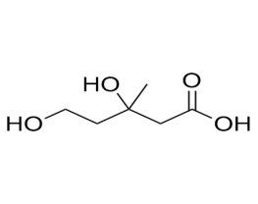
Q. What are ribozyme?
A ribozyme is a ribonucleic acid (RNA) enzyme that catalyzes a chemical reaction. The ribozyme catalyses specific reactions in a similar way to that of protein enzymes. Also called catalytic RNA, ribozymes are found in the ribosome where they join amino acids together to form protein chains.
Q name one coenzyme each derived from niacin and riboflavin
Ans: NAD (Nicotinamide-adenine dinucleotide) and
FAD(Flavin adenine dinucleotide).

DETERMINATION OF STRUCTURE OF PROTEINS/POLYPEPTIDES:
The various steps involved in the determination of structure and analysis of a protein are
1. IR spectrum,2. UV Spectrum ,
3. Amino acid analysis: Proteins are hudrolysed to polypeptide and then simple amino acids.the aminoacids are then separated by chromatography and identified using ir,uv and nmr spectroscopy.
4.Terminal residue analysis:The aminoacid residues at the two ends of a peptide chain are different from all other amino acid residues. N-terminal residue contains a free α-amino group and the C-terminal contain the fre –COOH group.
The two N-terminal and C-terminal residues are the identified as follows:
N-terminal residue analysis:
a) Sangers method: In this method DNFB is allowed to react with peptide followed by hydrolysis. The DNP derivative is the separated and identified as N terminal amino acid
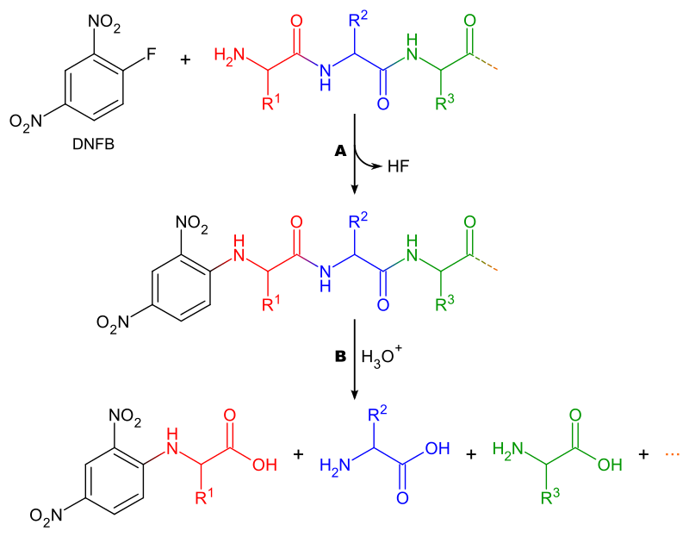
C- terminal Residue analysis:
Hydrazinolysis: It involves the heating of a protein or polypeptide with anhydrous hydrazine. This converts all amino acids except C-terminal into amino sacid hydrazides.
Q. How can you identify the N-terminal amino acid of a peptide?

