Inflation: Rapid and significant rise in price level is known as inflation.During inflation,the value of money falls,but the value of commodities rises.
Features of inflation:
a. Rise in price level
b. It is a monetary phenomenon.
c. It is a long period phenomenon.
c. Real inflation takes place after full employment.
d. Inflation is not the cause of increase in employment and production.

Types of inflation
On the basis of speed
It is divided as follows--
a. Creeping inflation
b. Walking inflation
c. Running inflation and
d. Hyper or Galloping inflation.
When annual rise in price level is almost 2%, this is called creeping inflation.
When annual rise in price level is almost 5%this is called walking inflation.
If annual rise in price level is 10% then it is called running inflation.
In galloping inflation, price rise takes place in each and every minute
and there is no limit of increase in price level

On the basis of Inducement, inflation is divided as follows--+
a. Wage induced inflation
b. Profit induced inflation
c. Scarcity induced inflation
d. Deficit induced inflation
e. Currency induced inflation
f. Foreign trade induced inflation
g. Credit induced inflation
If inflation takes place due to increase in wages,this is called wage induced inflation.
If inflation takes place due to pushing up prices for earning profit by the producer , it is called profit induced inflation.
If the supply of commodities can't be increased due to natural calamities,then the prices of commodities increase. This is called scarcity induced inflation.
If new money is printed in order to cover deficit in the budget, this is called deficit induced inflation.
If money supply is higher than the supply of goods, this is called currency induced inflation.
when inflation takes place due to increase in demand for export is called foreign trade induced inflation.
When inflation takes place due to expansion of credit is called credit induced inflation.

Division on the basis of time
a. Peace time inflation
b. War time inflation and
c. Post war inflation

Division on the basis of scope
a. Comprehensive inflation and
b. Sporadic inflation
When the prices of all goods and services in the economy goes on increasing,this is called comprehensive inflation.
When inflation emerges in aparticular sector spread to other sectors is called sporadic inflation.

Division on the basis of cause
a.Demand-pull inflation
b .Cost-push inflation
When total demand for goods and services exceeds total supply of goods and services,is called demand-pull inflation.
when inflation emerges due to increase in cost of production of commodities is called cost push inflation.

Division on the basis of Govt. reaction
a. Open inflation
b. Suppressed inflation
when the Govt.does not take any measures to control price rise,is called open inflation.
When the Govt.adopts measures to combat inflation,this is called controlled inflation.

CAUSES OF INFLATION
Inflation may emerge either due to excess demand over supply or limited supply of goods

Causes of excess demand
a.Increase in money supply
B.Increase in disposable income
C.Increase inpublic expenditure
D.Increase in consumption spending
E.Deficit financing
F. Repayment of public debt
G.Increase in export

Causes of decrease in supply:
1.Shortage of factors of production
2.Natural Calamities
3.Artificial Scarcities
4.Industrial disputes
5.Lopsided production
6.Increase in prices of imported goods
7.International factorvate sector
I.Black money
J.Cheap money policy

Theories of Inflation
There are two theories of inflation.One is Demand-pull theory and the another is Cost-push theory of inflation.
DEMAND PULL THEORY
According to this theory, if aggregate demand for goods and services is higher than their supply at current prices,then demand pull inflation takes place.
The Monetarists and Keynes explains differently the emergence of Demand pull inflation.
The Monetarist Theory:--The Monetarist theory is based on quantity theory of money.According to them,inflation is a monetary phenomenon.After attainment of fullemployment, increase in money supply increases money expenditure.So,price level increases proportionately with money supply though velocity of circulation remain constant.
Monetarists view is shown with the help of the following diagram.

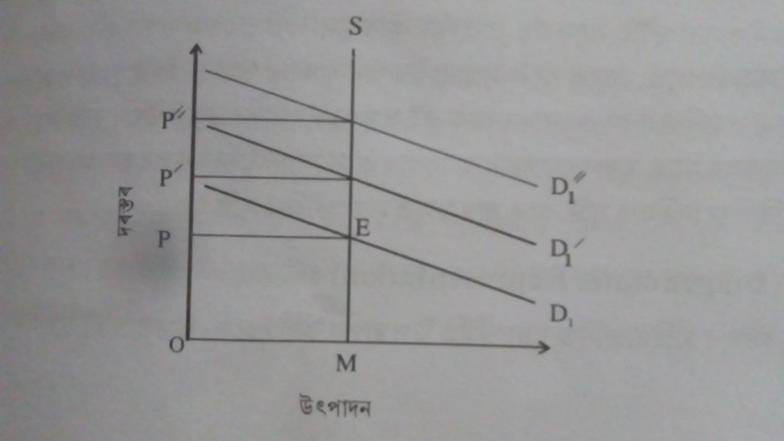

In this diagram,OM is the fullemployment output which is equal to OY aggregate supply line.At the preliminary stage of the economy, both aggregate demand and aggregate supply is equal at point E.So,OP is the equilibrium price.When money supply increases inthe economy DD curve shifts upward toD'D' &D''D''.As the aggregate supply remain constant,pricel level inreases due to increase in aggregate demandas a result of increasing money supply.This is demand pull inflation.

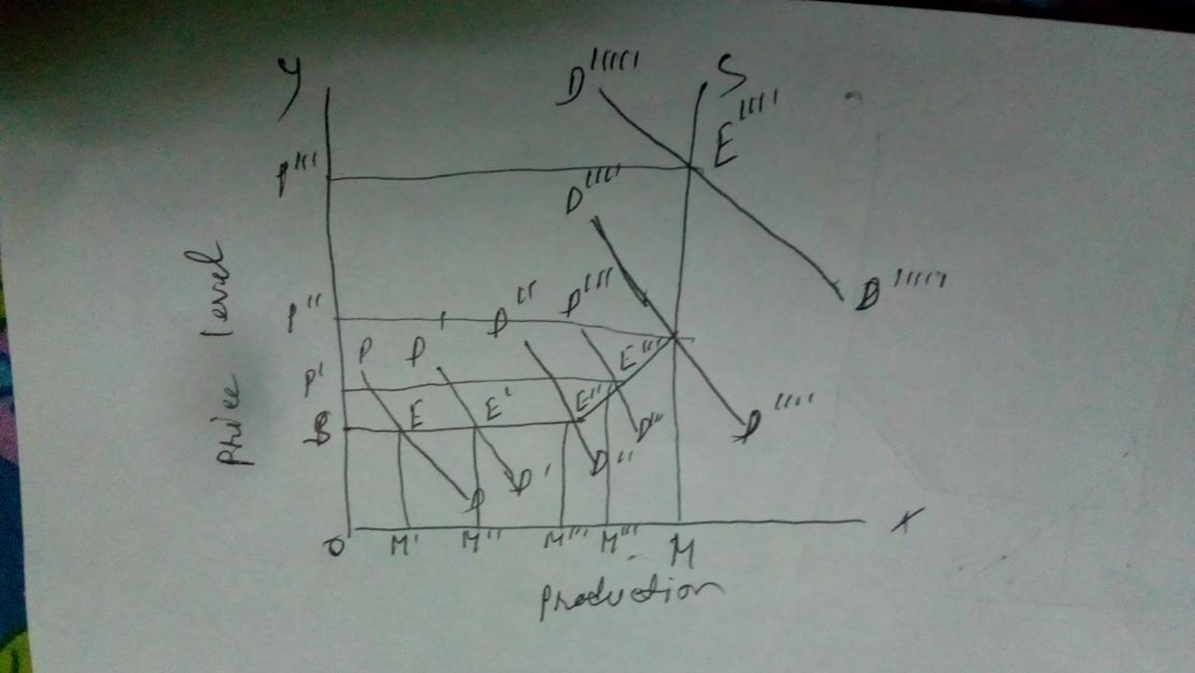

Keynesian theory
keynesian theory of demand pull inflation is shown with the help of the following diagram(you will write this sentence before drawing the diagram)Below the diagam, u will write as follows.
In this diagram,SS represents aggregate supply curve.One portion of the curve is horizontal,the next portion is upward going and the last portion is vertical.

when aggregate demand curve is DD ,amount of production is Aggregate demand while inreases to D'D' and D"D" production increases to OM' and OM".There is no increase in price level.With D'''D'''increase in aggregate demand, production increases to OM'''and price level increases to OP.When aggregate demand increases to D'''D'''' ,production touches fullemployment level which is OM and price level increases to OP".After fullemployment increase in aggregate demand increases price level as it is not accompanied with supply.So,it creates inflation

COST PUSH INFLATION

According to cost push theory inflation also caused by increase in cost of production.Increased cost pushes up the price and ultimately inflation emerges.There are three reasons of cost push inflation.These are--

1. Labour union's monopoly power to enhance wages.
2. Monopolist's power to increase profit
3. Increase in material cost.
Cost push inflation is shown with the help of the following diagram
In this diagram cost push inflation is shown with the help of aggregate demand and aggregate supply curve. Point E indicates fullemployment equillibrium. At this point
Full employment output is OM and price level is OP.Aggregate supply curve SES shifts upward to S'E'S due to increase in production cost and new equillibrium point is E'.At this point price level rises to OP' and production reduces to OM'.So, price level and unemployment rises simultaneously.
This is cost push inflation.
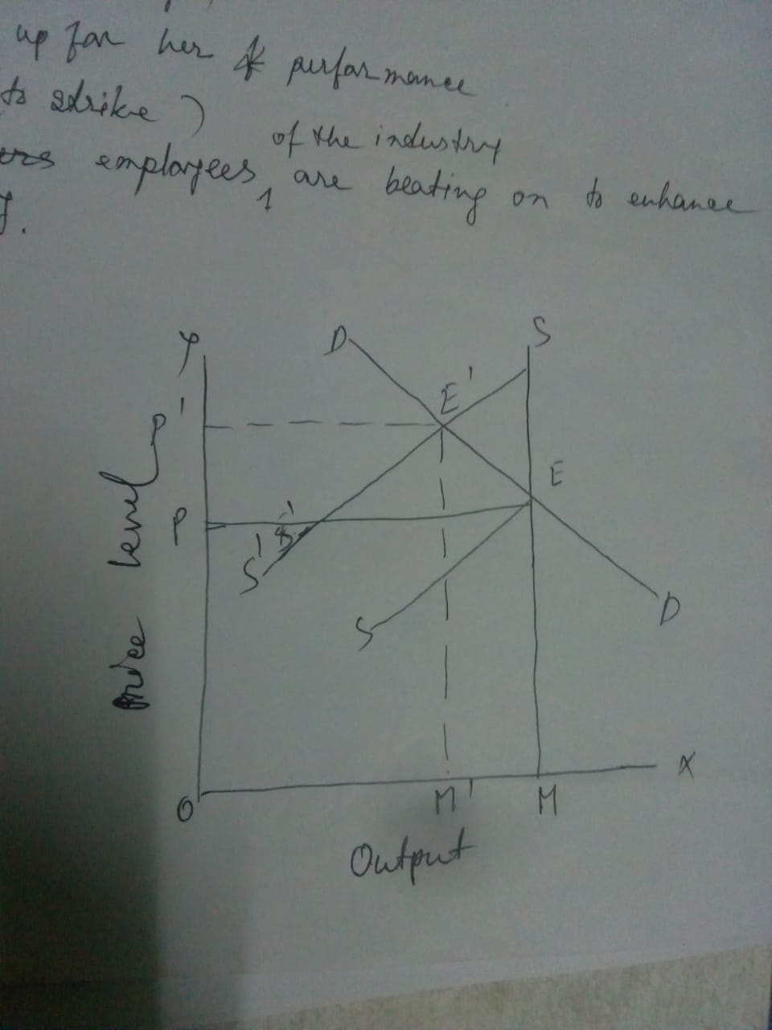
INFLATIONARY GAP

Inflationary gap is a keynesian concept.He explained this concept in his book"HOW TO PAY FOR WAR".In this book he states that inflationary gap is the excess of aggregate demand at fullployment production.when investmentand Govt.expenditure increases but production can't be increased due tol limitation of productive capacity,then inflationary gap takes place.Larger the amount of expenditure than income,greater will be the gap between the two and rate of inflation rises.
Inflationary gap can be called as gap between pre-intlationary money income and post-inflationary money income.It can be expressed as
Inflationary gap=Aggregate demand at current prices (-)Aggregate supply at constant prices
Inflationary gap can be explained with the help of an example pf war-time economy.On supply side, it is assumed that Gross National Product is 1000 crore at constant prices or at pre inflation prives. If the Govt. takes away production equal to the value pf 250 crores 750 crores of productipn will be available for civilian consumption..On the demand side,it is
assumed that total money income of the factors are 1500crores.If the Govt.takes away Rs.300crore from the citizens as tax,total
disposable income remain in their hand will be 1500--300=1200 crores.If the citizens saves Rs.100 crores from their disposable income, 1100 crores will be their net disposable income.So,1100 crores remain in the hand of the people for expenditure.But,total supply of commodities available is equal to 750 crores.So ,inflationary gap is=1100--750=350 crores.
The example can be shown in the form of a table.

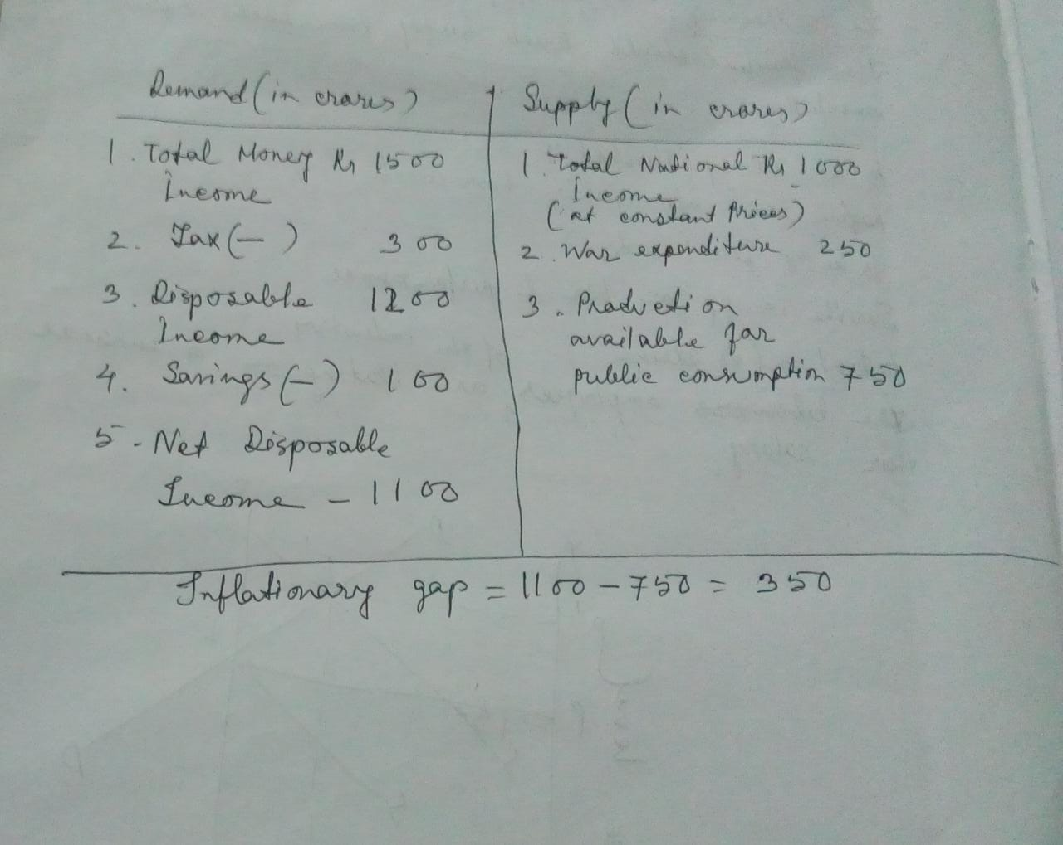

The inflationary gap is represented below with the help of diagram.

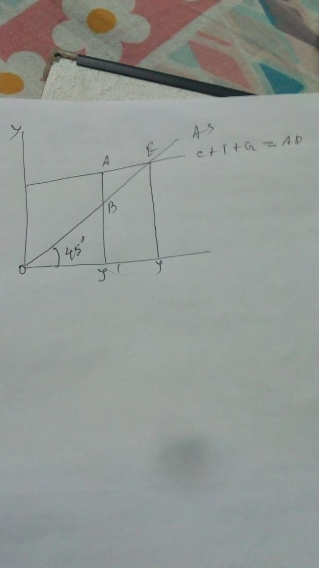

In this diagram, OY' is full employment income.45° line represents aggregate supply and C+I+G line indicate aggregate demand. AD line intersect the AS line
at point E. At this point, OY is aggregate income, which is larger than full employment income by the amount of OY'. Full employment aggregate supply is Y'B and aggregate demand is
Y'B .So, AB is inflationary gap.

