Post Production
Post Production is the stage after production when the filming is wrapped and the editing of the visual and audio material begins.
Post-Production refers to all of the tasks associated with cutting raw footage, assembling the footage, adding music, dubbing, sound effects, VFX, Sound mixing, Foley Sound etc. The Post-Production process is highly collaborative, across a few months to even a year, depending on the size and need of the project.
Post production can be broadly categorises in two definite part-
1. Editing of the Visuals
2. Editing of the Sound

Editing of the Visuals includes- Editing of the pictures to create the scenes and finally the whole film is put into sequential order to have a meaning full story or complete the storyline as desired by the director, VFX (Visual effects) if needed are added and then colour grading is done, title, credits and graphics is done.
Editing of the Sound includes- Sounds of the footage are edited and synchronized as required, music is added to boost the meaning of the visuals, foley sound is done, sound mixing is done, dubbing is done.
After all these final mastering is done to get the final product.
Distribution materials, publicity materials like teaser, trailer. Promos are also created during this stage of filmmaking.
Various professionals get involves during post production like-
- Editor, Assistant Editor
- VFX artist
- Sound Editor
- Music Director
- Foley Artist
- Dubbing Artist
- Colourist etc

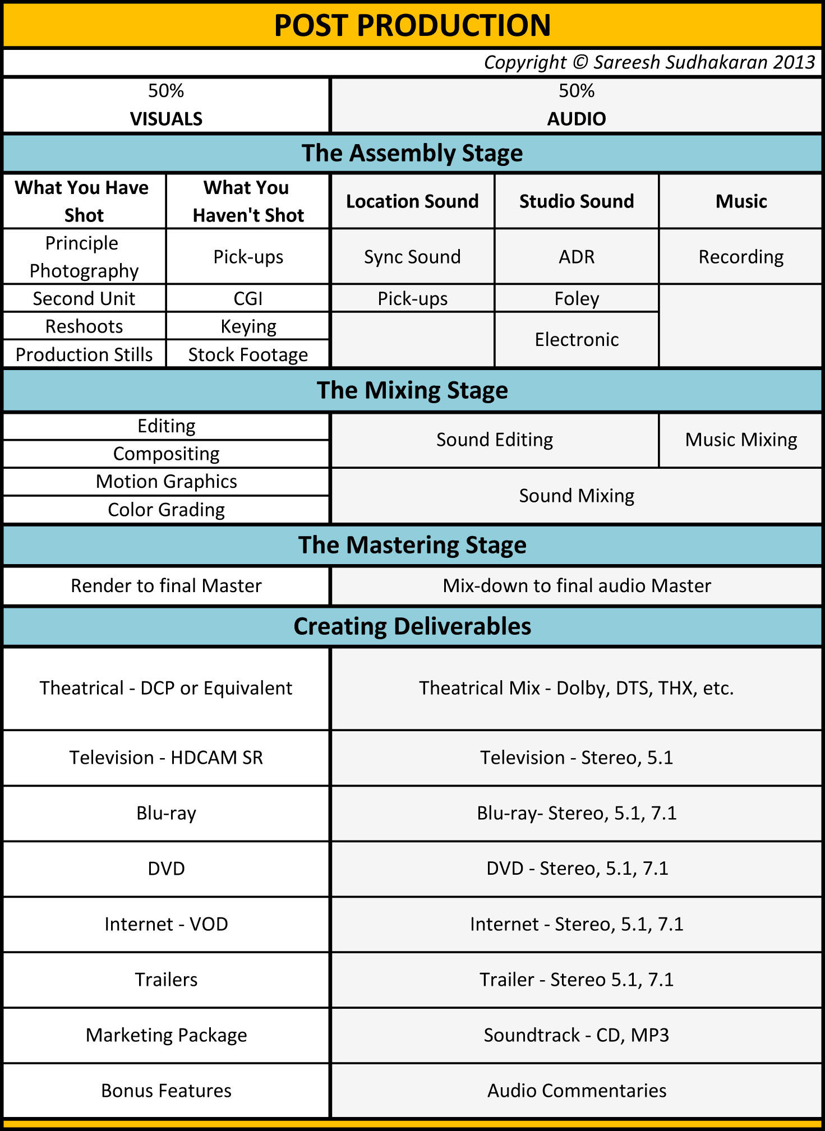

This chart of Post Production shows very clearly the flow of the work during this period.

