What is a storyboard?
A storyboard is a graphic representation of how a video will unfold, shot by shot. It is made up of number of squares with illustrations or pictures representing each shot, with notes about what’s going on in the scene and the dialogue. It looks like a comic book version of the script.
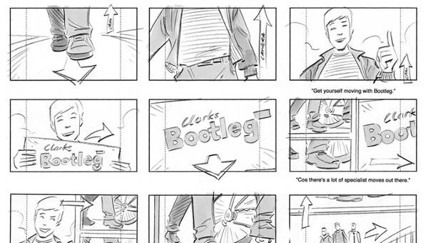
A storyboard is the roadmap while making a video.
Like a script, storyboard visually guides us throughout the production process. By planning our video, we know which shots we need to create and how to create them when filming begins. We can get others’ feedback early on and make simple adjustments to storyboard if required, rather than making major changes while filming.
To make a good storyboard, we don’t need to be a visual artist . A storyboard can be anything from comic book-like rough sketches to stick figures to computer-generated drawings.
- A storyboard is a planning tool for visualizing and organizing ideas.

Ideas are pictorially or verbally represented and displayed so that they can be developed, rearranged and discussed.
It's a perfect tool for people who want to organize information for proposals, presentations or productions. Using a storyboard transforms your information into a visual story and allows people to experiment with changes in the sequence or storyline during the creative process.

History of the storyboard

The storyboarding process was developed in Hollywood during the early 1930s for the first animated films and is still used today as a key step in making any movie.

Each scene of the film is drawn on paper and put in sequence on a large board that is hung on the wall. This allows the team to see and arrange the order of the film before it's made.
Years later, large companies like IBM and General Electric developed storyboarding as a planning tool to coordinate the construction of proposals, reports and presentations.

There are four types of storyboard. These are as follows.

- Thumbnail storyboard

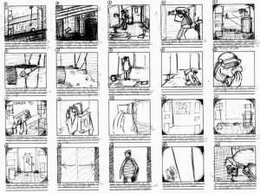
The Thumbnail Storyboard is what it is called, each shot in a small thumbnail sketch and allows to quickly put your ideas down but may not always be the most readable therefore it is usually a starting point.

- Floating storyboard.
The Floating Storyboard is a more wide-ranging board as the drawings are in rectangles matching the aspect ratio that the film will be shot in. However, it does not have to be within a rectangle hence the “floating storyboard” and doesn’t restrict you to a certain space.
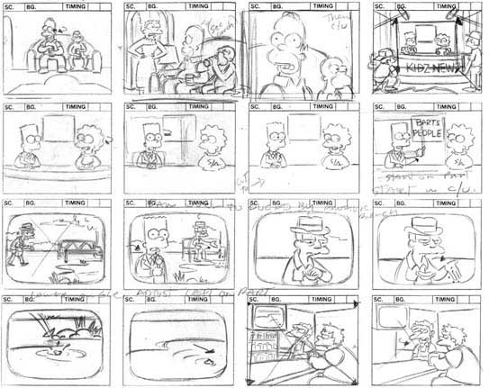

- Framed storyboard
The Framed Storyboard is where the drawings are in a fixed aspect ratio so that you are forced to think carefully about how things will be shown on the screen. This is a good storyboard for final ideas.
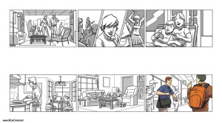

- Photo storyboard

The Photo Storyboard, is again as the name suggests. The aspect ratio is automatically produced therefore it is less of a worry. This time though you have puppets and small sets created so you can photograph them.
